Section2：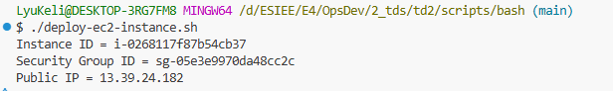
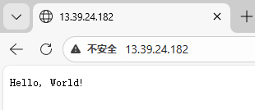
- Exercise2.1：
The security group 'td2-sample-app' already exists because of the last run of the script.
- Exercise2.2: First, check if the security group exists; if it does, directly obtain its ID.
Section3:

