Sprint 3 Notes

Back end – Testing different models: efficientNetsB7 and ResNet50 had the best results out of box using given training images. 33,702 dicom images

Front end – Launch of live website at 178.128.191.113

Currently trying to build opencv on server (to resize the dicom images). (Alternative maybe?) upload is failing unfortunately

But saved .h5 model loads

Current output is FVC predicted. However, this is only for one patient, to make the website more friendly, a user needs to input more than just a dicom image, they must import metadata in addition to a full set of dicom images.

Formula for FVC –

fvc = a * (weeks_true - weeks_true[0]) + fvc_true[0] in ml

Efficient Nets (LOWER IS BETTER)

B0 6.738611514006826
B1 6.738615758945669
B2 6.738613418004487
B3 6.738611774208092
B4 6.73860897087329
B5 6.738601180703329
B6 6.738588790331243
B7 6.738575492135848
B8 6.738583158434636
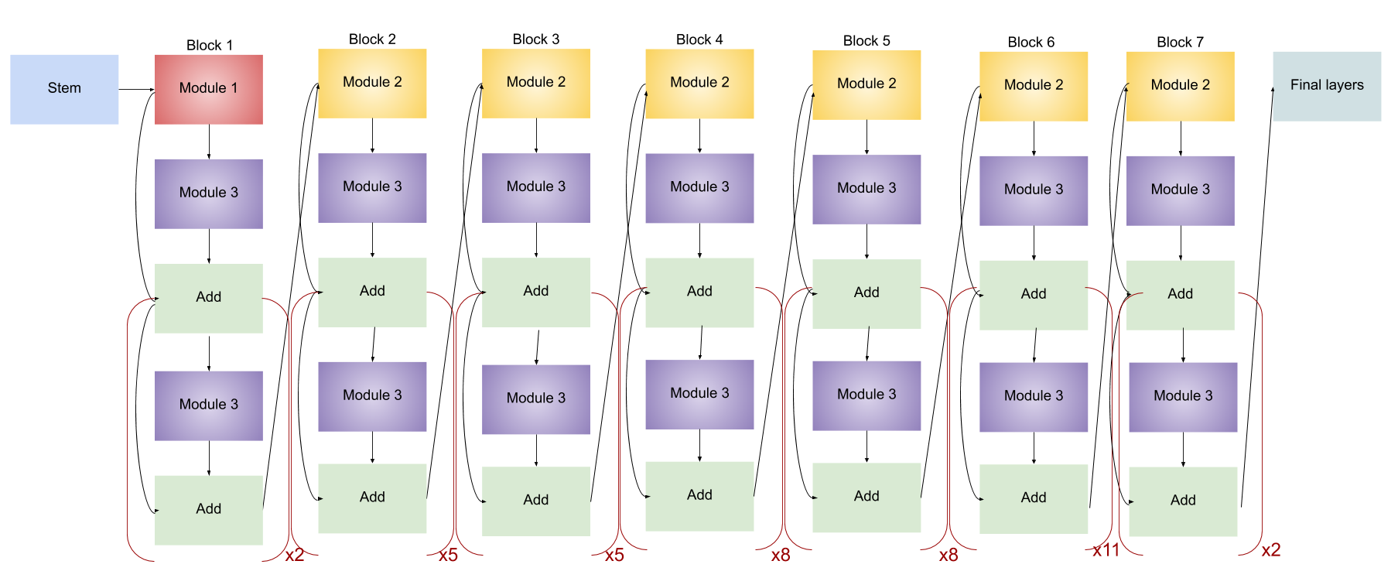

resNet 6.91???????? easiest to implement in live website

