24772 : KAMIKAZI Kellia

THIS IS A SCREENSHOT RECORDS OF THE ASSIGNMENT

You login this is the page you land on , it contains the information from the database of the users

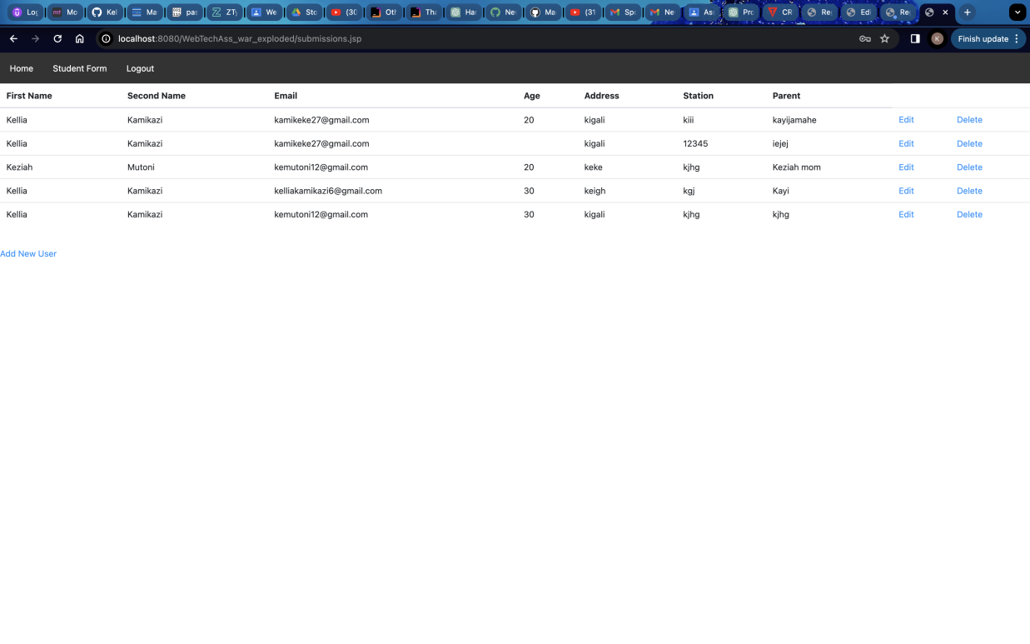

Once you click Add new user it takes you to a create userform

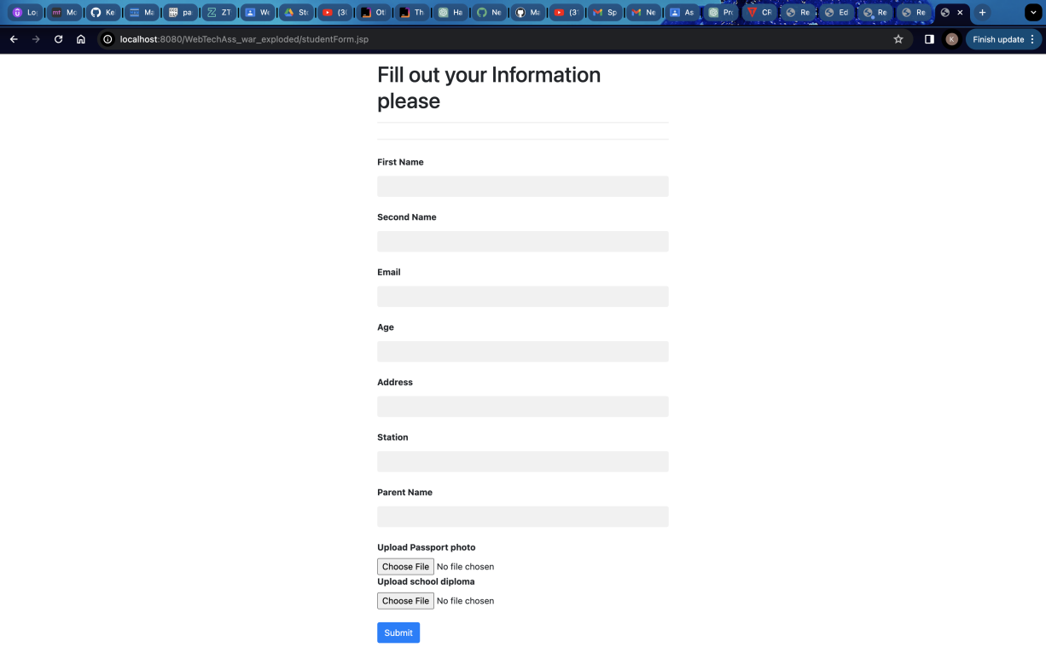

Once the update is clicked this is where it takes you , to the edit form

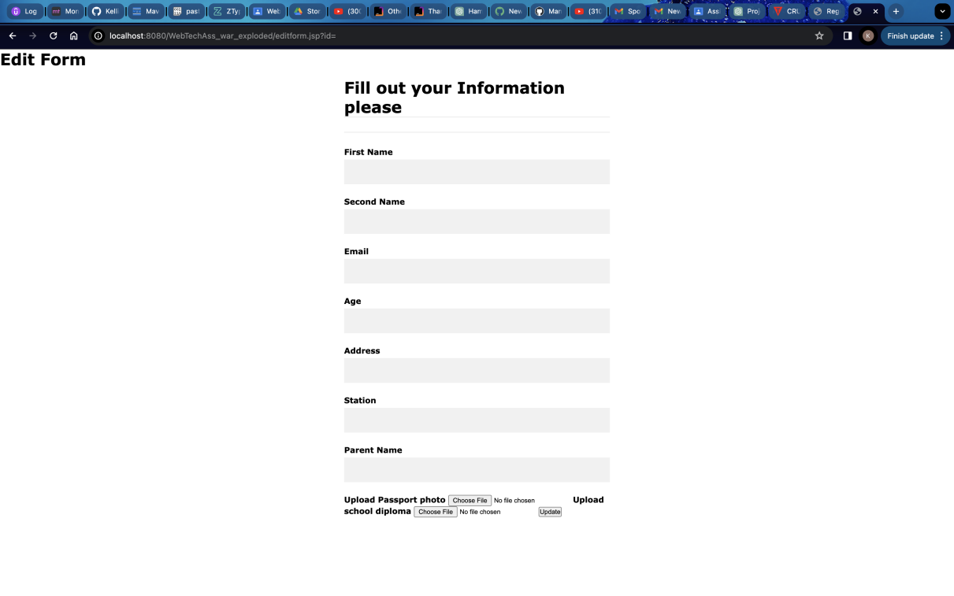

And when you click delele it call the delete function

Let us create someone called john doe with email [johndoe@gmail.com](mailto:johndoe@gmail.com) ,,, we will delete and edit his age to 80 and delete them

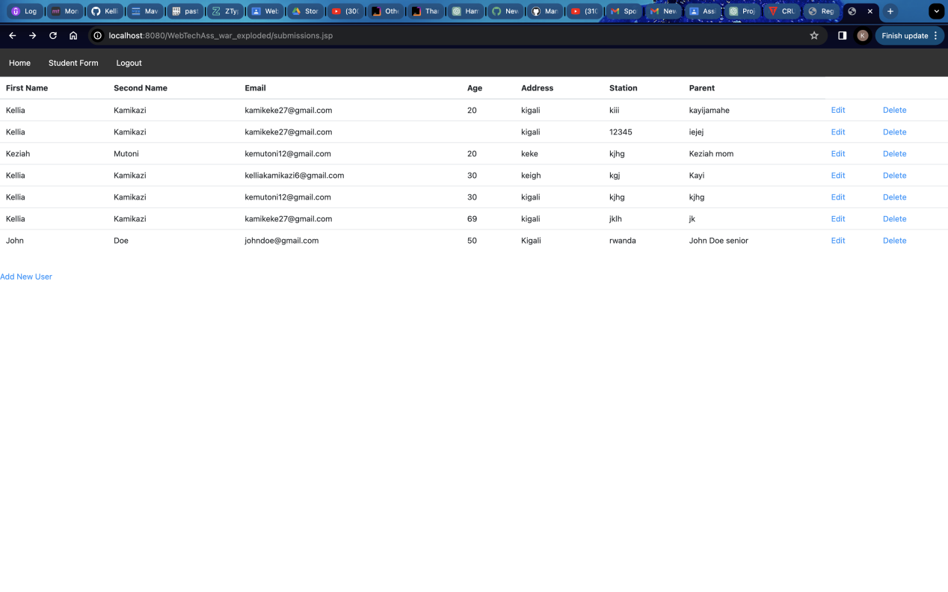

update from 50 to 80 years

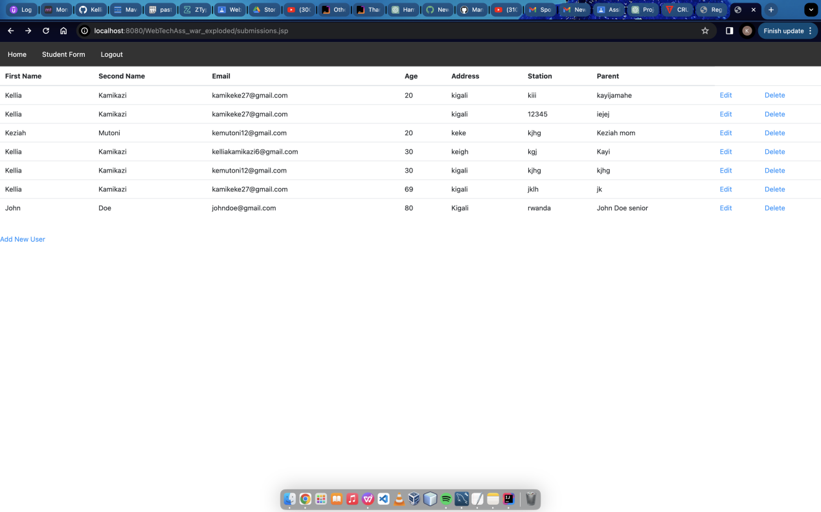

we delete them now

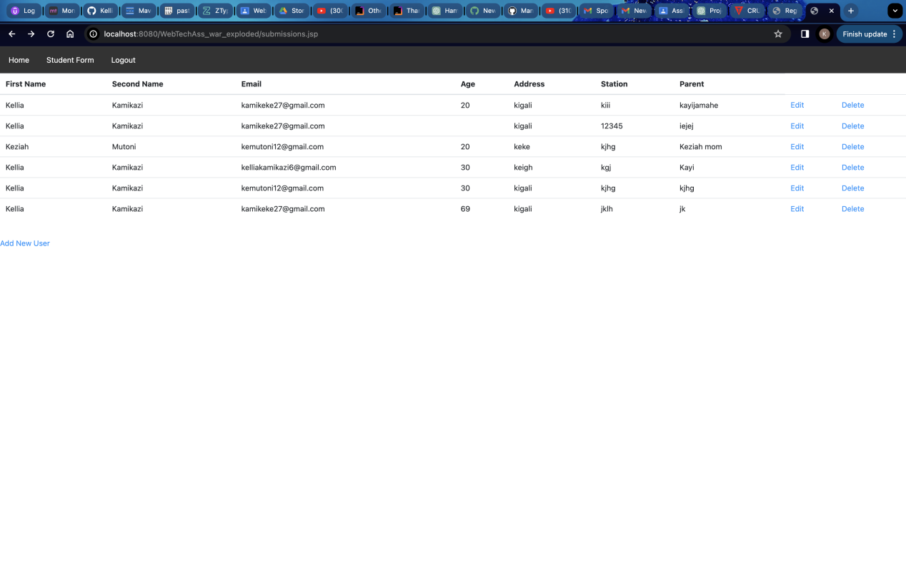

THANK YOU !!!!!