A simple demonstration of a diagram:

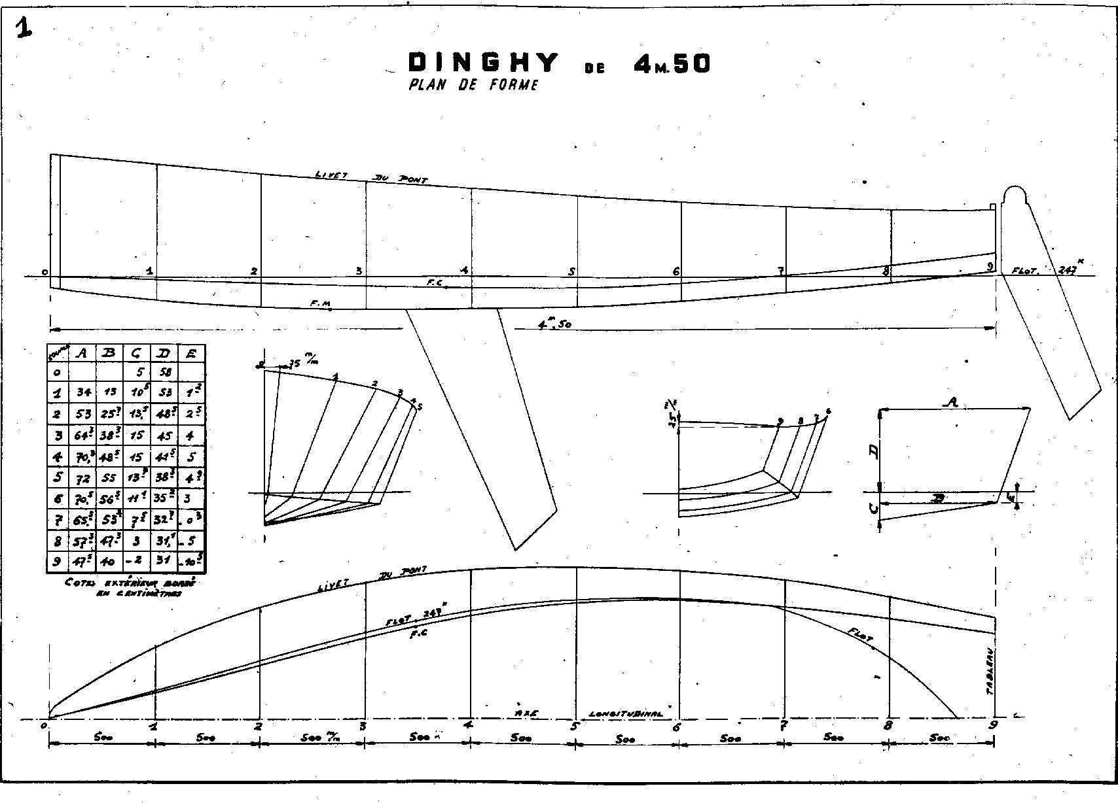

End of demonstration.