A simple demonstration of a MList :

bookmark

***~~some text~~***

**bookmarkRef**

***~~some text1~~***

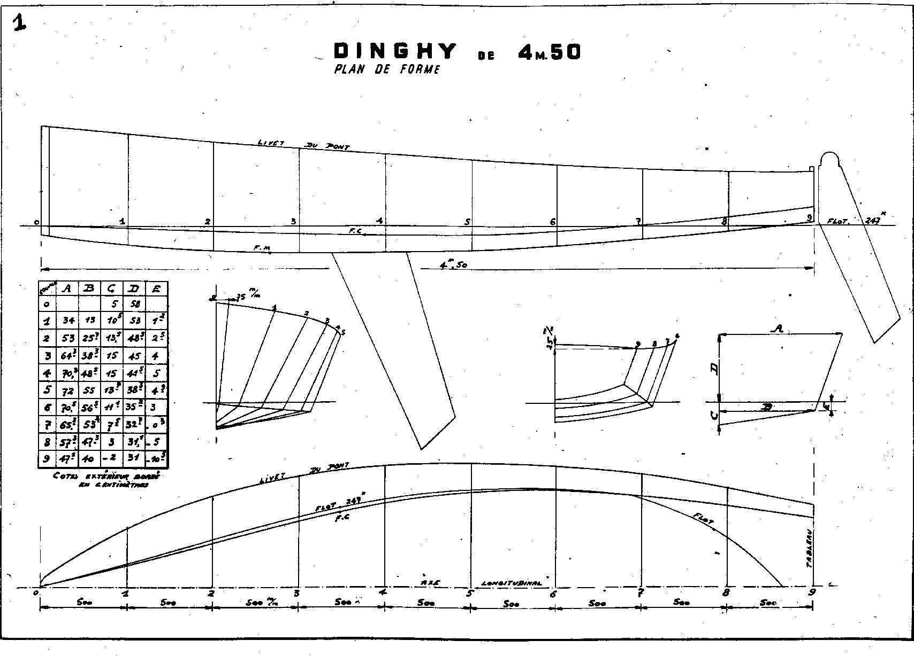

***~~some text2~~***

|  |  |  |  |  |
| --- | --- | --- | --- | --- |
|  | ***~~Bold~~*** | ***~~Italic~~*** | ***~~Underline~~*** | ***~~Strike through~~*** |
| ***~~Bold~~*** | ***~~0~~*** | ***~~1~~*** | ***~~2~~*** | ***~~3~~*** |
| ***~~Italic~~*** | ***~~4~~*** | ***~~5~~*** | ***~~6~~*** | ***~~7~~*** |
| ***~~Underline~~*** | ***~~8~~*** | ***~~9~~*** | ***~~10~~*** | ***~~11~~*** |
| ***~~Strike through~~*** | ***~~12~~*** | ***~~13~~*** | ***~~14~~*** | ***~~15~~*** |

***~~sample tablesome text3~~***

***~~sample tabletext in a list~~***

End of demonstration.