A simple demonstration of a static image :

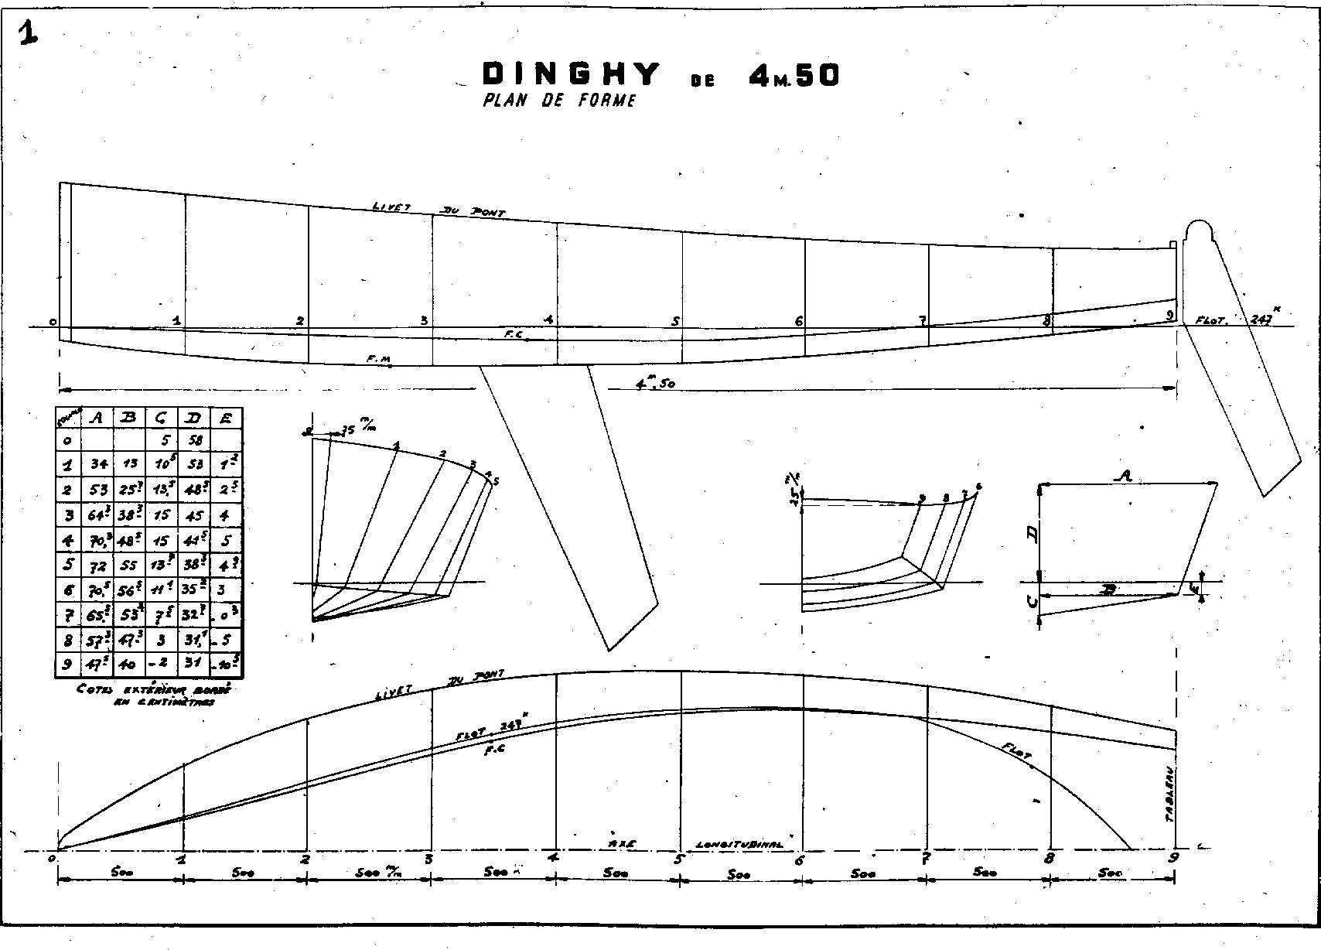End of demonstration.