A simple demonstration of a <---M2Doc version mismatch: template is 3.1.1 and runtime is 3.2.0 static image :

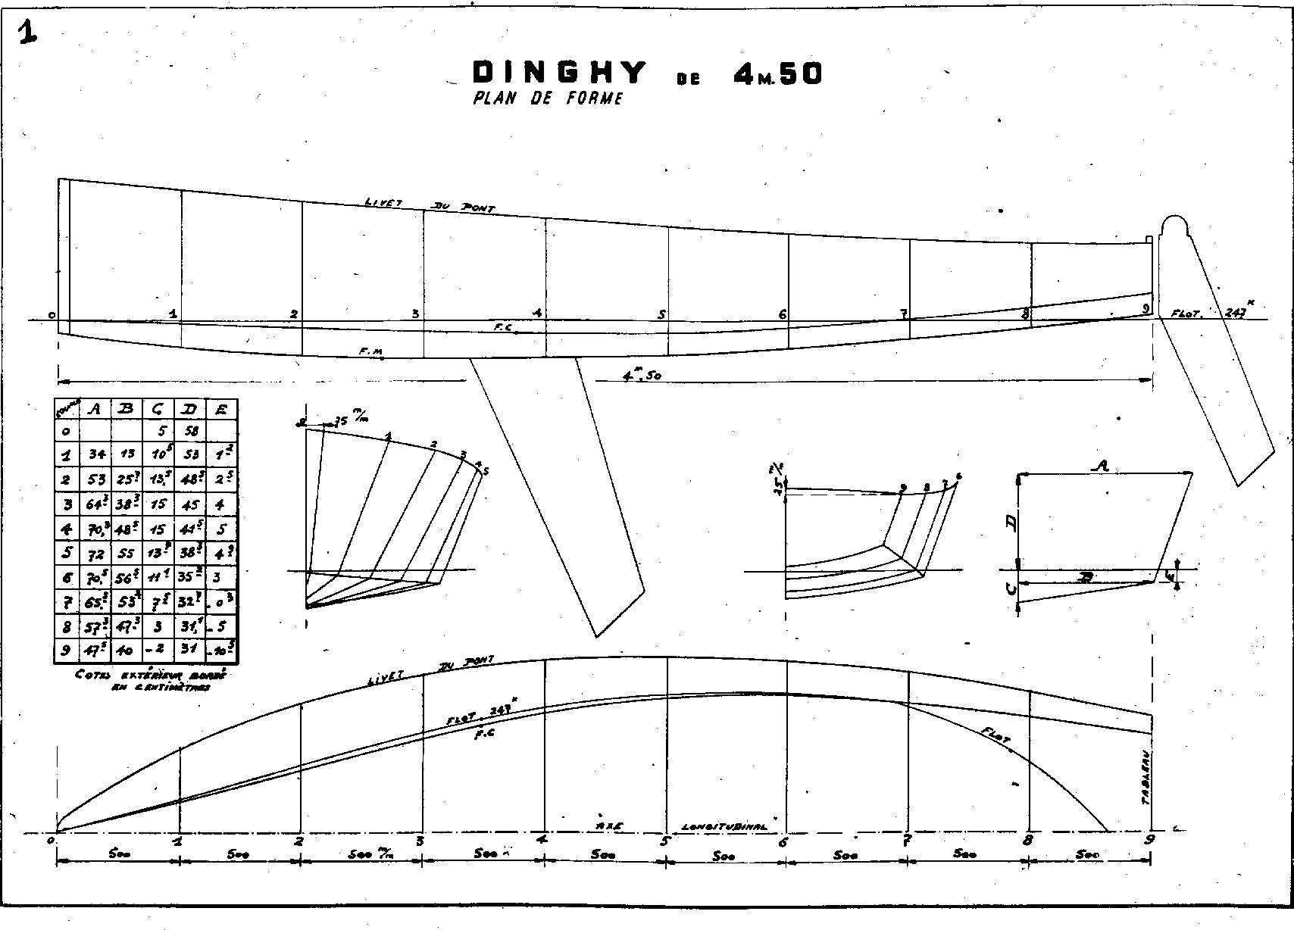End of demonstration.