<---M2Doc version mismatch: template is 3.1.1 and runtime is 3.2.0 A simple demonstration of a static text :

Some text.

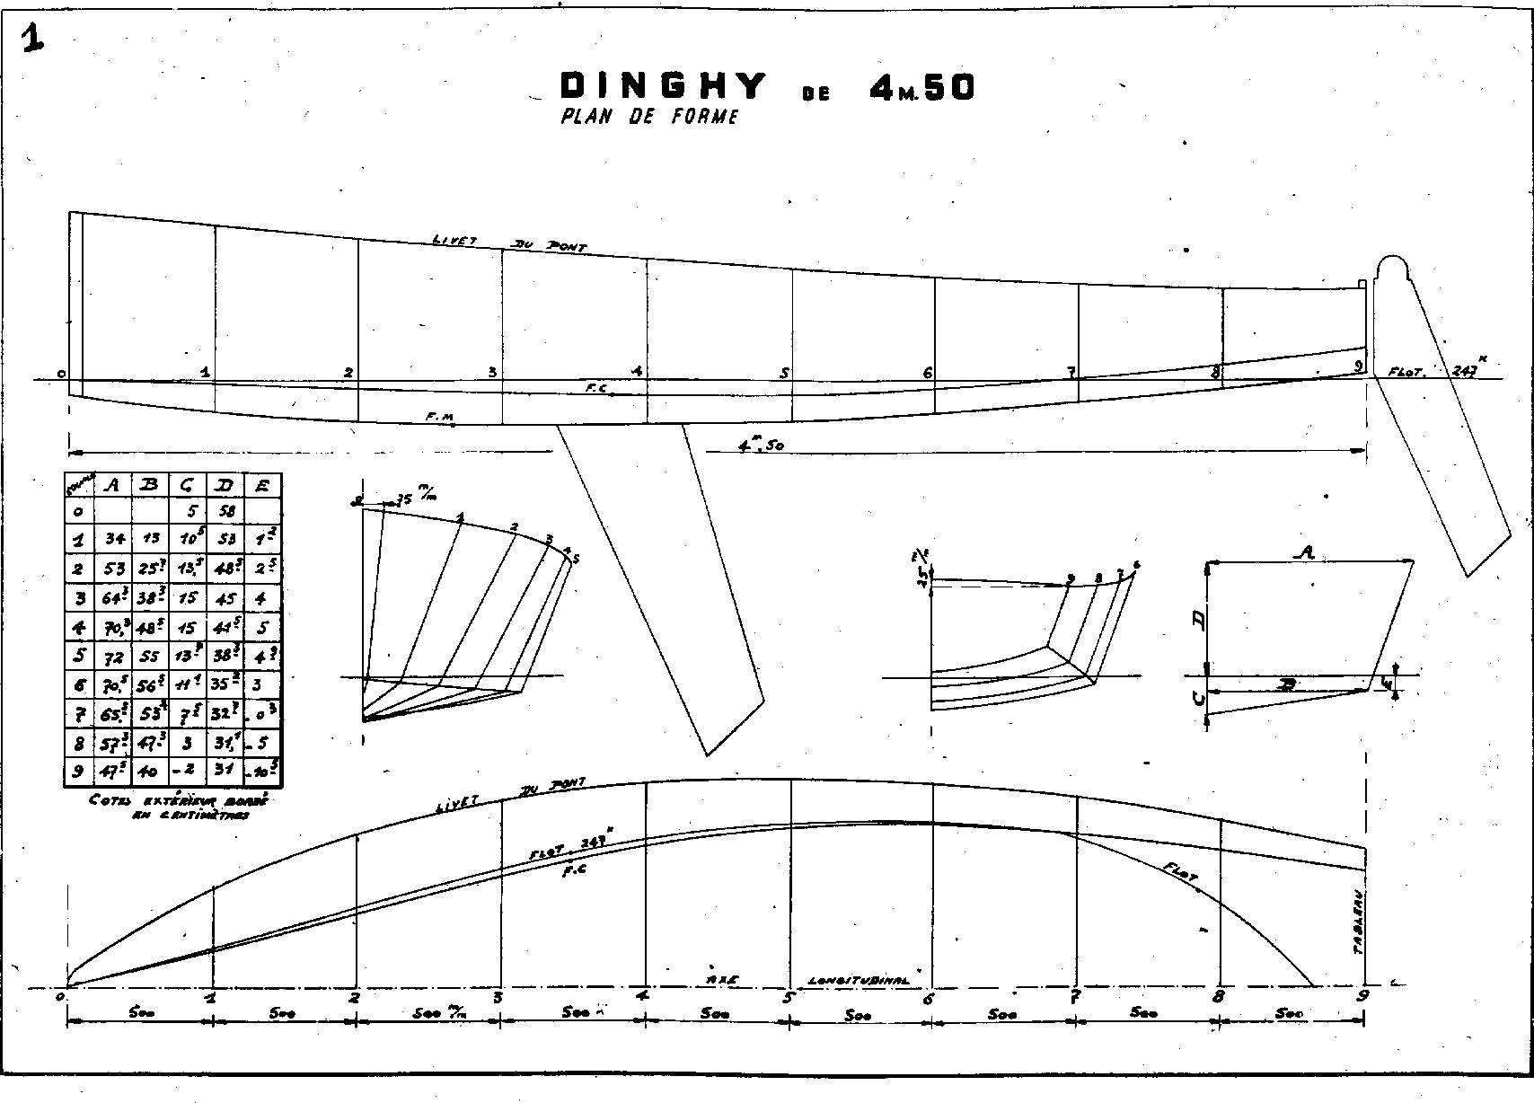

End of demonstration.