A simple demonstration of a user doc :

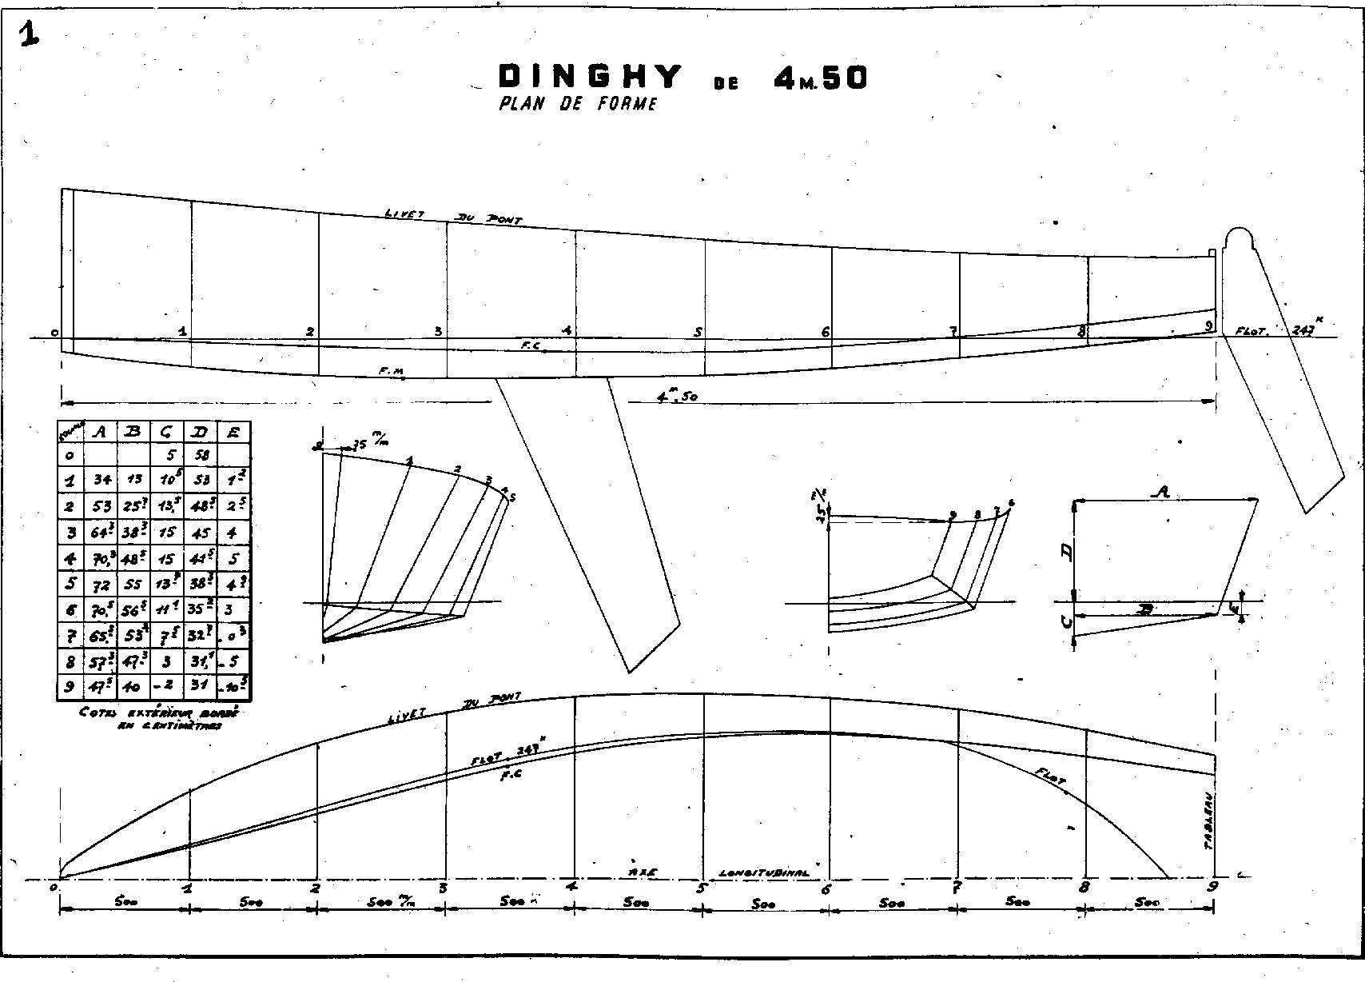

End of demonstration.