rostopic echo /RosAria/pose

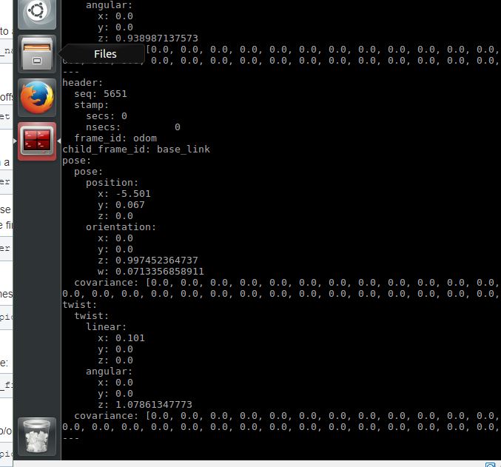



rostopic echo /tf

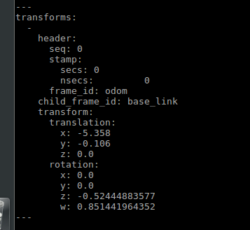

Visualize robot in scene

student@autonomous-systems:~ $ rosrun rviz rviz

Python program to listen

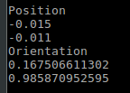

Position

X

Y

Orientation

Z

W

Python read_all.py

