Data files with Crustal Thickness Compilation for South America:

Raw data:
Compilation_SAm.06NOV2012.IXYEHU.dat =
compilation of all 937 Crustal thickness for South America (Assumpcao et al., 2013a,b).
columns are:
I = Identification (usually station name)
X,Y = long., lat.
E = elevation above msl in meters
H = crustal THICKNESS (km)!!! <= CAREFUL!!
includes topography in continents
includes ocean layer in oceanic part!
U = uncertainty (km)
(Other columns are references/observations)

Note that “Moho Depth” in km, relative to mean-sea-level = H - E/1000

[Compilation_Andres.XYEHU.dat + Compilation_Marcelo.06NOV2012.IXYEHU.dat
= Compilation_SAm.06NOV2012.IXYEHU.dat ]

Gridded data:
Two models are presented:
- model 1 with seismic point constraints only (from file “Compilation….IXYEHU.dat)” and some gravity-derived estimates to fill in blank areas in the Andes.
- model 3 with the same point constraints above and interpolated using surface-wave tomography.

model1_Crust_thickn_SAm_T0.5.grd = binary gmt grid file for model 1, spacing of 0.5º.
x_min: -90 x_max: -30
y_min: -45 y_max: 15

model1_Crust_thickn _SAm.xyz = text file for the grid above. Long, Lat, Thickness

model3_MohoDepth_tomo_2012Set.grd = model 3 with DEPTHS below msl. Spacing 0.2º.
x_min: -95 x_max: -20
y_min: -60 y_max: 18

model3_MohoD_SAm.xyz = text file for model3 above. Long, Lat, Moho Depth

Papers
Christensen_Mooney_JGR1995.pdf = classical paper on Continental Crust properties, P-wave only.
Chulick_etal_JSAmES2012.pdf = Compilation, maps of crustal thickness, average P- and S- velocities
Assumpcao_etal_Crust_thickn_Brazil_JSAmES2013.pdf = description of data compilation
Assumpcao_etal_MohoSam_Tecto2013.pdf = results of two models: 1) point constraints only,
and 2) points + tomographic interpolation.

Maps are shown below:
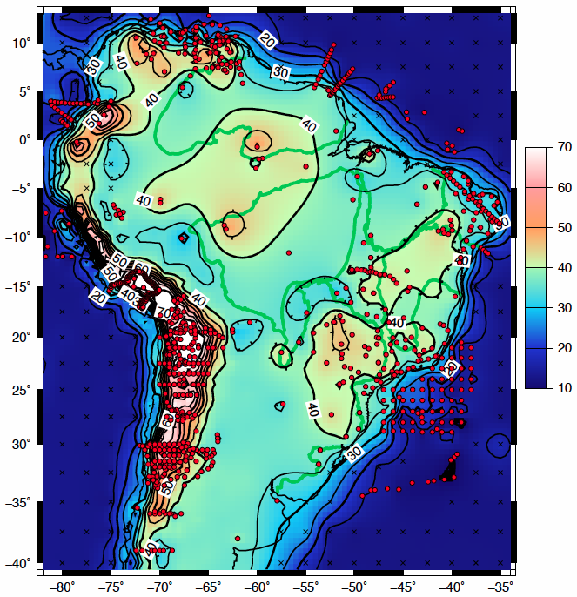
Model 1 (point constraint only).
Note large areas with smooth contours because of lack od seismic data!

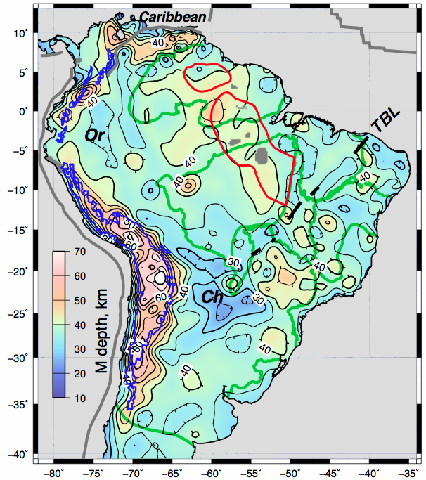
Model 3 (point constraint + surf-wave tomo).
Note that small-scale structure, away from point constraints, has poor resolution.

