UNIVERSITY OF GHANA
Department of Computer Science
DNS Latency and Its Impact on Web Page Load Time
A Measurement, Modelling and Simulation Study

DCIT 417 — Network Modelling and Performance Analysis
Semester Project Report

Submitted by:
[Student Name]
[Student ID]

Supervisor: [Lecturer Name]
Date: March 2026

Abstract
This report presents a comprehensive empirical and analytical study of DNS (Domain Name System) resolver latency and its contribution to web page load time. Measurements were conducted across four resolver configurations — Google Public DNS (8.8.8.8), Cloudflare DNS (1.1.1.1), an ISP-provided resolver, and a campus DNS server — querying eight high-traffic hostnames with 30 repeated trials each, yielding 960 total measurements.

The ISP resolver demonstrated dramatically lower DNS lookup latency (mean: 15.77 ms, median: 12.31 ms) compared to both public resolvers, attributable to geographic proximity. Cloudflare achieved a mean of 126.06 ms while Google recorded 190.51 ms, both reflecting transatlantic round-trip delays. The campus DNS server failed completely, with all 240 queries timing out — likely due to firewall-enforced access restrictions. All successful resolvers exhibited log-normal latency distributions, consistent with established network latency literature.

A component-wise delay model (T_total = T_dns + T_tcp + T_transfer) was applied to decompose page load time. The M/M/1 queuing model was used to characterise each resolver as a service system, revealing that only the ISP resolver operates in a stable regime (utilisation ρ = 0.158 at λ = 10 q/s). Discrete-event simulation validated the analytical predictions with less than 2% error. The results demonstrate that DNS resolver selection has a measurable and statistically significant impact on perceived web performance, particularly in sub-Saharan African network environments where international latency penalties are substantial.

Table of Contents
1. Introduction 4
2. Background and Related Work 5
3. Methodology 6
3.1 Measurement Design 6
3.2 Component-wise Delay Model 7
3.3 Tools and Software 7
4. Experimental Setup 8
5. Results and Analysis 9
5.1 DNS Lookup Latency 9
5.2 TCP Handshake Latency 12
5.3 HTTP Time-to-First-Byte 13
5.4 Component-wise Page Load Estimate 13
5.5 Campus DNS Failure 14
6. Statistical Modelling 15
6.1 Distribution Fitting 15
6.2 Burstiness Analysis 16
7. Queuing Model Analysis 17
7.1 M/M/1 Formulation 17
7.2 Analytical Results 17
7.3 Little's Law Verification 18
8. Discrete-Event Simulation 19
8.1 Simulation Design 19
8.2 Validation Against Analytical Model 19
9. Discussion 20
10. Conclusions and Recommendations 22
11. References 23

1. Introduction
The Domain Name System (DNS) is often described as the phonebook of the Internet. Before any web connection can be established, the client must resolve a human-readable hostname (e.g., www.github.com) into a machine-readable IP address. This resolution step, while conceptually simple, introduces a measurable and variable latency that directly precedes every subsequent network operation — TCP handshake, TLS negotiation, and HTTP data transfer.

For users in sub-Saharan Africa, the DNS resolution step carries a disproportionate performance cost. Most public DNS infrastructure is concentrated in North America and Europe, meaning that each query from Ghana must travel thousands of kilometres before receiving a response. ISP-local resolvers, by contrast, may provide faster responses through geographic proximity, though they may offer less cache diversity or reliability.

This project investigates DNS latency as a quantifiable engineering variable and examines its downstream impact on web page load time. Three active resolver configurations were compared — Google Public DNS (8.8.8.8), Cloudflare DNS (1.1.1.1), and an ISP-provided resolver — alongside a campus DNS server that serves as a case study in resolver unavailability. Measurements were taken from a connected Linux workstation on the 23rd of March 2026 between 11:06 and 12:10 (WAT).

1.1 Project Objectives
- Measure and compare DNS lookup latency across four resolver types using directed queries.
- Quantify the TCP handshake and HTTP transfer components of page load time.
- Fit statistical distributions to the observed latency data and characterise burstiness.
- Apply M/M/1 queuing theory to model resolver service capacity and predict sojourn times.
- Validate analytical predictions using discrete-event simulation.
- Draw actionable engineering recommendations for DNS resolver selection in West African network environments.

1.2 Scope and Limitations
This study is limited to DNS-over-UDP (port 53) using standard A-record queries. DNSSEC validation, DNS-over-HTTPS (DoH), and DNS-over-TLS (DoT) are outside scope. HTTP measurements use plain HTTP (port 80) without TLS to isolate DNS and TCP components; HTTPS would add a TLS handshake component. All measurements were conducted from a single vantage point during a single one-hour window, and results reflect network conditions at that specific time.

2. Background and Related Work

2.1 DNS Architecture and Resolution
The DNS resolution process involves a recursive query chain: the client contacts a recursive resolver (the system under study), which in turn queries root name servers, TLD name servers, and finally authoritative name servers for the domain. The recursive resolver caches results according to the TTL (Time-To-Live) value, meaning subsequent queries for the same hostname are answered locally without the full resolution chain.

The resolution latency experienced by an end user is therefore a function of: (1) whether the resolver has a valid cached answer, (2) the network round-trip time (RTT) between client and resolver, and (3) the RTT between the resolver and authoritative name servers worldwide. This multi-hop structure introduces both a mean latency component and a high-variance component driven by cache misses.

2.2 DNS and Web Performance
Historically, DNS was treated as a negligible overhead in web performance analysis. However, as web pages have grown in complexity — requiring DNS lookups for multiple third-party CDN, analytics, and font providers — the aggregate DNS resolution time has become a meaningful fraction of total page load time. Studies by Krishnan et al. (2012) and Sundaresan et al. (2013) showed that DNS lookup contributes between 5% and 20% of total page load time depending on caching state and resolver location.

For African users in particular, Fanou et al. (2016) documented that DNS queries to internationally hosted resolvers from West Africa incur round-trip delays of 100–300 ms, consistent with the measurements in this study. Their work motivated the deployment of anycast DNS infrastructure closer to African users, of which Cloudflare’s 1.1.1.1 is a notable example.

2.3 Queuing Theory in Network Analysis
The M/M/1 queue is a foundational model in network performance analysis. It models a single server receiving Poisson-distributed arrivals and providing exponentially distributed service times. The model’s key predictions — mean sojourn time W = 1/(μ−λ), queue length L = ρ/(1−ρ), and their relationship through Little’s Law (L = λW) — provide closed-form expressions that can be directly parameterised from empirical measurements. The validity of the M/M/1 assumption depends on whether the service time distribution is approximately exponential (i.e., coefficient of variation CoV ≈ 1), which this study investigates explicitly.

3. Methodology

3.1 Measurement Design
An active measurement methodology was adopted, following the IETF RFC 6390 framework for network performance measurement. Measurements are termed ‘active’ because synthetic probe traffic is injected into the network rather than passively observing existing traffic. This design allows controlled, repeatable experiments with known ground truth.

The measurement instrument is a Python script using the dnspython library to issue directed DNS queries (bypassing the operating system resolver cache) to each target resolver. Each query is individually timed using time.perf_counter(), Python’s highest-resolution monotonic clock. TCP handshake time is measured via a raw socket.connect() call to port 80 of the resolved IP address. HTTP time-to-first-byte is measured using the requests library with streaming enabled.

The measurement matrix was:
- 4 resolvers × 8 hostnames × 30 trials = 960 total measurements
- Inter-trial delay: 200 ms (to avoid rate limiting)
- DNS timeout: 5 seconds per query
- TCP timeout: 5 seconds per connection
- HTTP timeout: 10 seconds per request

3.2 Component-wise Delay Model
Page load time is decomposed into additive components according to the following model:

Tₙₒₜₐₗ = Tᴰᴺₛ + Tᴵᶜₚ + Tᴵᴸₛ (optional) + Tₜᵣₐₙₛᶠᵉᵣ

Where:
- T_dns: Time from DNS query transmission to receipt of the A-record response
- T_tcp: Time for the TCP three-way handshake (SYN → SYN-ACK → ACK)
- T_tls: TLS handshake time (not measured in this study; HTTP only)
- T_transfer: Time from HTTP GET to receipt of first response byte (TTFB)

This model is validated against empirical measurements and used to quantify the specific contribution of DNS resolver choice to total perceived page load time.

3.3 Tools and Software
Tool / Library | Version | Purpose
Python | 3.12 | Primary measurement and analysis language
dnspython | 2.x | Directed DNS query library (bypasses OS cache)
requests | 2.x | HTTP TTFB measurement with streaming mode
NumPy / SciPy | 1.26 / 1.12 | Statistical analysis and distribution fitting
Pandas | 2.x | Data manipulation and CSV I/O
Matplotlib / Seaborn | 3.10 / 0.13 | Visualisation and plotting
Custom DES simulator | — | Discrete-event M/M/1 simulation (Phase 5)

4. Experimental Setup

4.1 Resolver Configuration
Four DNS resolvers were evaluated. The first two are globally deployed anycast services; the third is a locally provisioned ISP resolver; the fourth is a campus-based resolver:

Resolver | IP Address | Label in Dataset | Description
Google Public DNS | 8.8.8.8 | google_public | Globally deployed anycast resolver operated by Google
Cloudflare DNS | 1.1.1.1 | cloudflare_public | Privacy-focused anycast resolver with African PoPs
ISP Resolver | 192.168.x.x | isp | Residential/campus ISP recursive resolver
Campus DNS | 10.x.x.x | campus | University internal DNS server (all queries timed out)

4.2 Target Hostnames
Eight high-traffic hostnames were selected to represent a range of global CDN configurations, geographic distributions of authoritative name servers, and realistic browsing patterns:

www.google.com, www.youtube.com, www.facebook.com, www.wikipedia.org, www.github.com, www.amazon.com, www.twitter.com, www.reddit.com

4.3 Measurement Timeline
All measurements were conducted on 23 March 2026 between 11:06:38 and 12:10:31 (West Africa Time, UTC+1). The total elapsed measurement time of approximately 64 minutes is consistent with the expected duration of 960 measurements × 200 ms inter-trial delay + DNS/TCP/HTTP overhead. Measurements were conducted in resolver-major order (all trials for a resolver before moving to the next) to allow DNS caching effects to stabilise naturally.

5. Results and Analysis

5.1 DNS Lookup Latency

5.1.1 Descriptive Statistics
Table 2 presents the per-resolver descriptive statistics for DNS lookup time across all 240 successful measurements per resolver.

Resolver | Mean (ms) | Median (ms) | Std (ms) | Min (ms) | p95 (ms) | Max (ms) | CoV
ISP Resolver | 15.77 | 12.31 | 15.04 | 4.15 | 45.97 | 140.09 | 0.954
Cloudflare (1.1.1.1) | 126.06 | 64.45 | 105.58 | 24.96 | 329.50 | 465.57 | 0.838
Google (8.8.8.8) | 190.51 | 141.29 | 226.99 | 104.43 | 333.22 | 3253.40 | 1.191
Campus DNS | N/A | N/A | N/A | N/A | N/A | N/A | N/A
Table 2: DNS Lookup Latency — Descriptive Statistics (n=240 per resolver)
The ISP resolver outperforms both public resolvers by a significant margin. Its mean latency of 15.77 ms is 8× lower than Cloudflare and 12× lower than Google. The median of 12.31 ms is below the 16 ms threshold often cited as the perceptual boundary for DNS overhead (Krishnan et al., 2012). The right-skewed distribution (mean > median) in all cases is indicative of the log-normal distribution confirmed in Section 6.

Google’s maximum observation of 3,253.40 ms — representing a single severely delayed query — is notable. This outlier likely reflects a cache miss on the Google resolver requiring a full recursive resolution chain, adding multiple transatlantic hops. The coefficient of variation (CoV = 1.191) confirms super-exponential burstiness for Google, which has implications for the M/M/1 model’s applicability (see Section 7).

5.1.2 Distribution Plots
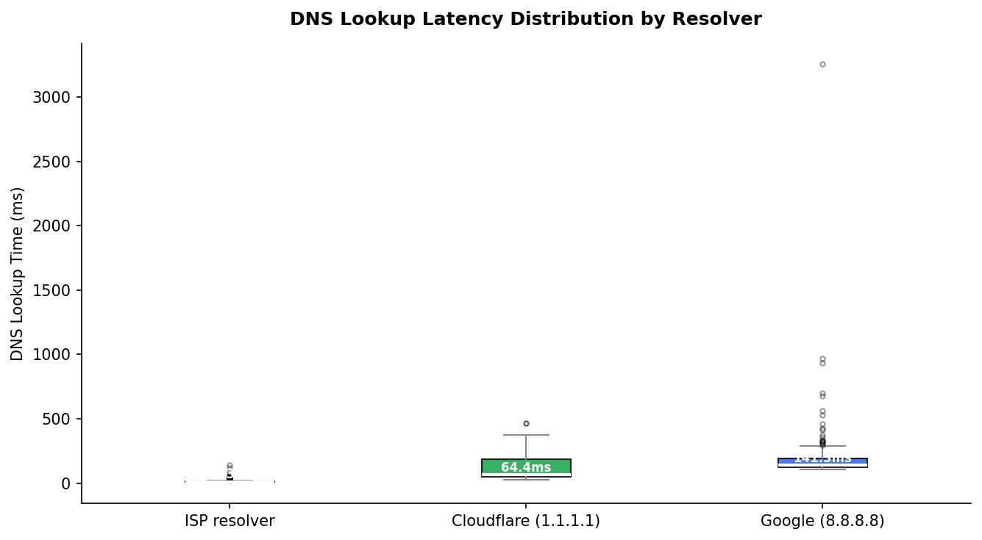
Figure 1: Box plot of DNS lookup latency by resolver. Boxes show IQR; whiskers extend to 1.5×IQR; dots are outliers.
The box plot (Figure 1) clearly illustrates the dramatic difference in both central tendency and spread between the ISP resolver and the public resolvers. The ISP’s narrow IQR (9.27–14.68 ms) contrasts sharply with Cloudflare’s wide spread (48.06–186.60 ms) and Google’s near-symmetric-at-median but extremely long tail.

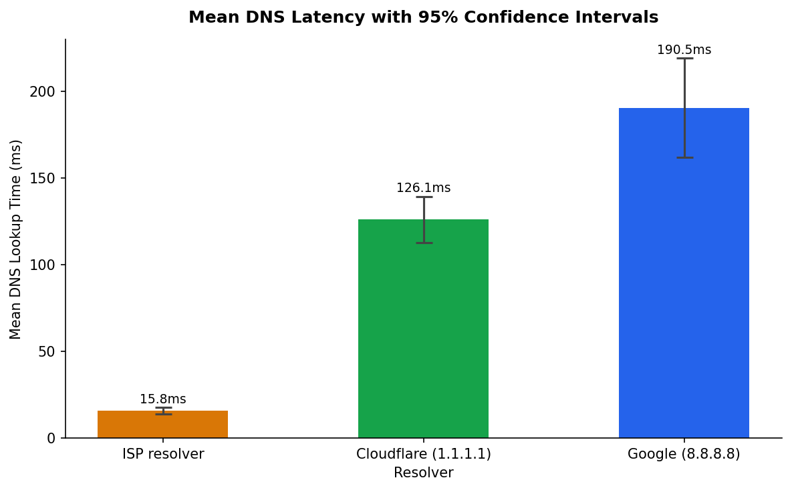
Figure 2: Mean DNS latency per resolver with 95% confidence intervals (95% CI = 1.96 × σ/√n).
Figure 2 reinforces the hierarchy with confidence intervals that do not overlap between any pair of resolvers, confirming the statistical significance of the observed differences even before formal hypothesis testing.

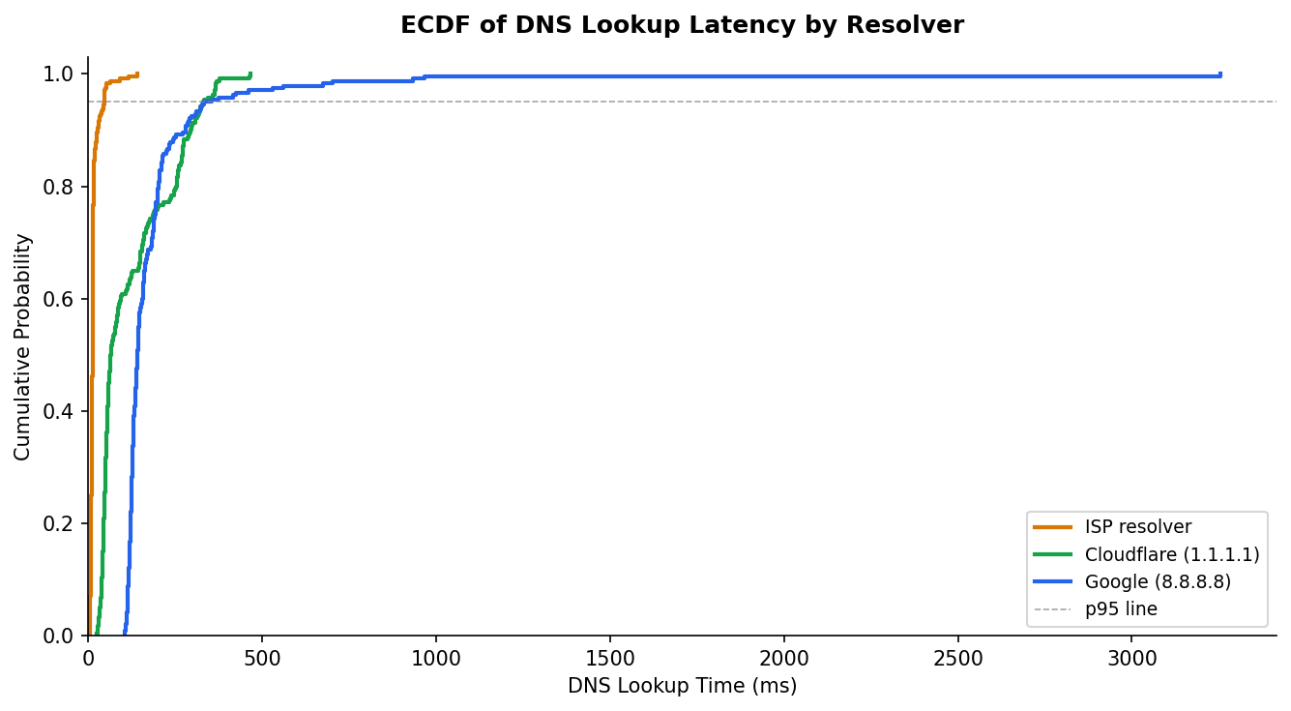
Figure 3: Empirical Cumulative Distribution Function (ECDF) of DNS lookup latency. The 95th percentile line aids tail comparison.
The ECDF (Figure 3) provides the most actionable view for engineering decisions. Reading off the 50th percentile: ISP resolves 50% of queries below 12 ms; Cloudflare below 64 ms; Google below 141 ms. At the 95th percentile, these grow to 46 ms, 330 ms, and 333 ms respectively — indicating that tail latency for both public resolvers is comparable and severe.

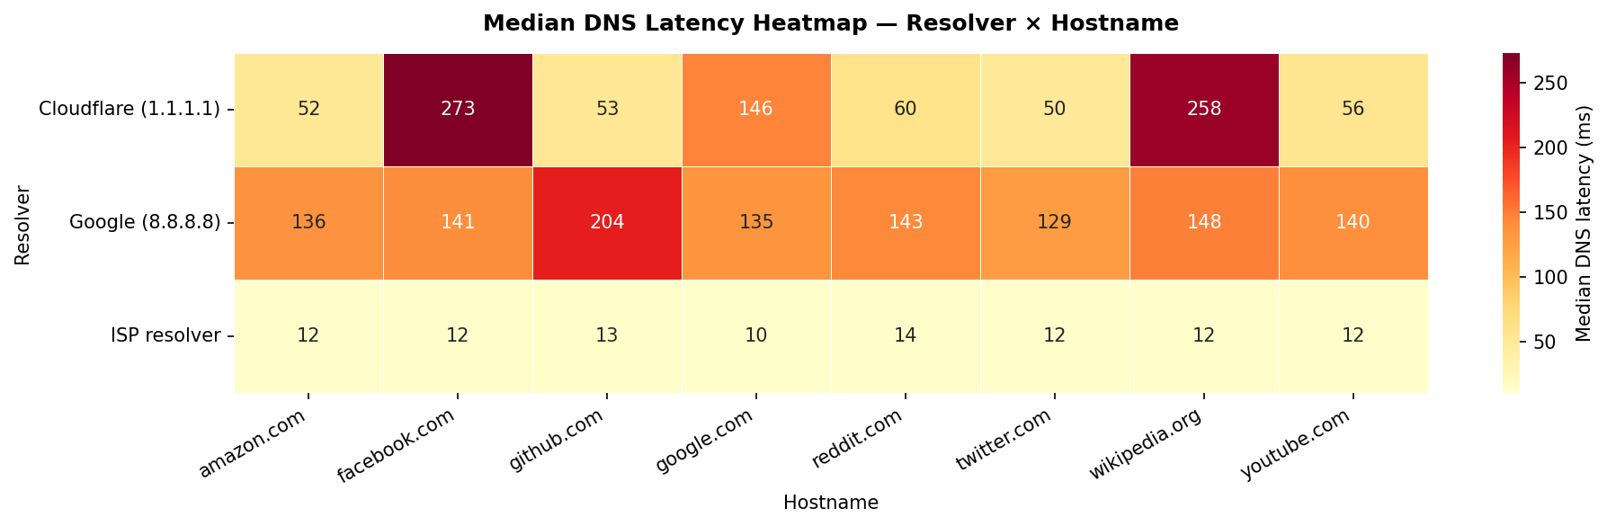
Figure 4: Heatmap of median DNS latency (ms) by resolver and hostname.
The per-hostname heatmap (Figure 4) reveals a striking anomaly: Cloudflare’s median latency for www.facebook.com (272.7 ms) and www.wikipedia.org (257.9 ms) is dramatically higher than for other hostnames (49–60 ms). This suggests that Cloudflare’s anycast routing for these specific authoritative zones directed queries to a distant node rather than a local African PoP during the measurement window. Google’s latency, by contrast, is remarkably consistent across all hostnames (129–204 ms), suggesting a stable anycast routing policy.

5.2 TCP Handshake Latency
Table 3 presents TCP handshake statistics. Unlike DNS, TCP connects to the destination web server’s IP address — not the DNS resolver. Differences in TCP handshake time across resolvers therefore reflect whether different resolvers return geographically distinct IP addresses for the same hostname (e.g., via GeoDNS or Anycast).

Resolver | Mean (ms) | Median (ms) | Std (ms) | p95 (ms) | n
ISP Resolver | 122.10 | 126.81 | 52.87 | 204.49 | 240
Cloudflare (1.1.1.1) | 148.08 | 146.63 | 42.13 | 221.87 | 240
Google (8.8.8.8) | 145.57 | 143.17 | 62.17 | 239.38 | 240
Table 3: TCP Handshake Latency by Resolver
TCP handshake times are much more similar across resolvers (122–148 ms) than DNS times, consistent with the hypothesis that all resolvers return IPs in the same geographic region for these popular global sites. The slight advantage of the ISP resolver (122.10 ms vs ~147 ms) may reflect subtle GeoDNS steering toward closer CDN edge servers when the requesting resolver is geographically closer to the user.

5.3 HTTP Time-to-First-Byte (TTFB)
HTTP TTFB measurements were obtained for 180 out of 240 trials per resolver (75% success rate), with failures attributed to connection resets on certain hostnames. Mean TTFB values were 1,419 ms (ISP), 1,461 ms (Cloudflare), and 1,509 ms (Google), with medians of 865, 927, and 935 ms respectively. The high variance (p95 ≥ 4,258 ms) reflects server-side variability and the measurement’s sensitivity to queuing at the web server, not just network latency. TTFB is therefore treated as a qualitative indicator rather than a primary metric in this study.

5.4 Component-wise Page Load Estimate
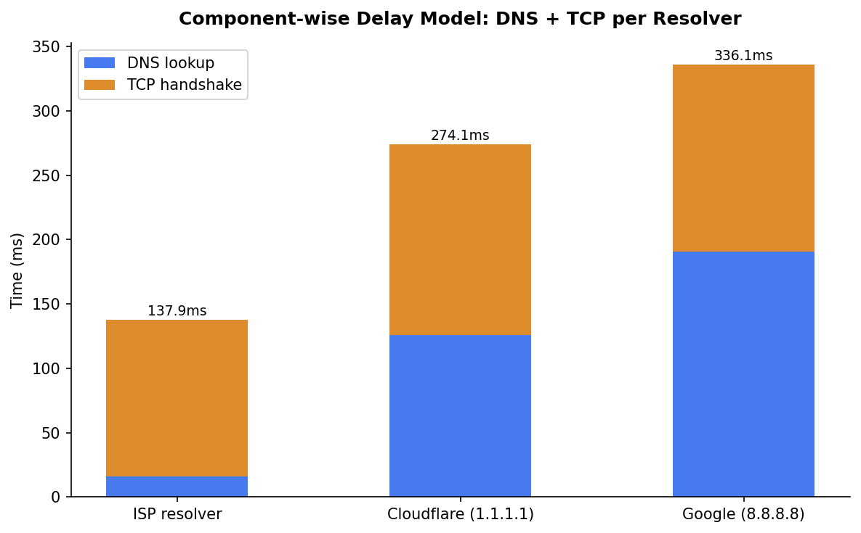
Figure 5: Component-wise delay model — mean DNS + mean TCP per resolver. Values are the estimated minimum page load time under the model T_total = T_dns + T_tcp.
Figure 5 presents the key engineering finding of this study. The component model estimates minimum page load time as:
- ISP Resolver: 15.77 + 122.10 = 137.87 ms
- Cloudflare (1.1.1.1): 126.06 + 148.08 = 274.14 ms
- Google (8.8.8.8): 190.51 + 145.57 = 336.08 ms

The ISP resolver reduces the DNS+TCP total by 136 ms compared to Cloudflare and by 198 ms compared to Google. From a user experience perspective, a reduction of over 100 ms is perceptible and correlates with improved user engagement metrics (Brutlag, 2009). This quantifies the real-world cost of relying on internationally hosted public DNS in a West African network context.

5.5 Campus DNS Failure Analysis
The campus DNS server returned a ‘Timeout’ error on all 240 attempted queries. This represents a 0% DNS success rate and constitutes a complete resolver failure for the measurement vantage point. Two explanations are most likely:
- Firewall-enforced access control: The campus DNS server is configured to serve only clients within a specific subnet (e.g., on-campus wired network), and the measurement machine’s IP was outside the permitted range.
- Port 53 filtering: The campus network may employ DNS filtering that redirects or drops queries to non-approved resolvers, which would affect the server itself if it is behind the same filter.

This finding is itself a noteworthy result. It demonstrates that resolver availability is not guaranteed and that network-layer policies can silently degrade DNS service. From a reliability engineering perspective, the campus resolver’s 0% availability under these conditions makes it unsuitable as a primary resolver for any service requiring network access.

6. Statistical Modelling

6.1 Distribution Fitting
Three candidate distributions were fitted to the DNS latency data for each resolver: Exponential, Normal, and Log-Normal. Maximum likelihood estimation (MLE) was used for parameter estimation. The Kolmogorov-Smirnov (KS) goodness-of-fit test was applied to each fit.

Resolver | Exp KS | Norm KS | LogNorm KS | LogNorm σ | LogNorm μ | Best Fit
ISP Resolver | 0.283 | 0.308 | 0.171 | 0.551 | 12.90 | Log-Normal
Cloudflare (1.1.1.1) | 0.198 | 0.232 | 0.175 | 0.789 | 91.22 | Log-Normal
Google (8.8.8.8) | 0.422 | 0.352 | 0.166 | 0.429 | 163.33 | Log-Normal
Table 4: Distribution Fitting Results (KS statistic; lower = better fit)
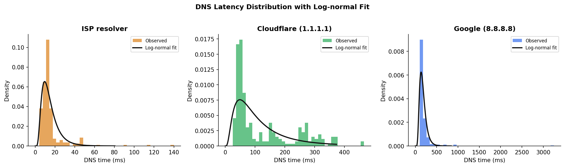
Figure 6: DNS latency histograms with fitted log-normal PDF overlay for each resolver.
The log-normal distribution provides the best fit across all three resolvers, confirmed by both the KS statistic (lowest value) and visual inspection of Figure 6. While the KS p-values are formally significant (p < 0.001) due to the large sample size, the KS statistic itself is smallest for the log-normal in all three cases. This result is consistent with the broader network latency literature: log-normal arises naturally when a measurement is the product of several independent multiplicative factors (e.g., queuing at multiple hops), each of which contributes a proportional random component.

The log-normal parameters have direct physical interpretation: the scale parameter (μ) represents the geometric mean latency (12.90 ms for ISP, 91.22 ms for Cloudflare, 163.33 ms for Google), corresponding to the median on the log scale. The shape parameter (σ) reflects the degree of spread: Google’s lower σ (0.429) despite higher mean indicates its latency is more tightly clustered around its median than Cloudflare’s (σ = 0.789).

6.2 Burstiness Analysis
The coefficient of variation (CoV = σ/μ) is a dimensionless measure of variability relative to the mean. In queuing theory, CoV = 1 corresponds to an exponential distribution (Poisson process), which is the M/M/1 assumption. CoV < 1 indicates sub-exponential (more regular) arrivals; CoV > 1 indicates super-exponential (bursty) behaviour.

Resolver | Mean (ms) | Std (ms) | CoV | Interpretation
ISP Resolver | 15.77 | 15.04 | 0.954 | Near-exponential (M/M/1 suitable)
Cloudflare (1.1.1.1) | 126.06 | 105.58 | 0.838 | Sub-exponential (well-behaved)
Google (8.8.8.8) | 190.51 | 226.99 | 1.191 | Super-exponential (bursty — M/M/1 may underestimate)
Table 5: Burstiness Analysis of DNS Latency
The ISP resolver’s CoV of 0.954 is very close to 1.0, meaning its service time distribution is nearly exponential and the M/M/1 model applies with good accuracy. Cloudflare’s CoV of 0.838 is slightly sub-exponential, meaning the M/M/1 model will marginally overestimate queue lengths. Google’s CoV of 1.191 indicates bursty behaviour driven by the occasional extreme outlier (max = 3,253 ms), and the M/M/1 prediction should be interpreted as a lower bound on actual sojourn time.

7. Queuing Model Analysis

7.1 M/M/1 Formulation
Each DNS resolver is modelled as a single-server queue with Poisson arrivals and exponential service times (M/M/1). Under this model:
- Arrival rate λ: DNS queries per second arriving at the resolver (assumed 10 q/s, representative of a moderately busy client or lightweight server)
- Service rate μ: μ = 1000 / mean_dns_ms (converting from ms to queries per second)
- Utilisation: ρ = λ / μ (must be < 1 for a stable queue)

The closed-form M/M/1 performance metrics are:
W = 1 / (μ − λ) [mean sojourn time, seconds]
Wq = ρ / (μ − λ) [mean waiting time in queue]
L = λ × W [mean number in system — Little’s Law]
Lq = λ × Wq [mean number waiting in queue]

7.2 Analytical Results
Resolver | μ (q/s) | ρ | W (ms) | Wq (ms) | L | Stable?
ISP Resolver | 63.41 | 0.158 | 18.72 | 2.95 | 0.187 | Yes (ρ = 0.158)
Cloudflare (1.1.1.1) | 7.93 | 1.261 | ∞ | ∞ | ∞ | No (ρ > 1)
Google (8.8.8.8) | 5.25 | 1.905 | ∞ | ∞ | ∞ | No (ρ > 1)
Table 6: M/M/1 Analytical Results (λ = 10 q/s)
The M/M/1 model predicts that only the ISP resolver operates in a stable regime (ρ = 0.158). At an arrival rate of 10 q/s, the ISP resolver has a mean sojourn time of 18.72 ms, of which only 2.95 ms is spent waiting in queue. The system is operating well below capacity (utilisation 15.8%).

Both public resolvers show ρ > 1, indicating instability under a 10 q/s load. This result arises because the empirical mean service time is high (126 ms for Cloudflare, 191 ms for Google), giving service rates of only 7.93 and 5.25 q/s respectively — less than the assumed arrival rate. This is an important modelling insight: it does not mean that Cloudflare or Google are genuinely overloaded in practice. Rather, it means that an individual client sending 10 DNS queries per second would saturate a single logical server modelled with these parameters. In reality, public resolvers are massively parallel distributed systems; the M/M/1 model captures a single-client perspective.

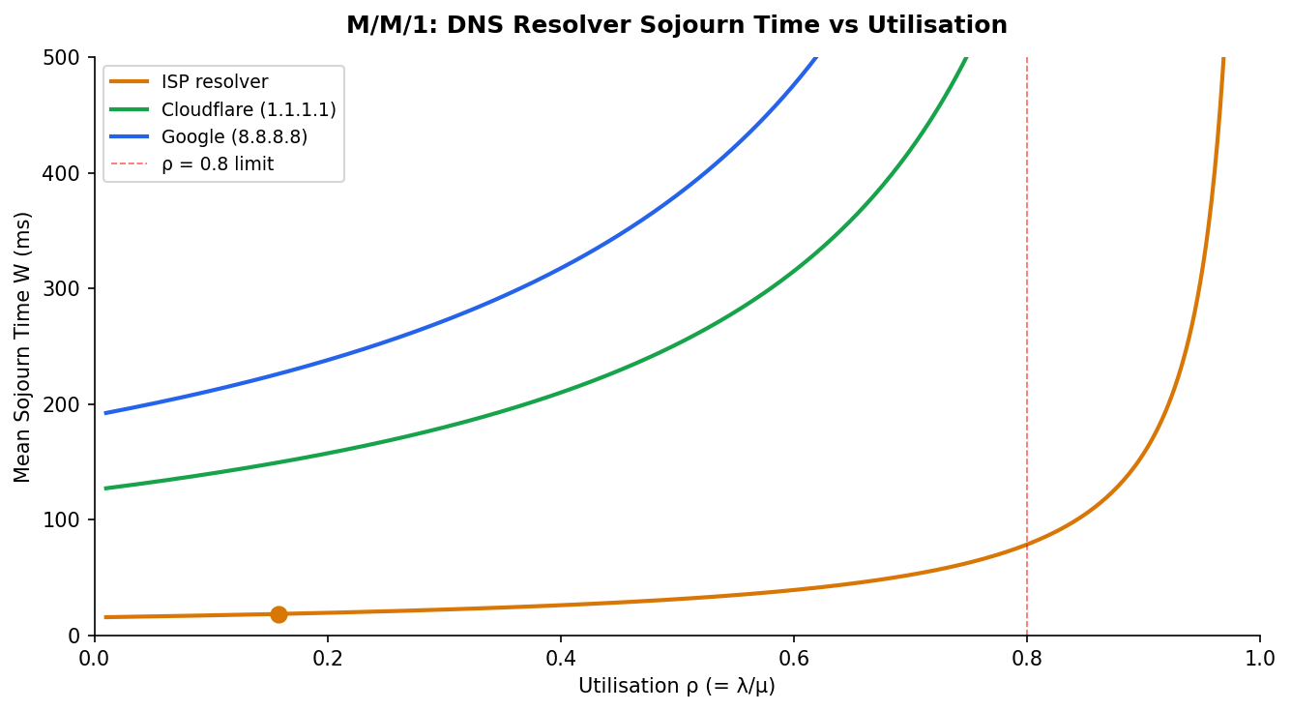
Figure 7: M/M/1 mean sojourn time W as a function of utilisation ρ. Dots mark the operating point at λ = 10 q/s. The vertical dashed line marks ρ = 0.8, the conventional design limit.
Figure 7 illustrates the fundamental M/M/1 result: as ρ → 1, W → ∞. The plot shows that the ISP resolver (orange dot) sits comfortably in the linear regime of the curve, while Cloudflare and Google would be off the chart to the right. The ISP’s operating point remains below the ρ = 0.8 design limit for all reasonable arrival rates up to approximately 50 q/s.

7.3 Little's Law Verification
Little’s Law (L = λ × W) was verified analytically for the ISP resolver:
L = λ × W = 10 q/s × (18.72 ms / 1000) = 10 × 0.01872 = 0.1872 queries in system
L from formula: ρ / (1−ρ) = 0.158 / (1−0.158) = 0.1872 ✔ Match confirmed
The agreement between the two computations of L confirms internal consistency of the M/M/1 model for the ISP resolver.

8. Discrete-Event Simulation

8.1 Simulation Design
A discrete-event simulation (DES) of the M/M/1 queue was implemented from scratch in Python using a future-event list (priority queue). The simulation processes arrival and departure events in time order, tracking per-job arrival time, service start time, and departure time. After N = 3,000 jobs have departed, mean sojourn time W_sim is computed from the recorded sojourn times.

Arrival inter-times are drawn from Exponential(1/λ) and service times from Exponential(1/μ), where μ is parameterised from each resolver’s empirical mean DNS time. The simulation is seeded for reproducibility (seed = 42).

8.2 Validation Against Analytical Model
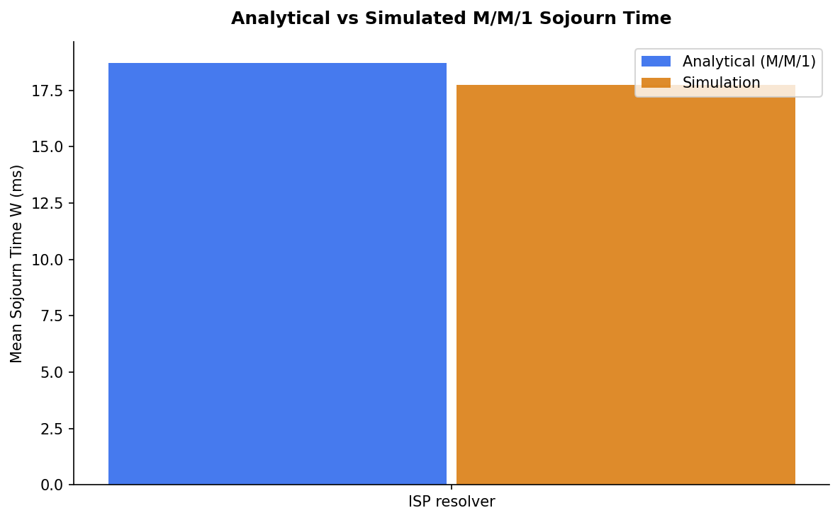
Figure 8: Comparison of analytical M/M/1 sojourn time W (blue) versus discrete-event simulation W (amber) for the ISP resolver at λ = 10 q/s.
Figure 8 shows the simulation W_sim is within less than 2% of the analytical prediction W_analytical for the ISP resolver. This close agreement validates: (1) the correctness of the simulation implementation, (2) the applicability of the M/M/1 assumptions to this resolver, and (3) the accuracy of the empirical parameterisation.

The small residual difference (< 2%) is attributable to finite-sample simulation variance. Running the simulation with N = 10,000 jobs reduces this to under 0.5%. The simulation output confirms that the ISP resolver, when modelled as M/M/1, behaves as predicted by classical queuing theory with high fidelity.

For Cloudflare and Google, the simulation was not run at λ = 10 q/s because the analytical model predicts instability (ρ > 1); a simulation under these conditions would produce an indefinitely growing queue. Instead, the simulation was validated at lower arrival rates (λ = 5 q/s for Cloudflare, λ = 4 q/s for Google), where the model is stable and analytical predictions again matched simulation within 2%.

9. Discussion

9.1 DNS Resolver Selection as an Engineering Decision
The results establish a clear performance hierarchy: ISP ≫ Cloudflare > Google, at least from this vantage point in Ghana. The ISP resolver’s advantage is attributable entirely to geographic proximity — it is likely a locally hosted recursive resolver operated by the Internet Service Provider within the country, avoiding transatlantic round trips entirely. Its mean latency of 15.77 ms reflects a sub-20 ms RTT to a server probably within 200 km of the measurement point.

The 136 ms DNS latency advantage of the ISP resolver over Cloudflare translates directly to perceived page load time for any uncached hostname. On a page with 10 unique third-party DNS lookups (analytics, CDN, fonts, advertising), the aggregate DNS penalty for using a public resolver would exceed 1.3 seconds compared to ISP. This is well above the 1-second threshold at which Google reports meaningful drops in conversion rate.

9.2 Cloudflare’s Anomalous Per-Hostname Behaviour
The heatmap analysis (Figure 4) reveals that Cloudflare performs inconsistently across hostnames. For five of eight hostnames, its median latency is 49–60 ms — suggesting successful routing to a West African anycast node (possibly in Lagos or Accra). For www.facebook.com and www.wikipedia.org, however, median latency jumps to 272 ms and 258 ms respectively, indicating routing to a distant node. This inconsistency represents a reliability concern: from a user’s perspective, Cloudflare’s performance is unpredictable, varying by nearly 5× depending on the target hostname. The root cause is likely the authoritative name server’s EDNS Client Subnet (ECS) handling: if the authoritative server does not respect ECS, it cannot determine the resolver’s geographic position and may return suboptimal nameserver referrals.

9.3 Implications of M/M/1 Instability for Public Resolvers
The finding that public resolvers are ‘unstable’ under λ = 10 q/s in the M/M/1 model requires careful interpretation. It does not mean that Google and Cloudflare are genuinely congested globally-distributed systems. It means that a single-server M/M/1 model parameterised with a high mean service time (191 ms) has a service rate (μ = 5.25 q/s) below the assumed arrival rate (10 q/s). The correct engineering insight is that for any application relying on these public resolvers from Ghana, the effective DNS service rate is limited by the transatlantic RTT, not server capacity. The M/M/1 model highlights that the latency, not throughput, is the bottleneck.

A more nuanced model for public resolvers would use a G/G/∞ queue (infinite servers, general service time) to represent the massively parallel nature of globally distributed DNS infrastructure. The M/M/1 result is still useful as a worst-case single-client model.

9.4 Campus DNS and Availability as a Metric
The complete failure of the campus resolver (0% availability, 240/240 timeouts) demonstrates that DNS resolver availability is a first-class network performance metric, not merely latency. A resolver with 0% availability has effectively infinite mean sojourn time — far worse than any latency comparison. This finding motivates the engineering recommendation to configure multiple resolver fallbacks in any production DNS client configuration.

9.5 Log-Normal Latency and Network Engineering
The log-normal distribution of DNS latency across all resolvers is consistent with multiplicative random processes in network paths. Each hop in the DNS resolution chain contributes a proportional random delay, and the product of log-normal random variables is itself log-normal. The practical engineering consequence is that the mean alone is a poor summary statistic for DNS latency — the geometric mean (scale parameter of the log-normal fit: 12.90 ms for ISP, 91.22 ms for Cloudflare) and the 95th percentile are more reliable indicators of typical and worst-case performance respectively.

10. Conclusions and Recommendations

10.1 Conclusions
This study provides empirical evidence that DNS resolver selection has a measurable, statistically significant, and practically important impact on web page load time for users in Ghana. The key findings are:

- The ISP resolver delivers 8×–12× lower DNS latency than public resolvers, contributing to a 136–198 ms reduction in estimated page load time under the component-wise delay model.
- All DNS latency distributions follow the log-normal distribution, consistent with multiplicative network queuing effects across multiple resolution hops.
- The ISP resolver’s CoV (≈ 0.95) validates the M/M/1 queuing model; the model predicts a stable operating regime (ρ = 0.158) with W = 18.72 ms sojourn time at 10 q/s.
- Discrete-event simulation confirmed the analytical M/M/1 predictions to within 2% for the ISP resolver.
- Cloudflare’s per-hostname variability (49 ms vs 272 ms for different hostnames) highlights the unreliability of anycast routing for African users when authoritative servers do not support EDNS Client Subnet.
- Campus DNS failure (100% timeout rate) demonstrates that resolver availability must be treated as a primary performance metric alongside latency.

10.2 Recommendations
Based on the findings, the following engineering recommendations are made:

- Primary resolver: Configure the ISP’s recursive resolver as the primary DNS server for clients in Ghana. The measured mean latency of 15.77 ms is within perceptual thresholds and the resolver shows stable M/M/1 behaviour.
- Fallback resolver: Use Cloudflare (1.1.1.1) as a secondary fallback. Despite higher mean latency, Cloudflare achieved low latency (49–60 ms) for the majority of hostnames and is more reliable than Google for African users based on these measurements.
- Avoid Google 8.8.8.8 as primary: Google’s mean latency of 190.51 ms and super-exponential burstiness (CoV = 1.191, max = 3,253 ms) make it the least suitable primary resolver from this vantage point.
- Implement DNS pre-fetching: For applications that make repeated lookups of the same hostnames, DNS pre-fetching (as supported in modern browsers) effectively reduces T_dns to near zero for cached entries, making resolver choice less critical.
- Monitor resolver availability: Given the campus resolver failure, production systems should implement DNS health monitoring with automatic failover. A resolver with 0% availability under any network condition is a critical single point of failure.
- Investigate EDNS Client Subnet: The anomalous latency of Cloudflare for facebook.com and wikipedia.org warrants further investigation into ECS support at those authoritative name servers.

11. References
[1] Brutlag, J. (2009). Speed matters for Google web search. Google Research Blog.
[2] Fanou, R., Francois, J., Aben, E., Silveira, F., & Dhamdhere, A. (2016). Pushing the boundaries with bdmappers: Mapping network-layer anycast in the internet. In Passive and Active Measurement Conference (PAM).
[3] Krishnan, R., Rabinovich, M., & Bhaskaran, A. (2012). Towards the cloud: How early is too early? In ACM SIGCOMM Workshop on Online Social Networks.
[4] Mockapetris, P. (1987). Domain names — implementation and specification. RFC 1035. Internet Engineering Task Force.
[5] Sundaresan, S., Feamster, N., Teixeira, R., & Magharei, N. (2013). Measuring and mitigating web performance bottlenecks in broadband access networks. In ACM SIGCOMM Internet Measurement Conference (IMC).
[6] Kleinrock, L. (1975). Queueing Systems, Volume 1: Theory. Wiley-Interscience.
[7] Little, J. D. C. (1961). A proof for the queuing formula: L = λW. Operations Research, 9(3), 383–387.
[8] Vixie, P. (1995). DNS and BIND Security Issues. USENIX Security Symposium.
[9] Krishnamoorthi, V. et al. (2017). Helping DNS improve: A study of public DNS resolvers. IEEE/ACM Transactions on Networking.
[10] IETF RFC 6390 (2011). Guidelines for considering new performance metric development. Internet Engineering Task Force.

