**Spike List to mc0**

**This document adapted from:** L:\Lab\NHEERL_MEA\Comprehensive AUC Analysis\Comprehensive_Analysis.docx, Last rev. June 20, 2019 by Brittany Lynch

**Software info:**

RStudio version: 1.2.1335

R version: 3.6.1

**Overview of the process**

This document outlines the process of transforming the recordings from a Microelectrode Array Network Formation Assay into an “mc0” file which can be analyzed with the ToxCast Pipeline (the tcpl package). The steps of the process are outlined in the flow chart below. Input data files are shown in blue boxes, intermediate output files are in purple boxes, and scripts are in orange boxes.

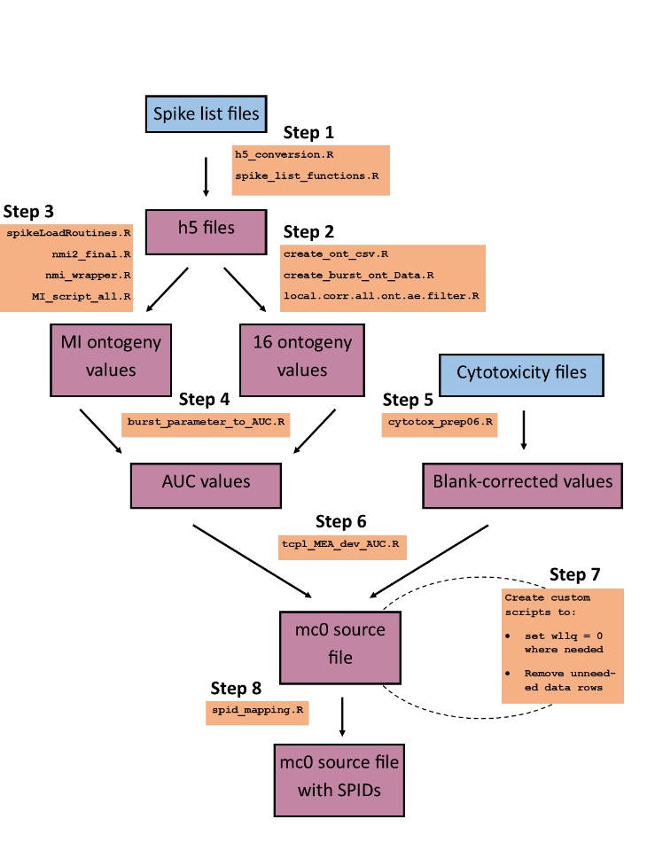

Figure 1: Flow chart for NHEERL_MEA_DEV pre-processing

**Preliminary notes**

* Input data. The input files should be named as show. The Plate# should be a 5-6 digit character including a dash (e.g. 1056-29).
  + Spike List files from MEA recordings, created by the AxIS Spike Detector
    - e.g., *ON_[date]_MW[Plate#]_[DIV]_00(000)_spike_list.csv*
  + Master Chemical List for each plate
    - e.g. *[date]_MW[Plate#]_MaestroExperimentLog_Ontogeny.csv*
  + Cytotoxicity data
    - e.g. *ON_[date]_MW[Plate#]__Summary.xlsx* for single plate data, or
    - *[date]_ON G8_2 Calculations.xlsx* for files with data for 3 plates
  + Sample ID file
    - This file is only needed if the chemicals are not referenced by SPID in the Master Chemical Lists. This file should contain a list of the tested chemicals and the corresponding sample ID (The sample ID column may be labelled “EPA_SAMPLE_ID” or “SPID”)
* Target output:
  + An mc0 file that is ready to be processed in the ToxCast Pipeline
  + Along the way, you will also get:
    - csv files containing well-level activity metrics for 17 endpoints across each DIV
    - csv file containing area-under-the-curve values of the well-level activity metrics for 17 endpoints

**Step 0: Prepare the files**

Download the R scripts from the BitBucket repository. Go to this link: <https://ncct-bitbucket.epa.gov/projects/NSLTM/repos/nfa-spike-list-to-mc0-r-scripts/browse>

Underneath the header “Source” there should be 2 gray boxes that say “master” and “…”. Click on the “…”. Then select “Download” and save the zip file. Create a folder for the scripts in your project folder and unzip the scripts into that folder.

Locate the spike list files for the current data set. These are usually named, for example, *ON_20151209_MW1056-28_05_00(000)_spike_list.csv*. This long file should have 3 columns that record the time, electrode, and amplitude of each spike. You will use only the 4 spike list files for DIV 5, 7, 9, and 12 for each plate. Do not include data for DIV 2, Bicuculline-treated wells (a second recording on DIV 12). Note that if the recording goes past 900 seconds, the spike list file will be truncated at 900 seconds in the script **spike_list_functions.R**.

Locate the Master Chemical Lists for each plate. These are usually located in a folder called “csv files”, and are named *[date]_MW[Plate#]_MaestroExperimentLog_Ontogeny.csv*

Locate the files containing the cytotoxicity data for all plates. You can either use the “Calculations” excel files located in each culture date folder (e.g. *[date]_ON [Group] Calculations.xlsx*) or the “Summary” excel files located in each plate folder (e.g. *ON_[date]_MW[Plate#]_Summary.xlsx*). The “Calculations” files contain data for 3 plates, and the “Summary” files contain data for one plate. The script **cytotox_prep06.R** will extract the raw blank-corrected data from these files.

Check the lab notebook to confirm which culture dates and plates should be used. If you need to remove only some wells from a plate or culture date, you can do that in step 7.

Processing Option 1 (preferred):

Put all the spike list files that you want to analyze in one folder in your main directory, e.g. “All Spike Lists”. Put all the Master Chemical Lists in another folder, e.g. “All Master Chem Lists”. Lastly, put all the files containing the cytotoxicity data in another folder.

Processing Option 2 (if you don’t want to move all the spike list files):

Leave spike list files, master chemical lists, and cytotoxicity data files in their current folders. You will run **h5_conversion.R** and every other script for each plate individually. You will be able to specify the location of the output in each script.

**Install required R packages**

1. Use the command install.packages(“package name”) to install any of the following packages that you do not already have:
   1. “xlsx” – includes functions for reading .xlsx Excel files
   2. “reshape” – includes `melt` function for transforming data to long file format
   3. “data.table” – for robust data manipulation
   4. “gtools” – includes useful functions such as ‘asc’ for getting ascii character code
   5. “devtools” – includes function needed to install packages from GitHub
   6. “BioInstaller” – includes function needed to install “rhdf5” package
   7. “pracma” – used in mutual information scripts
   8. “compiler” – used in mutual information scripts
2. Install the package “rhdf5” for reading, writing, and opening h5 files. Use the following commands:

if(!requireNamespace("BiocManager", quietly = TRUE))

install.packages("BiocManager")

BiocManager::install("rhdf5")

If it asks to Update all/some/none packages, select all.

Additional info: <https://bioconductor.org/install> and <https://stackoverflow.com/questions/15974643/how-to-deal-with-hdf5-files-in-r>

1. Use the command devtools::install_github(“package name”)to install the following packages from GitHub:
   1. "sje30/sjemea"
   2. "dianaransomhall/meadq"

Additional info: <https://github.com/dianaransomhall/meadq>, <https://github.com/sje30/sjemea>

<https://cran.r-project.org/web/packages/githubinstall/vignettes/githubinstall.html>

**Step 1: Create h5 Files from spike list files**

Open the following R scripts:

**h5_conversion.R**, **spike_list_functions.R,** and **get_spike_list_files.R**

Overview: This script will create one h5file from each spike list file. The output folder “*h5files”* will go in a folder specified by the user.

1. Source **spike_list_functions.R**. This script contains functions that **h5_conversion.R** will use.
2. In **h5_conversion.R**, in the USER INPUT section,
   1. Set the “basepath” variable to where you want the h5Files folder to be created. Note: if the h5Files folder is created in the same location as an existing h5Files folder, the new h5Files folder will overwrite the existing h5Files folder. (For all directory names in R, change all backward slashes to forward slashes)
   2. Set “remakeAll_choice” to TRUE if you are running for the first time. Set to FALSE if some of your h5Files already exist and your do not want to remake them.
   3. Set “select_or_search_for_files” as “select” or “search”
      1. If “select”, a dialog box will pop up and allow you to select all spike list files
      2. If “search”, functions in get_spike_list_files.R will search for the spike list files and master chemical lists in each culture folder and plate subfolder. You will get an error if 4 spike list files are not found per plate. You might need to make adjustments to the functions in get_spike_list_files.R to accommodate the structure of the data set. 2 log files will be created documenting the spike list files and master chemical lists that were selected with this function.
   4. If using “search”, set “start.dir” to the starting directory that contains the culture folders. Else set “start.dir” to “”.
3. Source **h5_conversion.R**
   1. This script will open a dialog box that asks for all the spike list files (the dialog box might not pop up or create an icon on the taskbar. If so, try minimizing RStudio to see the dialog box)
   2. Select the spike list files that you want to use
      1. If following Option 1, select all of the spike list files
      2. If following Option 2, select the 4 spike list files for the first plate
   3. Another dialog box will open asking for the Master Chemical Lists
      1. If following Option 1, select all of the Master Chemical List files
      2. If following Option 2, select the Master Chemical List for the first plate
   4. If following Option 2, repeat step 6 for each plate.
   5. This script completes approximately 1 h5 file per minute

**Step 2: Calculate activity metrics from the h5 files (for all endpoints except for normalized mutual information)**

Open the following R scripts:

**create_ont_csv.R, create_burst_ont _Data.R,**and **local.corr.all.ont.ae.filter.R**

Overview: This script will calculate activity metrics from the h5files for each DIV. One csv file will be created for each plate. The output files will be created in a folder named “*prepared_data*”

1. Source **create_burst_ont _Data.R** and **local.corr.all.ont.ae.filter.R**. These files contains functions that **create_ont_csv.R** will use
2. In **create_ont_csv.R**, in the USER INPUT section, define the “basepath” variable for where you want the “*prepared_data*” folder to be created
   1. Change all backward slashes to forward slashes
3. Source **create_ont_csv.R**
   1. This script will open a dialog box that asks for the h5files (the dialog box might not pop up or create an icon on the taskbar. If so, try minimizing RStudio to see the dialog box)
      1. If following Option 1, select all h5files for every plate
      2. If following Option 2, select the 4 h5 files for each DIV for the first plate
   2. Note: as the scripts process the data for each well, the following statement will appear multiple times:

*** No network spikes found

Other warnings generated are also normal.

* 1. If following Option 2, repeat step 9 for all plates. If all the output files are not in the same folder, put them in one master folder before the next step.

1. The output files will be in the “*prepared_data”* folder.

**Step 3: Calculate the Normalized Mutual Information from the h5 files**

Open the following R scripts:

**spikeLoadRountines.R, nmi2_final.R,** and **nmi_wrapper.R, MI_script_all.R**,

Overview: These scripts will calculate the normalized mutual information activity metric from the h5 files. This endpoint is calculated separately because it is significantly more computationally intensive (approximately 1 hour per plate). One file will be created for each plate. The output will go in a folder named “*All_MI*”. The output files will be named “*NMI_[date]_[plate].csv*”

1. Source **spikeLoadRountines.R**, **nmi2_final.R**, and **nmi_wrapper.R**
2. In **MI_script_all.R**, in the USER INPUT section, set the “basepath” variable to where you want the “*All_MI*” folder to be created
   1. Change all backward slashes to forward slashes
3. Source **MI_script_all.R**
   1. This script will open a dialog box that asks for the h5files (the dialog box might not pop up or create an icon on the taskbar. If so, try minimizing RStudio to see the dialog box)
      1. If following Option 1, select all h5files
      2. If following Option 2, select the h5 files for each DIV for the first plate
   2. If following Option 2, repeat step 14 for all plates. If all the output files are not in the same folder, put them in one master folder before the next step.
4. The console will print “MI files are ready in folder All_MI” when the script is complete.

**Step 4: Calculate the Area Under the Curve of the activity metrics over each DIV**

Open the following R scripts:

**burst_parameter_to_AUC.R**

Overview: This script merges the MI data with the other parameter values. Then, it calculates the trapezoidal area under the curve for each parameter over time in each well.

1. In **burst_parameter_to_AUC.R**, in the USER INPUT section, set the “basepath” variable for where you want the output file to be created. It is suggested that you create an “*output*” folder for the output files
2. Set the desired “filename” for the output file (e.g. *[name]_AUC.csv*)
3. Set “use_divs” to a list of the expected DIVs in the input data files. The script will output a warning if any plate is missing a DIV recording, or has non-standard DIVs)
4. Source the script **burst_parameter_to_AUC.R** . A pop-up window will allow you to select all of the ontogeny files. These are the files in the “*prepared_data”*  folder, created in Step #2.
5. A second pop-up window will allow you to select all of the mutual information files. These are the files in the “*All_MI”*  folder, created in Step #3.
6. Source **burst_parameter_to_AUC.R**. The output will go to the folder specified in “basepath”

**Step 5: Prepare the cytotoxicity data**

Open the following R script:

**cytotox_prep06.R**

Overview: This script reads in the raw, blank-corrected cytotoxicity Alamar Blue and LDH data and arranges the data in the mc0 long file format. You can either input files with data for one plate (usually called *ON_[date]_MW[Plate#]_Summary.xlsx*), or for 3 plates for a given culture date (usually called *[date]_ON [Group] Calculations.xlsx*). These files are usually found in the plate folders or culture date folders.

1. In the USER INPUT section, set the desired “basepath” for the location of the output file and the desired name of the output file (“filename”)
2. If your input files have LDH and Cell Titer Blue data for one plate in each file, set sheetdata = “one”. If your input files have data for 3 plates from one culture in each file, set sheetdata = “three”
3. If you are running the script for the first time or want to overwrite an existing file with the same filename, set newFile = TRUE. If you are appending to an existing file of the same name, set newFile = FALSE.
   1. If you have some “Summary” files and some “Calculations” files, you can run this script for the first set of files and then re-run with the new sheetdata value and newFile = FALSE.
4. Source **cytotox_prep_06.R**
   1. A dialog box will ask for the input cytotoxicity data
      1. If following Option 1, select all files that have the specified number of sheets in “sheetdata”
      2. If following Option 2, select the desired file containing the cytotoxicity data
   2. Another dialog box will ask for the Master Chemical List(s). You can select all of the master chemical lists corresponding to the plates represented in the selected input files. This is used to ensure that the chemical names in the cytotoxicity data match the names in the MEA data. If you want to just use the chemical names in the cytotoxicity data files, just hit cancel.
   3. If the script cannot find the tab in the excel sheets corresponding to the Alamar Blue or LDH data, you will be prompted to enter the name of the tab in the console
   4. The output file will go in the specified folder.
5. Repeat from Step 5.22 until you have one file with LDH and AB data for all plates and culture dates.

**Step 6: Create the mc0 file**

Open the following R scripts:

**tcpl_MEA_dev_AUC.R**

Overview: This script takes the AUC data and the cytotoxicity data as input. The AUC data is reformatted into a long table with the columns needed for ToxCast Pipeline level 0 data. Then, the cytotoxicity data rows are appended to the AUC data. For control wells (wherever conc == 0), this script also sets the well type to “n” and renames the treatment to the user-specified control treatment names (e.g., DMSO or Water).

1. In the USER INPUT section, set the working directory to where you want the output file to go
2. Set the desired name for the output file (“filename”)
3. Set the” AUCsourcefilename” to the input AUC file created in step 4.20
4. Set the “cytotox_filename” to the cytotoxicity file created in step 5.25
5. Set the “default_ControlTreatmentName” to the name of the most common vehicle control used in your experiment (usually DMSO)
   1. If there are some compounds that have a vehicle control other than the default, enter the compound names in the string vector “different_vehicleControlCompounds.” If there are no other vehicle controls used, leave this variable as an empty list (c() ).
   2. Add the corresponding vehicle control names to the variable “different_vehicleControls.” There should be a one to one correspondence between the control treatment names in this list and the “different_vehicleControlCompounds” list.
6. Set “check_unique_apid” to TRUE if you want to check if any plate ID was used in multiple culture dates. If so, a letter suffix will be added to distinguish the 2 plate IDs. If set to TRUE, the script will also compare each plate ID to the plate ID’s in any previously prepared level 0 data located in the folder defined in “compare_with_data_here.” Again, any re-used plate IDs will be renamed if needed. Any plate ID name changes will be printed to the console.
7. Source **tcpl_MEA_dev_AUC.R**
   1. The output file will be created in the specified folder

**Step 7: (optional) Clean up the data set as needed**

For each data set, you may need to create a custom script to make adjustments as needed. A few issues to consider:

* Are there any notes in the lab notebook indicating that some wells are not useable? If so, set wllq = 0 for these wells. The data for these wells will be removed in level 2 in the ToxCast Pipeline.
* Are there compounds that were tested on these plates that should not be included in the dataset? For example,
  + Was some of this data already pipelined for specific compounds on some plates (we don’t want duplicate data and artificially increase the number of replicates)
  + Are there any compounds for which you do not have Sample ID’s?

Remove the data rows corresponding to these compounds as needed. Note that the control treatment wells have already been renamed to “DMSO” (or other vehicle control name), so you will have to reference these data rows by rowi and coli, not just the treatment used in that plate row. The script **removeRows2.R** may serve as a useful starting point for implementing these changes.

**Step 8: (optional) Replace the “treatment” column with the sample ID’s**

Open the following R script:

**spid_mapping.R**

Overview: This script is designed to replace the treatment column in the mc0 file created by tcpl_MEA_dev_AUC.R with the corresponding sample IDs. This step is only necessary if the Master Chemical lists contain the compound names. In the future, the Master Chemical lists might instead contain the sample IDs. In that case, you can just set the rename the “treatment” column to “spid” in the mc0 data file.

1. In the USER INPUT section, set the “basepath” for the location of the output file
2. Set the desired name of the output file (“filename”).
3. Set the “mc0_filename”. This should be the output file from **tcpl_MEA_dev_AUC.R**
4. Set the “spidmap_filename”. This is the file that contains the sample ID’s.
   1. This file is expected to be .xlsx. If it is not, change the line spidmap = read.xlsx(spidmap_filename) to read the appropriate file extension
5. Set the “sheetName” to the sheet in the “spidmap_filename” that contains the sample IDs and chemical names
6. Set the “spidCol” as the name of the column in “spidmap_filename” that contains the sample IDs. Make sure that there is only 1 column with that name in the sheet.
7. Set the “mapMatchCol” as the name of the column in “spidmap_filename” that contains the chemical names in the same format as in the treatment column of the mc0 file
8. Set the “mc0MatchCol” as the name of the column in the mc0 file that contains the chemical names (this will always be “treatment”, unless you are using data from another source)
9. Source **spid_mapping.R**.
   1. If you get an error message, read the message, or type “chem” in the console to see the current chemical that is having issues. Check if there is a difference in how the chemical is named in the mc0 and spidmap files. If there is a difference, change the spelling, as demonstrated in the commented code around line 38.
   2. The output will go in the specified basepath location.