# BAN 502 Course Project Phase 1

## Kelly Quesnel

### Exploratory Analysis

#### Libraries

library(tidyverse)  
library(tidymodels)  
library(mice)  
library(VIM)  
library(naniar)  
library(skimr)  
library(UpSetR)  
library(rpart)  
library(rpart.plot)   
library(RColorBrewer)   
library(rattle)  
library(caret)  
library(usemodels)  
library(glmnet)  
library(ROCR)  
library(ranger)   
library(randomForest)  
library(GGally)  
library(gridExtra)  
library(vip)  
library(ggcorrplot)  
library(MASS)  
library(leaps)  
library(lmtest)  
library(splines)  
library(car)  
library(e1071)  
library(arules)  
library(corrplot)  
library(vcd)

#### Data

Read in

train <- read_csv("train.csv")  
test <- read_csv("test.csv")

Summarize

str(train)

## spc_tbl_ [26,570 × 26] (S3: spec_tbl_df/tbl_df/tbl/data.frame)  
## $ id : num [1:26570] 0 1 2 3 4 5 6 7 8 9 ...  
## $ product_code : chr [1:26570] "A" "A" "A" "A" ...  
## $ loading : num [1:26570] 80.1 84.9 82.4 101.1 188.1 ...  
## $ attribute_0 : chr [1:26570] "material_7" "material_7" "material_7" "material_7" ...  
## $ attribute_1 : chr [1:26570] "material_8" "material_8" "material_8" "material_8" ...  
## $ attribute_2 : num [1:26570] 9 9 9 9 9 9 9 9 9 9 ...  
## $ attribute_3 : num [1:26570] 5 5 5 5 5 5 5 5 5 5 ...  
## $ measurement_0 : num [1:26570] 7 14 12 13 9 11 12 4 9 10 ...  
## $ measurement_1 : num [1:26570] 8 3 1 2 2 4 2 8 6 4 ...  
## $ measurement_2 : num [1:26570] 4 3 5 6 8 0 4 8 5 7 ...  
## $ measurement_3 : num [1:26570] 18 18.2 18.1 17.3 19.3 ...  
## $ measurement_4 : num [1:26570] 12.5 11.5 11.7 11.2 12.9 ...  
## $ measurement_5 : num [1:26570] 15.7 17.7 16.7 18.6 17 ...  
## $ measurement_6 : num [1:26570] 19.3 17.9 18.2 18.3 15.7 ...  
## $ measurement_7 : num [1:26570] 11.7 12.7 12.7 12.6 11.3 ...  
## $ measurement_8 : num [1:26570] 20.2 17.9 18.3 19.1 18.1 ...  
## $ measurement_9 : num [1:26570] 10.7 12.4 12.7 12.5 10.3 ...  
## $ measurement_10: num [1:26570] 15.9 17.9 15.6 16.3 17.1 ...  
## $ measurement_11: num [1:26570] 17.6 17.9 NA 18.4 19.9 ...  
## $ measurement_12: num [1:26570] 15.2 11.8 13.8 10 12.4 ...  
## $ measurement_13: num [1:26570] 15 14.7 16.7 15.2 16.2 ...  
## $ measurement_14: num [1:26570] NA 15.4 18.6 15.6 12.8 ...  
## $ measurement_15: num [1:26570] 13 14.4 14.1 16.2 13.2 ...  
## $ measurement_16: num [1:26570] 14.7 15.6 17.9 17.2 16.4 ...  
## $ measurement_17: num [1:26570] 764 682 663 826 580 ...  
## $ failure : chr [1:26570] "No" "No" "No" "No" ...  
## - attr(*, "spec")=  
## .. cols(  
## .. id = col_double(),  
## .. product_code = col_character(),  
## .. loading = col_double(),  
## .. attribute_0 = col_character(),  
## .. attribute_1 = col_character(),  
## .. attribute_2 = col_double(),  
## .. attribute_3 = col_double(),  
## .. measurement_0 = col_double(),  
## .. measurement_1 = col_double(),  
## .. measurement_2 = col_double(),  
## .. measurement_3 = col_double(),  
## .. measurement_4 = col_double(),  
## .. measurement_5 = col_double(),  
## .. measurement_6 = col_double(),  
## .. measurement_7 = col_double(),  
## .. measurement_8 = col_double(),  
## .. measurement_9 = col_double(),  
## .. measurement_10 = col_double(),  
## .. measurement_11 = col_double(),  
## .. measurement_12 = col_double(),  
## .. measurement_13 = col_double(),  
## .. measurement_14 = col_double(),  
## .. measurement_15 = col_double(),  
## .. measurement_16 = col_double(),  
## .. measurement_17 = col_double(),  
## .. failure = col_character()  
## .. )  
## - attr(*, "problems")=<externalptr>

summary(train)

## id product_code loading attribute_0   
## Min. : 0 Length:26570 Min. : 33.16 Length:26570   
## 1st Qu.: 6642 Class :character 1st Qu.: 99.99 Class :character   
## Median :13284 Mode :character Median :122.39 Mode :character   
## Mean :13284 Mean :127.83   
## 3rd Qu.:19927 3rd Qu.:149.15   
## Max. :26569 Max. :385.86   
## NA's :250   
## attribute_1 attribute_2 attribute_3 measurement_0   
## Length:26570 Min. :5.000 Min. :5.00 Min. : 0.000   
## Class :character 1st Qu.:6.000 1st Qu.:6.00 1st Qu.: 4.000   
## Mode :character Median :6.000 Median :8.00 Median : 7.000   
## Mean :6.754 Mean :7.24 Mean : 7.416   
## 3rd Qu.:8.000 3rd Qu.:8.00 3rd Qu.:10.000   
## Max. :9.000 Max. :9.00 Max. :29.000   
##   
## measurement_1 measurement_2 measurement_3 measurement_4   
## Min. : 0.000 Min. : 0.000 Min. :13.97 Min. : 8.008   
## 1st Qu.: 5.000 1st Qu.: 4.000 1st Qu.:17.12 1st Qu.:11.051   
## Median : 8.000 Median : 6.000 Median :17.79 Median :11.733   
## Mean : 8.233 Mean : 6.257 Mean :17.79 Mean :11.732   
## 3rd Qu.:11.000 3rd Qu.: 8.000 3rd Qu.:18.47 3rd Qu.:12.410   
## Max. :29.000 Max. :24.000 Max. :21.50 Max. :16.484   
## NA's :381 NA's :538   
## measurement_5 measurement_6 measurement_7 measurement_8   
## Min. :12.07 Min. :12.71 Min. : 7.968 Min. :15.22   
## 1st Qu.:16.44 1st Qu.:16.84 1st Qu.:11.045 1st Qu.:18.34   
## Median :17.13 Median :17.52 Median :11.712 Median :19.02   
## Mean :17.13 Mean :17.51 Mean :11.717 Mean :19.02   
## 3rd Qu.:17.80 3rd Qu.:18.18 3rd Qu.:12.391 3rd Qu.:19.71   
## Max. :21.43 Max. :21.54 Max. :15.419 Max. :23.81   
## NA's :676 NA's :796 NA's :937 NA's :1048   
## measurement_9 measurement_10 measurement_11 measurement_12   
## Min. : 7.537 Min. : 9.323 Min. :12.46 Min. : 5.167   
## 1st Qu.:10.757 1st Qu.:15.209 1st Qu.:18.17 1st Qu.:10.703   
## Median :11.430 Median :16.127 Median :19.21 Median :11.717   
## Mean :11.431 Mean :16.118 Mean :19.17 Mean :11.703   
## 3rd Qu.:12.102 3rd Qu.:17.025 3rd Qu.:20.21 3rd Qu.:12.709   
## Max. :15.412 Max. :22.479 Max. :25.64 Max. :17.663   
## NA's :1227 NA's :1300 NA's :1468 NA's :1601   
## measurement_13 measurement_14 measurement_15 measurement_16   
## Min. :10.89 Min. : 9.14 Min. : 9.104 Min. : 9.701   
## 1st Qu.:14.89 1st Qu.:15.06 1st Qu.:13.957 1st Qu.:15.268   
## Median :15.63 Median :16.04 Median :14.969 Median :16.436   
## Mean :15.65 Mean :16.05 Mean :14.996 Mean :16.461   
## 3rd Qu.:16.37 3rd Qu.:17.08 3rd Qu.:16.018 3rd Qu.:17.628   
## Max. :22.71 Max. :22.30 Max. :21.626 Max. :24.094   
## NA's :1774 NA's :1874 NA's :2009 NA's :2110   
## measurement_17 failure   
## Min. : 196.8 Length:26570   
## 1st Qu.: 619.0 Class :character   
## Median : 701.0 Mode :character   
## Mean : 701.3   
## 3rd Qu.: 784.1   
## Max. :1312.8   
## NA's :2284

Factor conversion

train <- train %>%  
 mutate_if(is.character, as_factor)  
  
str(train)

## tibble [26,570 × 26] (S3: tbl_df/tbl/data.frame)  
## $ id : num [1:26570] 0 1 2 3 4 5 6 7 8 9 ...  
## $ product_code : Factor w/ 5 levels "A","B","C","D",..: 1 1 1 1 1 1 1 1 1 1 ...  
## $ loading : num [1:26570] 80.1 84.9 82.4 101.1 188.1 ...  
## $ attribute_0 : Factor w/ 2 levels "material_7","material_5": 1 1 1 1 1 1 1 1 1 1 ...  
## $ attribute_1 : Factor w/ 3 levels "material_8","material_5",..: 1 1 1 1 1 1 1 1 1 1 ...  
## $ attribute_2 : num [1:26570] 9 9 9 9 9 9 9 9 9 9 ...  
## $ attribute_3 : num [1:26570] 5 5 5 5 5 5 5 5 5 5 ...  
## $ measurement_0 : num [1:26570] 7 14 12 13 9 11 12 4 9 10 ...  
## $ measurement_1 : num [1:26570] 8 3 1 2 2 4 2 8 6 4 ...  
## $ measurement_2 : num [1:26570] 4 3 5 6 8 0 4 8 5 7 ...  
## $ measurement_3 : num [1:26570] 18 18.2 18.1 17.3 19.3 ...  
## $ measurement_4 : num [1:26570] 12.5 11.5 11.7 11.2 12.9 ...  
## $ measurement_5 : num [1:26570] 15.7 17.7 16.7 18.6 17 ...  
## $ measurement_6 : num [1:26570] 19.3 17.9 18.2 18.3 15.7 ...  
## $ measurement_7 : num [1:26570] 11.7 12.7 12.7 12.6 11.3 ...  
## $ measurement_8 : num [1:26570] 20.2 17.9 18.3 19.1 18.1 ...  
## $ measurement_9 : num [1:26570] 10.7 12.4 12.7 12.5 10.3 ...  
## $ measurement_10: num [1:26570] 15.9 17.9 15.6 16.3 17.1 ...  
## $ measurement_11: num [1:26570] 17.6 17.9 NA 18.4 19.9 ...  
## $ measurement_12: num [1:26570] 15.2 11.8 13.8 10 12.4 ...  
## $ measurement_13: num [1:26570] 15 14.7 16.7 15.2 16.2 ...  
## $ measurement_14: num [1:26570] NA 15.4 18.6 15.6 12.8 ...  
## $ measurement_15: num [1:26570] 13 14.4 14.1 16.2 13.2 ...  
## $ measurement_16: num [1:26570] 14.7 15.6 17.9 17.2 16.4 ...  
## $ measurement_17: num [1:26570] 764 682 663 826 580 ...  
## $ failure : Factor w/ 2 levels "No","Yes": 1 1 1 1 1 1 2 2 1 1 ...

summary(train)

## id product_code loading attribute_0   
## Min. : 0 A:5100 Min. : 33.16 material_7:21320   
## 1st Qu.: 6642 B:5250 1st Qu.: 99.99 material_5: 5250   
## Median :13284 C:5765 Median :122.39   
## Mean :13284 D:5112 Mean :127.83   
## 3rd Qu.:19927 E:5343 3rd Qu.:149.15   
## Max. :26569 Max. :385.86   
## NA's :250   
## attribute_1 attribute_2 attribute_3 measurement_0   
## material_8:10865 Min. :5.000 Min. :5.00 Min. : 0.000   
## material_5:10362 1st Qu.:6.000 1st Qu.:6.00 1st Qu.: 4.000   
## material_6: 5343 Median :6.000 Median :8.00 Median : 7.000   
## Mean :6.754 Mean :7.24 Mean : 7.416   
## 3rd Qu.:8.000 3rd Qu.:8.00 3rd Qu.:10.000   
## Max. :9.000 Max. :9.00 Max. :29.000   
##   
## measurement_1 measurement_2 measurement_3 measurement_4   
## Min. : 0.000 Min. : 0.000 Min. :13.97 Min. : 8.008   
## 1st Qu.: 5.000 1st Qu.: 4.000 1st Qu.:17.12 1st Qu.:11.051   
## Median : 8.000 Median : 6.000 Median :17.79 Median :11.733   
## Mean : 8.233 Mean : 6.257 Mean :17.79 Mean :11.732   
## 3rd Qu.:11.000 3rd Qu.: 8.000 3rd Qu.:18.47 3rd Qu.:12.410   
## Max. :29.000 Max. :24.000 Max. :21.50 Max. :16.484   
## NA's :381 NA's :538   
## measurement_5 measurement_6 measurement_7 measurement_8   
## Min. :12.07 Min. :12.71 Min. : 7.968 Min. :15.22   
## 1st Qu.:16.44 1st Qu.:16.84 1st Qu.:11.045 1st Qu.:18.34   
## Median :17.13 Median :17.52 Median :11.712 Median :19.02   
## Mean :17.13 Mean :17.51 Mean :11.717 Mean :19.02   
## 3rd Qu.:17.80 3rd Qu.:18.18 3rd Qu.:12.391 3rd Qu.:19.71   
## Max. :21.43 Max. :21.54 Max. :15.419 Max. :23.81   
## NA's :676 NA's :796 NA's :937 NA's :1048   
## measurement_9 measurement_10 measurement_11 measurement_12   
## Min. : 7.537 Min. : 9.323 Min. :12.46 Min. : 5.167   
## 1st Qu.:10.757 1st Qu.:15.209 1st Qu.:18.17 1st Qu.:10.703   
## Median :11.430 Median :16.127 Median :19.21 Median :11.717   
## Mean :11.431 Mean :16.118 Mean :19.17 Mean :11.703   
## 3rd Qu.:12.102 3rd Qu.:17.025 3rd Qu.:20.21 3rd Qu.:12.709   
## Max. :15.412 Max. :22.479 Max. :25.64 Max. :17.663   
## NA's :1227 NA's :1300 NA's :1468 NA's :1601   
## measurement_13 measurement_14 measurement_15 measurement_16   
## Min. :10.89 Min. : 9.14 Min. : 9.104 Min. : 9.701   
## 1st Qu.:14.89 1st Qu.:15.06 1st Qu.:13.957 1st Qu.:15.268   
## Median :15.63 Median :16.04 Median :14.969 Median :16.436   
## Mean :15.65 Mean :16.05 Mean :14.996 Mean :16.461   
## 3rd Qu.:16.37 3rd Qu.:17.08 3rd Qu.:16.018 3rd Qu.:17.628   
## Max. :22.71 Max. :22.30 Max. :21.626 Max. :24.094   
## NA's :1774 NA's :1874 NA's :2009 NA's :2110   
## measurement_17 failure   
## Min. : 196.8 No :20921   
## 1st Qu.: 619.0 Yes: 5649   
## Median : 701.0   
## Mean : 701.3   
## 3rd Qu.: 784.1   
## Max. :1312.8   
## NA's :2284

#### Deal with missing values

Visualize missing data

gg_miss_var(train)

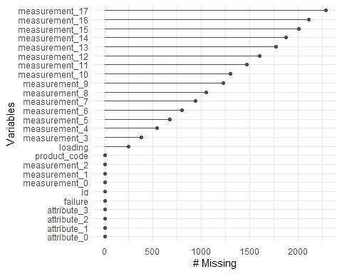

gg_miss_fct(x = train, fct = failure)

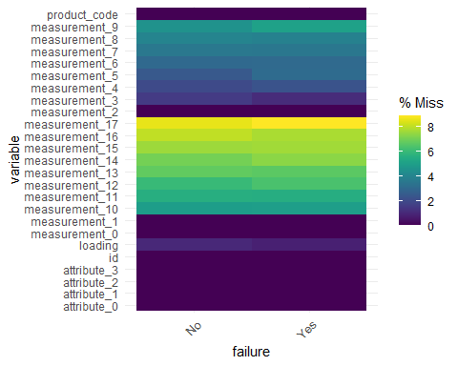

gg_miss_case(train)

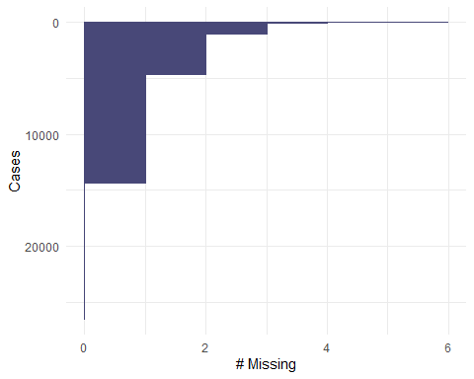

vis_miss(train)

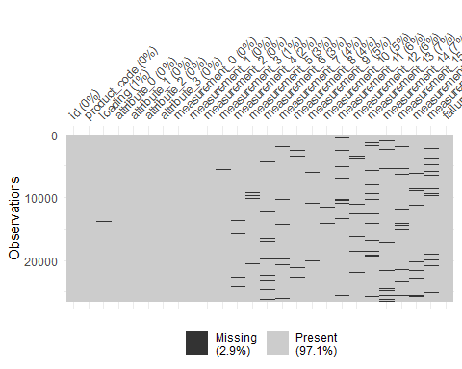

Imputation

set.seed(1234)  
imp_measures <-  
 mice(train, m=5, method='pmm', printFlag=FALSE)

## Warning: Number of logged events: 756

summary(imp_measures)

## Class: mids  
## Number of multiple imputations: 5   
## Imputation methods:  
## id product_code loading attribute_0 attribute_1   
## "" "" "pmm" "" ""   
## attribute_2 attribute_3 measurement_0 measurement_1 measurement_2   
## "" "" "" "" ""   
## measurement_3 measurement_4 measurement_5 measurement_6 measurement_7   
## "pmm" "pmm" "pmm" "pmm" "pmm"   
## measurement_8 measurement_9 measurement_10 measurement_11 measurement_12   
## "pmm" "pmm" "pmm" "pmm" "pmm"   
## measurement_13 measurement_14 measurement_15 measurement_16 measurement_17   
## "pmm" "pmm" "pmm" "pmm" "pmm"   
## failure   
## ""   
## PredictorMatrix:  
## id product_code loading attribute_0 attribute_1 attribute_2  
## id 0 1 1 1 1 1  
## product_code 1 0 1 1 1 1  
## loading 1 1 0 1 1 1  
## attribute_0 1 1 1 0 1 1  
## attribute_1 1 1 1 1 0 1  
## attribute_2 1 1 1 1 1 0  
## attribute_3 measurement_0 measurement_1 measurement_2  
## id 1 1 1 1  
## product_code 1 1 1 1  
## loading 1 1 1 1  
## attribute_0 1 1 1 1  
## attribute_1 1 1 1 1  
## attribute_2 1 1 1 1  
## measurement_3 measurement_4 measurement_5 measurement_6  
## id 1 1 1 1  
## product_code 1 1 1 1  
## loading 1 1 1 1  
## attribute_0 1 1 1 1  
## attribute_1 1 1 1 1  
## attribute_2 1 1 1 1  
## measurement_7 measurement_8 measurement_9 measurement_10  
## id 1 1 1 1  
## product_code 1 1 1 1  
## loading 1 1 1 1  
## attribute_0 1 1 1 1  
## attribute_1 1 1 1 1  
## attribute_2 1 1 1 1  
## measurement_11 measurement_12 measurement_13 measurement_14  
## id 1 1 1 1  
## product_code 1 1 1 1  
## loading 1 1 1 1  
## attribute_0 1 1 1 1  
## attribute_1 1 1 1 1  
## attribute_2 1 1 1 1  
## measurement_15 measurement_16 measurement_17 failure  
## id 1 1 1 1  
## product_code 1 1 1 1  
## loading 1 1 1 1  
## attribute_0 1 1 1 1  
## attribute_1 1 1 1 1  
## attribute_2 1 1 1 1  
## Number of logged events: 756   
## it im dep meth  
## 1 1 1 loading pmm  
## 2 1 1 loading pmm  
## 3 1 1 measurement_3 pmm  
## 4 1 1 measurement_3 pmm  
## 5 1 1 measurement_4 pmm  
## 6 1 1 measurement_4 pmm  
## out  
## 1 product_codeB, product_codeD, attribute_0material_5, attribute_1material_5, attribute_3  
## 2 mice detected that your data are (nearly) multi-collinear.\nIt applied a ridge penalty to continue calculations, but the results can be unstable.\nDoes your dataset contain duplicates, linear transformation, or factors with unique respondent names?  
## 3 product_codeB, loading, attribute_1material_6, measurement_0, measurement_4  
## 4 mice detected that your data are (nearly) multi-collinear.\nIt applied a ridge penalty to continue calculations, but the results can be unstable.\nDoes your dataset contain duplicates, linear transformation, or factors with unique respondent names?  
## 5 product_codeB, attribute_1material_5, attribute_1material_6, measurement_0, measurement_2  
## 6 mice detected that your data are (nearly) multi-collinear.\nIt applied a ridge penalty to continue calculations, but the results can be unstable.\nDoes your dataset contain duplicates, linear transformation, or factors with unique respondent names?

train_complete <-  
 complete(imp_measures)  
  
summary(train_complete)

## id product_code loading attribute_0   
## Min. : 0 A:5100 Min. : 33.16 material_7:21320   
## 1st Qu.: 6642 B:5250 1st Qu.: 99.96 material_5: 5250   
## Median :13284 C:5765 Median :122.36   
## Mean :13284 D:5112 Mean :127.82   
## 3rd Qu.:19927 E:5343 3rd Qu.:149.16   
## Max. :26569 Max. :385.86   
## attribute_1 attribute_2 attribute_3 measurement_0   
## material_8:10865 Min. :5.000 Min. :5.00 Min. : 0.000   
## material_5:10362 1st Qu.:6.000 1st Qu.:6.00 1st Qu.: 4.000   
## material_6: 5343 Median :6.000 Median :8.00 Median : 7.000   
## Mean :6.754 Mean :7.24 Mean : 7.416   
## 3rd Qu.:8.000 3rd Qu.:8.00 3rd Qu.:10.000   
## Max. :9.000 Max. :9.00 Max. :29.000   
## measurement_1 measurement_2 measurement_3 measurement_4   
## Min. : 0.000 Min. : 0.000 Min. :13.97 Min. : 8.008   
## 1st Qu.: 5.000 1st Qu.: 4.000 1st Qu.:17.12 1st Qu.:11.013   
## Median : 8.000 Median : 6.000 Median :17.79 Median :11.716   
## Mean : 8.233 Mean : 6.257 Mean :17.80 Mean :11.710   
## 3rd Qu.:11.000 3rd Qu.: 8.000 3rd Qu.:18.48 3rd Qu.:12.405   
## Max. :29.000 Max. :24.000 Max. :21.50 Max. :16.484   
## measurement_5 measurement_6 measurement_7 measurement_8   
## Min. :12.07 Min. :12.71 Min. : 7.968 Min. :15.22   
## 1st Qu.:16.39 1st Qu.:16.84 1st Qu.:11.049 1st Qu.:18.38   
## Median :17.10 Median :17.52 Median :11.713 Median :19.07   
## Mean :17.08 Mean :17.51 Mean :11.717 Mean :19.12   
## 3rd Qu.:17.79 3rd Qu.:18.18 3rd Qu.:12.391 3rd Qu.:19.81   
## Max. :21.43 Max. :21.54 Max. :15.419 Max. :23.81   
## measurement_9 measurement_10 measurement_11 measurement_12   
## Min. : 7.537 Min. : 9.323 Min. :12.46 Min. : 5.167   
## 1st Qu.:10.734 1st Qu.:15.173 1st Qu.:18.24 1st Qu.:10.715   
## Median :11.420 Median :16.110 Median :19.32 Median :11.690   
## Mean :11.414 Mean :16.083 Mean :19.28 Mean :11.695   
## 3rd Qu.:12.065 3rd Qu.:16.975 3rd Qu.:20.35 3rd Qu.:12.699   
## Max. :15.412 Max. :22.479 Max. :25.64 Max. :17.663   
## measurement_13 measurement_14 measurement_15 measurement_16   
## Min. :10.89 Min. : 9.14 Min. : 9.104 Min. : 9.701   
## 1st Qu.:14.85 1st Qu.:15.08 1st Qu.:13.820 1st Qu.:15.263   
## Median :15.65 Median :16.07 Median :14.806 Median :16.534   
## Mean :15.64 Mean :16.09 Mean :14.812 Mean :16.718   
## 3rd Qu.:16.31 3rd Qu.:17.13 3rd Qu.:15.918 3rd Qu.:17.846   
## Max. :22.71 Max. :22.30 Max. :21.626 Max. :24.094   
## measurement_17 failure   
## Min. : 196.8 No :20921   
## 1st Qu.: 614.1 Yes: 5649   
## Median : 698.6   
## Mean : 697.3   
## 3rd Qu.: 783.6   
## Max. :1312.8

#### Visualize and explore relationships

p1 <-  
 ggplot(train_complete, aes(x=product_code, fill = failure)) +  
 geom_bar() +  
 theme_bw()  
  
p2 <-  
 ggplot(train_complete, aes(x=attribute_0, fill = failure)) +  
 geom_bar() +  
 theme_bw()  
  
p3 <-   
 ggplot(train_complete, aes(x=attribute_1, fill = failure)) +  
 geom_bar() +  
 theme_bw()  
  
grid.arrange(p1,p2,p3,ncol=2)

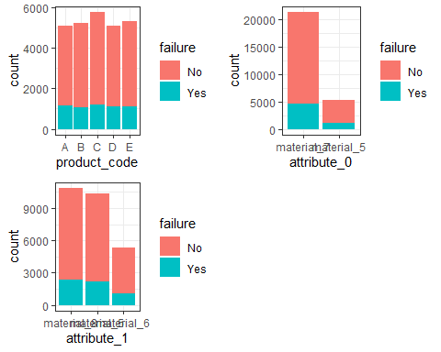

p1 <-  
 ggplot(train_complete, aes(x=product_code, fill = failure)) +  
 geom_bar(position = "fill") +  
 theme_bw()  
  
p2 <-   
 ggplot(train_complete, aes(x=attribute_0, fill = failure)) +  
 geom_bar(position = "fill") +  
 theme_bw()  
  
p3 <-   
 ggplot(train_complete, aes(x=attribute_1, fill = failure)) +  
 geom_bar(position = "fill") +  
 theme_bw()  
  
grid.arrange(p1,p2,p3,ncol=2)

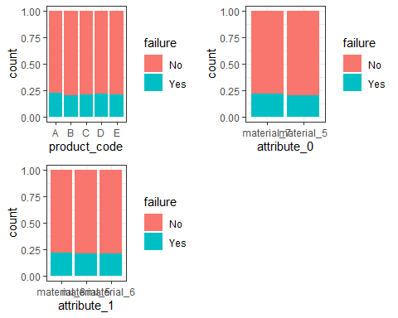

p1 <-  
 ggplot(train_complete, aes(x = failure, y = loading)) +  
 geom_boxplot() +  
 theme_bw()  
  
p2 <-  
 ggplot(train_complete, aes(x = failure, y = attribute_2)) +  
 geom_boxplot() +  
 theme_bw()  
  
grid.arrange(p1,p2,ncol=2)

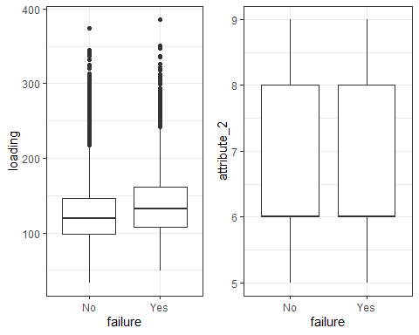

p3 <-  
 ggplot(train_complete, aes(x = failure, y = attribute_3)) +  
 geom_boxplot() +  
 theme_bw()  
  
grid.arrange(p3,ncol=2)

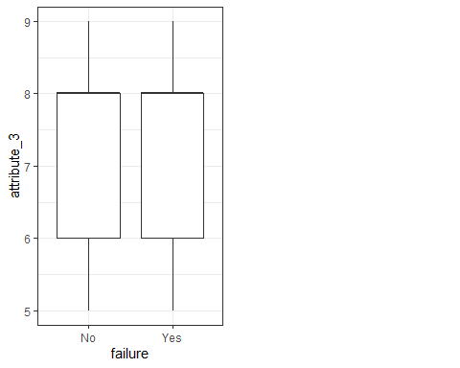

p1 <-  
 ggplot(train_complete, aes(x = failure, y = measurement_0)) +  
 geom_boxplot() +  
 theme_bw()  
  
p2 <-  
 ggplot(train_complete, aes(x = failure, y = measurement_1)) +  
 geom_boxplot() +  
 theme_bw()  
  
grid.arrange(p1,p2,ncol=2)

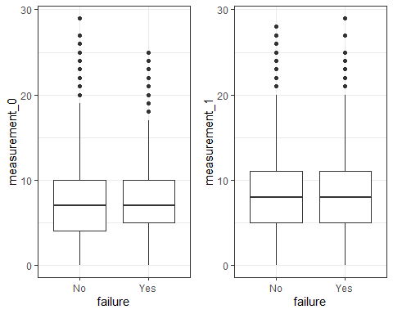

p3 <-  
 ggplot(train_complete, aes(x = failure, y = measurement_2)) +  
 geom_boxplot() +  
 theme_bw()  
  
p4 <-  
 ggplot(train_complete, aes(x = failure, y = measurement_3)) +  
 geom_boxplot() +  
 theme_bw()  
  
grid.arrange(p3,p4,ncol=2)

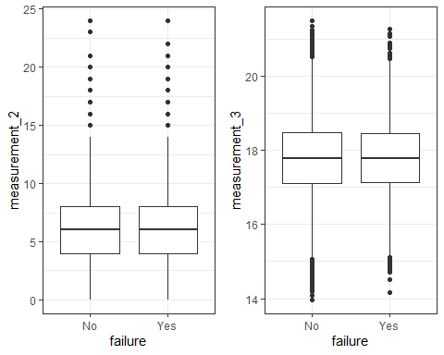

p1 <-  
 ggplot(train_complete, aes(x = failure, y = measurement_4)) +  
 geom_boxplot() +  
 theme_bw()  
  
p2 <-  
 ggplot(train_complete, aes(x = failure, y = measurement_5)) +  
 geom_boxplot() +  
 theme_bw()  
  
grid.arrange(p1,p2,ncol=2)

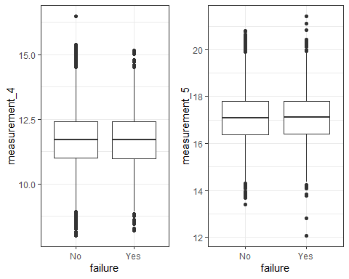

p3 <-  
 ggplot(train_complete, aes(x = failure, y = measurement_6)) +  
 geom_boxplot() +  
 theme_bw()  
  
p4 <-  
 ggplot(train_complete, aes(x = failure, y = measurement_7)) +  
 geom_boxplot() +  
 theme_bw()  
  
grid.arrange(p3,p4,ncol=2)

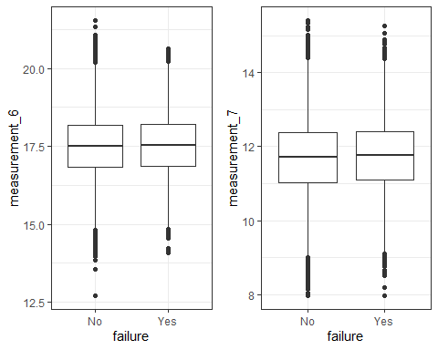

p1 <-  
 ggplot(train_complete, aes(x = failure, y = measurement_8)) +  
 geom_boxplot() +  
 theme_bw()  
  
p2 <-  
 ggplot(train_complete, aes(x = failure, y = measurement_9)) +  
 geom_boxplot() +  
 theme_bw()  
  
grid.arrange(p1,p2,ncol=2)

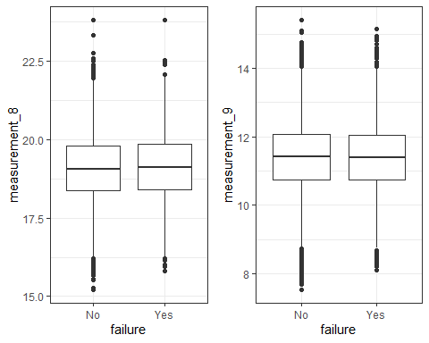

p3 <-  
 ggplot(train_complete, aes(x = failure, y = measurement_10)) +  
 geom_boxplot() +  
 theme_bw()  
  
p4 <-  
 ggplot(train_complete, aes(x = failure, y = measurement_11)) +  
 geom_boxplot() +  
 theme_bw()  
  
grid.arrange(p3,p4,ncol=2)

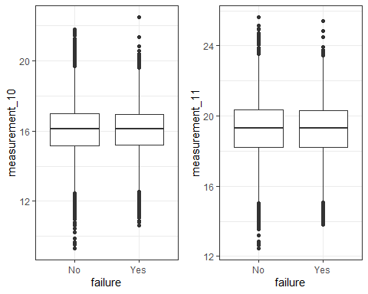

p1 <-  
 ggplot(train_complete, aes(x = failure, y = measurement_12)) +  
 geom_boxplot() +  
 theme_bw()  
  
p2 <-  
 ggplot(train_complete, aes(x = failure, y = measurement_13)) +  
 geom_boxplot() +  
 theme_bw()  
  
grid.arrange(p1,p2,ncol=2)

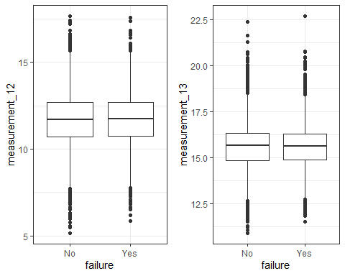

p3 <-  
 ggplot(train_complete, aes(x = failure, y = measurement_14)) +  
 geom_boxplot() +  
 theme_bw()  
  
p4 <-  
 ggplot(train_complete, aes(x = failure, y = measurement_15)) +  
 geom_boxplot() +  
 theme_bw()  
  
grid.arrange(p3,p4,ncol=2)

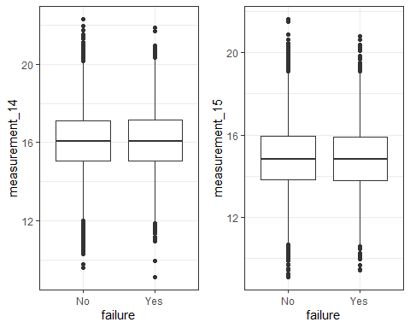

p1 <-  
 ggplot(train_complete, aes(x = failure, y = measurement_16)) +  
 geom_boxplot() +  
 theme_bw()  
  
p2 <-  
 ggplot(train_complete, aes(x = failure, y = measurement_17)) +  
 geom_boxplot() +  
 theme_bw()  
  
grid.arrange(p1,p2,ncol=2)

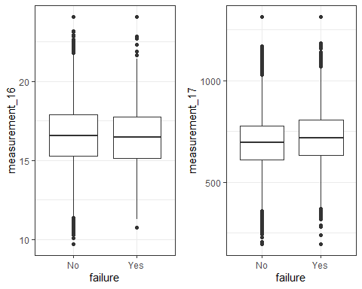

Look at a few variables of possible interest

ggplot(train_complete, aes(x = failure, y = loading, fill = failure)) +   
 geom_violin(trim = FALSE) +  
 theme_bw()

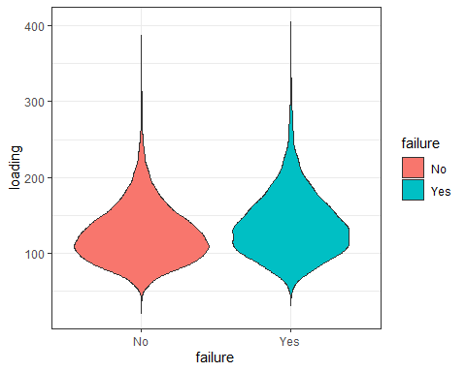

ggplot(train_complete, aes(x = failure, y = measurement_17, fill = failure)) +   
 geom_violin(trim = FALSE) +  
 theme_bw()

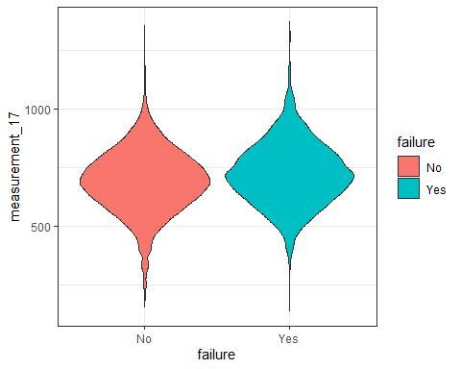

Look at summary stats with groups split by failure

train_failyes <- train_complete[(which(train_complete$failure %in% "Yes")),]  
train_failno <- train_complete[(which(train_complete$failure %in% "No")),]

summary(train_failyes)

## id product_code loading attribute_0   
## Min. : 6 A:1159 Min. : 49.64 material_7:4597   
## 1st Qu.: 6282 B:1052 1st Qu.:107.29 material_5:1052   
## Median :13182 C:1220 Median :131.83   
## Mean :13173 D:1112 Mean :137.44   
## 3rd Qu.:19840 E:1106 3rd Qu.:161.05   
## Max. :26559 Max. :385.86   
## attribute_1 attribute_2 attribute_3 measurement_0   
## material_8:2379 Min. :5.000 Min. :5.000 Min. : 0.000   
## material_5:2164 1st Qu.:6.000 1st Qu.:6.000 1st Qu.: 5.000   
## material_6:1106 Median :6.000 Median :8.000 Median : 7.000   
## Mean :6.772 Mean :7.187 Mean : 7.492   
## 3rd Qu.:8.000 3rd Qu.:8.000 3rd Qu.:10.000   
## Max. :9.000 Max. :9.000 Max. :25.000   
## measurement_1 measurement_2 measurement_3 measurement_4   
## Min. : 0.000 Min. : 0.000 Min. :14.17 Min. : 8.196   
## 1st Qu.: 5.000 1st Qu.: 4.000 1st Qu.:17.13 1st Qu.:10.985   
## Median : 8.000 Median : 6.000 Median :17.79 Median :11.710   
## Mean : 8.145 Mean : 6.357 Mean :17.81 Mean :11.689   
## 3rd Qu.:11.000 3rd Qu.: 8.000 3rd Qu.:18.46 3rd Qu.:12.398   
## Max. :29.000 Max. :24.000 Max. :21.27 Max. :15.164   
## measurement_5 measurement_6 measurement_7 measurement_8   
## Min. :12.07 Min. :14.09 Min. : 7.968 Min. :15.82   
## 1st Qu.:16.40 1st Qu.:16.87 1st Qu.:11.099 1st Qu.:18.40   
## Median :17.13 Median :17.55 Median :11.758 Median :19.11   
## Mean :17.10 Mean :17.54 Mean :11.754 Mean :19.15   
## 3rd Qu.:17.80 3rd Qu.:18.20 3rd Qu.:12.416 3rd Qu.:19.85   
## Max. :21.43 Max. :20.62 Max. :15.269 Max. :23.81   
## measurement_9 measurement_10 measurement_11 measurement_12   
## Min. : 8.103 Min. :10.63 Min. :13.80 Min. : 5.867   
## 1st Qu.:10.729 1st Qu.:15.19 1st Qu.:18.24 1st Qu.:10.728   
## Median :11.406 Median :16.10 Median :19.31 Median :11.729   
## Mean :11.407 Mean :16.08 Mean :19.27 Mean :11.710   
## 3rd Qu.:12.054 3rd Qu.:16.95 3rd Qu.:20.32 3rd Qu.:12.703   
## Max. :15.154 Max. :22.48 Max. :25.43 Max. :17.594   
## measurement_13 measurement_14 measurement_15 measurement_16   
## Min. :11.50 Min. : 9.14 Min. : 9.425 Min. :10.73   
## 1st Qu.:14.87 1st Qu.:15.08 1st Qu.:13.779 1st Qu.:15.15   
## Median :15.63 Median :16.07 Median :14.804 Median :16.45   
## Mean :15.63 Mean :16.11 Mean :14.795 Mean :16.46   
## 3rd Qu.:16.30 3rd Qu.:17.18 3rd Qu.:15.888 3rd Qu.:17.74   
## Max. :22.71 Max. :21.85 Max. :20.784 Max. :24.09   
## measurement_17 failure   
## Min. : 196.8 No : 0   
## 1st Qu.: 634.1 Yes:5649   
## Median : 717.8   
## Mean : 722.5   
## 3rd Qu.: 807.5   
## Max. :1312.8

summary(train_failno)

## id product_code loading attribute_0   
## Min. : 0 A:3941 Min. : 33.16 material_7:16723   
## 1st Qu.: 6733 B:4198 1st Qu.: 98.09 material_5: 4198   
## Median :13309 C:4545 Median :119.90   
## Mean :13315 D:4000 Mean :125.22   
## 3rd Qu.:19955 E:4237 3rd Qu.:145.94   
## Max. :26569 Max. :374.33   
## attribute_1 attribute_2 attribute_3 measurement_0   
## material_8:8486 Min. :5.000 Min. :5.000 Min. : 0.000   
## material_5:8198 1st Qu.:6.000 1st Qu.:6.000 1st Qu.: 4.000   
## material_6:4237 Median :6.000 Median :8.000 Median : 7.000   
## Mean :6.749 Mean :7.255 Mean : 7.395   
## 3rd Qu.:8.000 3rd Qu.:8.000 3rd Qu.:10.000   
## Max. :9.000 Max. :9.000 Max. :29.000   
## measurement_1 measurement_2 measurement_3 measurement_4   
## Min. : 0.000 Min. : 0.000 Min. :13.97 Min. : 8.008   
## 1st Qu.: 5.000 1st Qu.: 4.000 1st Qu.:17.12 1st Qu.:11.020   
## Median : 8.000 Median : 6.000 Median :17.79 Median :11.719   
## Mean : 8.256 Mean : 6.229 Mean :17.80 Mean :11.715   
## 3rd Qu.:11.000 3rd Qu.: 8.000 3rd Qu.:18.48 3rd Qu.:12.407   
## Max. :28.000 Max. :24.000 Max. :21.50 Max. :16.484   
## measurement_5 measurement_6 measurement_7 measurement_8   
## Min. :13.39 Min. :12.71 Min. : 7.973 Min. :15.22   
## 1st Qu.:16.39 1st Qu.:16.83 1st Qu.:11.036 1st Qu.:18.37   
## Median :17.10 Median :17.51 Median :11.705 Median :19.06   
## Mean :17.08 Mean :17.50 Mean :11.708 Mean :19.11   
## 3rd Qu.:17.79 3rd Qu.:18.17 3rd Qu.:12.383 3rd Qu.:19.80   
## Max. :20.79 Max. :21.54 Max. :15.419 Max. :23.81   
## measurement_9 measurement_10 measurement_11 measurement_12   
## Min. : 7.537 Min. : 9.323 Min. :12.46 Min. : 5.167   
## 1st Qu.:10.736 1st Qu.:15.168 1st Qu.:18.24 1st Qu.:10.714   
## Median :11.423 Median :16.113 Median :19.32 Median :11.681   
## Mean :11.415 Mean :16.083 Mean :19.28 Mean :11.691   
## 3rd Qu.:12.067 3rd Qu.:16.982 3rd Qu.:20.36 3rd Qu.:12.699   
## Max. :15.412 Max. :21.761 Max. :25.64 Max. :17.663   
## measurement_13 measurement_14 measurement_15 measurement_16   
## Min. :10.89 Min. : 9.593 Min. : 9.104 Min. : 9.701   
## 1st Qu.:14.85 1st Qu.:15.075 1st Qu.:13.826 1st Qu.:15.287   
## Median :15.65 Median :16.076 Median :14.808 Median :16.555   
## Mean :15.64 Mean :16.086 Mean :14.817 Mean :16.789   
## 3rd Qu.:16.31 3rd Qu.:17.115 3rd Qu.:15.926 3rd Qu.:17.882   
## Max. :22.39 Max. :22.303 Max. :21.626 Max. :24.094   
## measurement_17 failure   
## Min. : 196.8 No :20921   
## 1st Qu.: 609.4 Yes: 0   
## Median : 693.5   
## Mean : 690.5   
## 3rd Qu.: 776.5   
## Max. :1312.8

Split numerical and categorical for correlation analysis

num_vars <- train_complete %>%  
 select_if(is.numeric) %>%  
 dplyr::select(-id)  
  
cat_vars <- train_complete %>%  
 select_if(is.factor)

Correlation matrix of numerical variables

cor_matrix <- cor(num_vars, use = "pairwise.complete.obs")  
corrplot(cor_matrix, method = "color", tl.cex = 0.7)

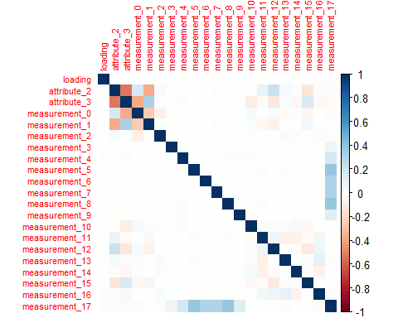

Chi-squared test for categorical variables

for(var in names(cat_vars)) {  
 print(var)  
 print(chisq.test(table(cat_vars[[var]], train_complete$failure)))  
}

## [1] "product_code"  
##   
## Pearson's Chi-squared test  
##   
## data: table(cat_vars[[var]], train_complete$failure)  
## X-squared = 13, df = 4, p-value = 0.01127  
##   
## [1] "attribute_0"  
##   
## Pearson's Chi-squared test with Yates' continuity correction  
##   
## data: table(cat_vars[[var]], train_complete$failure)  
## X-squared = 5.7525, df = 1, p-value = 0.01646  
##   
## [1] "attribute_1"  
##   
## Pearson's Chi-squared test  
##   
## data: table(cat_vars[[var]], train_complete$failure)  
## X-squared = 4.5013, df = 2, p-value = 0.1053  
##   
## [1] "failure"  
##   
## Pearson's Chi-squared test with Yates' continuity correction  
##   
## data: table(cat_vars[[var]], train_complete$failure)  
## X-squared = 26564, df = 1, p-value < 2.2e-16

# BAN 502 Course Project Phase 2

## Kelly Quesnel

### Model Building and Predictions

#### Libraries

library(tidyverse)  
library(tidymodels)  
library(mice)  
library(VIM)  
library(naniar)  
library(skimr)  
library(UpSetR)  
library(rpart)  
library(rpart.plot)   
library(RColorBrewer)   
library(rattle)  
library(caret)  
library(usemodels)  
library(glmnet)  
library(ROCR)  
library(ranger)   
library(randomForest)  
library(GGally)  
library(gridExtra)  
library(vip)  
library(ggcorrplot)  
library(MASS)  
library(leaps)  
library(lmtest)  
library(splines)  
library(car)  
library(e1071)  
library(arules)  
library(corrplot)  
library(vcd)  
library(doParallel)  
library(themis)

#### Copy to new data frame and rename for clarity

dataset <- train_complete

#### Look for Outliers

*Going back to exploratory analysis for a moment to explore and deal with outliers as suggested.*

ggplot(dataset, aes(x=loading)) +  
 geom_histogram() +  
 theme_bw()

## `stat_bin()` using `bins = 30`. Pick better value with `binwidth`.

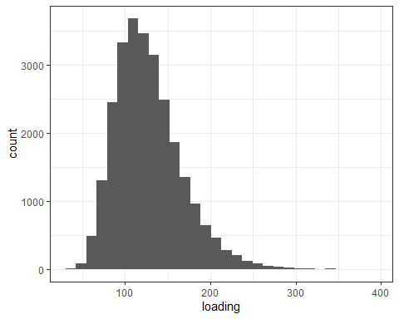

ggplot(dataset, aes(x=measurement_0)) +  
 geom_histogram() +  
 theme_bw()

## `stat_bin()` using `bins = 30`. Pick better value with `binwidth`.

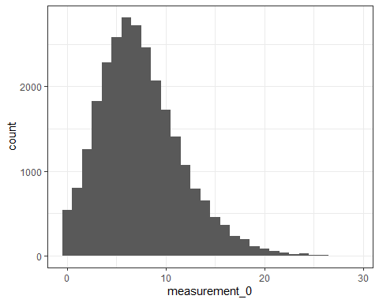

ggplot(dataset, aes(x=measurement_1)) +  
 geom_histogram() +  
 theme_bw()

## `stat_bin()` using `bins = 30`. Pick better value with `binwidth`.

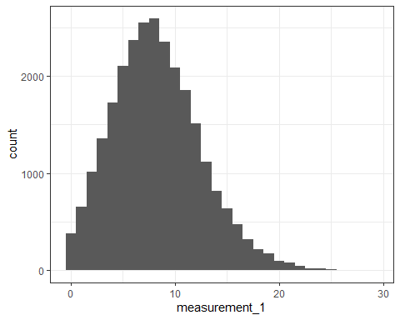

ggplot(dataset, aes(x=measurement_2)) +  
 geom_histogram() +  
 theme_bw()

## `stat_bin()` using `bins = 30`. Pick better value with `binwidth`.

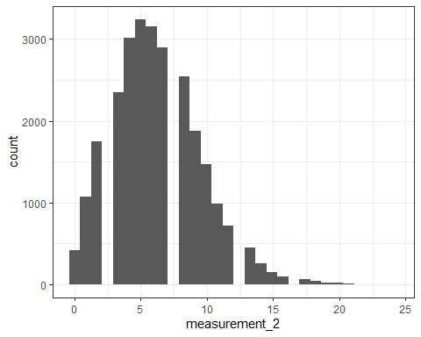

ggplot(dataset, aes(x=measurement_3)) +  
 geom_histogram() +  
 theme_bw()

## `stat_bin()` using `bins = 30`. Pick better value with `binwidth`.

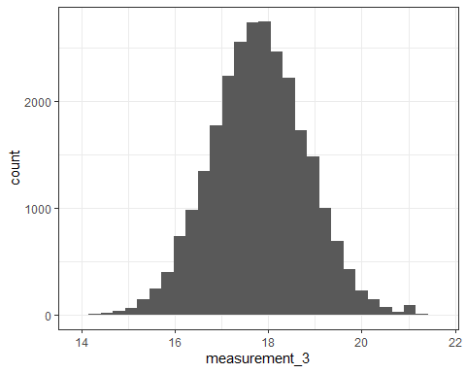

ggplot(dataset, aes(x=measurement_4)) +  
 geom_histogram() +  
 theme_bw()

## `stat_bin()` using `bins = 30`. Pick better value with `binwidth`.

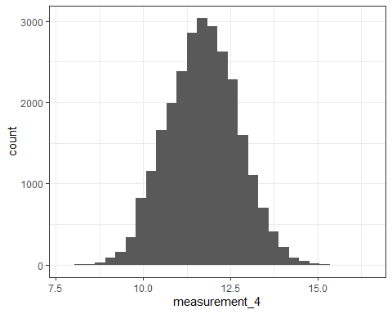

ggplot(dataset, aes(x=measurement_5)) +  
 geom_histogram() +  
 theme_bw()

## `stat_bin()` using `bins = 30`. Pick better value with `binwidth`.

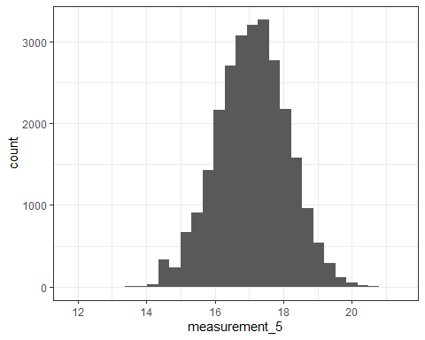

ggplot(dataset, aes(x=measurement_6)) +  
 geom_histogram() +  
 theme_bw()

## `stat_bin()` using `bins = 30`. Pick better value with `binwidth`.

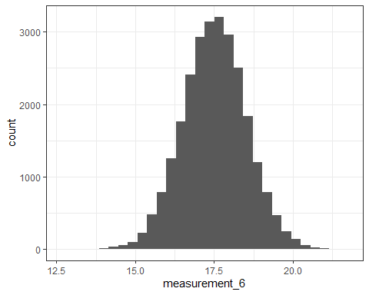

ggplot(dataset, aes(x=measurement_7)) +  
 geom_histogram() +  
 theme_bw()

## `stat_bin()` using `bins = 30`. Pick better value with `binwidth`.

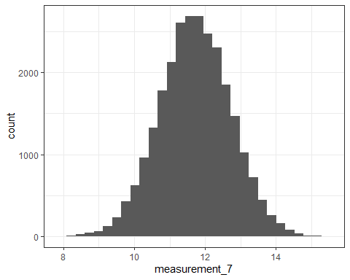

ggplot(dataset, aes(x=measurement_8)) +  
 geom_histogram() +  
 theme_bw()

## `stat_bin()` using `bins = 30`. Pick better value with `binwidth`.

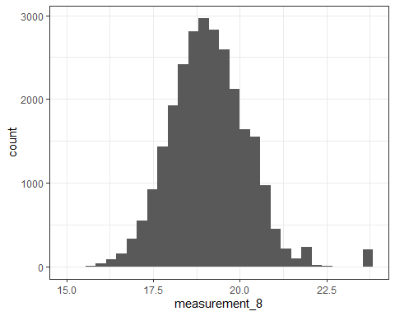

ggplot(dataset, aes(x=measurement_9)) +  
 geom_histogram() +  
 theme_bw()

## `stat_bin()` using `bins = 30`. Pick better value with `binwidth`.

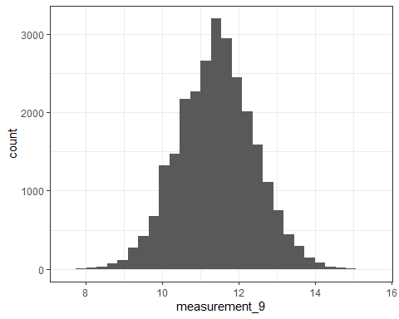

ggplot(dataset, aes(x=measurement_10)) +  
 geom_histogram() +  
 theme_bw()

## `stat_bin()` using `bins = 30`. Pick better value with `binwidth`.

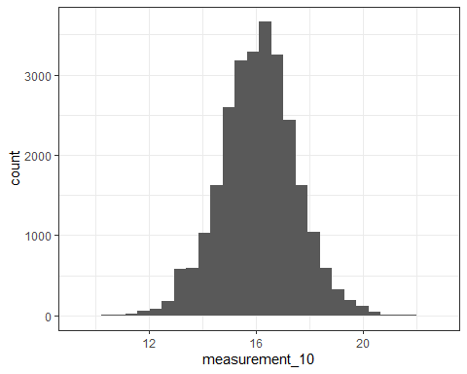

ggplot(dataset, aes(x=measurement_11)) +  
 geom_histogram() +  
 theme_bw()

## `stat_bin()` using `bins = 30`. Pick better value with `binwidth`.

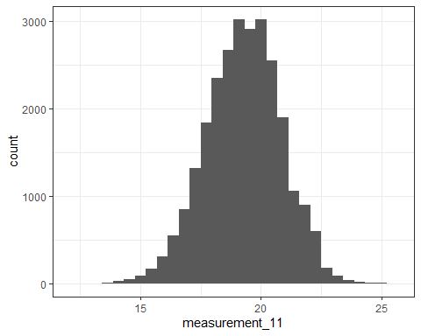

ggplot(dataset, aes(x=measurement_12)) +  
 geom_histogram() +  
 theme_bw()

## `stat_bin()` using `bins = 30`. Pick better value with `binwidth`.

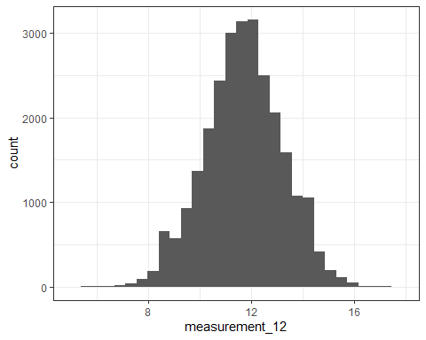

ggplot(dataset, aes(x=measurement_13)) +  
 geom_histogram() +  
 theme_bw()

## `stat_bin()` using `bins = 30`. Pick better value with `binwidth`.

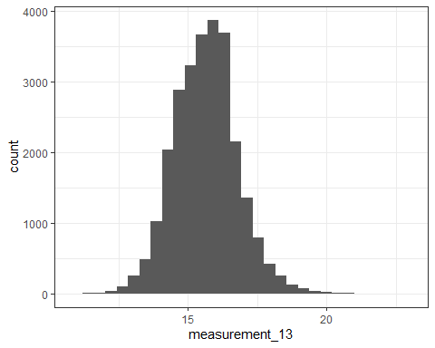

ggplot(dataset, aes(x=measurement_14)) +  
 geom_histogram() +  
 theme_bw()

## `stat_bin()` using `bins = 30`. Pick better value with `binwidth`.

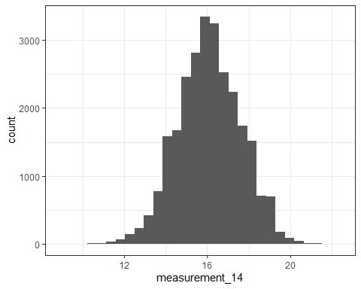

ggplot(dataset, aes(x=measurement_15)) +  
 geom_histogram() +  
 theme_bw()

## `stat_bin()` using `bins = 30`. Pick better value with `binwidth`.

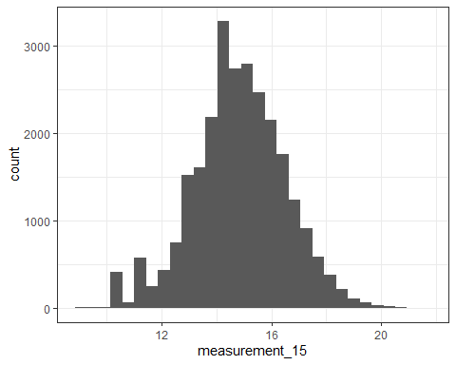

ggplot(dataset, aes(x=measurement_16)) +  
 geom_histogram() +  
 theme_bw()

## `stat_bin()` using `bins = 30`. Pick better value with `binwidth`.

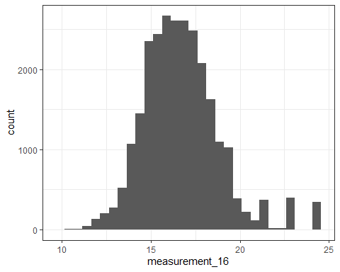

ggplot(dataset, aes(x=measurement_17)) +  
 geom_histogram() +  
 theme_bw()

## `stat_bin()` using `bins = 30`. Pick better value with `binwidth`.

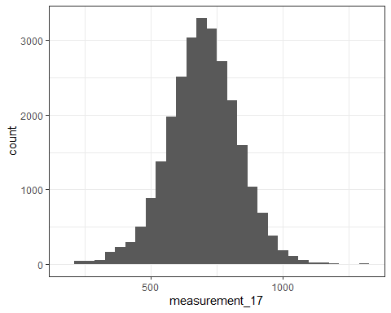

*Not immediately concerned with anything except perhaps loading.*

dataset <- dataset %>%  
 filter(loading < 300)  
  
ggplot(dataset, aes(x=loading)) +  
 geom_histogram() +  
 theme_bw()

## `stat_bin()` using `bins = 30`. Pick better value with `binwidth`.

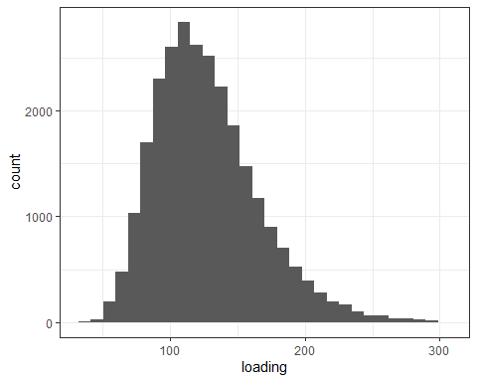

#### Remove ID column

dataset <- dataset %>%  
 dplyr::select(-id)

#### Split data for modeling

set.seed(123)  
data_split <- initial_split(dataset, prop = 0.80, strata = failure)  
data_train <- training(data_split)  
data_test <- testing(data_split)

#### Create k folds

set.seed(123)  
folds <- vfold_cv(data_train, v = 5)

#### Logistic Regression

Build model

model_logreg <-  
 logistic_reg(mode = "classification") %>%  
 set_engine("glm")  
  
recipe_logreg <-  
 recipe(failure ~., data_train)  
  
wf_logreg <-  
 workflow() %>%  
 add_recipe(recipe_logreg) %>%  
 add_model(model_logreg)  
  
set.seed(123)  
cv_results <-   
 tune_grid(wf_logreg,  
 resamples = folds)

## Warning: No tuning parameters have been detected, performance will be evaluated  
## using the resamples with no tuning. Did you want to [tune()] parameters?

fit_logreg <-  
 fit(wf_logreg, data_train)

Summarize model

summary(fit_logreg$fit$fit$fit)

##   
## Call:  
## stats::glm(formula = ..y ~ ., family = stats::binomial, data = data)  
##   
## Coefficients: (5 not defined because of singularities)  
## Estimate Std. Error z value Pr(>|z|)   
## (Intercept) 6.0824432 1.0143409 5.996 2.02e-09 ***  
## product_codeB -0.0794745 0.0627645 -1.266 0.205429   
## product_codeC -0.0766105 0.0598599 -1.280 0.200605   
## product_codeD -0.0628186 0.0627333 -1.001 0.316653   
## product_codeE -0.1346088 0.0639194 -2.106 0.035212 *   
## loading 0.0074916 0.0004255 17.605 < 2e-16 ***  
## attribute_0material_5 NA NA NA NA   
## attribute_1material_5 NA NA NA NA   
## attribute_1material_6 NA NA NA NA   
## attribute_2 NA NA NA NA   
## attribute_3 NA NA NA NA   
## measurement_0 0.0010453 0.0045701 0.229 0.819089   
## measurement_1 -0.0010678 0.0047153 -0.226 0.820854   
## measurement_2 0.0160031 0.0054431 2.940 0.003281 **   
## measurement_3 -0.0171207 0.0169991 -1.007 0.313862   
## measurement_4 -0.0876981 0.0174640 -5.022 5.12e-07 ***  
## measurement_5 -0.1463659 0.0191176 -7.656 1.92e-14 ***  
## measurement_6 -0.0965416 0.0189829 -5.086 3.66e-07 ***  
## measurement_7 -0.0957374 0.0189881 -5.042 4.61e-07 ***  
## measurement_8 -0.1274277 0.0183484 -6.945 3.79e-12 ***  
## measurement_9 -0.0622270 0.0177282 -3.510 0.000448 ***  
## measurement_10 -0.0165795 0.0122765 -1.351 0.176853   
## measurement_11 -0.0051708 0.0112956 -0.458 0.647114   
## measurement_12 0.0182019 0.0117273 1.552 0.120640   
## measurement_13 0.0291015 0.0153363 1.898 0.057754 .   
## measurement_14 -0.0009377 0.0113743 -0.082 0.934294   
## measurement_15 -0.0018697 0.0104080 -0.180 0.857433   
## measurement_16 -0.0796316 0.0085957 -9.264 < 2e-16 ***  
## measurement_17 0.0034741 0.0002014 17.252 < 2e-16 ***  
## ---  
## Signif. codes: 0 '***' 0.001 '**' 0.01 '*' 0.05 '.' 0.1 ' ' 1  
##   
## (Dispersion parameter for binomial family taken to be 1)  
##   
## Null deviance: 21943 on 21224 degrees of freedom  
## Residual deviance: 21179 on 21201 degrees of freedom  
## AIC: 21227  
##   
## Number of Fisher Scoring iterations: 4

Predict on training

logreg_train_pred <- predict(fit_logreg, data_train, type = "class")  
  
logreg_train_results <- data_train %>%  
 mutate(logreg_pred_class = logreg_train_pred$.pred_class)  
  
logreg_train_acc <- accuracy(logreg_train_results, truth = failure, estimate = logreg_pred_class)  
  
print(logreg_train_acc)

## # A tibble: 1 × 3  
## .metric .estimator .estimate  
## <chr> <chr> <dbl>  
## 1 accuracy binary 0.790

confusionMatrix(logreg_train_pred$.pred_class,data_train$failure,positive="Yes")

## Confusion Matrix and Statistics  
##   
## Reference  
## Prediction No Yes  
## No 16677 4422  
## Yes 43 83  
##   
## Accuracy : 0.7896   
## 95% CI : (0.7841, 0.7951)  
## No Information Rate : 0.7878   
## P-Value [Acc > NIR] : 0.2539   
##   
## Kappa : 0.0246   
##   
## Mcnemar's Test P-Value : <2e-16   
##   
## Sensitivity : 0.018424   
## Specificity : 0.997428   
## Pos Pred Value : 0.658730   
## Neg Pred Value : 0.790417   
## Prevalence : 0.212250   
## Detection Rate : 0.003910   
## Detection Prevalence : 0.005936   
## Balanced Accuracy : 0.507926   
##   
## 'Positive' Class : Yes   
##

Predict on testing

logreg_test_pred <- predict(fit_logreg, data_test, type = "class")  
  
logreg_test_results <- data_test %>%  
 mutate(logreg_pred_class = logreg_test_pred$.pred_class)  
  
logreg_test_acc <- accuracy(logreg_test_results, truth = failure, estimate = logreg_pred_class)  
  
print(logreg_test_acc)

## # A tibble: 1 × 3  
## .metric .estimator .estimate  
## <chr> <chr> <dbl>  
## 1 accuracy binary 0.791

confusionMatrix(logreg_test_pred$.pred_class,data_test$failure,positive="Yes")

## Confusion Matrix and Statistics  
##   
## Reference  
## Prediction No Yes  
## No 4179 1108  
## Yes 2 19  
##   
## Accuracy : 0.7909   
## 95% CI : (0.7797, 0.8018)  
## No Information Rate : 0.7877   
## P-Value [Acc > NIR] : 0.2906   
##   
## Kappa : 0.0255   
##   
## Mcnemar's Test P-Value : <2e-16   
##   
## Sensitivity : 0.016859   
## Specificity : 0.999522   
## Pos Pred Value : 0.904762   
## Neg Pred Value : 0.790429   
## Prevalence : 0.212321   
## Detection Rate : 0.003580   
## Detection Prevalence : 0.003956   
## Balanced Accuracy : 0.508190   
##   
## 'Positive' Class : Yes   
##

#### Logistic Regression #2

Split data

set.seed(123)  
data_split2 <- initial_split(dataset, prop = 0.70, strata = failure)  
data_train2 <- training(data_split2)  
data_test2 <- testing(data_split2)

Create folds

set.seed(123)  
folds10 <- vfold_cv(data_train2, v = 10)

Build model

model_logreg2 <-  
 logistic_reg(mode = "classification") %>%  
 set_engine("glm")  
  
recipe_logreg2 <-  
 recipe(failure ~ loading + measurement_2 +  
 measurement_4 + measurement_5 +  
 measurement_6 + measurement_7 +   
 measurement_8 + measurement_9 +   
 measurement_16 + measurement_17 +  
 attribute_0,  
 data_train2)  
  
wf_logreg2 <-  
 workflow() %>%  
 add_recipe(recipe_logreg2) %>%  
 add_model(model_logreg2)  
  
set.seed(123)  
cv_results <-   
 tune_grid(wf_logreg2,  
 resamples = folds10)

## Warning: No tuning parameters have been detected, performance will be evaluated  
## using the resamples with no tuning. Did you want to [tune()] parameters?

fit_logreg2 <-  
 fit(wf_logreg2, data_train2)  
  
summary(fit_logreg$fit$fit$fit)

##   
## Call:  
## stats::glm(formula = ..y ~ ., family = stats::binomial, data = data)  
##   
## Coefficients: (5 not defined because of singularities)  
## Estimate Std. Error z value Pr(>|z|)   
## (Intercept) 6.0824432 1.0143409 5.996 2.02e-09 ***  
## product_codeB -0.0794745 0.0627645 -1.266 0.205429   
## product_codeC -0.0766105 0.0598599 -1.280 0.200605   
## product_codeD -0.0628186 0.0627333 -1.001 0.316653   
## product_codeE -0.1346088 0.0639194 -2.106 0.035212 *   
## loading 0.0074916 0.0004255 17.605 < 2e-16 ***  
## attribute_0material_5 NA NA NA NA   
## attribute_1material_5 NA NA NA NA   
## attribute_1material_6 NA NA NA NA   
## attribute_2 NA NA NA NA   
## attribute_3 NA NA NA NA   
## measurement_0 0.0010453 0.0045701 0.229 0.819089   
## measurement_1 -0.0010678 0.0047153 -0.226 0.820854   
## measurement_2 0.0160031 0.0054431 2.940 0.003281 **   
## measurement_3 -0.0171207 0.0169991 -1.007 0.313862   
## measurement_4 -0.0876981 0.0174640 -5.022 5.12e-07 ***  
## measurement_5 -0.1463659 0.0191176 -7.656 1.92e-14 ***  
## measurement_6 -0.0965416 0.0189829 -5.086 3.66e-07 ***  
## measurement_7 -0.0957374 0.0189881 -5.042 4.61e-07 ***  
## measurement_8 -0.1274277 0.0183484 -6.945 3.79e-12 ***  
## measurement_9 -0.0622270 0.0177282 -3.510 0.000448 ***  
## measurement_10 -0.0165795 0.0122765 -1.351 0.176853   
## measurement_11 -0.0051708 0.0112956 -0.458 0.647114   
## measurement_12 0.0182019 0.0117273 1.552 0.120640   
## measurement_13 0.0291015 0.0153363 1.898 0.057754 .   
## measurement_14 -0.0009377 0.0113743 -0.082 0.934294   
## measurement_15 -0.0018697 0.0104080 -0.180 0.857433   
## measurement_16 -0.0796316 0.0085957 -9.264 < 2e-16 ***  
## measurement_17 0.0034741 0.0002014 17.252 < 2e-16 ***  
## ---  
## Signif. codes: 0 '***' 0.001 '**' 0.01 '*' 0.05 '.' 0.1 ' ' 1  
##   
## (Dispersion parameter for binomial family taken to be 1)  
##   
## Null deviance: 21943 on 21224 degrees of freedom  
## Residual deviance: 21179 on 21201 degrees of freedom  
## AIC: 21227  
##   
## Number of Fisher Scoring iterations: 4

Predict on train

logreg_train_pred2 <- predict(fit_logreg2, data_train2, type = "class")  
  
logreg_train_results2 <- data_train2 %>%  
 mutate(logreg_pred_class2 = logreg_train_pred2$.pred_class)  
  
logreg_train_acc2 <- accuracy(logreg_train_results2, truth = failure, estimate = logreg_pred_class2)  
  
print(logreg_train_acc2)

## # A tibble: 1 × 3  
## .metric .estimator .estimate  
## <chr> <chr> <dbl>  
## 1 accuracy binary 0.789

confusionMatrix(logreg_train_pred2$.pred_class,data_train2$failure,positive="Yes")

## Confusion Matrix and Statistics  
##   
## Reference  
## Prediction No Yes  
## No 14598 3878  
## Yes 32 64  
##   
## Accuracy : 0.7895   
## 95% CI : (0.7835, 0.7953)  
## No Information Rate : 0.7877   
## P-Value [Acc > NIR] : 0.2863   
##   
## Kappa : 0.0218   
##   
## Mcnemar's Test P-Value : <2e-16   
##   
## Sensitivity : 0.016235   
## Specificity : 0.997813   
## Pos Pred Value : 0.666667   
## Neg Pred Value : 0.790106   
## Prevalence : 0.212255   
## Detection Rate : 0.003446   
## Detection Prevalence : 0.005169   
## Balanced Accuracy : 0.507024   
##   
## 'Positive' Class : Yes   
##

Predict on test

logreg_test_pred2 <- predict(fit_logreg2, data_test2, type = "class")  
  
logreg_test_results2 <- data_test2 %>%  
 mutate(logreg_pred_class2 = logreg_test_pred2$.pred_class)  
  
logreg_test_acc2 <- accuracy(logreg_test_results2, truth = failure, estimate = logreg_pred_class2)  
  
print(logreg_test_acc2)

## # A tibble: 1 × 3  
## .metric .estimator .estimate  
## <chr> <chr> <dbl>  
## 1 accuracy binary 0.790

confusionMatrix(logreg_test_pred2$.pred_class,data_test2$failure,positive="Yes")

## Confusion Matrix and Statistics  
##   
## Reference  
## Prediction No Yes  
## No 6264 1664  
## Yes 7 26  
##   
## Accuracy : 0.7901   
## 95% CI : (0.781, 0.799)  
## No Information Rate : 0.7877   
## P-Value [Acc > NIR] : 0.3068   
##   
## Kappa : 0.0222   
##   
## Mcnemar's Test P-Value : <2e-16   
##   
## Sensitivity : 0.015385   
## Specificity : 0.998884   
## Pos Pred Value : 0.787879   
## Neg Pred Value : 0.790111   
## Prevalence : 0.212285   
## Detection Rate : 0.003266   
## Detection Prevalence : 0.004145   
## Balanced Accuracy : 0.507134   
##   
## 'Positive' Class : Yes   
##

**LOG REG EVALUATION: The model results in just under 80% accuracy on both training and testing for both log reg models. This is an okay level of accuracy, but could probably be better. The good news is that the accuracy consistency shows little evidence of overfitting..**

#### Classification Tree

Build model

tree_recipe <-   
 recipe(failure ~., data_train)  
  
tree_model <-  
 decision_tree() %>%   
 set_engine("rpart", model = TRUE) %>%  
 set_mode("classification")  
  
tree_wf <-  
 workflow() %>%   
 add_model(tree_model) %>%   
 add_recipe(tree_recipe)  
  
set.seed(123)  
cv_tree <- tune_grid(  
 tree_wf,  
 resamples = folds)

## Warning: No tuning parameters have been detected, performance will be evaluated  
## using the resamples with no tuning. Did you want to [tune()] parameters?

tree_fit <-   
 fit(tree_wf, data_train)  
  
tree_best <- select_best(cv_tree, metric = "accuracy")  
  
tree_wf_final <- finalize_workflow(tree_wf, tree_best)  
  
tree_fit_final <- fit(tree_wf_final, data_train)  
  
tree <-   
 tree_fit_final %>%   
 pull_workflow_fit() %>%   
 pluck("fit")

## Warning: `pull_workflow_fit()` was deprecated in workflows 0.2.3.  
## ℹ Please use `extract_fit_parsnip()` instead.  
## This warning is displayed once every 8 hours.  
## Call `lifecycle::last_lifecycle_warnings()` to see where this warning was  
## generated.

rpart.plot(tree)

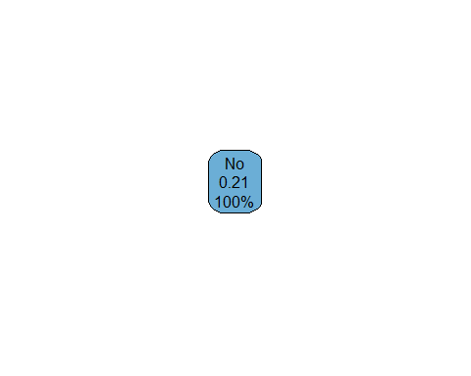

**I tried many, many edits to this and tuning options and no matter what cannot get more than one node. I even subsetted the data, and that resulted in a branched tree, but no matter what I just can’t get this one to branch. I probably should not have deleted out the other 10+ attempts at this that I made that resulted in the same single node, but I did. I’m going to move on to random forest modeling and see what happens there.**

#### Random Forest

Build model

cl <- makePSOCKcluster(detectCores() - 1) # Borrowed code to try and speed processing  
registerDoParallel(cl)  
  
rf_recipe <-  
 recipe(failure ~., data_train) %>%  
 step_dummy(all_nominal(), -all_outcomes())  
  
rf_model <-  
 rand_forest(mtry = tune(), min_n = tune(), trees = 100) %>%  
 set_engine("ranger") %>%   
 set_mode("classification")  
  
rf_wf <-   
 workflow() %>%   
 add_model(rf_model) %>%   
 add_recipe(rf_recipe)  
  
grid <- grid_regular(  
 mtry(range = c(1, 25)),  
 min_n(range = c(1, 10)),   
 levels = 5)   
  
set.seed(123)  
rf_res <- tune_grid(  
 rf_wf,  
 resamples = folds,  
 grid = grid)  
  
stopCluster(cl)  
registerDoSEQ()

rf_res %>%  
 collect_metrics() %>%  
 filter(.metric == "accuracy") %>%  
 mutate(min_n = factor(min_n)) %>%  
 ggplot(aes(mtry, mean, color = min_n)) +  
 geom_line(alpha = 0.5, size = 1.5) +  
 geom_point() +  
 labs(y = "Accuracy")

## Warning: Using `size` aesthetic for lines was deprecated in ggplot2 3.4.0.  
## ℹ Please use `linewidth` instead.  
## This warning is displayed once every 8 hours.  
## Call `lifecycle::last_lifecycle_warnings()` to see where this warning was  
## generated.

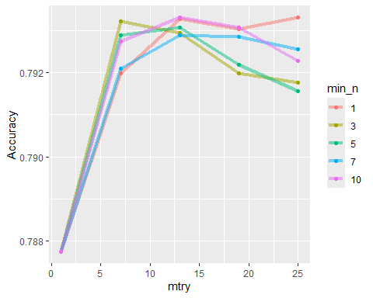

Final fit

rf_best <-  
 select_best(rf_res, metric = "accuracy")  
  
rf_final <-  
 finalize_workflow(rf_wf, rf_best)  
  
rf_final

## ══ Workflow ════════════════════════════════════════════════════════════════════  
## Preprocessor: Recipe  
## Model: rand_forest()  
##   
## ── Preprocessor ────────────────────────────────────────────────────────────────  
## 1 Recipe Step  
##   
## • step_dummy()  
##   
## ── Model ───────────────────────────────────────────────────────────────────────  
## Random Forest Model Specification (classification)  
##   
## Main Arguments:  
## mtry = 25  
## trees = 100  
## min_n = 1  
##   
## Computational engine: ranger

rf_final_fit <-  
 fit(rf_final, data_train)

Predict on train

rf_train_pred <-  
 predict(rf_final_fit, data_train)  
  
head(rf_train_pred)

## # A tibble: 6 × 1  
## .pred_class  
## <fct>   
## 1 No   
## 2 No   
## 3 No   
## 4 No   
## 5 No   
## 6 No

confusionMatrix(rf_train_pred$.pred_class,  
 data_train$failure,  
 positive = "Yes")

## Confusion Matrix and Statistics  
##   
## Reference  
## Prediction No Yes  
## No 16720 0  
## Yes 0 4505  
##   
## Accuracy : 1   
## 95% CI : (0.9998, 1)  
## No Information Rate : 0.7878   
## P-Value [Acc > NIR] : < 2.2e-16   
##   
## Kappa : 1   
##   
## Mcnemar's Test P-Value : NA   
##   
## Sensitivity : 1.0000   
## Specificity : 1.0000   
## Pos Pred Value : 1.0000   
## Neg Pred Value : 1.0000   
## Prevalence : 0.2122   
## Detection Rate : 0.2122   
## Detection Prevalence : 0.2122   
## Balanced Accuracy : 1.0000   
##   
## 'Positive' Class : Yes   
##

Predict on test

rf_test_pred <-  
 predict(rf_final_fit, data_test)  
  
head(rf_test_pred)

## # A tibble: 6 × 1  
## .pred_class  
## <fct>   
## 1 No   
## 2 No   
## 3 No   
## 4 No   
## 5 No   
## 6 No

confusionMatrix(rf_test_pred$.pred_class,  
 data_test$failure,  
 positive = "Yes")

## Confusion Matrix and Statistics  
##   
## Reference  
## Prediction No Yes  
## No 4154 1089  
## Yes 27 38  
##   
## Accuracy : 0.7898   
## 95% CI : (0.7785, 0.8006)  
## No Information Rate : 0.7877   
## P-Value [Acc > NIR] : 0.3633   
##   
## Kappa : 0.0416   
##   
## Mcnemar's Test P-Value : <2e-16   
##   
## Sensitivity : 0.033718   
## Specificity : 0.993542   
## Pos Pred Value : 0.584615   
## Neg Pred Value : 0.792294   
## Prevalence : 0.212321   
## Detection Rate : 0.007159   
## Detection Prevalence : 0.012246   
## Balanced Accuracy : 0.513630   
##   
## 'Positive' Class : Yes   
##

**There appears to be significant overfitting happening here. On data_test, we got Accuracy: 0.9999, Sensitivity: 0.9993, Specificity: 1, No Information Rate: 0.7878. On data_test, that turned into Accuracy: 0.7924, Sensitivity: 0.040816, Specificity: 0.994977, No Information Rate: 0.7877.**

*Plan for RF #2: Use ideal values of mtry and min_n found above. Let’s see what happens…*

#### Random Forest #2

Build model

cl <- makePSOCKcluster(detectCores() - 1) # Borrowed code to try and speed processing  
registerDoParallel(cl)  
  
set.seed(123) # Plugging this in again just to make sure, though pretty sure it's already fine.  
folds <- vfold_cv(data_train, v = 5)   
  
rf_recipe2 <-  
 recipe(failure ~., data_train) %>%  
 step_dummy(all_nominal(), -all_outcomes())  
  
rf_model2 <-   
 rand_forest(mtry = tune(),   
 min_n = tune(),   
 trees = 100) %>%  
 set_engine("ranger") %>%  
 set_mode("classification")  
  
rf_wf2 <- workflow() %>%  
 add_model(rf_model2) %>%  
 add_recipe(rf_recipe2)  
  
grid2 <-   
 grid_regular(mtry(range = c(13, 13)),  
 min_n(range = c(3, 3)),  
 levels = 5)  
  
set.seed(123)  
rf_res2 <-   
 tune_grid(rf_wf2,  
 resamples = folds,  
 grid = grid2)  
  
stopCluster(cl)  
registerDoSEQ()

Final fit

rf_best2 <-  
 select_best(rf_res2, metric = "accuracy")  
  
rf_final2 <-  
 finalize_workflow(rf_wf2, rf_best2)  
  
rf_final2

## ══ Workflow ════════════════════════════════════════════════════════════════════  
## Preprocessor: Recipe  
## Model: rand_forest()  
##   
## ── Preprocessor ────────────────────────────────────────────────────────────────  
## 1 Recipe Step  
##   
## • step_dummy()  
##   
## ── Model ───────────────────────────────────────────────────────────────────────  
## Random Forest Model Specification (classification)  
##   
## Main Arguments:  
## mtry = 13  
## trees = 100  
## min_n = 3  
##   
## Computational engine: ranger

rf_final_fit2 <-  
 fit(rf_final2, data_train)

Predict on train

rf_train_pred2 <-  
 predict(rf_final_fit2, data_train)  
  
head(rf_train_pred2)

## # A tibble: 6 × 1  
## .pred_class  
## <fct>   
## 1 No   
## 2 No   
## 3 No   
## 4 No   
## 5 No   
## 6 No

confusionMatrix(rf_train_pred2$.pred_class,  
 data_train$failure,  
 positive = "Yes")

## Confusion Matrix and Statistics  
##   
## Reference  
## Prediction No Yes  
## No 16720 2  
## Yes 0 4503  
##   
## Accuracy : 0.9999   
## 95% CI : (0.9997, 1)  
## No Information Rate : 0.7878   
## P-Value [Acc > NIR] : <2e-16   
##   
## Kappa : 0.9997   
##   
## Mcnemar's Test P-Value : 0.4795   
##   
## Sensitivity : 0.9996   
## Specificity : 1.0000   
## Pos Pred Value : 1.0000   
## Neg Pred Value : 0.9999   
## Prevalence : 0.2122   
## Detection Rate : 0.2122   
## Detection Prevalence : 0.2122   
## Balanced Accuracy : 0.9998   
##   
## 'Positive' Class : Yes   
##

Predict on test

rf_test_pred2 <-  
 predict(rf_final_fit2, data_test)  
  
head(rf_test_pred2)

## # A tibble: 6 × 1  
## .pred_class  
## <fct>   
## 1 No   
## 2 No   
## 3 No   
## 4 No   
## 5 No   
## 6 No

confusionMatrix(rf_test_pred2$.pred_class,  
 data_test$failure,  
 positive = "Yes")

## Confusion Matrix and Statistics  
##   
## Reference  
## Prediction No Yes  
## No 4163 1089  
## Yes 18 38  
##   
## Accuracy : 0.7914   
## 95% CI : (0.7803, 0.8023)  
## No Information Rate : 0.7877   
## P-Value [Acc > NIR] : 0.257   
##   
## Kappa : 0.045   
##   
## Mcnemar's Test P-Value : <2e-16   
##   
## Sensitivity : 0.033718   
## Specificity : 0.995695   
## Pos Pred Value : 0.678571   
## Neg Pred Value : 0.792650   
## Prevalence : 0.212321   
## Detection Rate : 0.007159   
## Detection Prevalence : 0.010550   
## Balanced Accuracy : 0.514706   
##   
## 'Positive' Class : Yes   
##

**Still looks like overfitting, although upon further research I am seeing a lot of data science professionals saying that with random forests this is not only common but also not super concerning, like it would be for other models like log regs and classification trees. So I’m going to let this ride.**

*Random code I borrowed to attempt to estimate how much time running the RF model would take*

cl <- makePSOCKcluster(detectCores() - 1) # Borrowed code to try and speed processing registerDoParallel(cl)

set.seed(123) data_sample <- data_train %>% sample_n(1000)

set.seed(123) folds_sample <- vfold_cv(data_sample, v = 5)

rf_recipe_samp <- recipe(failure ~., data_sample) %>% step_dummy(all_nominal(), -all_outcomes())

rf_model_samp <- rand_forest(mtry = tune(), min_n = tune(), trees = 100) %>% set_engine(“ranger”) %>% set_mode(“classification”)

rf_wf_samp <- workflow() %>% add_model(rf_model_samp) %>% add_recipe(rf_recipe_samp)

grid <- grid_regular( mtry(range = c(1, 25)), min_n(range = c(1, 10)),  
levels = 3)

start_time <- Sys.time()

set.seed(123) rf_res <- tune_grid( rf_wf_samp, resamples = folds_sample, grid = grid)

end_time <- Sys.time() single_iteration_time <- end_time - start_time print(single_iteration_time)

single_iteration_seconds <- as.numeric(single_iteration_time, units = “secs”) num_resamples <- 5 num_combinations <- 25 total_estimated_time_seconds <- single_iteration_seconds * num_resamples * num_combinations total_estimated_time_minutes <- total_estimated_time_seconds / 60 total_estimated_time_hours <- total_estimated_time_minutes / 60

print(total_estimated_time_minutes) print(total_estimated_time_hours)