|  |  |
| --- | --- |
|  | HCI 2017 – Assignment 1 Cover Sheet: Web User Interface Critique |

# *Complete this cover sheet and include it as the first page in your submission. Please review the yellow form for more details regarding assignment originality. The assignment is an electronic submission on Moodle.*

## Section 1.1 Personal Details

|  |  |  |  |
| --- | --- | --- | --- |
| Full Name: | Shan | Wang |  |
|  | Last | First |  |

|  |  |
| --- | --- |
| Student Number: | Z5119666 |

|  |  |
| --- | --- |
| Course enrolled (put X next to applicable course): | Enrolled tutorial Details (Eg. Day: Wed; Time: 09): |
| _X_ COMP3511 | Day: ____Monday___ Time: ____13-15pm_____ |
| ___ COMP9511 |  |

## Section 1.2 Declaration

*I declare that:*

*This assessment item is entirely my own original work, except where I have acknowledged use of source materials [such as books, journals, articles, other published material, the internet, and the work of other student/s or any person/s].*

*This assessment item has not been submitted for assessment for academic credit in this, or any other course at UNSW or elsewhere.*

*I understand that:*

*The assessor of this assessment item may for the purpose of assessing this item, reproduce this assessment item and provide a copy to another member of the university.*

*The assessor may communicate a copy of this assessment item to a plagiarism checking service (which may then retain a copy of the assessment item on its database for the purpose of future plagiarism checking).*

|  |  |  |  |
| --- | --- | --- | --- |
| Signature: | Shan Wang | 22/8/2017 |  |
|  | Signature | Date |  |

## Section 1.3 Assessment: Tutor Use ONLY

|  |  |  |
| --- | --- | --- |
| Interface | /3 |  |
| Users | /3 |  |
| Tasks and Walkthrough | /9 |  |
| Analysis | /21 |  |
| Accessibility Issues and Observations | /9 |  |
| Appendix: Sketches and Screenshots | /6 |  |
| Appendix: Issues Table | /6 |  |
| Overall Presentation (includes grammar, layout and referencing) | /12 |  |
| Total | /69 |  |
| Comments |  | |

**COMP3511**

**Human Computer Interaction**

2017 -- Semester 2

**Assignment 1**

**User Interface Critique**

Submitted 23 August 2017

Wang, Shan z5119666 z5119666@ad.unsw.edu.au

Tutor - Angus Yuen (Monday 13pm)

**Interface**

The analysis target of this report is ‘Sydney Trains’ which belongs to public transportation category. ‘Sydney Trains’ is used to generate all possible routes to meet different types of customer needs which are to reach a destination from another place in minimal time. The clients that the website is facing are a wide range people, for instance, students, and working adults. The passengers who use ‘Sydney Trains’ intend to obtain a route to arrive at the destinations in minimal time with less spending. Therefore, the priority consideration of routing is less time-consumption and less money-consumption, which usually competitive to driving and other means of transportations. The routes provided by ‘Sydney Trains’ supposed to have a high accuracy of reality and real-time updates. Moreover, the website is also obligated to solve the problems about Sydney transportation met by the users who are not only experts but also the novice.

**Users**

Samantha is a university student who intends to find the last train which allows her to arrive at the lecture on time so that she can increase sleeping time. Tom is a 30-year-old accountant who has to take bus and train to reach his company, and he wants to find a route with minimal intervals between different transportations. Bob is a 70-year-old senior citizen who intends to visit a general practitioner at the medical centre by public transports with minimal transfer and less walking. Jane is 30 years old American who has a plan to travel to Sydney for a week, and she prefers to take public transport from the airport to the hotel she booked. Ken is a 15-year-old teenager whose leg injured during a soccer competition, and he intends to find accessible buses with wheelchair access.

**Tasks**

Samantha uses ‘Sydney Trains’ at night before going to lectures. She was staying up for several days to accomplish her assignments and wants to waste less time in the morning so that she can sleep 10 minutes more. She selects a route from these which the website generated, which allows her to leave home as late as possible and attend the lecture on time.

Tom lives in the suburban area go to his company which locates in the city centre. He needs to take a train and transfer bus to reach his workplace. He intends to obtain an appropriate route which has minimal intervals between two types of transportation so that he can arrive at his company in minimal time before 9 am.

Bob is going to visit his general practitioner to make regular body examination. He wants to reach the medical centre by public transport alone. He cannot walk a long distance and cannot memorise complicate routes. He intends to gain a simple route to the medical centre with less walking from 'Sydney Trains'.

Jane plans to visit Sydney during her holidays. The first route is from the airport to the hotel. She browses the ‘Sydney Trains’ intend to gain some knowledge about the public transportation in Sydney, which includes the money consumption and time consumption and payment method and process of taking public transports.

Ken’s leg was injured because of a soccer competition. And he still wants to go to the high school by himself. The only means of transportation is public transports. Thus, he uses ‘Sydney trains’ to find out the location of lift when he takes a train and estimates the approximate time he will spend.

**Walkthrough & Analysis**

Bob is not familiar with the arrangement of transports network. Therefore, he searches the name of the medical centre and selects the route which meets his needs. Jane has little knowledge about Sydney carries, so she searches the name of the hotel from ‘Sydney Trains’ and chooses a route which meets her requirements. The reason for choosing these two is that senior citizens and tourists are not the largest combinations of customers but the specialist. For issues encountered by them are typical and representative. They have an amount of aspects in common. For instance, they are both inexperienced users. They would have difficulties that local commuters rarely encountered. Therefore, senior citizens and tourists requirements and feedbacks are worth to analysis.

The basic arrangement of ‘Sydney Trains’ is well organised. On the homepage of the website, there is two type of searching engines. One is searching for train lines, and the other is searching for the destination which arranged in an apparent field. This effectiveness design provides users satisfying and encourages users to engage (Preece, Sharp and Rogers, 2015). 'Effectiveness' is a primary target and indicates the performance of functional design (Preece, Sharp and Rogers, 2015) (issue 1). Moreover, since searching for train lines is intended for experienced users and the other one is more likely to be used by a novice (Figure 1.2). The two different searching type offers users 'flexibility and efficiency' which is helpful (Preece, Sharp and Rogers, 2015) (issue 2). 'Flexibility and efficiency of use' states that for experienced users they provide ‘accelerator’ to increase the speed of using the system and the ‘accelerator’ can be ignored by the novice (Preece, Sharp and Rogers, 2015). Furthermore, the searching engine called ‘search train timetable’ (Figure 1.2) indicates that customers can select instead of typing train lines provides affordance (issue 3). Affordance means the nature of an object that instructs users by clues (Preece, Sharp and Rogers, 2015). ‘Plan your trip’ searching engine provides no searching history, which means users have to type the places every time that is not efficient to use and annoying users (Preece, Sharp and Rogers, 2015) (issue 4). The definition of ’efficiency’ is the method that the product provided to help users to achieve the tasks (Preece, Sharp and Rogers, 2015). The ‘Remember me’ box has to be ticked each time whenever the user is searching for a route, which is also not efficient. Unlike other website, ‘Sydney Trains’ does not have ‘sign in’ button on the top bar (figure 1.3) and ‘sign up’ is in the middle of the page (figure 1.4), which is not appropriate because the consistency and standards state that users suppose to not be confused by different circumstances which refer to the same issue (Interaction design p404, issue 5). The arrows shown in Figure 1.3 provide no utility since there is no feedback after clicking the arrows (issue 6). ‘Utility’ states that the product should offer the correct functionality so that the users can achieve the tasks which arise in their mind (Preece, Sharp and Rogers, 2015). Feedback is the reaction on the action the user has done (Preece, Sharp and Rogers, 2015).

The section of ‘live travel news’ also have no access to the second interface which does not have utility, which always confusing users (issue 7). When the cursor moves the ‘Service updates’ field (Figure 1.6), the helpful feedback is provided (issue 8).

After searching for a destination, the website goes to the second interface and generated routes are shown on the sidebar (Figure 2.1). The process offers efficiency and learnability (issue 9). The learnability indicates that how simple the product can be learn to use (Preece, Sharp and Rogers, 2015). The details of the routes are hidden provide a pleasurable user experience which corresponds to the ‘aesthetic and minimalist design’ principle (issue 10). The ‘aesthetic and minimalist design’ shows that the interface should not contain unnecessary or irrelevant information and decrease relative visibility (Preece, Sharp and Rogers, 2015). The routes are shown on the maps with the station and walking logo which make the route matching between the system and the real world (Figure 2.2) (issue 11). ‘Match between system and the real world’ states that the system use expressions which familiar by users instead of the expressions used by the system, and information shows on the basis of the real world (Preece, Sharp and Rogers, 2015). A wheelchair showed on Figure 2.3 which matches the real world wheelchair to indicate the wheelchair access (Issue 12). For the users just arrive in Sydney, the payment method is important to know. When the novice click the fare (Figure 2.3), there is a sequence of help and documentation (Figure 2.5 and Figure 2.6) which achieve a high quality of user experience (issue 14). ‘Help and documentation’ mean that although the product should get rid of documentation, sometimes are essential, and the information should easy to obtain and offer users a sequence of steps to conduct (Preece, Sharp and Rogers, 2015).

The information of time is not obvious since there are no instructions to indicate the empty bar is for date and ‘23’ and ‘10’ are time (Figure 2.4). This issue may be confused users (issue 13). When the users want to return to the homepage, they cannot get access to the original page. Instead, the system returns to ‘Transport’ website which is not 'Sydney Trains' (Figure 2.7). This issue violates user control and freedom principle (issue 15). ‘User control and freedom’ says that when the users get access to a function by mistake, they can exit to the last interface by a single step (Preece, Sharp and Rogers, 2015).

The ‘My Sydney trains’ can only save the most recent searching result even if the ‘Remember me’ was chosen (Figure 2.8). This design does not provide utility, and the user experience of the design is boring and annoying (issue 17). Figure 2.9 is used to clear saved routes. The drawback of this design is there is no confirmation of clear all the data, which means there is no error prevention and not safe to use (Issue 18). ’Error prevention’ states that a message used to prevent problems from happening (Preece, Sharp and Rogers, 2015). Furthermore, ‘safety’ is protecting the user from unexpected conditions (Preece, Sharp and Rogers, 2015).

**Accessibility**

Figure 1.3 shows a button to accessibility page. For website accessibility, access keys instructions can be used to help physically disabled (Figure 3.2). Furthermore, the page ‘station details’ provide details about availability (Figure 3.1). It provides physically disabled information on whether the station has accessibility. For visually impaired, only the font can modify. Therefore, other disabilities can hardly use this website, and there are no instructions on accessing stations.

The design for disabled is not enough. Firstly, there are no other supports for other disabled except for visually impaired and physically handicapped. Secondly, although the size of the font can increase, some disabled do not have eyesight, which is useless and crude.

**Reference**

Preece, J., Sharp, H. and Rogers, Y. (2015). *INTERACTION DESIGN - BEYOND HUMAN-COMPUTER INTERACTION 4E*. 5th ed. Chichester: Wiley.

**Appendix A**

|  |  |  |  |
| --- | --- | --- | --- |
| **Design Principles** | **User Experience Goals** | **Usability Goals** | **Heuristics** |
| Affordance | Satisfying | Effectiveness | Flexibility and efficiency of use |
| Feedback | Engaging | Efficiency | Consistency and standards |
|  | Helpful | Utility | Aesthetic and minimalist design |
|  | Annoying | Learnability | Match between system and the real world |
|  | Confusing | Safety | Help and documentation |
|  | Pleasure |  | User control and freedom |
|  |  |  | Error prevention |

**Appendix B**

|  |  |  |  |  |
| --- | --- | --- | --- | --- |
| **Reference** | **Issue Description** | **Principle** | **Type** | **Severity** |
| Issue 1 | Obvious searching engine | Effectiveness | + | 1 |
| Issue 2 | Consider both novice and experienced users | Flexibility and efficiency of use | + | 2 |
| Issue 3 | Provide selections | Affordance | + | 3 |
| Issue 4 | No searching history provided | Efficiency | - | 3 |
| Issue 5 | No sign in and sign up | Consistency and standards | - | 3 |
| Issue 6 | No functionality of arrows | Utility | - | 4 |
| Issue 7 | No access to the news | Utility/Feedback | - | 4 |
| Issue 8 | Instance feedback | Feedback | + | 2 |
| Issue 9 | Two steps obtain routes | Learnability/Efficiency | + | 2 |
| Issue 10 | Hide routes details | Aesthetic and minimalist design | + | 1 |
| Issue 11 | Show routes on map | Match between system and the real world | + | 2 |
| Issue 12 | Wheelchair access | Match between system and the real world | + | 2 |
| Issue 13 | Meaningless numbers | User Experience Goals | - | 1 |
| Issue 14 | Introduction of Opal card | Help and documentation | + | 3 |
| Issue 15 | Cannot return to homepage | User control and freedom | - | 4 |
| Issue 16 | ‘Remember me’ initialise every time | Efficiency | - | 2 |
| Issue 17 | Only save the most recent search | User experience/Efficiency | - | 3 |
| Issue 18 | No error prevention | Error prevention/Safety | - | 2 |

**Screenshots**

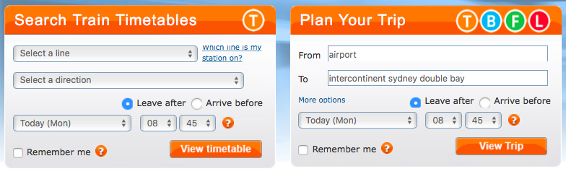

Figure 1.2



Figure 1.3

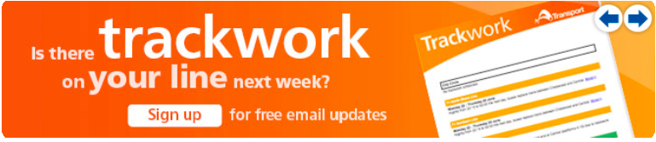 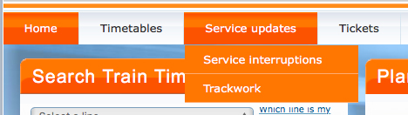

Figure 1.4 Figure 1.6

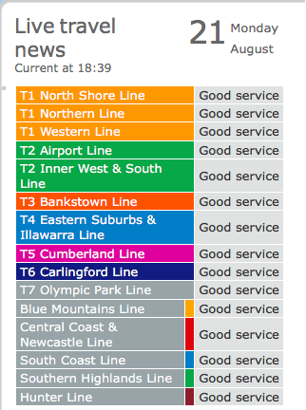 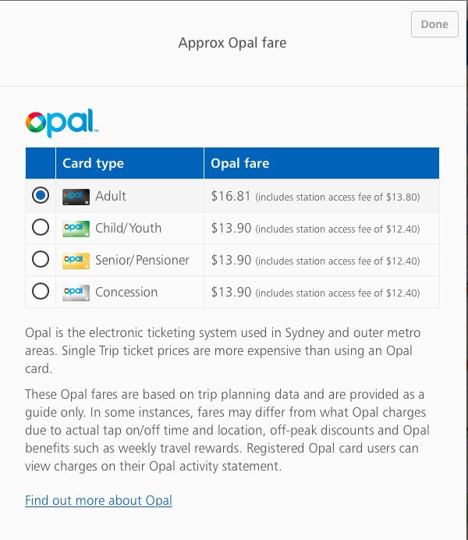

Figure 1.5 Figure 2.5

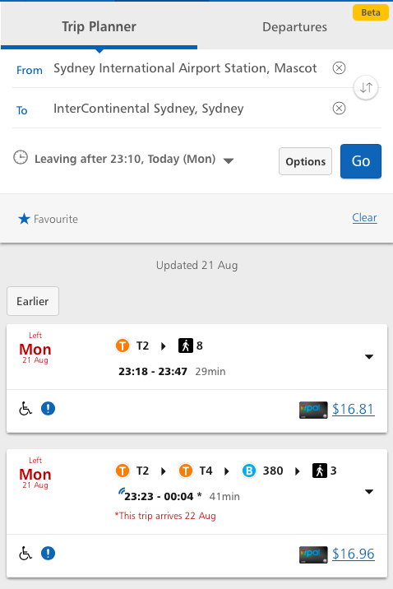 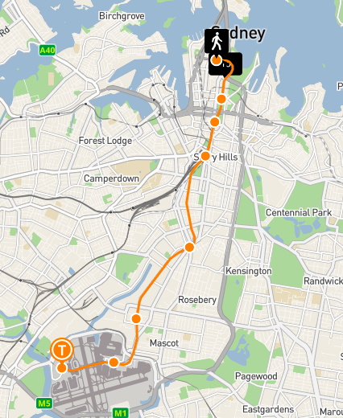

Figure 2.1 Figure 2.2

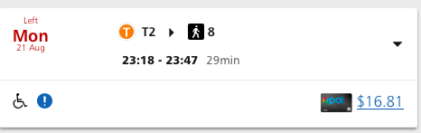

Figure 2.3

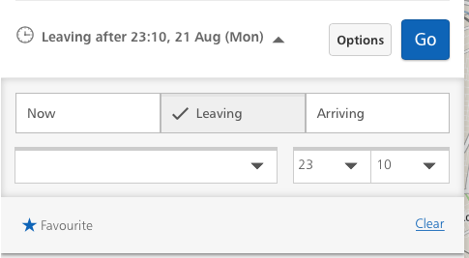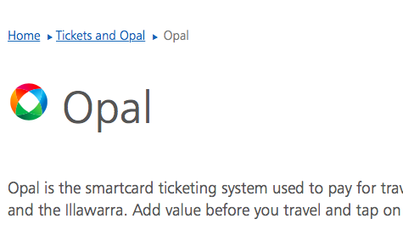

Figure 2.4 Figure 2.6

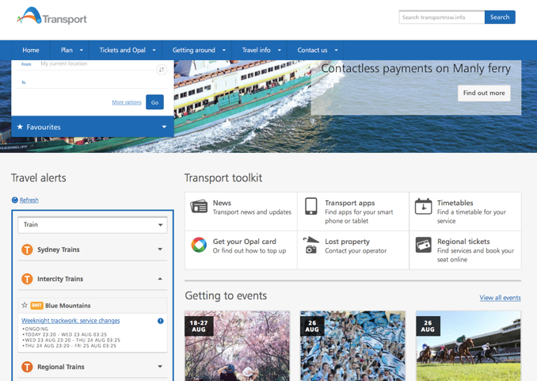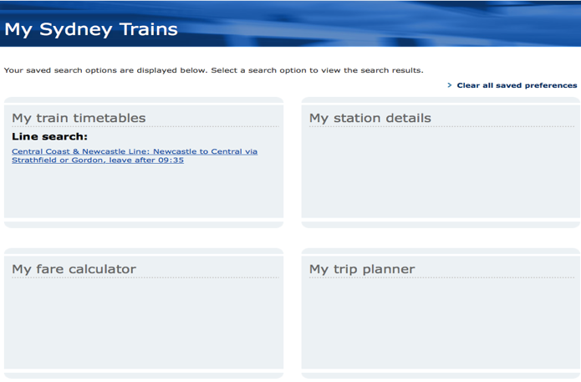

Figure 2.7 Figure 2.8

creen Shot 2017-08-22 at 09.46.24.png

Figure 2.9

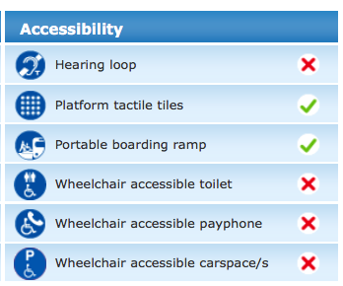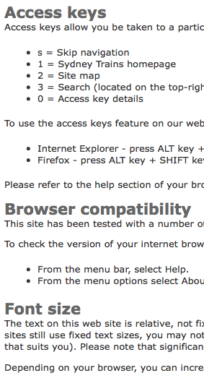

Figure 3.1 Figure 3.2