

# COMP9321 Data Services Engineering

## Assignment 3

## Design and Development of a Data Analytics Service

**Hungry Jack’s Group Plan**

Mentor : Alireza Tabebordbar

|  |  |  |
| --- | --- | --- |
| **Name** | **Student ID and Email** | **Signature** |
| Wenxin Wang (Jack) | z3454684 specialjack2@gmail.com |  |
| Bojing Fu (Jenny) | z5142286 jennifer0fbj@gmail.com |  |
| Rui Liang (Ray) | z5174445, [liangrui00@gmail.com](mailto:liangrui00@gmail.com) |  |
| Moyao Wang (Elena) | z5099162  wangmoyaoelena@gmail.com |  |
| Shan Wang (Kelly) | z5119666  [z5119666@ad.unsw.edu.au](mailto:z5119666@ad.unsw.edu.au) |  |

**What is the scenario and service to offer ?**

In this group project, we are going to analyse the data of Melbourne Housing Market since 2016 and predict the housing price which consumers consult via GUI.

User first need to log in or sign up to using our service. Then user need to input two values which are landing size and suburb. We training our machine model using data in the suburb and predict a housing price of the landing size. (Schematic diagram appendix)

**‐ What is the aim of the service?**

Analyzing and predict the pricing of real estate property with a specific landing size in Melbourne for our customers.

**‐ What are the datasets?**

[Melbourne Housing Market form kaggle.com](https://www.kaggle.com/anthonypino/melbourne-housing-market#Melbourne_housing_FULL.csv)

# **Roles and Tasks**

We have divided into two teams, which are front-end squad and back-end squad.

Elena and Kelly are in charge of doing front-end work. They will design a RESTful API to offer web services(Authority), and implement a few webpages to display data and other useful information(GUI).

Back-end crew including Jack, Jennifer and Ray. They will first extract data from sources with an existing API, and then clean data, integration, pre-processing, analyzing database. As well as building a machine learning model to train and test. Finally, it would produce the predicted data to user.

**Communication Channel**:

We use WeChat to discuss specific issues occurring in the project

**Code repository :**

For sharing the code, we use github to track changes and get the latest code[GitHub Link](https://github.com/Liang-Rui/Assignment_3)

**Tips:**

The duration of the project is three weeks due on the 21rd of October.

Carefully read the provided instructions and requirements and possibly re-read them periodically so as to refresh your memory and make sure you do the right thing. Do some preparing before attending every Group Meeting

Post, reply, comment on GitHub regularly.

Question: What is the submission code different with demo coding ?

Question: Meeting 3, demo 70% ? group 10% ?

* 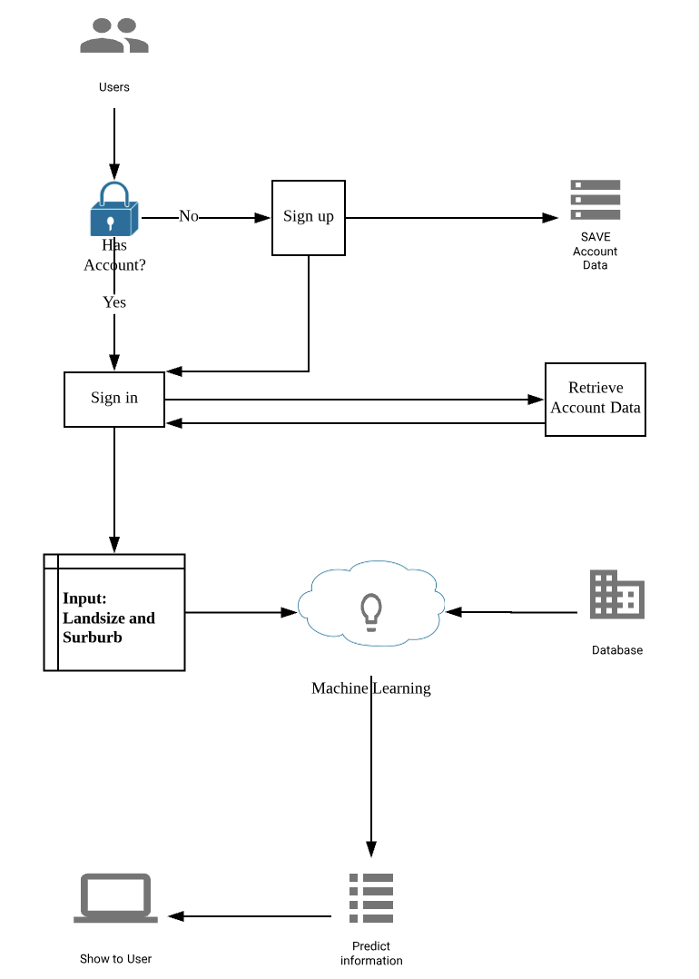

**Notes (Bring one-page document)**

- What is the aim of the service?

For this project, we are going to acquire as well we analysis data from Melbourne

Housing Market since year 2016, and predict the price of real estate property in Melbourne that consumers consult. It is documented.

- What are the datasets?

Melbourne Housing Market form kaggle.com with csv format.

- What is your communication channel?

For communicating with group members, we use wechat to discuss specific issues

occurring in the project.

- What is your code repository?

For sharing the code, we use github to track changes and get the latest code.

- A very brief description of each member’s role in the project.

Our team are divided into two groups, front-end and back-end.

Elena and Kelly are in charge of doing front-end work. They will design a RESTful API

to offer services, and implement a few webpages to display data and other useful

information.

Jack, Jennifer, and Ray are in charge of back-end work. They will first extract data from sources with an existing API, and then analysis as well as process the data into

the database, and eventually build a machine learning model to train and evaluate.

- Project documentation; correctly described use cases using notations, such as sequence diagrams, mock-ups, or plain natural language; the method is optional.