**Introduction**

* What’s the Internet?
  + “nuts and bolts” 组成细节角度
    - Millions of connected computing devices
    - Communication links 通信链路
    - Packet switches: forward packets (chunks of data) 转发分组（数据包）
  + a service view 服务角度
    - Infrastructure that provides services to applications 通信基础设施
    - Provides programming interface to apps 接口api
* Internet structure - network of networks
  + End system connect to Internet via access ISPs (Internet Service Provider) 边缘接入核心
  + Access ISPs in turn must be interconnected
  + Ideally global ISP, but evolution was driven by economics and national policies
    - Commercial ISPs and content provider network (Tier 1 ISP) connected by peering link or IXP(Internet Exchange Point)
* Network structure
  + Network edge 网络边缘
  + Access networks, physical media 接入网络，物理介质
  + Network core 网络核心
* What’s a protocol?
  + Protocols define format, order of messages sent and received among network entities, and actions taken on message transmission, receipt.
* How to connect end system to edge router?
  + Residential access networks 住宅接入
  + Institutional access networks 机构接入
  + Mobile access networks 移动接入
* Keep in mind 用户关心什么？
  + Bandwidth (bps) of access network 带宽
  + Shared or dedicated? 共享/独占
* Access net: DSL (Digital Subscriber Line) 数字用户网络 dedicated
  + Use existing telephone line to central office DSLAM (DSL Access Multiplexer)
  + Voice, data transmitted at different frequencies over dedicated line to central office. E.g. Data -> Internet, Voice -> telephone net
  + ADSL (Asymmetrical DSL)
    - < 2.5 Mbps upstream transmission rate (typically < 1 Mbps) 上行速率 upload
    - < 24 Mbps downstream transmission rate (typically < 10 Mbps) 下行速率 download
* Access net: cable network 电缆网络 shared
  + FDM (Frequency Division Multiplexing) 频分多路复用
    - different channels transmitted in different frequency bands
  + HFC (Hybrid Fiber Coax) 混合光纤同轴电缆
    - Asysmmetric, up to 30 Mbps downstream, 2 Mbps upstream transmission rate.
  + Network of cable, fiber attaches homes to ISP router 光纤接入ISP路由器
    - Homes share access network to cable headend
* Wireless access networks 无线接入网络
  + Shared wireless access network connects to end system to router 无线连接主机和路由器
    - Via “base station” aka “access point” 基站 aka 接入点
  + Wireless LANs 无线局域网 Wi-Fi
  + Wide-area wireless access 广域无线接入 流量
* The network core 网络核心
  + Mesh of interconnected routers/switches
  + Two forms of switched networks
    - Circuit switching 电路交换
    - Packet switching 分组交换
  + Two key network core functions
    - Routing: determines source-destination route taken by packets
      * Source is changing, destination is not
      * Routing algorithms (head value -> output link)
    - Forwarding: move packets from router’s input to appropriate output
* Circuit switching 电路交换
  + FDM vs TDM 频分多路复用 vs 时分多路复用
    - Multiplexing - Carry multi-services in one media
    - “资源片”独占，有可能闲置 (idle)
  + Dedicated resources 独占资源
* Packet Switching 分组交换
  + Packets consist of a “header” and “payload”
  + Switches “forward” packets based on their headers
  + Statistical multiplexing 统计多路复用 序列不确定，按需共享链路
* Forwarding (in the router) and routing (between routers)
  + Store and forward (cut-through): receive the header, read it (i.e. don’t store), send part of packet as long as it received (i.e. don’t need to wait for the whole packet arrived).
  + Forwarding: Which interface I’m sending to in the router
  + Routing: how the packet arrive to destination, source is changing (dest not), no storage of header just read
* Packet switching VS Circuit switching

|  |  |
| --- | --- |
| **Circuit switching** | **Packet switching** |
| Dedicated (FDM, TDM i.e. no resource share) | Resource sharing |
| Circuit setup | simpler |
| Fixed transmission rate | Most apps need dynamic rates |
|  | No reliability (congestion i.e.delay and loss) |
| Not scalable |  |

* How do loss and delay occur?
  + Packet arrival rate to link (temporarily) exceeds output link capacity
* Four sources of packet delay
  + Nodal processing 节点处理延迟
    - Check bit errors; determine output link
  + Queueing delay 排队延迟
    - Time waiting at output link for transmission; depends on congestion level of router
    - Traffic intensity 流量强度 La/R
      * La/R ~ 0: delay is small
      * La/R ->1: delays become large
      * La/R > 1: infinite delay
  + Transmission delay d = L/R 传输延迟
  + Propagation delay d = d/s 传播延迟
  + Real delay: 4种求和，总路程求和
  + Note:
    - a = packet arrival rate 平均分组到达速率
    - L = packet length (bits) 分组长度
    - R = link bandwidth (bps) 链路带宽
    - d = physical link length 物理链路长度
    - s = propagation speed ~2*10^8m/s 信号传播速率
* Packet loss 丢包
  + Queue (aka buffer) preceding link in buffer has finite capacity 缓存有限
  + Packet arriving to full queue dropped (aka lost) 丢包
  + Lost packet may be retransmitted (may not) 可能重发
* Throughput 吞吐量
  + Rate (bits/time) at which bits transferred between sender/receiver (instantaneous or average)
  + Bottleneck link 瓶颈链路
    - Link on end-end path that constraints end-end throughput 限制端到端吞吐量的链路
* Internet protocol stack 5层参考模型
  + Applications 应用层: supporting network apps (FTP, SMTP, HTTP, Skype, …)
  + Transport 传输层: process-process data transfer (TCP, UDP) 进程-进程的数据传输
  + Network 网络层: routing of datagrams from src to dest (IP, routing protocols) 数据分组路由与转发
  + Link 链路层: data transfer between neighbouring network elements (Ethernet, 802.111(wifi), PPP) 相邻网络元素（主机、交换机、路由器等）的数据传输
  + Physical 物理层: bits “on the wire” 比特传输
* Three Observations
  + Each layer
    - Depends on layer below 任一层实体要使用下层服务
    - Supports layer above 向上层提供服务
    - Independent of others 下层协议的实现对上层的服务用户是透明的
  + Multiple versions in layer
  + But only one IP layer IP可为各式各样的应用程序提供服务
    - Unifying protocol 统一协议
* Why layering?
  + Explicit structure allows identification, relationship of complex system’s pieces 结构清晰 有利于识别复杂系统的部件及其关系
    - Layered reference model for discussion 分层的参考模型
  + Modularization eases maintenance, updating of system 模块化的分层易于系统更新 维护
    - Change of implementation of layer’s service transparent to rest of system 任何一层服务实现的改变对于系统其它层都是透明的
* Why layers?
  + Break down functions to each layers
  + Trouble shoot
  + Causes extra timing (delay)
* Is layering harmful?
  + Layer N may duplicate lower level functionality
  + Information hiding may hurt performance
  + Headers start to get really big
  + Layer violations when the gains too great to resist
  + Layer violations when network doesn’t trust ends
* Layers across machines
  + Host : applications - transport - network - link - physical
  + Router: network - link - physical
  + Switch: link - physical
* Encapsulation 封装
  + (format) Message (application) -> segment (transport) -> datagram (network) -> frame (link)
* OSI Model (Open System Interconnection Model)
  + Application Layer: network applications
    - Protocols include FTP (File Transfer), HTTP/S (Web Surfing), SMTP (Email), Telnet (Virtual Terminals)
  + Presentation Layer: receive data from app layer

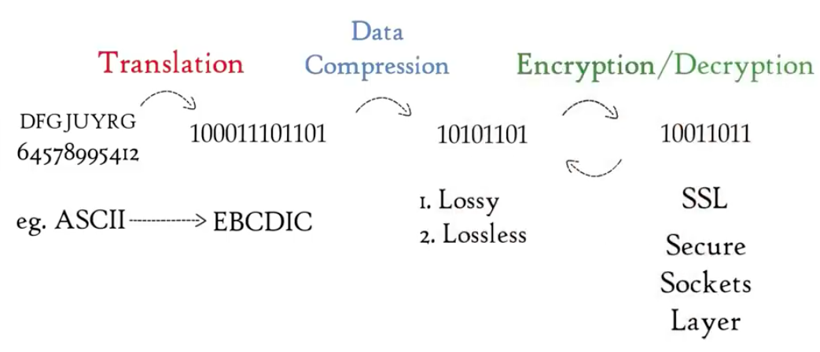

* + Session Layer
    - Authentication, Authorization, Session management
  + Transport Layer
    - Segmentation: data -> data units (seq. num. & port num.) (checksum)
    - Flow control: adjust bandwidth difference
    - Error control: automatic repeat request i.e. data loss -> retransmission
    - Connection-oriented transmission -> TCP (Transmission Control Protocol) 传输控制协议
    - Connectionless transmission -> UDP (User Datagram Protocol) 用户数据报协议
      * UCP faster than TCP, since no feedback and data loss tolerant
  + Network Layer: receive segments
    - Logical addressing, routing, path determination
    - Packets (IP1, IP2, segments)
    - IP (Internet Protocol)
  + Data link Layer: data from network layer
    - Physical addressing
    - Access the media (by CSMA Carrier Sense Multiple Access) (Framing)
      * Frame (MAC1, MAC2, Packets, Tail)
    - Controls how data is placed and received from the media
  + Physical Layer
    - Binary bits -> signal by CSMA