Part 1 Activities
(Due end of Week 6, Thursday 11.59pm AWST)
Done counter: 4/25
Choose any 25 activities from the following list to complete and submit.

A1. Discover security concepts used on campus.
Students and staff get a campus card which they can use for electronic access to buildings, among its many other functions.
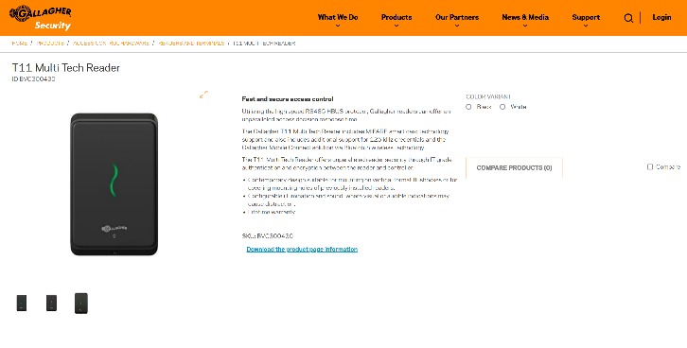
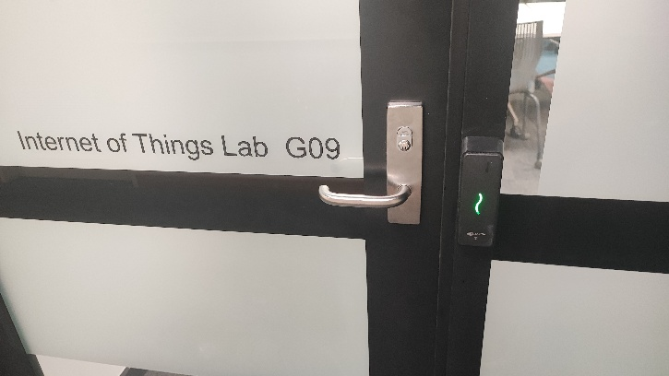
Upon further investigation, it seems that the card reader comes from the company Gallagher and specifically has the model T11 Multi Tech Reader. This card reader provides reader security through authentication and encryption between the reader and the controller.
A2. Discover security concepts used in public space.
Need to take pic of cctv used in woollies/coles.
A3. Discover security concepts used in your house.
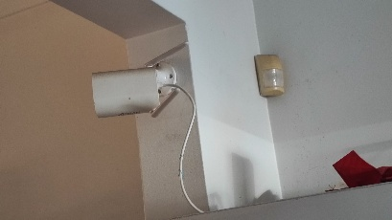
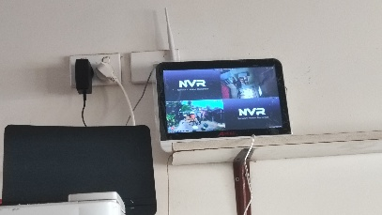
My house uses CCTV to monitor the outside of the house and the kitchen. The security camera comes from the company ANRAN, which is known to offer smart surveillance systems.

A4. Discover a vulnerable website.
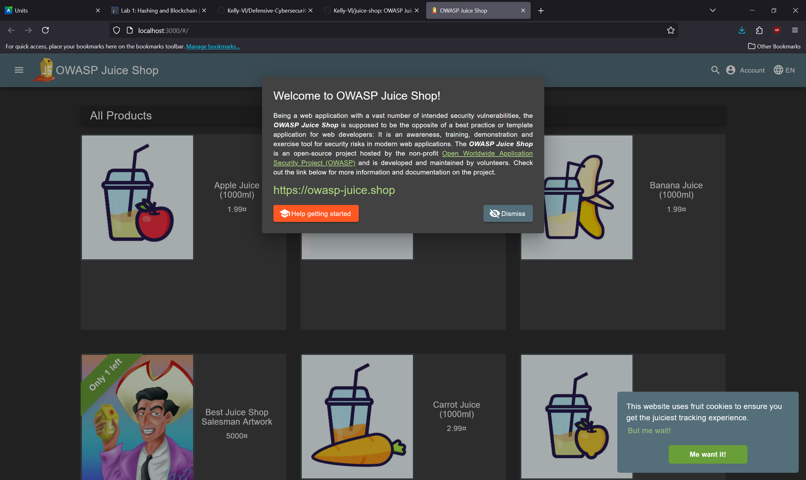
After looking around online, I found the OWASP Vulnerable Web Applications Directory (https://vwad.owasp.org/), which contains a comprehensive registry of known and intentionally vulnerable web applications used for legal security testing and training. The OWASP Juice Shop (https://owasp.org/www-project-juice-shop/) is one of the most popular insecure web applications and encompasses vulnerabilities from the entire OWASP Top Ten as well as other security flaws. I will be forking and cloning this vulnerable website to my Github repository to use for other tasks and to gain evidence.
A5. Discover cryptographic implementation used online.
A6. Discover cryptographic implementation used offline.
A7. Discover cryptography used in modern networks.
A8. Discover cryptography used in Internet of Things devices.
A9. Discover privacy technique used online.
A10. Discover privacy technique used offline.
A11. Discover 5 unique access control devices.
A12. Discover 5 unique offline security tools.
A13. Discover 5 unique online security tools.
A14. Discover 5 AI-enabled security solutions.
A15. Discover 5 recent security incidents.
A16. Discover 3 local security incidents.
A17. Discover 10 different types of locks in use.
A18. Discover two hallucination cases when using a generative AI system.
A19. Join a CS/DS/cybersecurity club.
I have joined the discord servers of several of UWA’s CS/DS/Cybersecurity clubs, such as Coders For Causes (CFC), Programming Competitive Society (PCS), University Computer Club (UCC), UWA CS/DS, and Computer Science Students’ Club. All evidence of this will be under the directory “A19”.
A20. Participate in a discussion with your friends about cybersecurity event.
A21. Participate in an online cybersecurity discussion.
A22. Perform a prompt injection attack on a generative AI assistant (controlled test only).
A23. Enhance the cybersecurity at your home.
A24. Teach your family about cybersecurity topic of your choice.
A25. Design and implement a privacy-preserving technique for an appropriate application.
A26. Research and implement a system bug.
A27. Research and implement a system vulnerability.
A28. Implement a security solution of your choice and put it on your GitHub.
A29. Find a publicly available AI-generated image, video, or audio clip, use at least one detection or verification tool to analyse it.
A30. Complete an online cybersecurity module.

