Part 2 Activities
(Due end of Week 12, Friday 11.59pm AWST).
Done counter: 2/25
Choose any 25 activities from the following list to complete and submit.

B1. Discover 5 unique weak/vulnerable security implementations.
B2. Discover 5 unique strong security implementations.
B3. Discover 3 proactive security implementations in practice.
B4. Participate in 3 in-class activities in labs (facilitators will administer such activities).
In-Class Lab Activity 1 (Thursday 5 March 2026)
Since Week 2 lecture topics was about Cryptography, the class activity in the labs had us form groups and come up with multiple plaintexts, encrypt them with some simple cryptography you can do by hand and get their ciphertexts, and write down the decryption algorithm to decrypt. Then we went around to see what the other groups had written and attempted to decrypt their ciphertexts.
My group had the plain text “Cryptography is hard” and “Lemons are sour”, and our decryption algorithm was to do ROT13 and reverse the text. We solved the other groups’ decryption where one had Morse Code and ROT5, and another had multiple shifts using ROT.
Evidence for this activity will be under directory “B4” with images “In-Class Lab Activity 1.1 - 1.6”.

B5. Attend 2 cybersecurity related talks/seminars.
B6. Attend 2 cyber ethics/law related talks/seminars.
B7. Participate in CS/DS/cybersecurity clubs’ activity.
B8. Participate in a hackathon.
B9. Participate in an industry-related cybersecurity event.
B10. Participate in a cybersecurity activity as part of job/internship/volunteering etc.
B11. Talk to 2 cybersecurity experts from the industry and find out their latest projects.
B12. Discover two bias cases when using a generative AI system.
B13. Perform a jailbreak attack on a generative AI assistant (controlled test only).
B14. Teach your friends about cybersecurity topic of your choice.
B15. Teach an elderly person about cybersecurity topic of your choice.
B16. Survey the current state-of-the-art solutions in cybersecurity.
B17. Implement one of the current state-of-the-art solutions and evaluate it.
B18. Contribute to an open-source project related to cybersecurity.
B19. Find and fix a vulnerability from a GitHub project.
B20. Enhance the security of a GitHub project.
B21. Design and implement a cybersecurity learning activity.
B22. Enhance the cybersecurity of a website from your community.
B23. Test an intrusion detection system and discuss its effectiveness.
B24. Design and implement access control of your choice.
B25. Design and implement a threat intelligence module of your choice.
B26. Help another student in this unit struggling to understand/learn a cybersecurity concept.
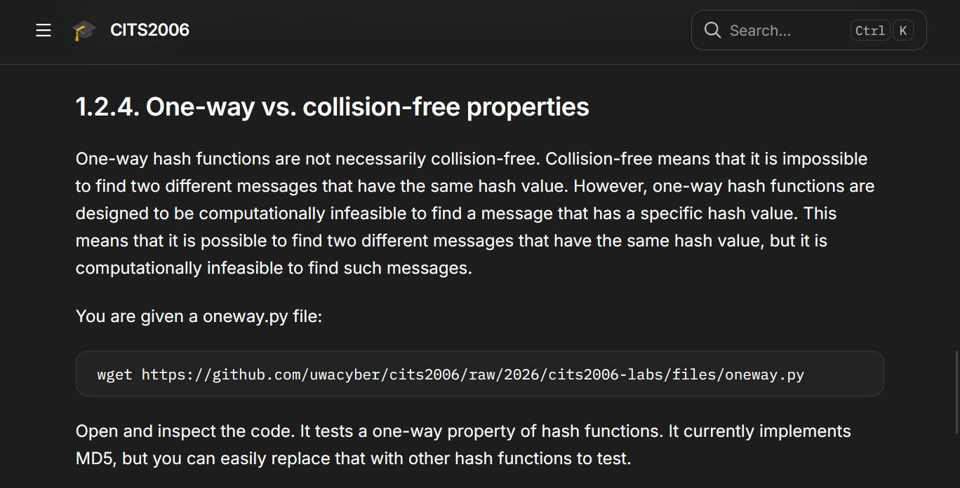
My friend and I met up on Wednesday, 4 March 2026 to do Lab 1 together. While going through the task, we stumbled upon this section of Lab 1 which gave us a bit of confusion. After researching a bit more about the property and discussing it together, we came up with this understanding:
- One-way property means that it is easy to get the hash of the message (forward direction), but it is very difficult/computationally infeasible to do the inverse, i.e. figure out the message from its hash. Thus, even if two messages have the same hash value, it is very difficult to find what the messages are that gave those same hash results.
- Collision-free property (which is apparently also known as collision resistance property) means that it is hard to find two inputs that hash to the same output value. However, just because it is hard (computationally infeasible), doesn’t mean that it doesn’t exist or it is impossible to find one since the Pigeonhole Principle states that any hash function that has more inputs than outputs will have collisions. This is because the input can technically have infinite bits, while the output is limited to a fixed bit size, such as 128-bit hash value for MD5 and 256-bit for SHA-256.
- So even in one-way property, collisions do exist, but they are very hard to find/compute intentionally.
B27. Apply a learned concept in this unit to a real-world application/problem/environment.
B28. Produce a cyber safety flyer for (choose 1): elders, high school students, CEOs, Uni students.
B29. Find a CVE in this year and fix it using three different generative AI systems (e.g., ChatGPT, Gemini), comparing the consistency.
B30. Generate an AI-created image, applying an imperceptible watermark on it and then perform an image-to-image regeneration or editing process to make sure the watermark is detectable---the watermark survives.

