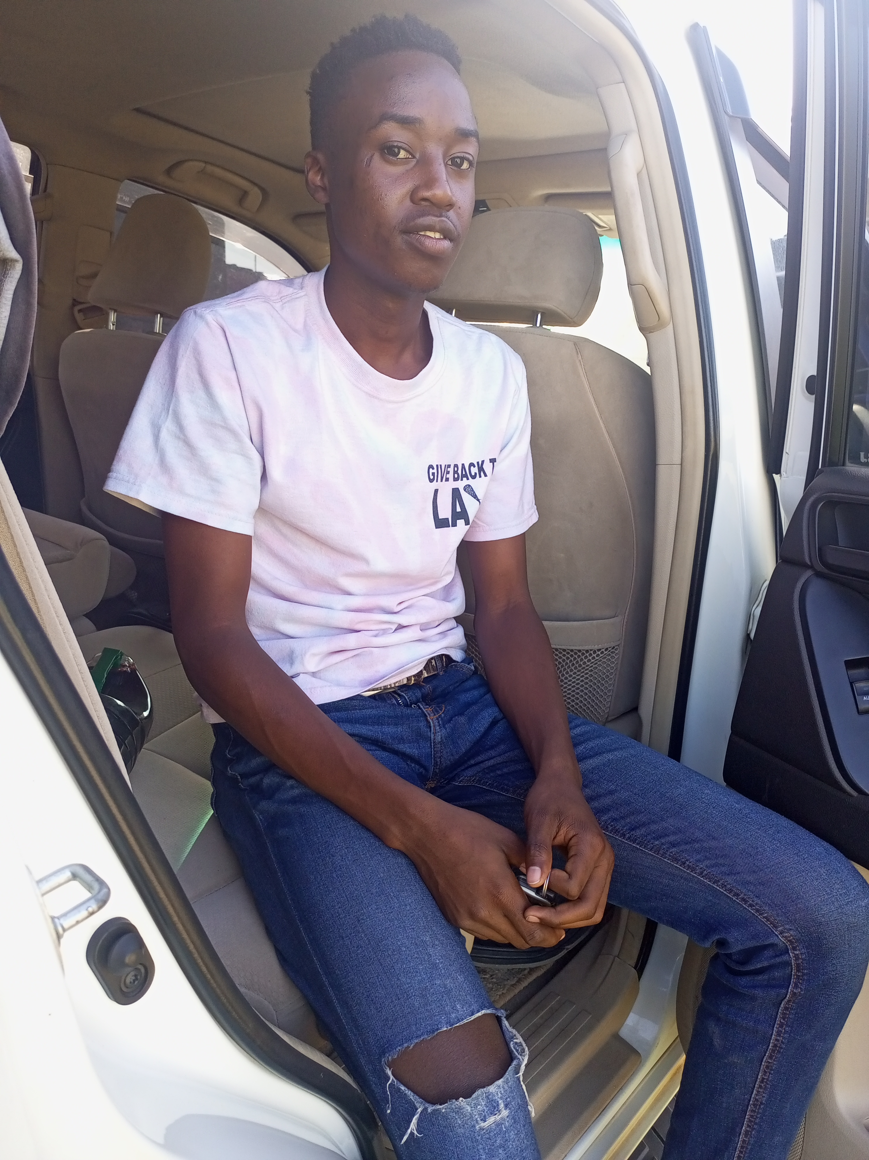

NAME: Kelly Indeche  
PHONE NUMBER: 0797394102  
EMAIL: kellyindeche@gmail.com

# About me

Im the coolest and smartes person in the world

# Work experience

**Isuzu Kenya**20192021  
It was cool and nice and had the best working environment ever**Toyota Kenya**2022 - 2024  
I had more eperience on how my work is done. It taught me alot of things

# Skills

Software Development  
Cooking  
Programming  
finish