methodology(1-2)

For our research, we divided it in to three parts: Signal acquisition, Signal processing and Signal output.

1. Signal acquisition:

First, we collect the EEG signals with the mindwave device which is made by the Nerousky Company. And the second step is to send the signal information to the computer through Bluetooth into the computer serial port, so that we could analyze this information detailed. So we write a c# program to receive the EEG signals.

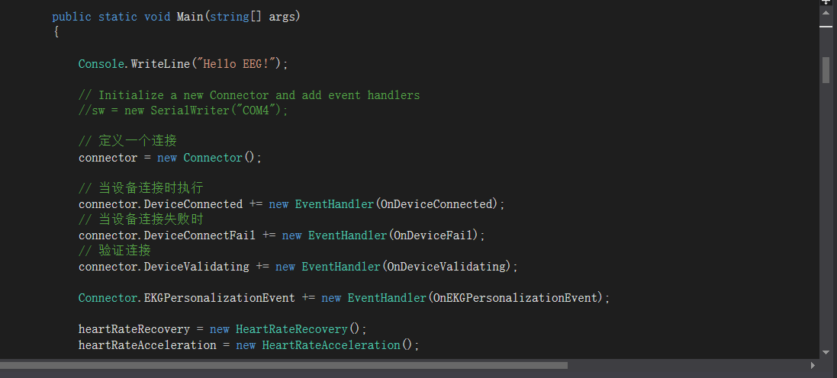

picture1 estimate the connection

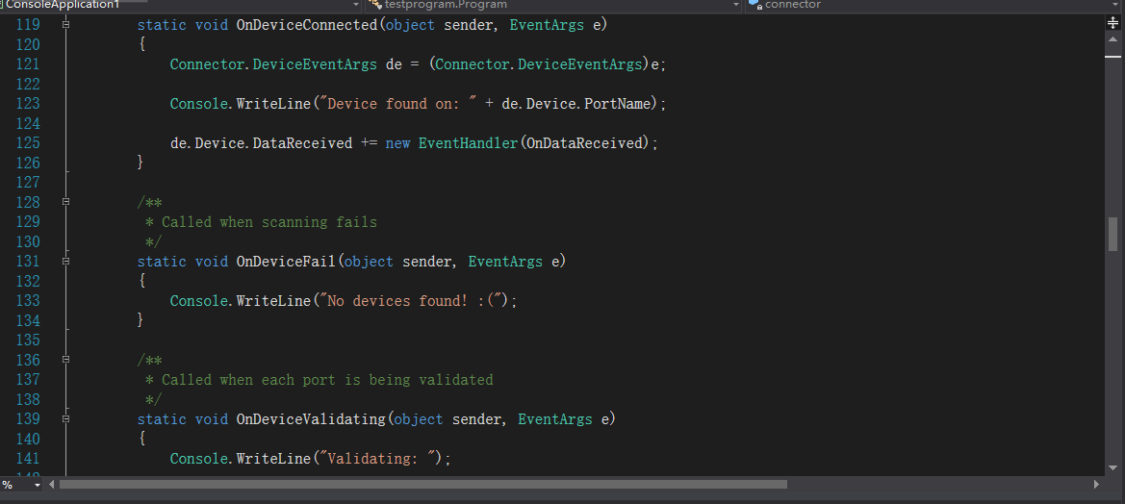

picture2 output the situation the device connect

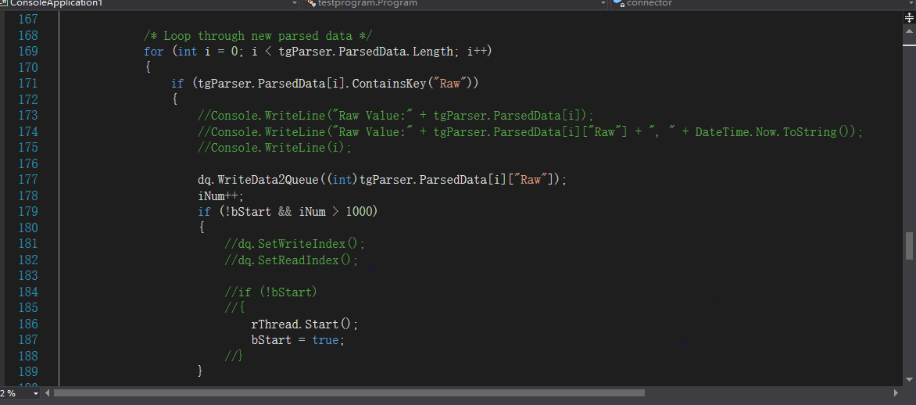

picture3 read in the EEG signals to the computer

2. Signal processing:

According to some generated actions we collect human brain waves, and use c # language to induct and reorganize the Brainwaves.

Through testing several people’s signals and normalizing peak value into a specific range, we define two kinds of EEG signal to trig movements, while each one corresponds to a specific action of the smart car: blink - turn right, fist - Turn left.

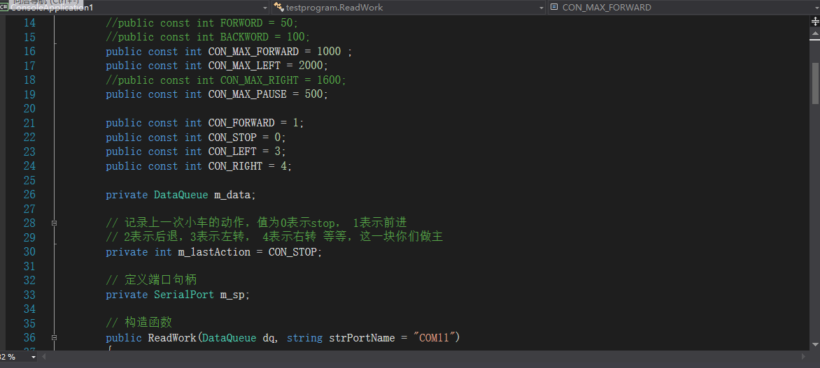

picture4 define the data

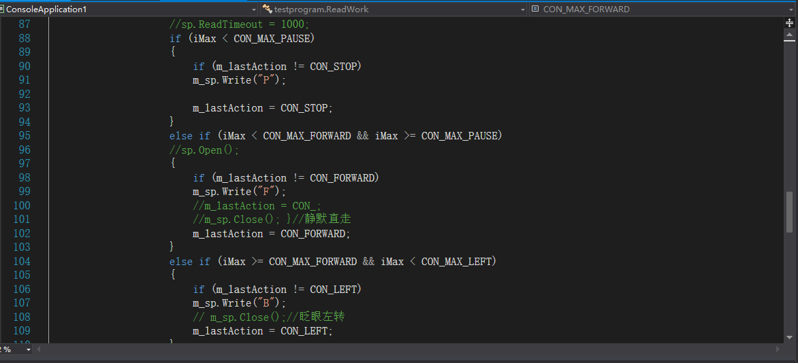

picture5 corresponds the signals to a specific action of the smart car

3. Signal output:

Through the computer's serial port, the Bluetooth signal connect the car and the computer, then the computer send the action instruction to operate the smart car. 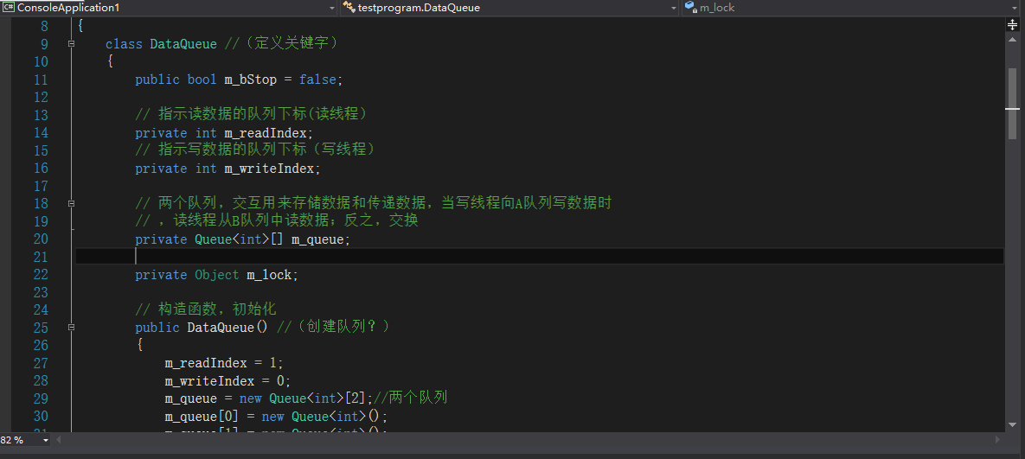

picture6 the two data line to read and write the information through the smart car and the EEG signals

achievement against activities and milestones(1)

|  |  |  |
| --- | --- | --- |
| Goal | Current situation | Performance |
| Find out a proper way to do the EEG research. | Use the smart car as a model to study the EEG signal.  Learn how to use Mindwave. | Finish |
| Find out a certain platform to drive the smart car. | Assure Arduino as the basic platform for building the smart car;  Purchase related hardware and software;  Learn how Arduino works and write application program. | Finish |
| Learn how to use the EEG signal to trig the smart car. | Use C# programming application to test the program, collect data and analyze them.  Compare EEG signals between collected ones and peak value of specific diseases to check the peak value and its characteristics;  Connect the Mindwave data output module and smart car movement module to ensure the smart could receive data then do the comparison progress. | Finish |
| Build a platform for a disease. | Since we could hardly find a accurate EEG information despite corporate with some hospital. We haven't develop this part in our cornerstone project. But through the work we have done, we believe we could finish this part if we have enough information. | Unfinish |