The power of sexual selection to drive changes in mate recognition traits gives it the potential to be a potent force in speciation. Sexual selection is often powerful enough to produce features that are harmful to the individual's survival. Sexual selection is prominent in a lot of species, including ducks. Females ducks are pickier to who they choose as their mates. These criteria are what females look for includes the area of courtship, strong plumage dimorphism, and migratory behavior.

Forty-one species of ducks were examined, and data has collected that fit the criteria of the area of courtship, strong plumage dimorphism, and migratory behavior (Johnson, 1999). The first factor that was looked at was if the species of ducks performed their courtship display on land and water or solely on the water (Johnson, 1999). The next test was to see if the duck species showed strong plumage dimorphism. The duck species either showed monomorphic plumage means only one color or dimorphic has two color forms (Johnson,1999). The third factor to discuss is migratory factors. Species that do not migrate have to have more elaborate traits since there are less choice better males (Johnson, 1999). Table 1: Duck Species Factors

|  |  |  |  |  |  |
| --- | --- | --- | --- | --- | --- |
| Species | Pair Formations | Land courtship | Strong plumage | Migratory | Factors |
| Lophonetta specularioides | 8 | ? | 0 | 0 | 0 |
| Tachyeres pteneres | 8 | ? | 0 | 0 | 0 |
| Amazonetta brasiliensis | 1 | ? | 0 | 0 | 0 |
| Speculanas specularis | 8 | ? | 0 | 0 | 0 |
| Anas formosa | 9 | 1 | 1 | 1 | 3 |
| Anas querquedula | 7 | ? | 1 | 1 | 2 |
| Anas versicolor | 7 | ? | 0 | 0 | 0 |
| Anas hottentota | 4 | ? | 0 | 0 | 0 |
| Anas platalea | 7 | ? | 1 | 0 | 1 |
| Anas cyanoptera | 11 | ? | 1 | 1 | 2 |
| Anas discors | 7 | 0 | 1 | 1 | 2 |
| Anas smithii | 5 | 0 | 0 | 0 | 0 |
| Anas clypeata | 8 | 0 | 1 | 1 | 2 |
| Anas rhynchotis | 3 | ? | 1 | 0 | 1 |
| Anas strepera | 8 | 0 | 1 | 1 | 2 |
| Anas falcata | 9 | 0 | 1 | 1 | 2 |
| Anas penelope | 7 | ? | 1 | 1 | 2 |
| Anas americana | 7 | 1 | 1 | 1 | 3 |
| Anas sibilatrix | 7 | 1 | 0 | 0 | 1 |
| Anas chlorotis | 3 | 1 | 1 | 0 | 2 |
| Anas capensis | 4 | 1 | 0 | 0 | 1 |
| Anas erythrorhyncha | 4 | 1 | 0 | 0 | 1 |
| Anas bahamensis | 7 | 1 | 0 | 0 | 1 |
| Anas georgica | 8 | 1 | 0 | 0 | 1 |
| Anas acuta | 8 | 0 | 1 | 1 | 2 |
| Anas castanea | 3 | 0 | 1 | 0 | 1 |
| Anas gibberifrons | 3 | 0 | 0 | 0 | 0 |
| Anas crecca | 6 | 0 | 1 | 1 | 2 |
| Anas carolinensis | 7 | 0 | 1 | 1 | 2 |
| Anas flavirostris | 8 | 1 | 0 | 0 | 1 |
| Anas sparsa | 4 | 0 | 0 | 0 | 0 |
| Anas undulata | 4 | ? | 0 | 0 | 0 |
| Anas melleri | 2 | ? | 0 | 0 | 0 |
| Anas platyrhynchos | 8 | 0 | 1 | 1 | 2 |
| Anas rubripes | 4 | 0 | 0 | 1 | 1 |
| Anas fulvigula | 7 | 0 | 0 | 0 | 0 |
| Anas superciliosa | 1 | ? | 0 | 0 | 0 |
| Anas laysanensis | 0 | 0 | 0 | 0 | 0 |
| Anas luzonica | 1 | ? | 0 | 0 | 0 |
| Anas zonorhyncha | 8 | ? | 0 | 0 | 0 |
| Anas poecilorhyncha | 7 | ? | 0 | 0 | 0 |

Graph 1: Species mating

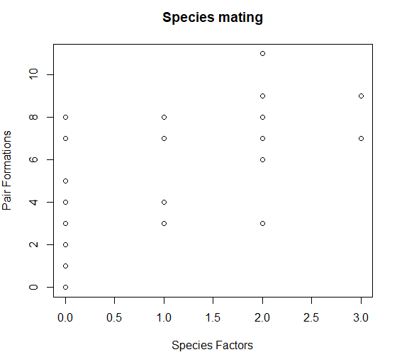

The graph represents the species factors, which the number in which it follows the criteria. If a duck species displayed land and water courtship, strong plumage dimorphism, and migratory patterns, it has a three for posting all those factors. The data for the land and water, if the species had a question mark for not being sure of its courtship habitat it received a zero for that portion.

The graph does show they duck species that fit all three of these criteria have a high chance of mating. The two species of ducks that provide all three of these factors have a high probability of finding a pair. The reason the species with none of these factors have a wide range of possibility is due to the fact some of those spices had questionable mating area. The *loponetta speculariodes* had a high mating pair formation even though it did not have strong plumage dimorphism or show a migratory pattern. The reason some could have higher mating pairs could be because its area of mating was unsure, so there is a possibility it mated on both land and water, giving it a higher chance of mating.

These results suggest that ecological (habitat) as well as social (sexual selection) factors may be necessary for driving the evolution of displays in the dabbling ducks. While structural colors are used in mate choice and pairing, the condition dependence of such traits is less obvious. There are two possible reasons the ducks with that exaggerated plumage or courtship displays are thought to have "good genes" and signal genetic or physiological superiority (Hegyi, 2008). The other purpose is the "sexy son" hypothesis, which proposes that female choice is based on the genetic advantage passed on to her male offspring. Several studies have been conducted on birds to test these theories (Hegyi, 2008). Both of these theories lines up with the fact that ducks have evolved to have strong dimorphic plumage and fancy courtship rituals.

Work citied

Hegyi, Gergely, et al. “The Roles of Ecological Factors and Sexual Selection in the Evolution of

White Wing Patches in Ducks.” Behavioral Ecology, vol. 19, no. 6, 2008, pp. 1208–1 216., doi:10.1093/beheco/arn085.

Johnson, K. P. “The Evolution of Bill Coloration and Plumage Dimorphism Supports the

Transference Hypothesis in Dabbling Ducks.” Behavioral Ecology, vol. 10, no. 1, Jan. 1999, pp. 63–67., doi:10.1093/beheco/10.1.63.

Livezey, Bradley C., and Philip S. Humphrey. “Sexual Dimorphism in Continental Steamer

Ducks.” The Condor, vol. 86, no. 4, 1984, pp. 368–377., doi:10.2307/1366809.