班级： 姓名： 学号： 任课教师：
装 订 线 装 订 线 装 订 线

西安电子科技大学
考试时间 120 分钟
试 题
题号 | I | II | III | IV | 总分
分数 | 30 | 10 | 30 | 30
1.考试形式：闭卷□ 开卷□ A卷
2.考试日期： 年 月 日(答题内容请写在装订线外)

I. Single Choice (2 * 15 = 30 points)
- Software is a set of instructions (programs)，( ) , and documents。
A. data B. test C. process D. architectures
- Software engineering means the application of a systematic, measureable and ( ) approach to the development, operation, and maintenance of software. That is, the application of engineering to software.
A. reliable B. disciplined C. readable D. traceable
- The ( ) is the company, organization, or person who is building the software system for the customer.
A. user B. coder C. developer D. designer
- An ( ) is part of the project that takes place over a period of time.
A. milestone B. activity C. schedule D. timetable
- We can think of a set of ordered tasks as a process, a series of steps involving constraints ( ) and resources that produce an intended output of some kind.
A. steps B. testing C. coding D. activities
6. A requirement is an expression of software ( ).
A. ability B. lifecycle C. behavior D. product
7. Design is the creative process of figuring out how to implement all the customer’s requirements; the ( ) plan is called the design.
A. resulting B. final C. document D. product
8. In client-server architecture, the ( ) component offer services, and the client access them using a request/reply protocol.
A. peer B. server C. pipe D. filter
9. The ( ) model is a standard for software process quality.
A. CMM B. CPM C. ROI D. WBS
10. Design principles are guidelines for ( ) our system’s required functionality and
behavior into modules.
A. decomposing B. testing
C. understanding D. reading
11. Modularity, also called ( ), is the principle of keeping separating
the various unrelated aspects of the system.
A. separation concern B. process concern
C. data concern D. performance concern
12. In pipe-and-filter style, the filter functions is to pass the input data through a sequence of data-transforming component, and the ( ) simply transmit data from one filter to the next without modifying the data.
A. filter B. pipe C. peer D. client
13. The ( ) method is used to express the software requirement.
A .use case diagram B. beta test
C. black box D. white box
14. No matter how what language is used, each program component involves at least three major aspects, ( ) algorithms and data structures.
A. parameters B. units C. interfaces D. control structures
15. Stress or overload fault occur when the data structures are filled past their specified ( ).
A. function B. volume C. performance D. capacity

II. T(True) or F(False) (1*10 = 10 points)
- ( ) When the process involves building of some product we sometime refer to the process as life cycle.
- ( ) The critical path is a path that the slack time as every node is non-zero.
- ( ) DFD is used in the stage of software testing.
- ( ) Any work done to change the system after it is in operation is considered to be maintenance.
- ( ) In acceptance test stage, an in-house test is beta test, and the alpha test is out-house test.
班级： 姓名： 学号： 任课教师：
装 订 线 装 订 线 装 订 线

- ( ) Software Requirement Specification is read by developer.
- ( ) Head Comment Block is a descriptive material written directly within code.
- ( ) Black-Box test methods are usually used to test program’s internal structures.
- ( ) A WHILE-DO construct do not wear out after 10000 loops, and the semicolons do not fall off the end of statement.
- ( ) In Bottom-Up integration test, we should write driver components.

III. Questions（6 *5= 30 points）
- Describe the Waterfall model and its advantages and disadvantages.
- Briefly describe the functions of three core constructs of ERD (Entity Relation Diagram).
- Briefly describe functions of the Filer and the Pipe in Pipe-Filter architecture style, respectively.
- Give out the contents of Head Block Comment.
- Briefly describe the concept of corrective maintenance.

IV. Problem Solving（10 * 3= 30 points）
1、Figure 1 is an activity graph. Find out the critical path(s).
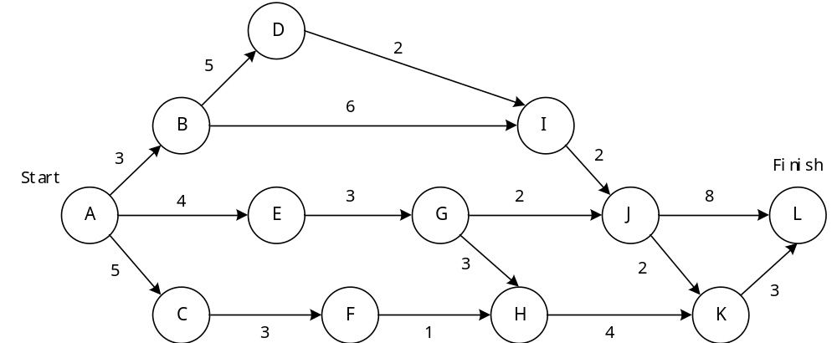

Figure 1 An Activity Graph

2、Figure 2 is the flow chart of a component. Give out the test case for the branch test.
X=X/A
（A>5）AND (B=8 )
(A=6) OR ( X>6)
F
a
Finish
Start
T
F
X=X+5
T
b
c
d
e
Figure 2 A Flow Chart
3、Figure 3 is the control flow of a component. Find out all the paths of path testing.
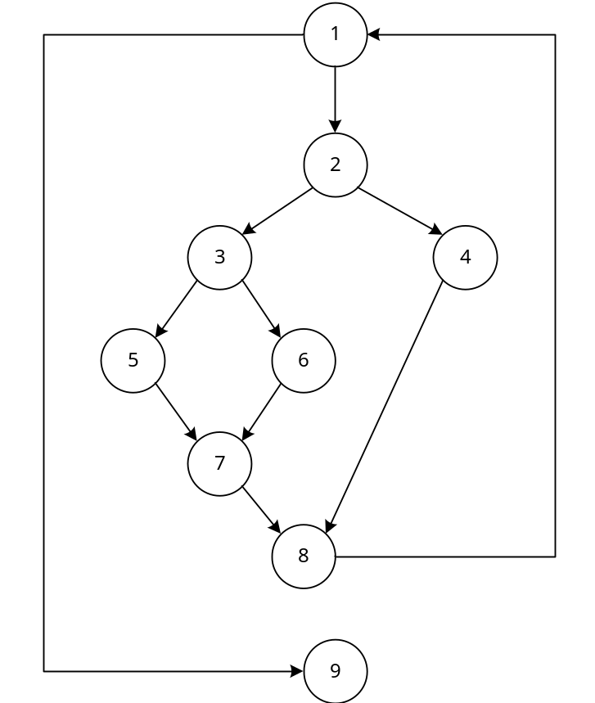
Figure 3 A Control Flow of a Component

