**西安电子科技大学**

**考试时间 120 分钟**

**班级： 姓名： 学号： 任课教师：**

**装 订 线 装 订 线 装 订 线**

**试 题**

|  |  |  |  |  |  |
| --- | --- | --- | --- | --- | --- |
| **题号** | **一** | **二** | **三** | **四** | **总分** |
| **分数** |  |  |  |  |  |

**1.考试形式：闭卷☑ 开卷□**

**2.考试日期： 年 月 日(答题内容请写在装订线外)**

**I. Single Choice (2 * 10= 20 points)**

**1. We do NOT consider quality software in the way** **[ ]**.

**A. The quality of the product**

**B. The quality of the process**

**C. The quality of the development team**

**D. The quality in the context of the business environment**

**2. Which of the following process model concerns the risks? [ ]**

**A. Waterfall model B. V model**

**C. Prototyping model D.** **Spiral model**

**3. [ ] is NOT an activity of risk assessment**

1. **Risk identification B. Risk analysis**
2. **Risk prioritization（优先级） D. Risk management planning**

**4. “The response time for user transaction operations is less than 3 seconds” is a question corresponding to [ ].**

**A. Functional requirements B. Quality requirements**

**C. Design constraints D. Process constraints**

**5.** **The UML notation – [ ] can be used to represent an E-R diagram.**

**A. Use case diagram B. Class diagram**

**C. Sequence diagram D. Collaboration diagram**

1. **The reason for using independent software test teams is that [ ].**

**A. Software developers do not need to do any testing**

**B. Testers do not get involved with the project until testing begins**

**C. Strangers will test the software mercilessly（无情地）**

**D. The conflicts of interest between developers and testers is reduced**

**7. [ ] is the probability（概率） that a system is operating successfully according to specification at a given point in time.**

**A. Reliability B. availability C. Scalability D. Maintainability**

**8. [ ] address the handling of large amount of data in the system.**

**A. Stress tests B. Volume tests**

**C. Regression tests D. Quality tests**

**9. People usually adopt [ ] when designing signal（信号） processing and pattern recognition systems.**

**A. Pipes and filters B. Implicit invocation**

**C. Repositories D. P2P**

**10. If the output from one part of a component is input to the next part, the component has [ ].**

**A. Logical cohesive B. Procedurally cohesive**

**C. Sequential cohesion D. Function cohesion**

**II. Questions (40 points)**

1. **Briefly describe prototyping model and compare two approaches of prototyping.**
2. **Please describe the function of document during the software development. Please list the necessary documents**
3. **Briefly describe the UML use case diagram and give an example.**
4. **Briefly describe publish-subscribe (订阅发布) architecture style and give an example.**
5. **What are the steps of software testing? How do these tests relate to the various phases of software development.**

**III. Requirement Modeling (20 points)**

**The school needs a computer purchasing（采购） management system. It allows administrators（管理员） to register basic information about computers, including their number, brand（品牌）, model, and configuration. Administrators can also query and update the inventory(库存) of computers, including current available quantity and total quantity（数量）. For teachers and students, they can submit computer purchasing requests to administrators, which include requested quantity, purpose, and expected delivery time. Administrators can review and approve/deny the submitted purchasing requests, and can also cancel approved purchases if the computers have not yet been delivered.**

**Please complete the following questions according to the above description.**

1. **Please create a use case model for the school's computer purchasing management system.**

**2. Please list the main classes in the school's computer purchasing management system and create a brief UML class diagram of the system (only include important attributes in the classes; pay attention to identifying the relationships between classes).**

**IV. Problem Solving (20 points)**

**1. This is an activity diagram for a software development project. The number on each edge represents days required to complete this activity.**

1

9

2

6

**FINISH**

1

4

**START**

7

4

5

2

4

**You are required to find out the critical path and calculate the duration of the project.**

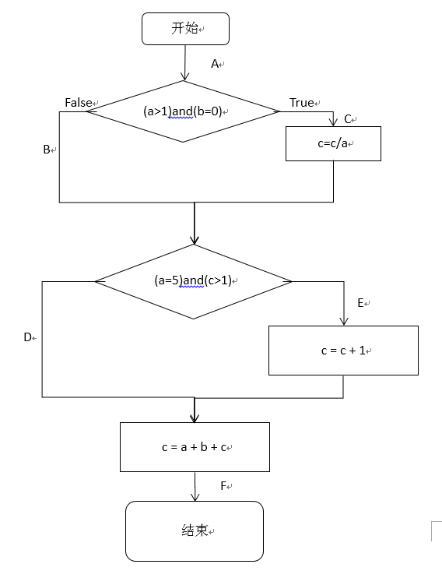**2. The following figure is the flow chart of a component. Find out all the paths of statement testing and path testing. (such as path ACEF)**