**班级： 姓名： 学号： 任课教师：**

**装 订 线 装 订 线 装 订 线**

**西安电子科技大学**

**考试时间 120 分钟**

**试 题**

|  |  |  |  |  |  |
| --- | --- | --- | --- | --- | --- |
| **题号** | **I** | **II** | **III** | **IV** | **总分** |
| **分数** |  |  |  |  |  |

**1.考试形式：闭卷 A卷**

**2.考试日期：2021年6 月30日(答题内容请写在装订线外)**

**I. Single Choice (2 * 15 = 30 points)**

1. The ( ) is a kind of specific philosophy that represents the construction of software.

A. method B. paradigm C. procedure D. architecture

1. The goal of software engineering is to use ( ) and productive methods to form effective solutions to related problems.

A. efficient B. safe C. readable D. calculable

1. ( ) is the person who submits data or reads the output at the terminal.

A. user B. coder C. developer D. customer

1. A project consists of several phases, and a phase consist of several ( ).

A. activities B. paths C. steps D. stages

1. ( ) is a judgment factor used in CPM to determine whether a node is critical.

A. available time B. slack time C. real time D. due date

1. The requirements ( ) describes the requirements as about how the system to be built will behave and be provided to other software developers.

A. definition B. description C. specification D. explanation

1. ( ) prototype not only helps answer questions, it may also become the final system.

A. Throwaway B. Incremental C. Rapid D. Evolutionary

1. ( ) decomposition is NOT a commonly used method in architecture design.

A. Functional B. Feature-oriented C. Data-oriented D. Aspect-oriented

1. In repository architecture, the ( ) component is a kind of independent data storage used to execute processes.

A. storage B. blackboard C. knowledge source D. database

1. In the interface specification, the ( ) specifies the exceptions raised, and the changes of public variables.

A. probe B. postcondition C. precondition D. quality attribute

1. Different modules operate or generate the same data set. The modules constructed around the data set are ( ) cohesion.

A. logical B. coincidental C. data D. communicational

1. Which of the following testing strategies has the highest intensity ( ).

A. all-uses testing B. all-computational-use testing

C. all-predicate-uses testing D. all-definition-use path testing

1. In software testing, the system that can operate according to the designer's intention is called the ( ) system.

A .approved B. accepted C. verified D. validated

1. Which of the following indicators is calculated by other indicators ( ).

A. MTTF B. MTFR C. MTTR D. MTBF

1. When maintaining the system, the ( ) maintenance checks the documentation, design, code, and tests to make improvements.

A. preventive B. corrective C. adaptive D. perfective

**II. T(True) or F(False) (1*10 = 10 points)**

1. Class is a further abstraction of objects with common characteristics.
2. Rapid prototyping technology is suitable for scenarios such as software products requiring a large number of user interaction, or producing a large number of visual output, or designing some complex algorithms.
3. It is a practical method to test with exhaustive method.
4. A requirement definition is a complete list of everything a customer wants.
5. The activity of modifying software to adapt to the change of software running environment is called improving maintenance.
6. The decision table consists of four parts. The upper left part lists all possible actions.
7. A testing technique that assembles software parts into a system is called system testing.
8. The highest module cohesion is time cohesion.
9. Software architecture style is a large-scale system architecture pattern that has been established.
10. Before releasing a system to customers, let users from own company test the system. Such a test is called β test.

**班级： 姓名： 学号： 任课教师：**

**装 订 线 装 订 线 装 订 线**

**III. Questions（8 *5= 40 points）**

1. Describe the V model, and describe what this model focuses on.
2. Briefly describe the UML class diagrams and give an example that includes at least three relationship types.
3. Briefly describe the layering architecture style by an example and discuss the strengths and weaknesses of this architectural style.
4. Give out and explain at least three kinds of coupling.
5. Briefly describe the concept of sandwich integration and give an example to describe the test process.

**IV. Problem Solving（10* 2= 20 points）**

1. Figure 1 is an activity graph. Find out the critical path(s), the earliest start time, latest start time, and slack time of 2.3-2.4 and 3.2-3.3.

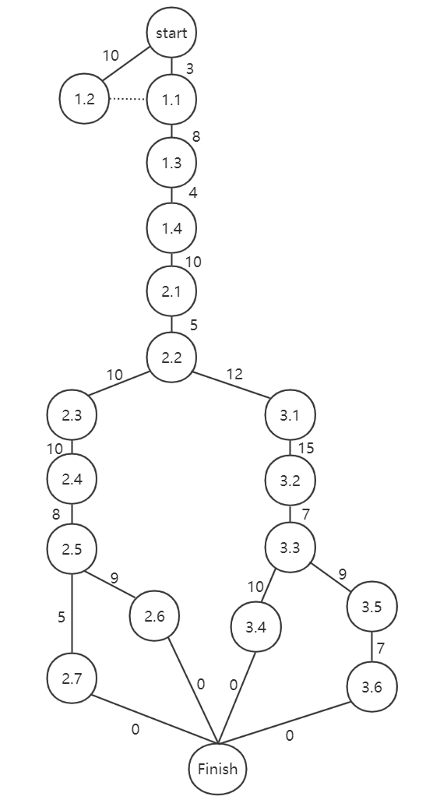

**Figure 1 An activity graph**

1. Figure 2 is the flow chart of a component. Find out all the paths of statement testing, branch testing and path testing.

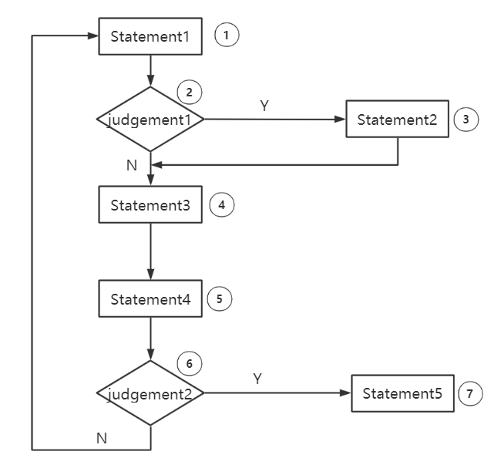

**Figure 2 A flow chart**