西安电子科技大学

考试时间 120 分钟

# 试 题

|  |  |  |  |  |  |  |
| --- | --- | --- | --- | --- | --- | --- |
| 题号 | 一 | 二 | 三 | 四 | 五 | 总分 |
| 分数 |  |  |  |  |  |  |

1.考试形式：闭卷☑ 开卷□ 2.考试日期： 年 月 日

3.可中文作答。

班级： 学号： 姓名： 任课教师：

## I. Single choice questions (20 points)

**There are 10 questions in this section. For each of them there are four choices marked A, B, C and D. You should decide on the ONLY best choice and write the corresponding letter into the square brackets.**

1. Capacity Maturity Model is a measure of ( ).
   1. Reliability of a software product
   2. Maintainability of a software product.
   3. The quality of the software process
   4. Quality in the context of the business environment
2. Performance is a requirement characteristic of ( ).
   1. Functional requirements B. Nonfunctional requirement

C. Design constraint D. Process constraint

1. ( ) is a requirement modeling notation representing a sequence of events that are exchanged between entities.
   1. ER diagram B. UML State chart diagram

C. Petri net D. Message sequence chart

1. ( ) is NOT an element of state chart models.
   1. State B. Transition C. Event D. Relationship.
2. The main task for software architectural design is to determine the ( ) .
   1. algorithms and data structures
   2. software architecture
   3. functions
   4. programming styles and standards
3. ( ) is most appropriate for the architectural design of a protocol stack such as TCP/IP.
   1. Pipes and Filters B. Implicit Invocation

C. Layering D. P2P

1. To improve the independence of components, the internal parts of a component should be ( ).
   1. Functional cohesion B. Communicational cohesion

C. Procedural cohesion D. Logical cohesion

1. A test suite（测试集） satisfying branch coverage also fulfills the ( ) coverage criteria.
   1. Statement B. All definition-use paths

C. All uses D. All paths

1. Bug fixing is an activity of ( ).
   1. Corrective maintenance B. Adaptive maintenance

C. Perfective maintenance D. Preventive maintenance

## II. Questions (40 points)

1. Briefly explain the waterfall model and explain the advantages and disadvantages of the model.

1. Please enumerate(列举) and explain at least 3 kinds of component coupling.

1. Please enumerate and explain at least 3 kinds of requirement modeling notations.

1. Briefly explain the main steps in system testing and the test basis for each step.

1. Briefly explain types of requirements and give examples.

## III. Requirement Modeling (20 points)

The library management system should provide customers with the functions of lending, returning and booking books. When the book is overdue, a reminder letter shall be sent, and a fine of 0.2 yuan shall be imposed for each overdue day. Students can borrow books for four weeks, and teachers can borrow books for three months. As long as no other customers request to borrow books, they can renew them. The library management system must provide very convenient online directory indexing and retrieval functions.

Please complete the following questions according to the above description

1. Draw the use case model of the library management system;

1. Identify the main classes of lending use cases and draw the sequence diagram of lending use cases

## IV. Problem Solving (20 points)

1. The action we must do for the printer which does not print is as follow: If the red light is flashing and the printer is unrecognized; we should check the printer-computer cable, ensure printer software is installed and check/replace ink.

If the red light is flashing and the printer is recognized; we should check/replace ink and check for paper jam.

If the red light is not flashing and the printer is unrecognized; we should check the power cable, check the printer-computer cable and ensure printer software is installed.

If the red light is not flashing and the printer is recognized; we should just Check for paper jam（卡纸）.

You are required to draw the **decision table** modeling these conditions.

1. This is an activity diagram for a software development project. The number on each edge represents days required to complete this activity..

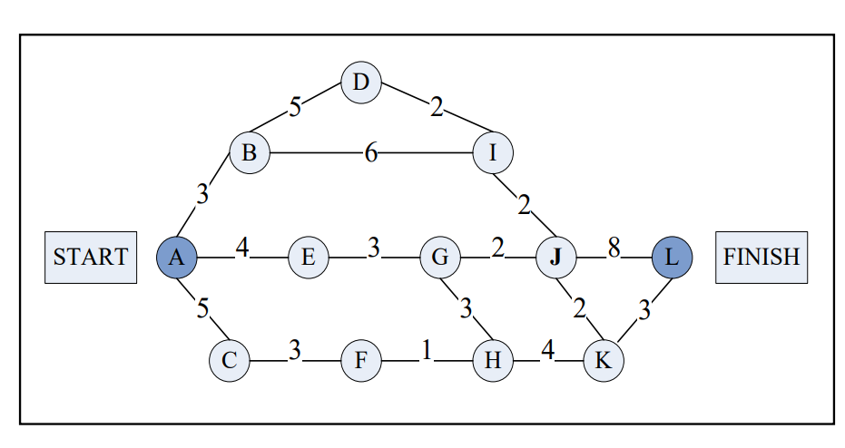

You are required to find out the critical path and calculate the duration of the project.