**DPPL-oo-01**

DESCRIPTION OF SOFTWARE DESIGN

**Food Ordering Mobile Application for Small-scale Restaurant**

for:

Student and Lecturer at Telkom University

Prepared by:

- Raka Adhi Bagaskara (1301164587)

- M. Rikbal Ikhsani (1301163598)

- Hasna F Hasya (1301164594)

- Kt. Sudyatmika Putra (1301180494)

Bachelor of Informatics – Faculty of Informatics (School of Computing)

Telkom University

Jalan Telekomunikasi Terusan Buah Batu, Bandung

Indonesia

|  |  |  |  |  |
| --- | --- | --- | --- | --- |
|  | **Informatics Bachelor – Faculty of Informatics** | Document Number | | Pages |
| *DPPL-oo-01* | |  |
| Revision |  | *Date:* |

# CHANGES LIST

|  |  |
| --- | --- |
| Revision | Description |
| A | Change from bahasa to English, purpose of writing document, scope of problem, definition and term, references, systematics discussion , Design implementation environment, Architectural description, Component description |
| B | Use case realization, class identification, sequence diagram, class diagram |
| C | Admin class, menu class, customers class, receipt class |
| D | Class diagram, algorithm/ query, interface, design of class, frown matrix |
| E | Change sequence diagram, change class diagram, change component diagram |
| F | edit detail class design, edit component description, |
| G |  |

|  |  |  |  |  |  |  |  |  |
| --- | --- | --- | --- | --- | --- | --- | --- | --- |
| INDEX  DATE | - | A | B | C | D | E | F | G |
| Written by |  |  |  |  |  |  |  |  |
| Examined by |  |  |  |  |  |  |  |  |
| Approved by |  |  |  |  |  |  |  |  |

# PAGES CHANGES LIST

|  |  |  |  |
| --- | --- | --- | --- |
| Pages | Revision | Pages | Revision |
|  |  |  |  |

# TABLE OF CONTENTS

CHANGES LIST 2

PAGES CHANGES LIST 3

TABLE OF CONTENTS 4

LIST OF FIGURE 7

LIST OF TABLE 9

1 Preliminary 10

1.1 Purpose of Writing Document 10

1.2 Scope of Problem 10

1.3 Definition and term 10

1.4 Reference 10

1.5 Systematics discussion 10

2 Description of Global Design 11

2.1 Design implementation environment 11

2.2 Architectural description 11

2.3 Component description 12

3 Detailed design 13

3.1 Use case realization 13

3.1.1 Input Order Use Case 14

3.1.1.1 Class Identification 14

3.1.1.2 Sequence Diagram 14

3.1.1.3 Class diagram 14

3.1.2 Modify Order Use Case 15

3.1.2.1 Class Identification 15

3.1.2.2 Sequence Diagram 15

3.1.2.3 Class Diagram 15

3.1.3 Confirm Order Use Case 16

3.1.3.1 Class Identification 16

3.1.3.2 Sequence Diagram 16

3.1.3.3 Class Diagram 16

3.1.4 Print Receipt Use Case 17

3.1.4.1 Class Identification 17

3.1.4.2 Sequence Diagram 17

3.1.4.3 Class Diagram 17

3.1.5 Notify Customer Use Case 18

3.1.5.1 Class Identification 18

3.1.5.2 Sequence Diagram 18

3.1.5.3 Class Diagram 18

3.1.6 Confirm Order Use Case 19

3.1.6.1 Class Modification 19

3.1.6.2 Sequence Diagram 19

3.1.6.3 Class Diagram 19

3.1.7 Check Menu Use Case 20

3.1.7.1 Class Identification 20

3.1.7.2 Sequence Diagram 20

3.1.7.3 Class Diagram 20

3.1.8 Input Menu Use Case 21

3.1.8.1 Class Identification 21

3.1.8.2 Sequence Diagram 21

3.1.8.3 Class Diagram 21

3.1.9 Delete Menu Use Case 22

3.1.9.1 Class Identification 22

3.1.9.2 Sequence Diagram 22

3.1.9.3 Class Diagram 22

3.1.10 Check Stock Use Case 23

3.1.10.1 Class Identification 23

3.1.10.2 Sequence Diagram 23

3.1.10.3 Class Diagram 23

3.1.11 Input Stock Use Case 24

3.1.11.1 Class Identification 24

3.1.11.2 Sequence Diagram 24

3.1.11.3 Class Diagram 24

3.1.12 Delete Stock Use Case 25

3.1.12.1 Class Identification 25

3.1.12.2 Sequence Diagram 25

3.1.12.3 Class Diagram 25

3.1.13 Admin Login Use Case 26

3.1.13.1 Class Identification 26

3.1.13.2 Sequence Diagram 26

3.1.13.3 Class Diagram 26

3.2 Detail Class Design 27

3.2.1 Admin Login Class 27

3.2.2 Admin Homepage Class 27

3.2.3 Admin Stock Information Class 27

3.2.4 Admin Menu Information Class 28

3.2.5 Admin Confirmation Page Class 28

3.2.6 Receipt Class 28

3.2.7 Menu Class 29

3.2.8 Ordered Items Class 29

3.2.9 Message Class 29

3.2.10 Customers Homepage Class 30

3.2.11 Customers Class 30

3.2.12 Customers Confirm Page Class 30

3.3 Class Diagram 31

3.4 Algorithm / Query 32

3.4.1 *Add Quantity* 32

3.4.2 *Minus Quantity* 32

3.4.3 *Get menu* 32

3.5 Interface Design 33

3.5.1 Interface : 001 – Customers Home Page 33

3.5.2 Interface : 002 – Customers Confirm Page 34

3.5.3 Interface : 003 – Admin Homepage 35

3.5.4 Interface : 004 – Admin Order Page 36

3.5.5 Interface : 005 – Admin Menu Information Page 37

3.5.6 Interface : 006 – Admin Stock Information Page 38

3.5.7 Interface : 007 – Admin Login Page 39

3.6 Design of Class Persistence Representations 40

4 Frown Matrix 40

# LIST OF FIGURE

Figure 2. 1 Component Diagram 11

Figure 3. 1 Use Case Diagram 13

Figure 3. 2 Sequence Input Order 14

Figure 3. 3 Class Diagram Input Order 14

Figure 3. 4 Sequence Modify Order 15

Figure 3. 5 Class Diagram Modify Order 15

Figure 3. 6 Sequence Confirm Order 16

Figure 3. 7 Class Diagram Confirm Order 16

Figure 3. 8 Sequence Print Receipt 17

Figure 3. 9 Class Diagram Print Receipt 17

Figure 3. 10 Sequence Notify Customers 18

Figure 3. 11 Class Diagram Notify Customer 18

Figure 3. 12 Sequence Confirm Order 19

Figure 3. 13 Class Diagram Confirm Order 19

Figure 3. 14 Sequence Check Menu 20

Figure 3. 15 Class Diagram Check Menu 20

Figure 3. 16 Sequence Input Menu 21

Figure 3. 17 Class Diagram Input Menu 21

Figure 3. 18 Sequence Delete Menu 22

Figure 3. 19 Class Diagram Delete Menu 22

Figure 3. 20 Sequence Check Stock 23

Figure 3. 21 Class Diagram Check Stock 23

Figure 3. 22 Sequence Input Stock 24

Figure 3. 23 Class Diagram Input Stock 24

Figure 3. 24 Sequence Delete Stock 25

Figure 3. 25 Class Diagram Delete Stock 25

Figure 3. 26 Sequence Delete Stock 26

Figure 3. 27 Class Diagram Admin Login 26

Figure 3. 28 Class Diagram 31

Figure 3. 29 Customers Home Page 33

Figure 3. 30 Customers Confirm Page 34

Figure 3. 31 Admin Homepage 35

Figure 3. 32 Admin Order Page 36

Figure 3. 33 Admin Menu Information Page 37

Figure 3. 34 Admin Stock Information Page 38

Figure 3. 35 Admin Login Page 39

Figure 3. 36 Class Persistence Representations 40

# LIST OF TABLE

Table 2. 1 Design Implementation 11

Table 2. 2 Component Description 12

Tabel 3. 1 Input order 14

Tabel 3. 2 Modify Order 15

Tabel 3. 3 Confirm Order 16

Tabel 3. 4 Print Receipt 17

Tabel 3. 5 Notify Customers 18

Tabel 3. 6 Confirm Order 19

Tabel 3. 7 Check Menu 20

Tabel 3. 8 Input Menu 21

Tabel 3. 9 Delete Menu 22

Tabel 3. 10 Check Stock 23

Tabel 3. 11 Input Stock 24

Tabel 3. 12 Delete Stock 25

Tabel 3. 13 Class Identification Admin Login 26

Tabel 3. 14 Detail Class Design 27

Tabel 3. 15 Admin Class 27

Tabel 3. 16 Admin Homepage 27

Tabel 3. 17 Admin Stock Information 27

Tabel 3. 18 Admin Menu Information 28

Tabel 3. 19 Admin Confirmation Page 28

Tabel 3. 20 Receipt Class 28

Tabel 3. 21 Menu Class 29

Tabel 3. 22 Ordered Items 29

Tabel 3. 23 Message Class 29

Tabel 3. 24 Customers Homepage 30

Tabel 3. 25 Customers Class 30

Tabel 3. 26 Customers Confirm Page 30

Tabel 3. 27 Add Quantity 32

Tabel 3. 28 Minus Quantity 32

Tabel 3. 29 Get Menu 32

Tabel 3. 30 Description Customers Home Page 33

Tabel 3. 31 Description Customers Confirm Page 34

Tabel 3. 32 Description Admin Homepage 35

Tabel 3. 33 Description Admin Order Page 36

Tabel 3. 34 Description Admin Menu Information Page 37

Tabel 3. 35 Description Admin Stock Info Page 38

Tabel 3. 36 Description Admin Login Page 39

Table 4. 1 Frown Matrix 40

# 1 Preliminary

## Purpose of Writing Document

This Software Design Description Document was written with the aim of becoming a document of the requirements of the software to be developed. With this document, it will describe what the application looks like.

## Scope of Problem

Based on our experience a lot of small – scale restaurant with limited staff distress if there is a lot of customers. In this project, we create an application to help the customer order the food from the restaurant that has limited staff such as warteg to help them minimize an order error occurred.

## Definition and term

* SRS, is Software Requirement Specification. Document analysis results that contain specifications of user needs.
* SDD, is the Software Design Description. The document that will describe in detail about the software to be built.
* Database: A collection of data stored systematically on a computer that can be processed or manipulated using software (application programs) to produce information.
* Use case Diagram: Description of the process that involves an actor.
* Class Diagram: Diagram that shows the system’s structure from class definition to build a system.

## Reference

The documents used to make the Software Design Description (SDD) are based on:

1. SRS our group on Food Ordering Mobile Application for small-scale Restaurant , Department of Informatics S1, Telkom University
2. Template DPPL Object-Oriented Analysis S1 Informatics Engineering Study Program Telkom University, Faculty of Informatics
3. SDD document from last years

## Systematics discussion

1. Chapter 1 explain about the purpose of writing the SDD document and the scope of the problem, continue to also explain terms that are rarely known to ordinary people and also the reference from which we use to make this SDD document.
2. Chapter 2 explain the design scope of the software implementation environment, architectural description, and component description of the architectural diagram.
3. Chapter 3 explain about each use case that exists and each class as well.
4. Chapter 4 explain about each use case using any class.

# Description of Global Design

The global design description includes an explanation of the design scope of the software implementation environment, an architectural description, and a description of the components of the architectural diagram used for software development.

## Design implementation environment

|  |  |
| --- | --- |
| System Description | Spesification |
| Operating System | Androids |
| DBMS | MySQL |
| Development Tools | Androids Studio, Flutter, MS Visual code studio |
| Language | Dart |

Table 2. 1 Design Implementation

## Architectural description

Is an architectural description or component that will be applied to the software "Food Ordering Mobile Application for Small-scale Restaurant" to facilitate the development and manufacture of the formation of the software, and to implement this software.

**Component Diagram**

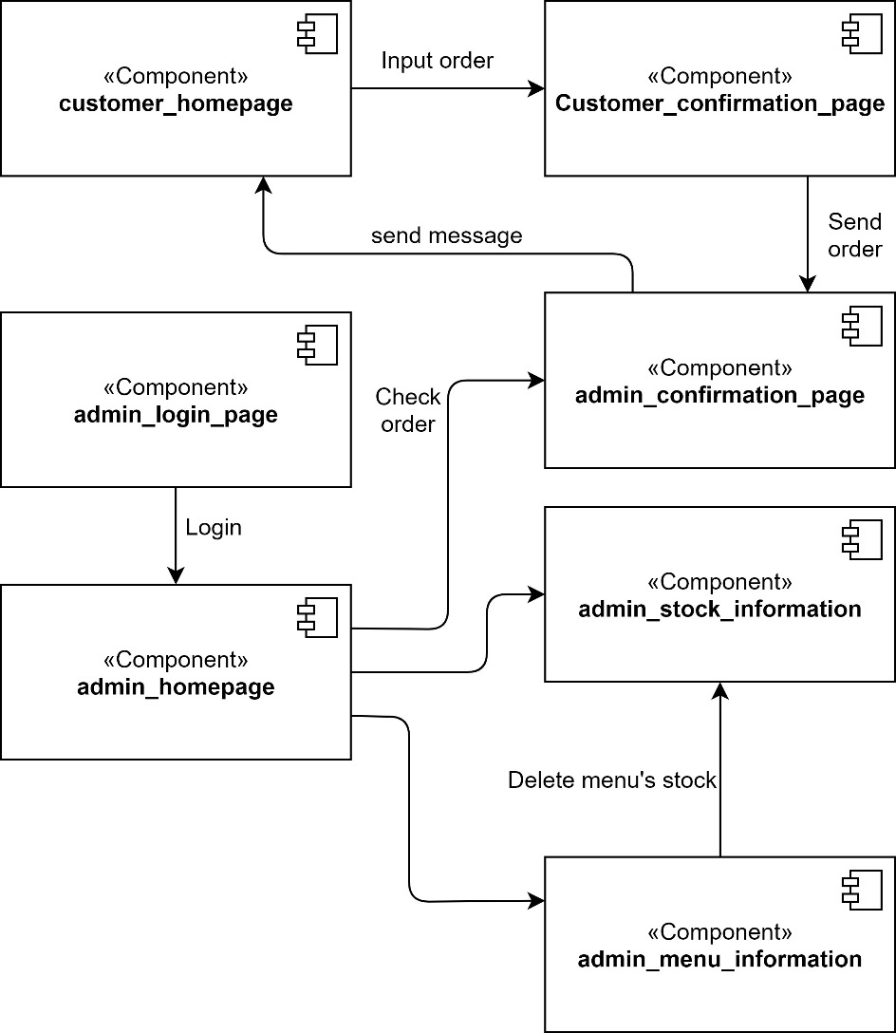

Figure 2. 1 Component Diagram

## Component description

The module list can be in the following table form:

|  |  |  |
| --- | --- | --- |
| **No** | **Component name** | **Explanation** |
| 1. | Customer_homepage | To display the list of menu |
| 2. | Customer_confirmation_page | To display the notif from admin |
| 3. | Admin_confirmation_page | To display the notif from cust |
| 4. | Admin_login_page | To display the login page |
| 5. | Admin_homepage | To display the list of notification from cust |
| 6. | Admin_stock_information | To display and edit the list of stock food |
| 7. | Admin_menu_information | To display and edit the list of the menu |

Table 2. 2 Component Description

# Detailed design

## Use case realization

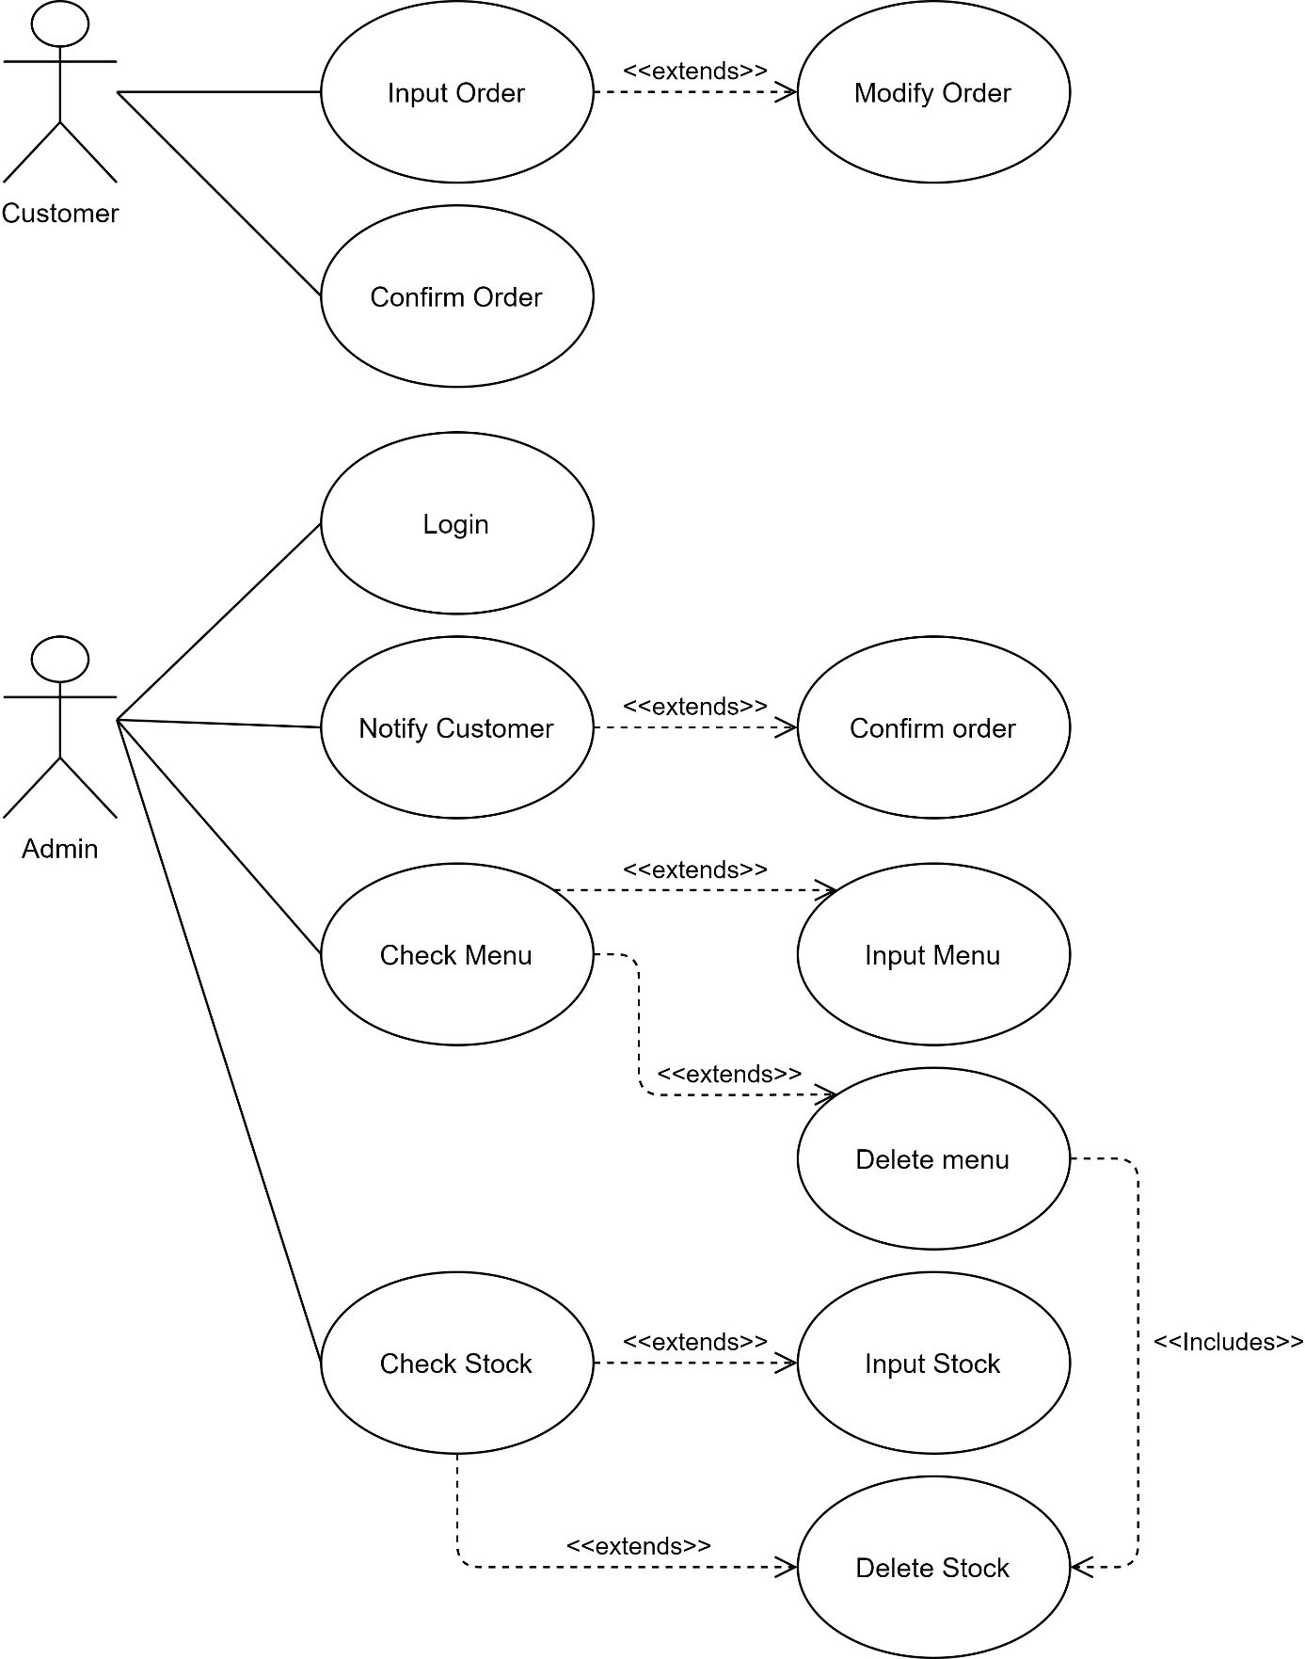

Figure 3. 1 Use Case Diagram

### Input Order Use Case

Input Order Use Case is a use case that belong to Customer or User to input their chosen order.

#### Class Identification

|  |  |  |
| --- | --- | --- |
| No. | Class Name | Class Type |
| 1 | CustomerHomepage | Model |
| 2 | AppProcess | Controller |
| 3 | Database | Database |

Tabel 3. 1 Input order

#### Sequence Diagram

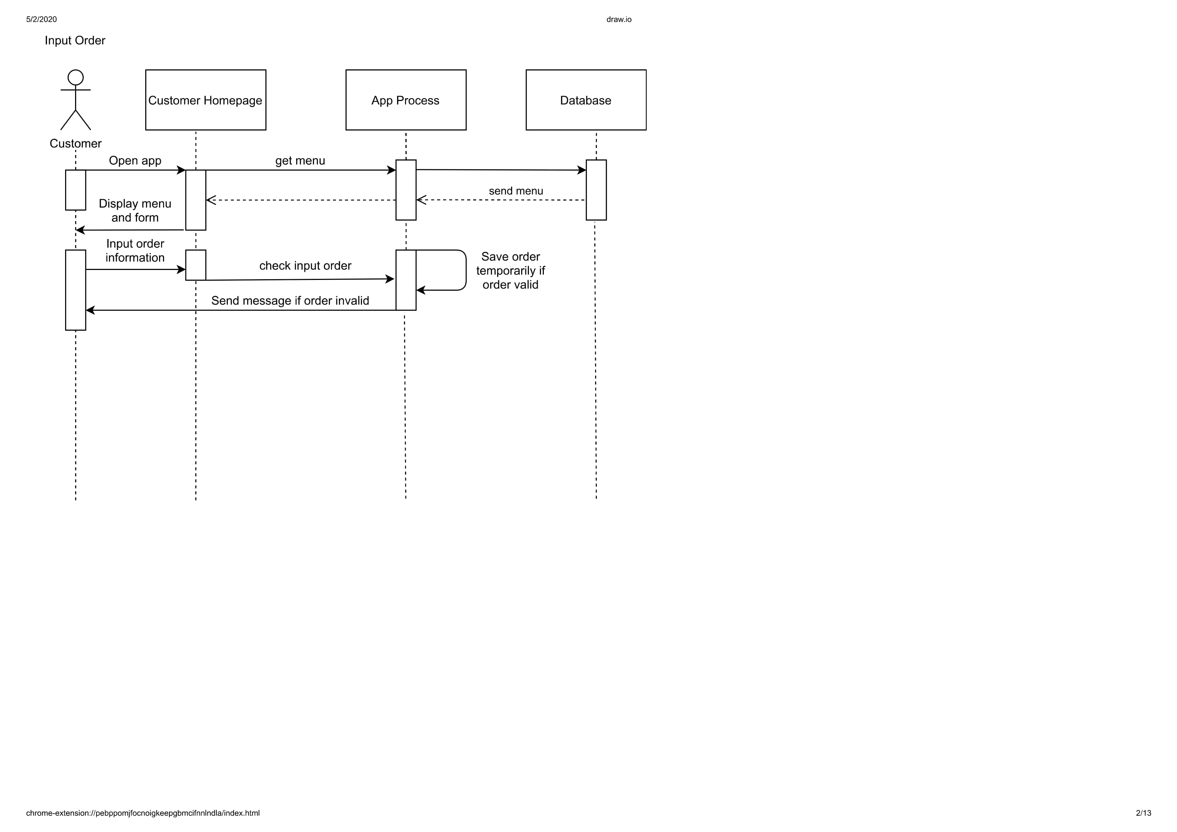

Figure 3. 2 Sequence Input Order

#### Class diagram

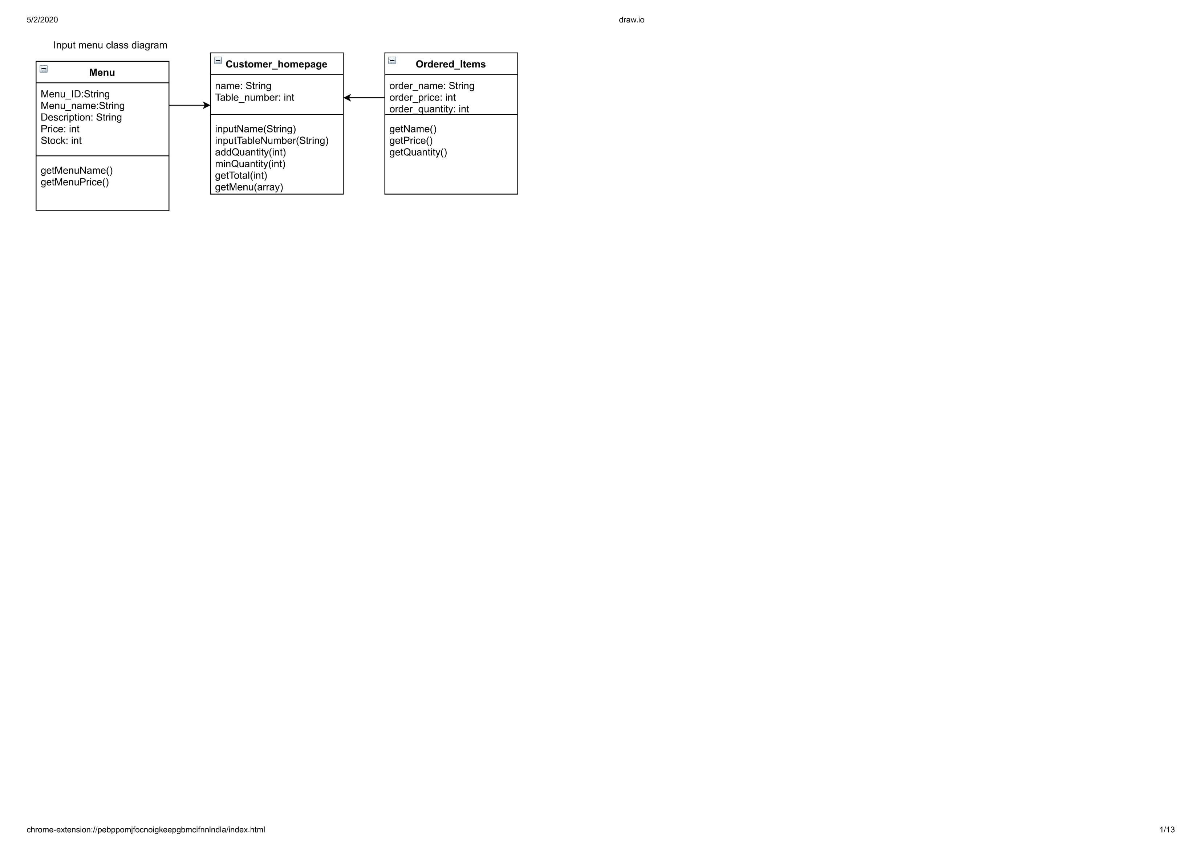

Figure 3. 3 Class Diagram Input Order

### 3.1.2 Modify Order Use Case

Modify Order Use Case is a use case that belong to Customer or User that has function to change their chosen order before.

#### 3.1.2.1 Class Identification

|  |  |  |
| --- | --- | --- |
| No. | Class Name | Class Type |
| 1 | CustomerConfirmPage | Model |
| 2 | AppProcess | Controller |
| 3 | Database | Database |

Tabel 3. 2 Modify Order

#### 3.1.2.2 Sequence Diagram

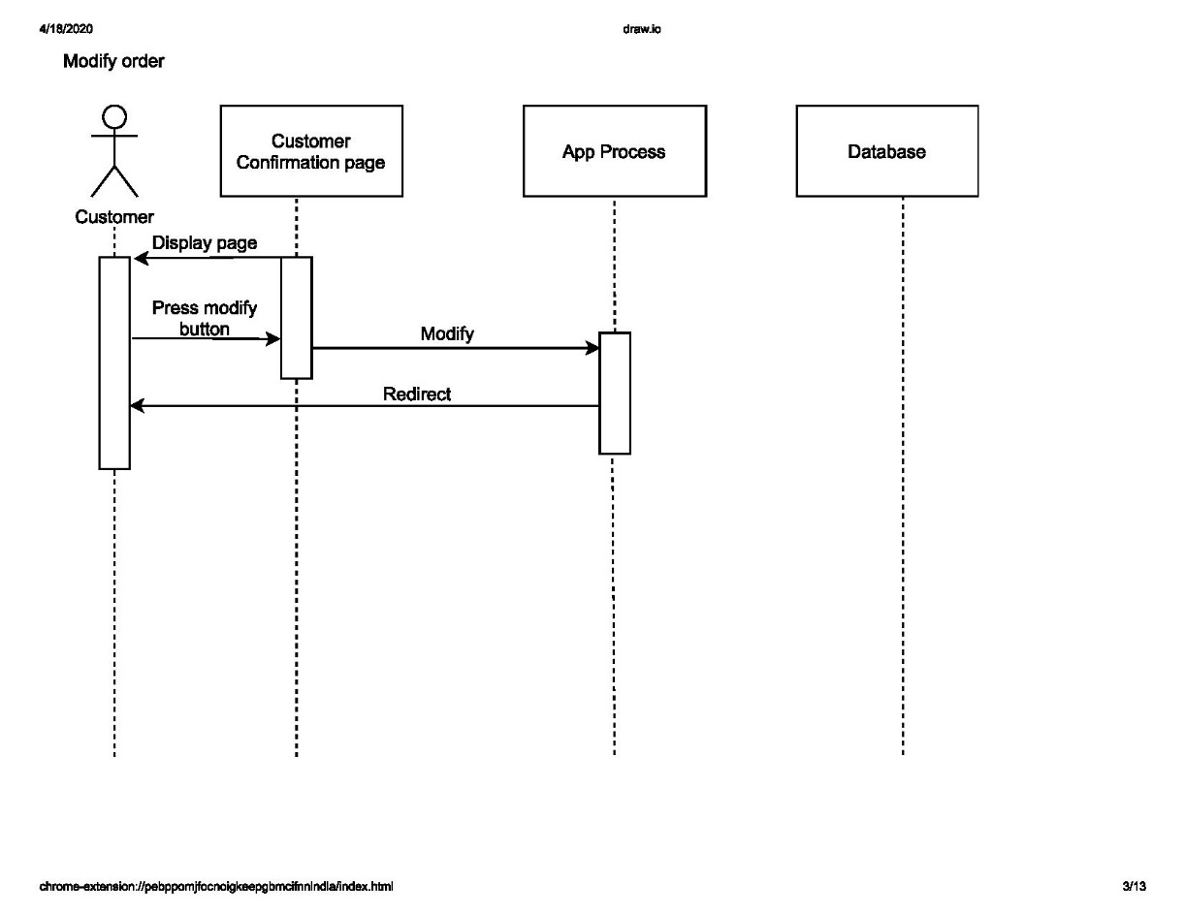

Figure 3. 4 Sequence Modify Order

#### 3.1.2.3 Class Diagram

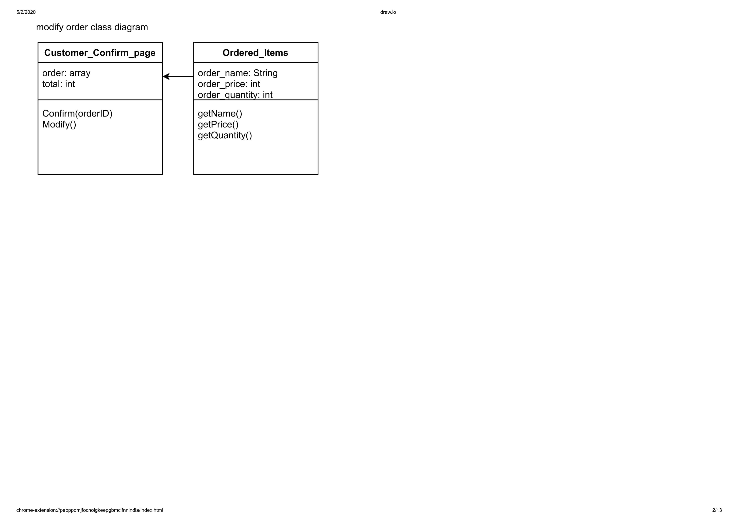

Figure 3. 5 Class Diagram Modify Order

### 3.1.3 Confirm Order Use Case

Confirm Order Use Case is a use case that belong to Customer or User that has function to confirm their chosen order.

#### 3.1.3.1 Class Identification

|  |  |  |
| --- | --- | --- |
| No. | Class Name | Class Type |
| 1 | CustomerConfirmPage | Model |
| 2 | AppProcess | Controller |
| 3 | Database | Database |

Tabel 3. 3 Confirm Order

#### 3.1.3.2 Sequence Diagram

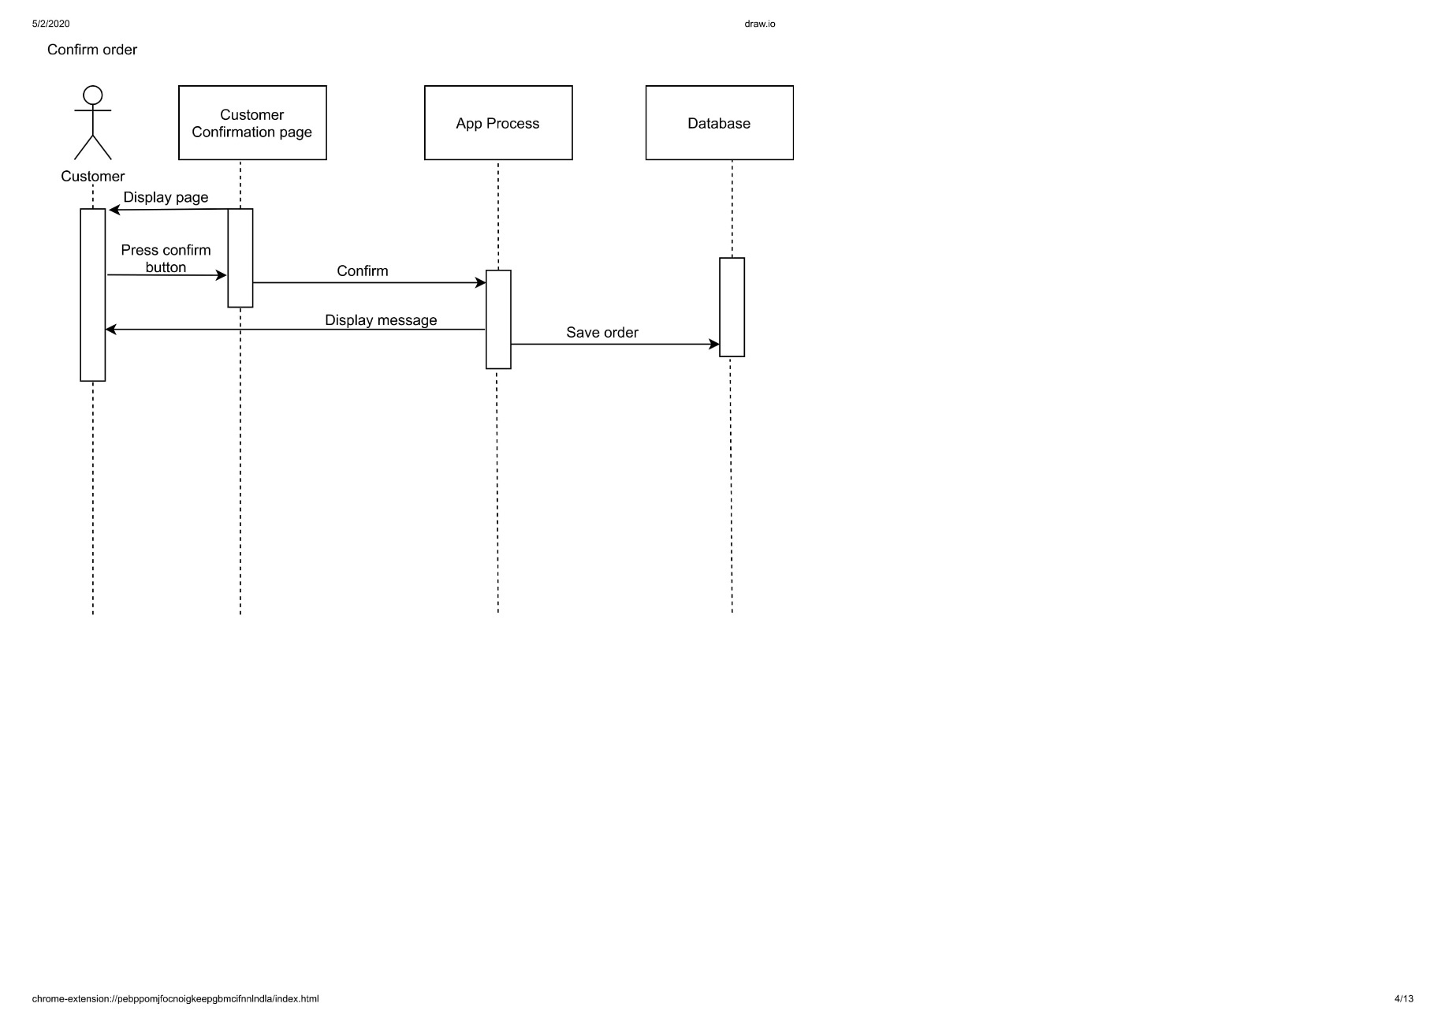

Figure 3. 6 Sequence Confirm Order

#### 3.1.3.3 Class Diagram

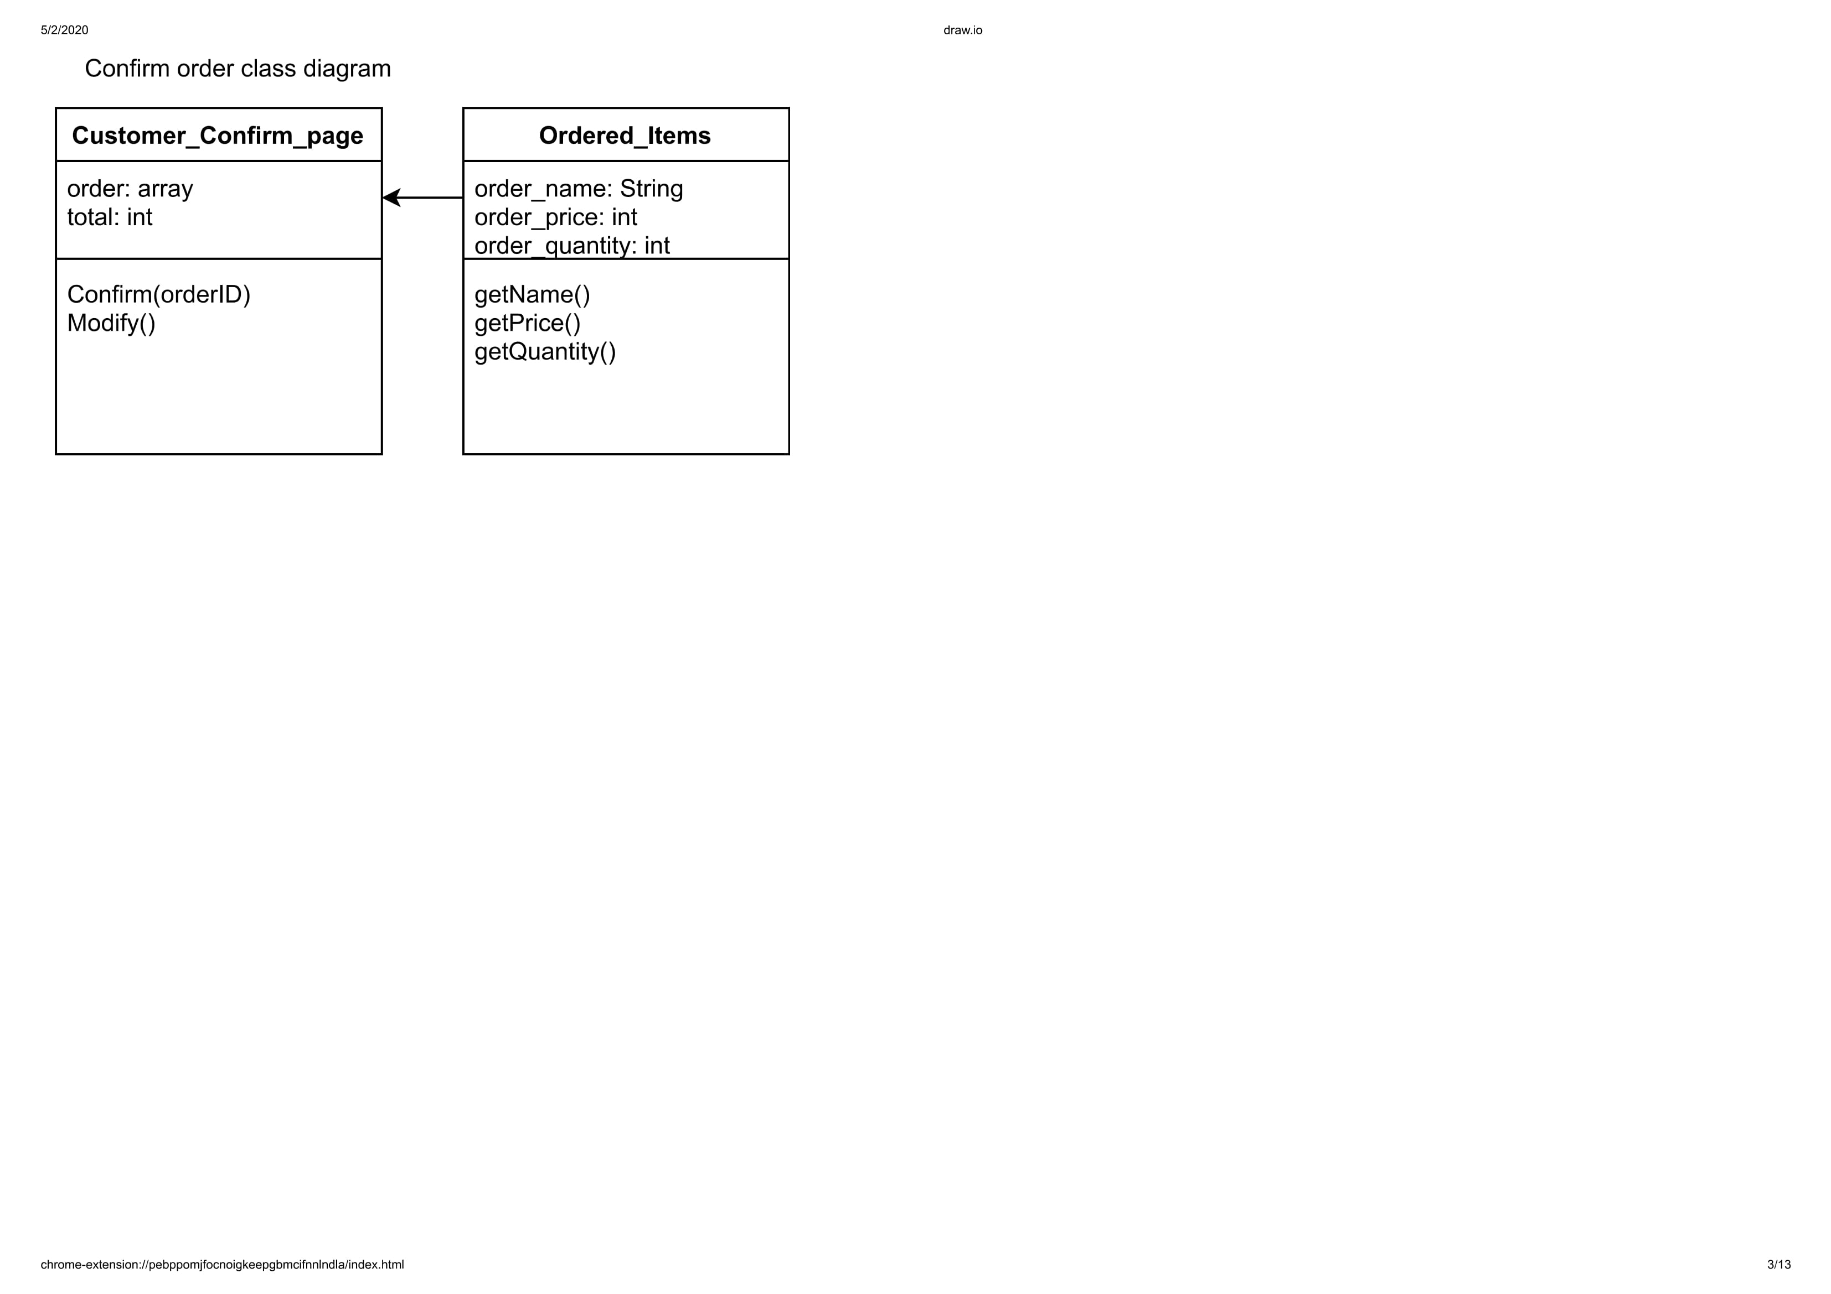

Figure 3. 7 Class Diagram Confirm Order

### 3.1.4 Print Receipt Use Case

Print Receipt Use Case is a use case that belong to Admin that has function to print the receipt of the Customer’s order.

#### 3.1.4.1 Class Identification

|  |  |  |
| --- | --- | --- |
| No. | Class Name | Class Type |
| 1 | AdminConfirmPage | Model |
| 2 | AppProcess | Controller |
| 3 | Database | Database |

Tabel 3. 4 Print Receipt

#### 3.1.4.2 Sequence Diagram

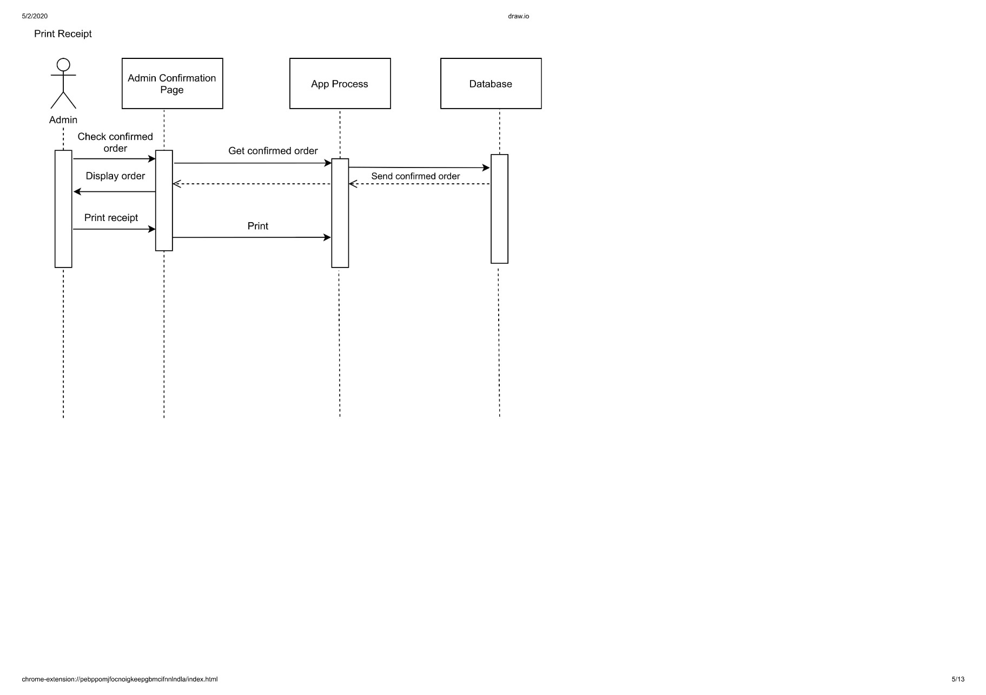

Figure 3. 8 Sequence Print Receipt

#### 3.1.4.3 Class Diagram

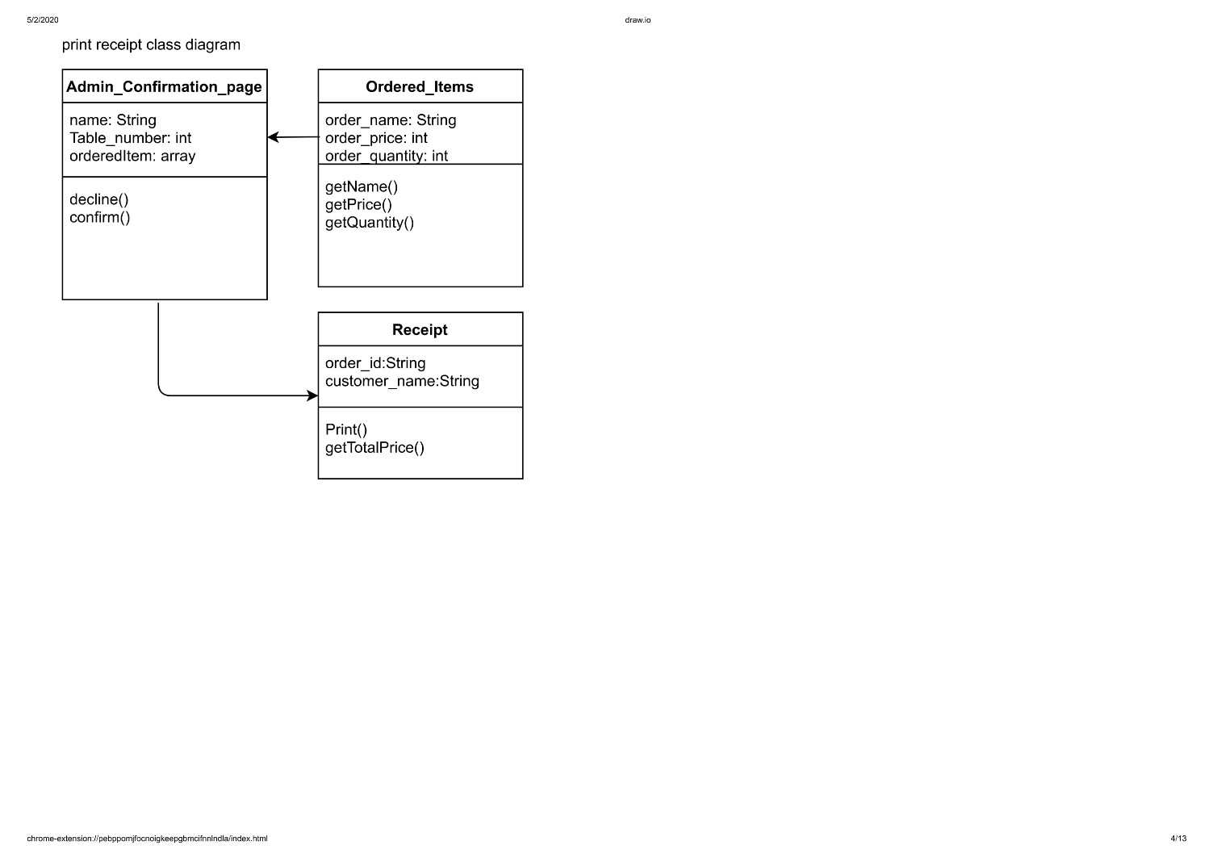

Figure 3. 9 Class Diagram Print Receipt

### 3.1.5 Notify Customer Use Case

Notify Customer Use Case is a use case that belong to Admin that has function to notify the customer if the Stock isn’t available or another condition.

#### 3.1.5.1 Class Identification

|  |  |  |
| --- | --- | --- |
| No. | Class Name | Class Type |
| 1 | AdminConfirmPage | Model |
| 2 | AppProcess | Controller |
| 3 | Database | Database |

Tabel 3. 5 Notify Customers

#### 3.1.5.2 Sequence Diagram

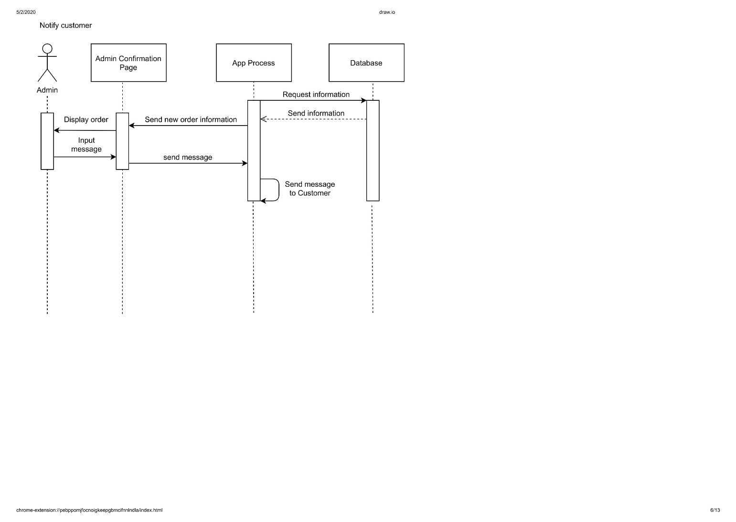

Figure 3. 10 Sequence Notify Customers

#### 3.1.5.3 Class Diagram

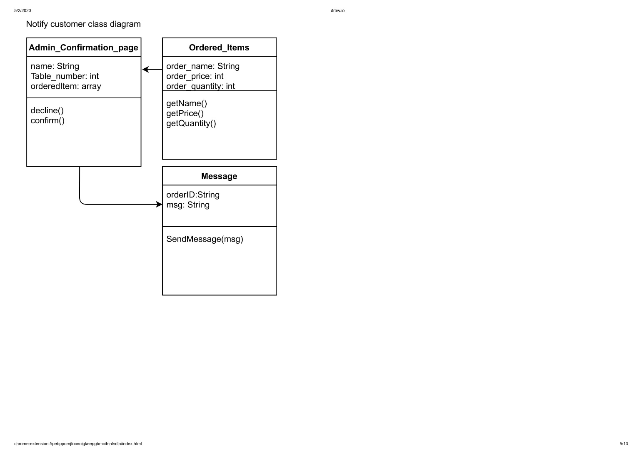

Figure 3. 11 Class Diagram Notify Customer

### 3.1.6 Confirm Order Use Case

Confirm Order Use Case is a use case that belong to Admin that has function to Confirm the order from the Customer.

#### 3.1.6.1 Class Modification

|  |  |  |
| --- | --- | --- |
| No. | Class Name | Class Type |
| 1 | AdminConfirmPage | Model |
| 2 | AppProcess | Controller |
| 3 | Database | Database |

Tabel 3. 6 Confirm Order

#### 3.1.6.2 Sequence Diagram

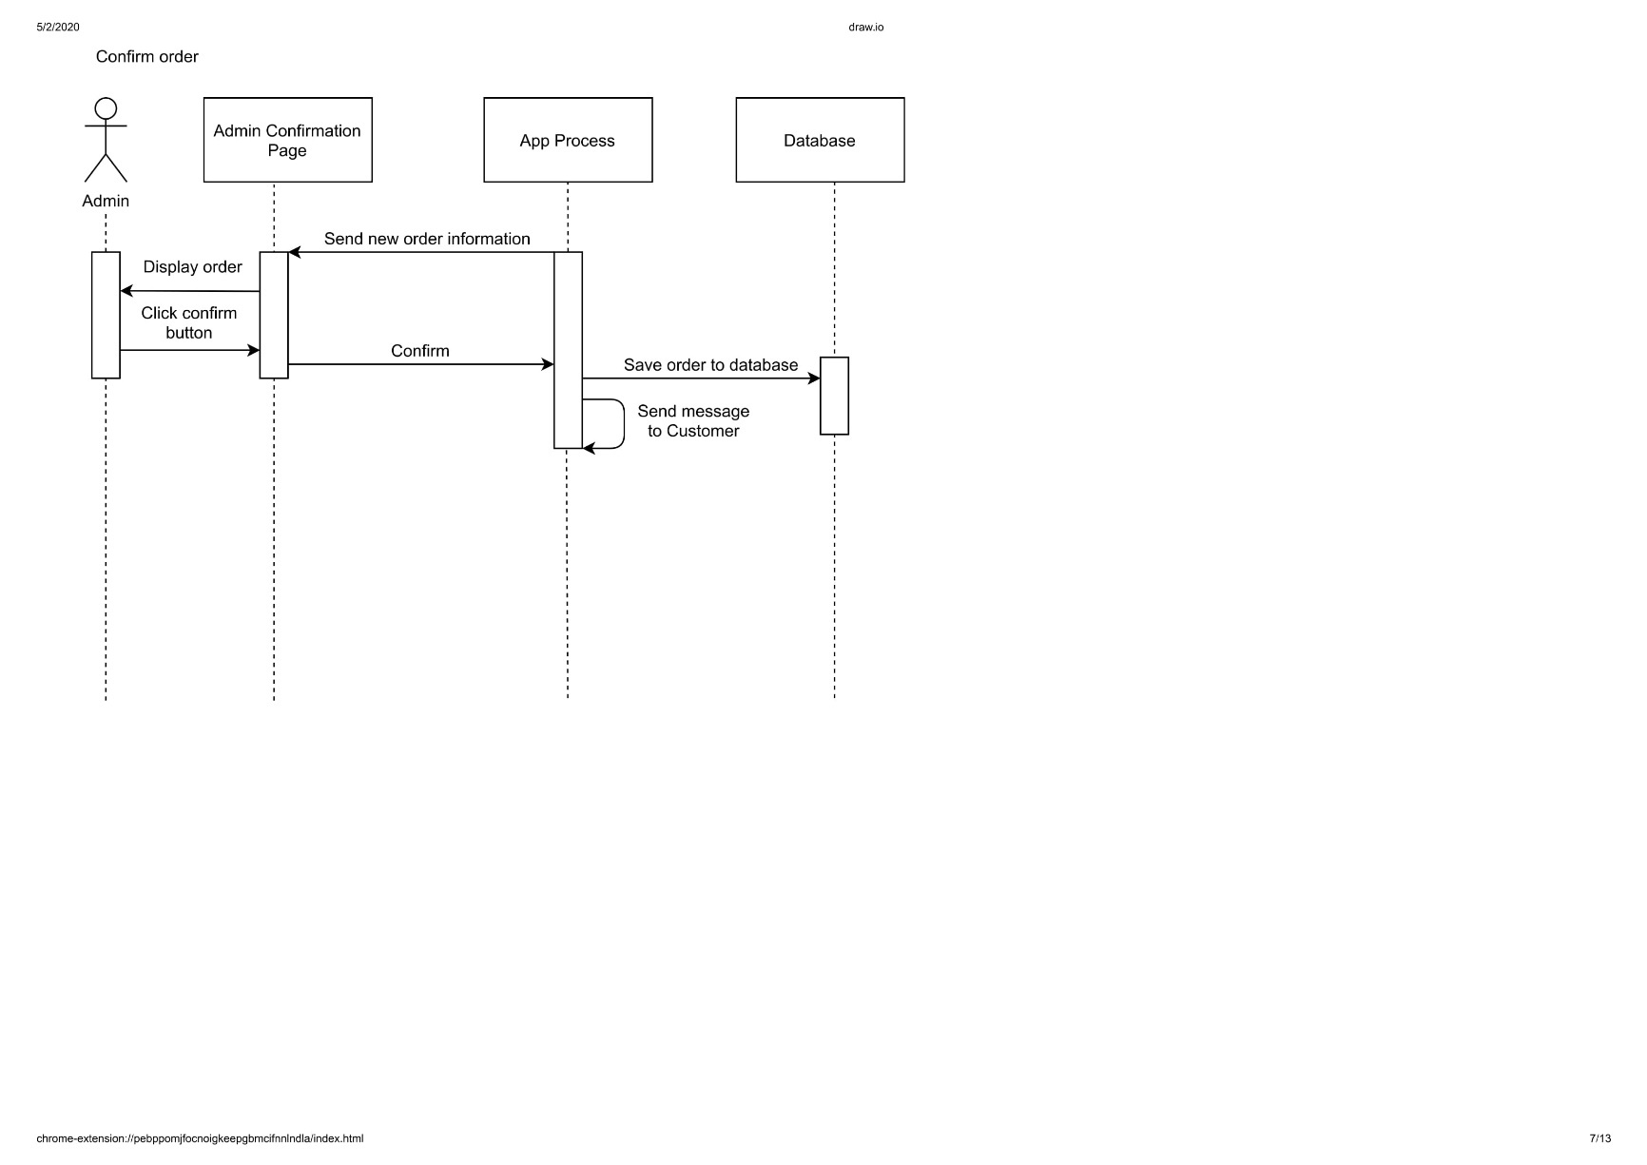

Figure 3. 12 Sequence Confirm Order

#### 3.1.6.3 Class Diagram

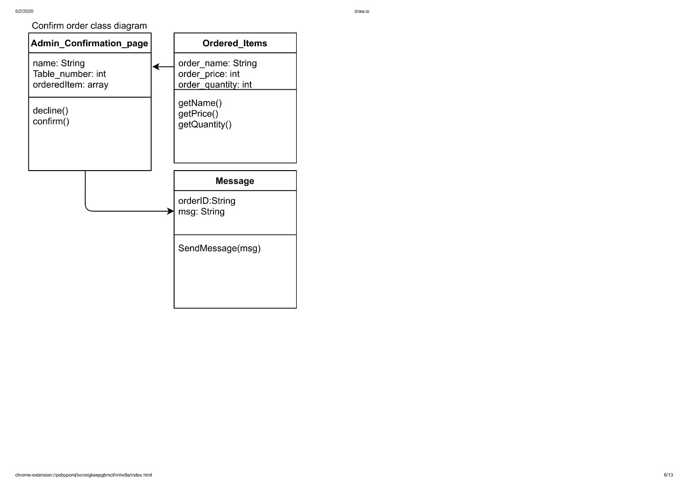

Figure 3. 13 Class Diagram Confirm Order

### 3.1.7 Check Menu Use Case

Check Menu Use Case is a use case that belong to Admin that has function to check the menu to get the information of the menu whether it’s available or out of stock

#### 3.1.7.1 Class Identification

|  |  |  |
| --- | --- | --- |
| No. | Class Name | Class Type |
| 1 | AdminMenuPage | Model |
| 2 | AppProcess | Controller |
| 3 | Database | Database |

Tabel 3. 7 Check Menu

#### 3.1.7.2 Sequence Diagram

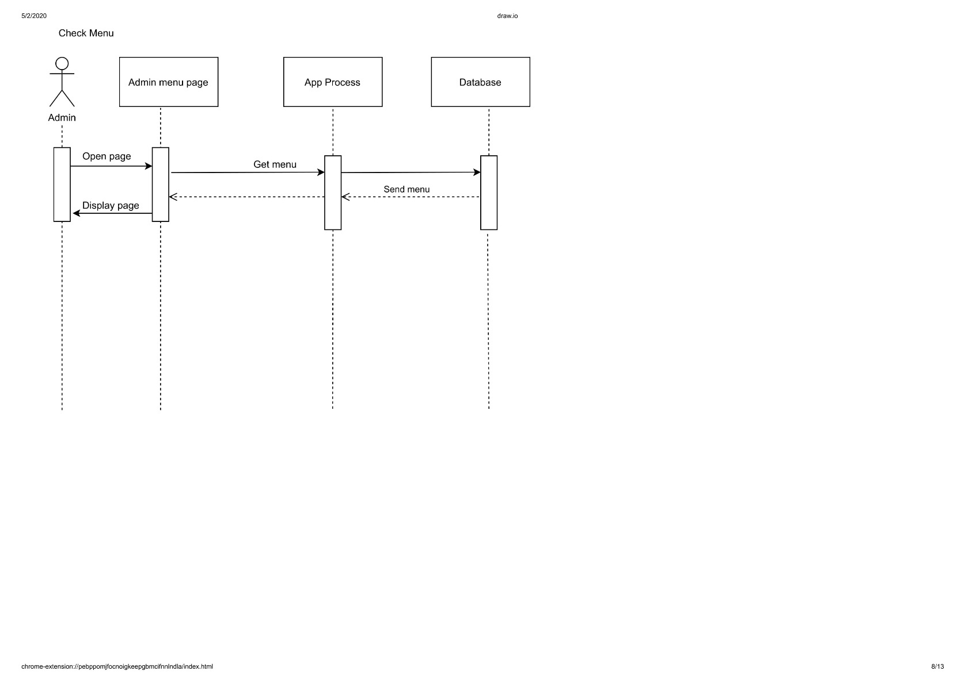

Figure 3. 14 Sequence Check Menu

#### 3.1.7.3 Class Diagram

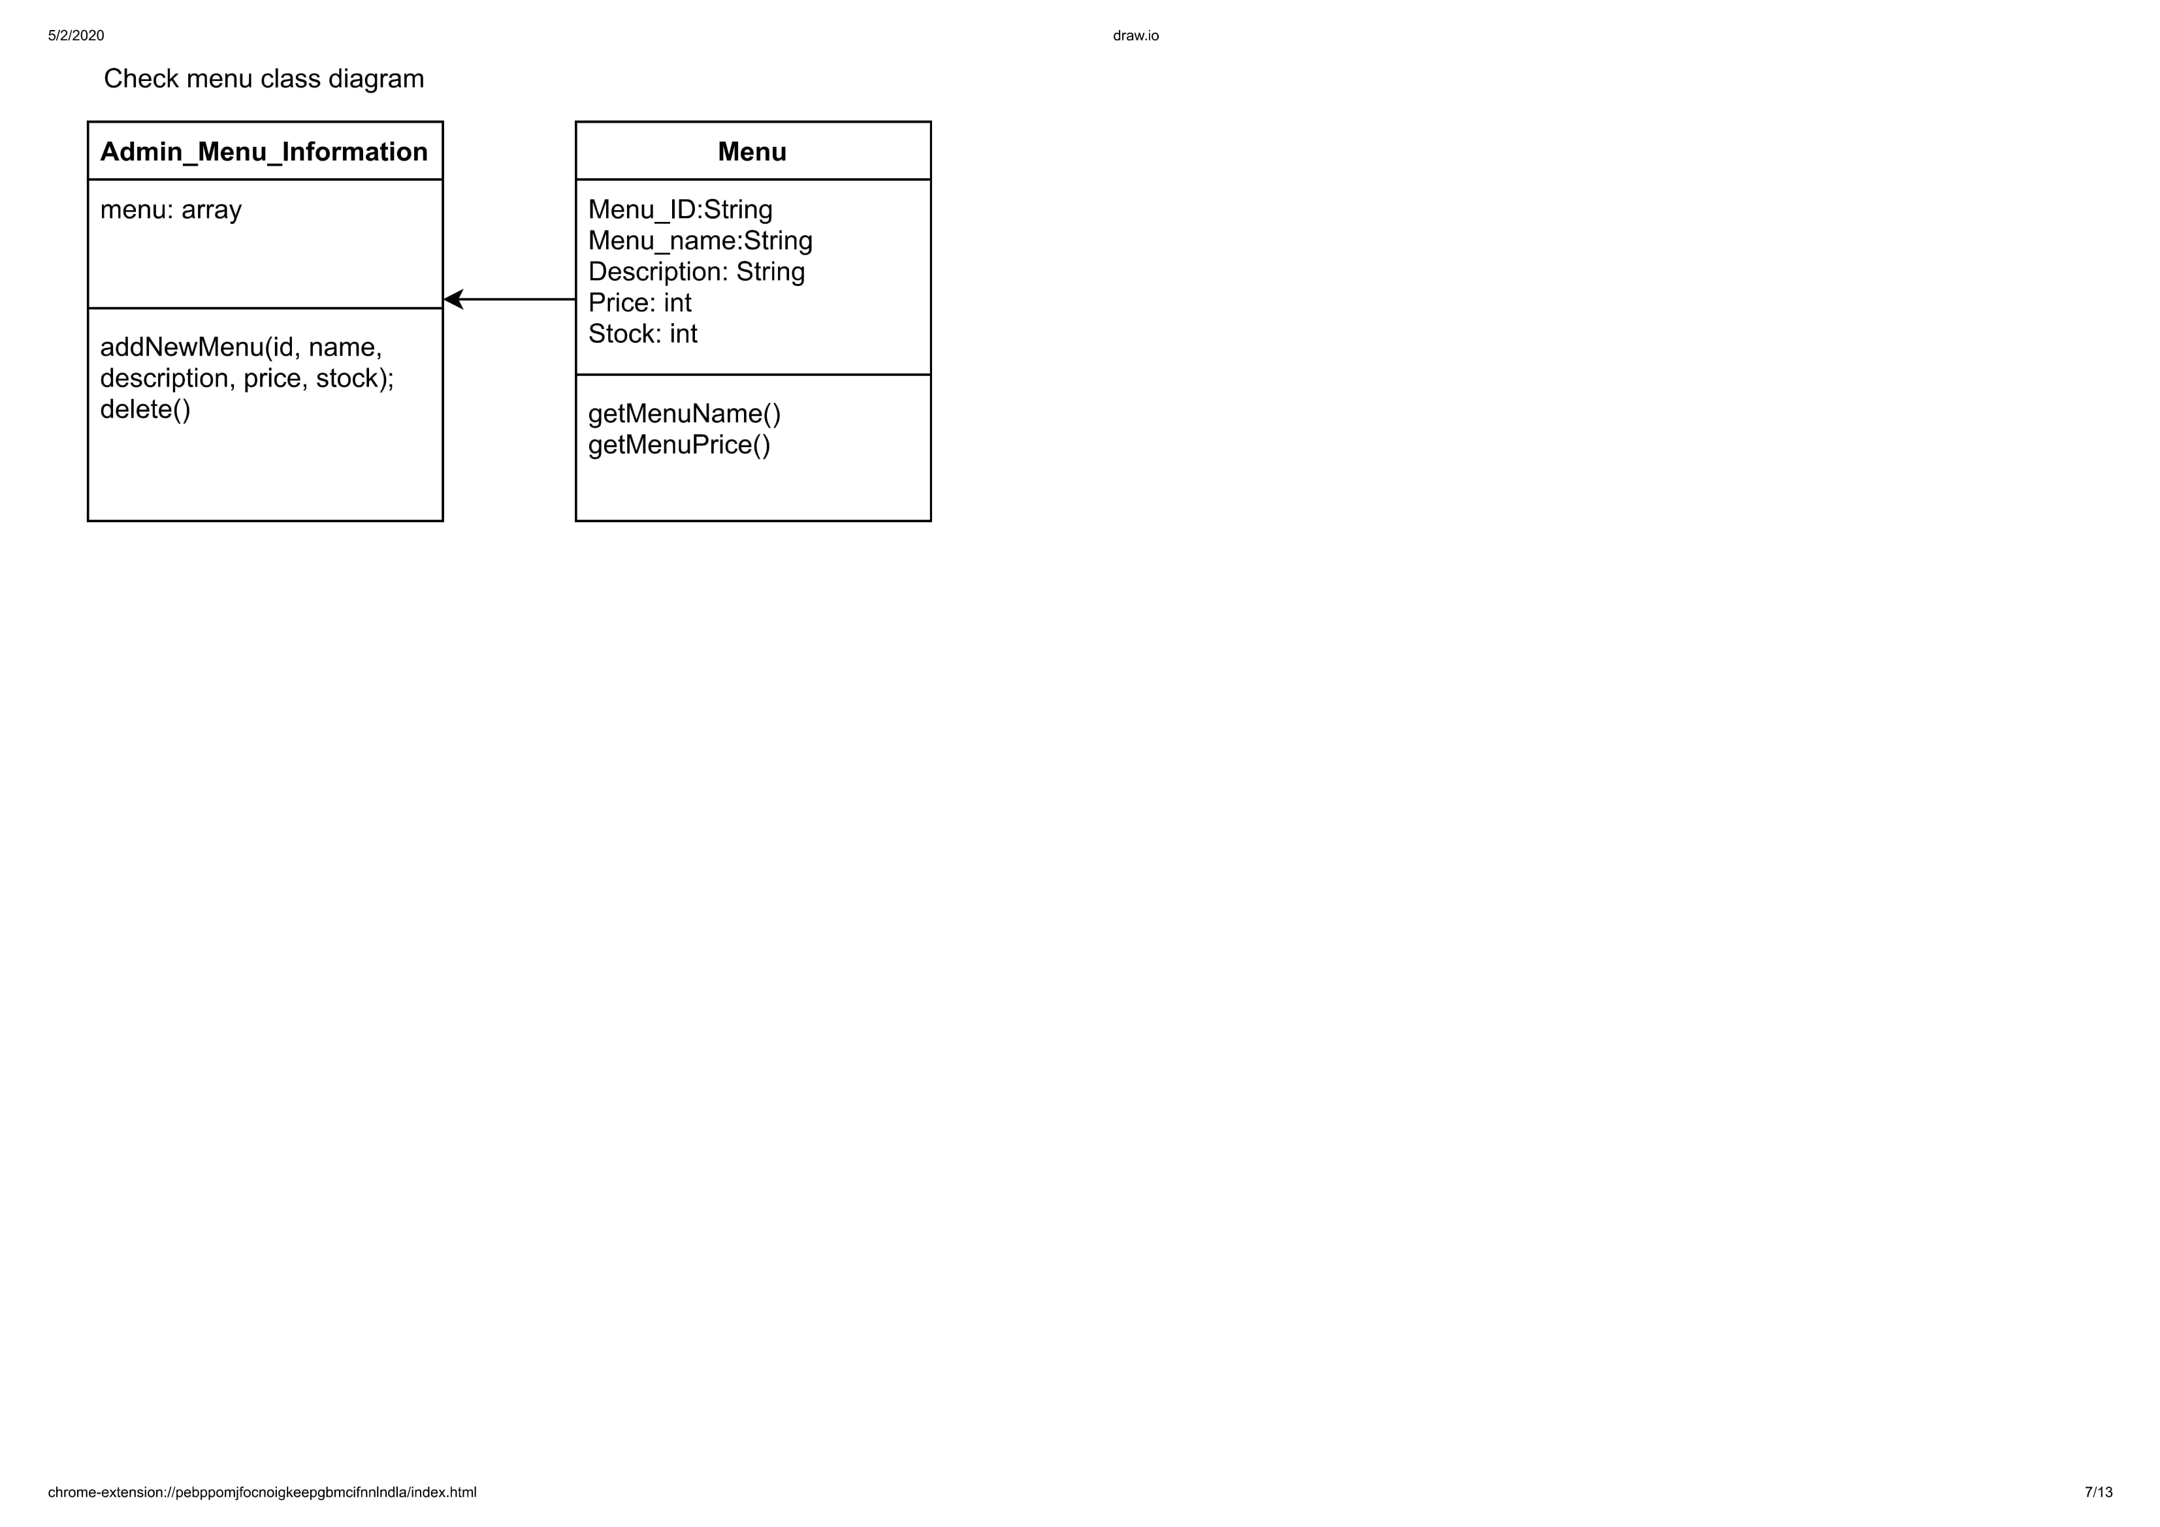

Figure 3. 15 Class Diagram Check Menu

### 3.1.8 Input Menu Use Case

Input Menu Use Case is a use case that belong to Admin that has function to input new menu in the menu list.

#### 3.1.8.1 Class Identification

|  |  |  |
| --- | --- | --- |
| No. | Class Name | Class Type |
| 1 | AdminMenuPage | Model |
| 2 | AppProcess | Controller |
| 3 | Database | Database |

Tabel 3. 8 Input Menu

#### 3.1.8.2 Sequence Diagram

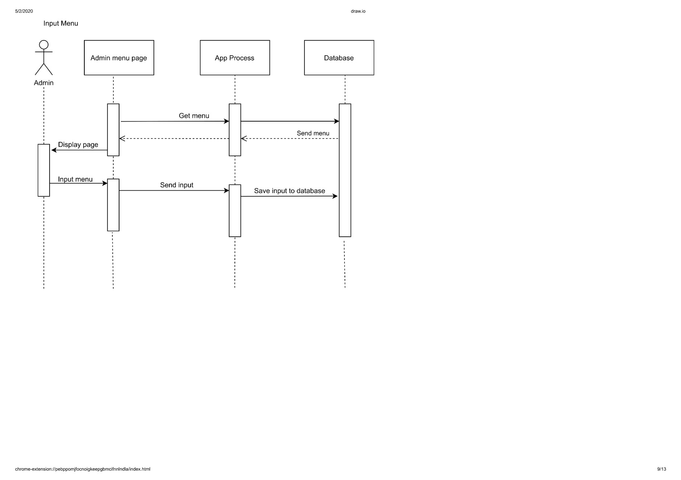

Figure 3. 16 Sequence Input Menu

#### 3.1.8.3 Class Diagram

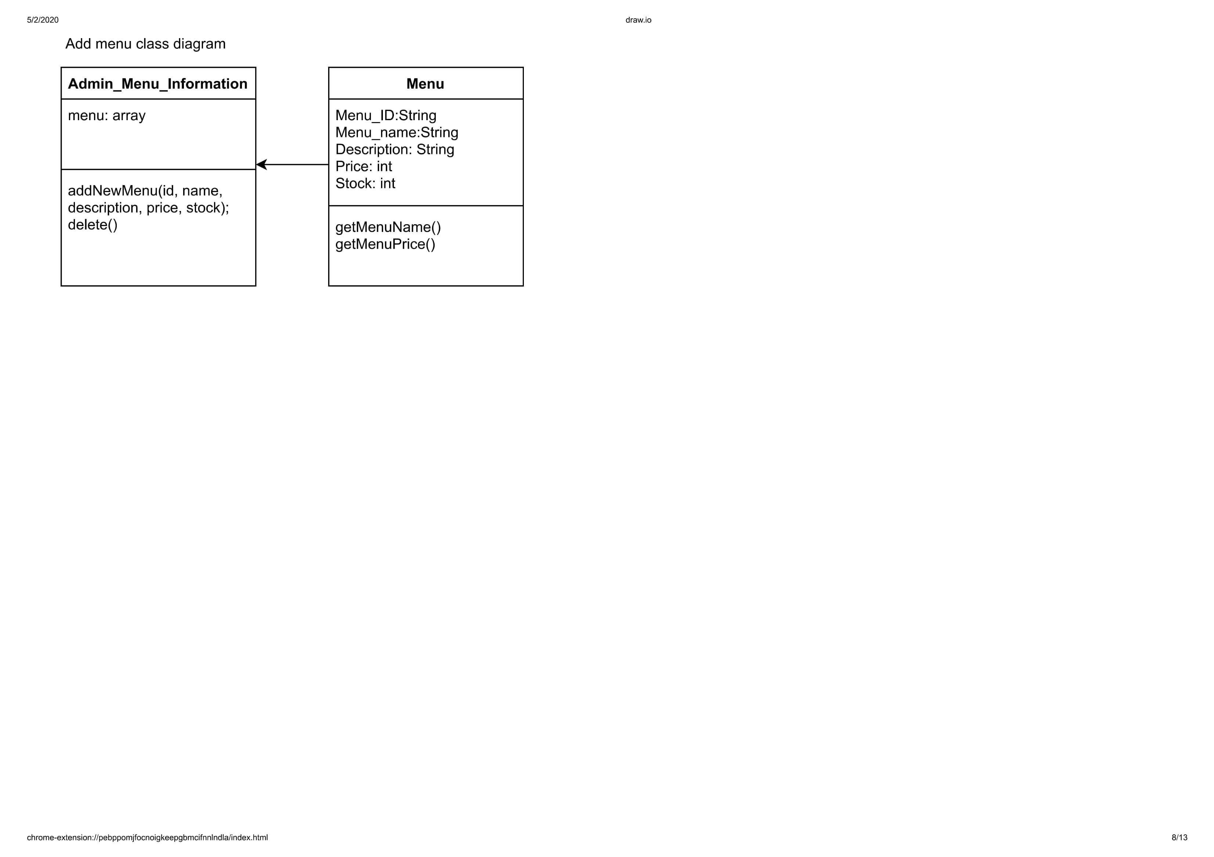

Figure 3. 17 Class Diagram Input Menu

### 3.1.9 Delete Menu Use Case

Delete Menu Use Case is a use case that belong to Admin that has function to delete the menu from the menu list.

#### 3.1.9.1 Class Identification

|  |  |  |
| --- | --- | --- |
| No. | Class Name | Class Type |
| 1 | AdminMenuPage | Model |
| 2 | AppProcess | Controller |
| 3 | Database | Database |

Tabel 3. 9 Delete Menu

#### 3.1.9.2 Sequence Diagram

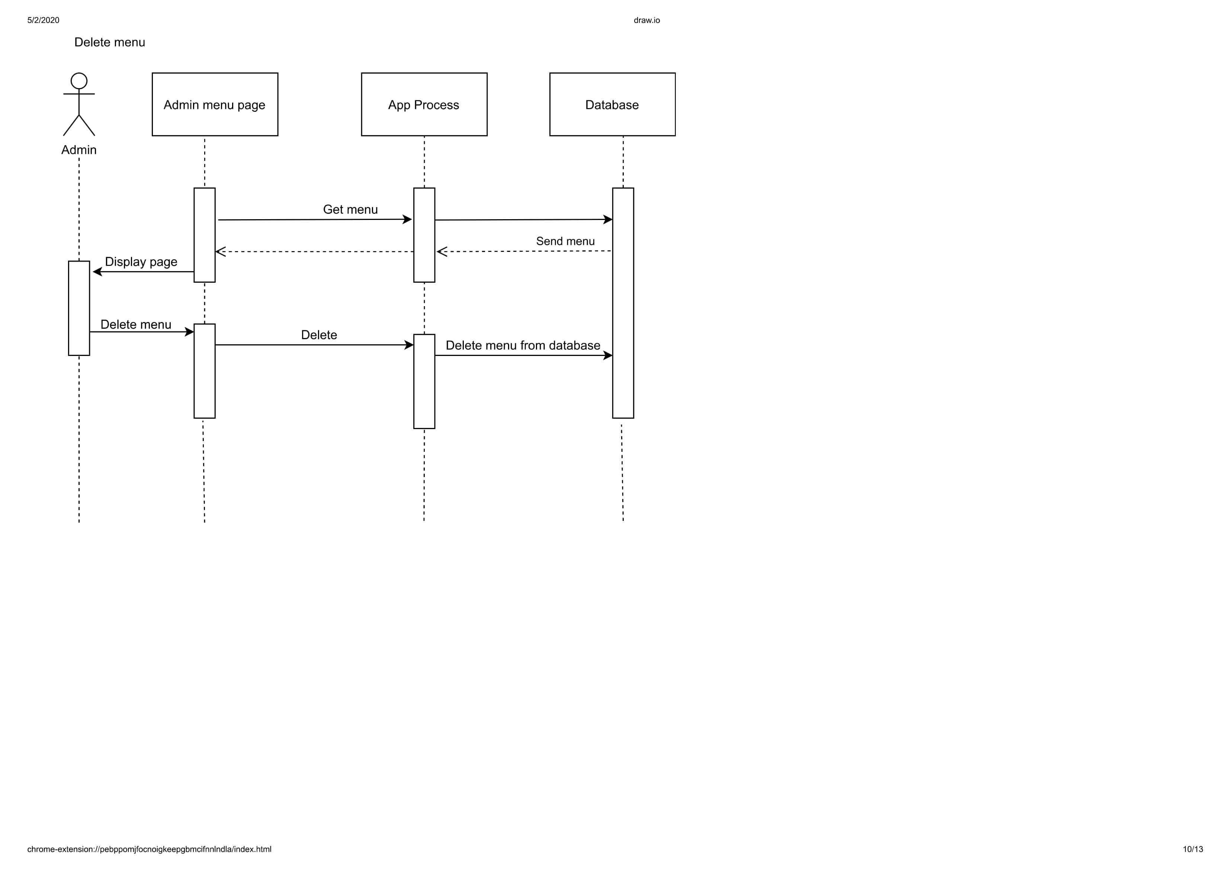

Figure 3. 18 Sequence Delete Menu

#### 3.1.9.3 Class Diagram

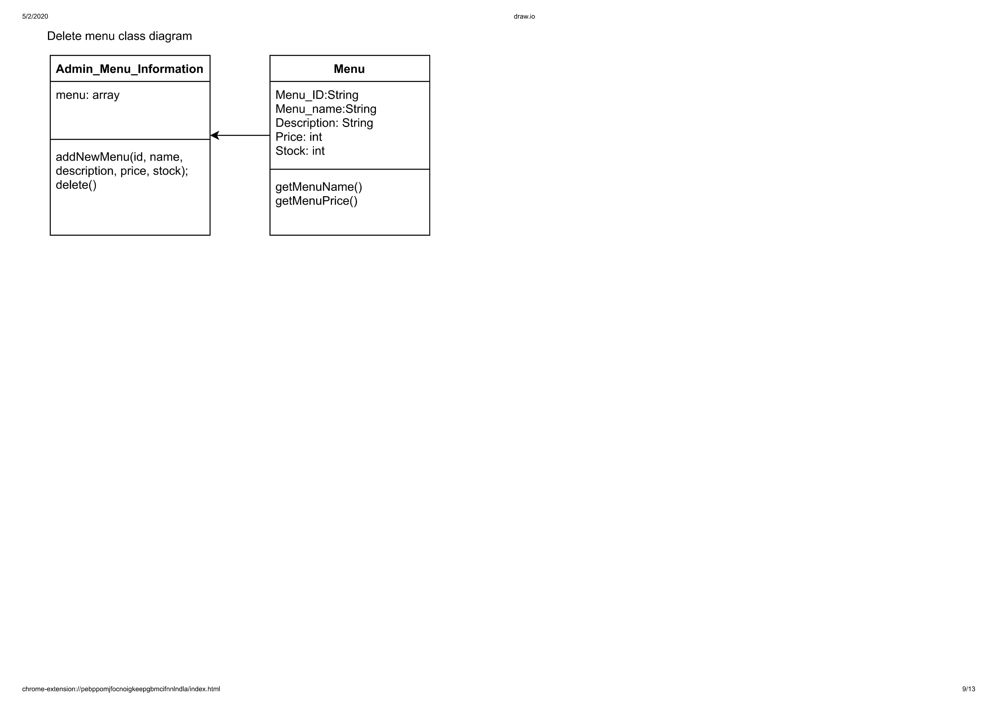

Figure 3. 19 Class Diagram Delete Menu

### 3.1.10 Check Stock Use Case

Check Stock Use Case is a use case that belong to Admin that has function to check the stock availability of the menu.

#### 3.1.10.1 Class Identification

|  |  |  |
| --- | --- | --- |
| No. | Class Name | Class Type |
| 1 | AdminStockPage | Model |
| 2 | AppProcess | Controller |
| 3 | Database | Database |

Tabel 3. 10 Check Stock

#### 3.1.10.2 Sequence Diagram

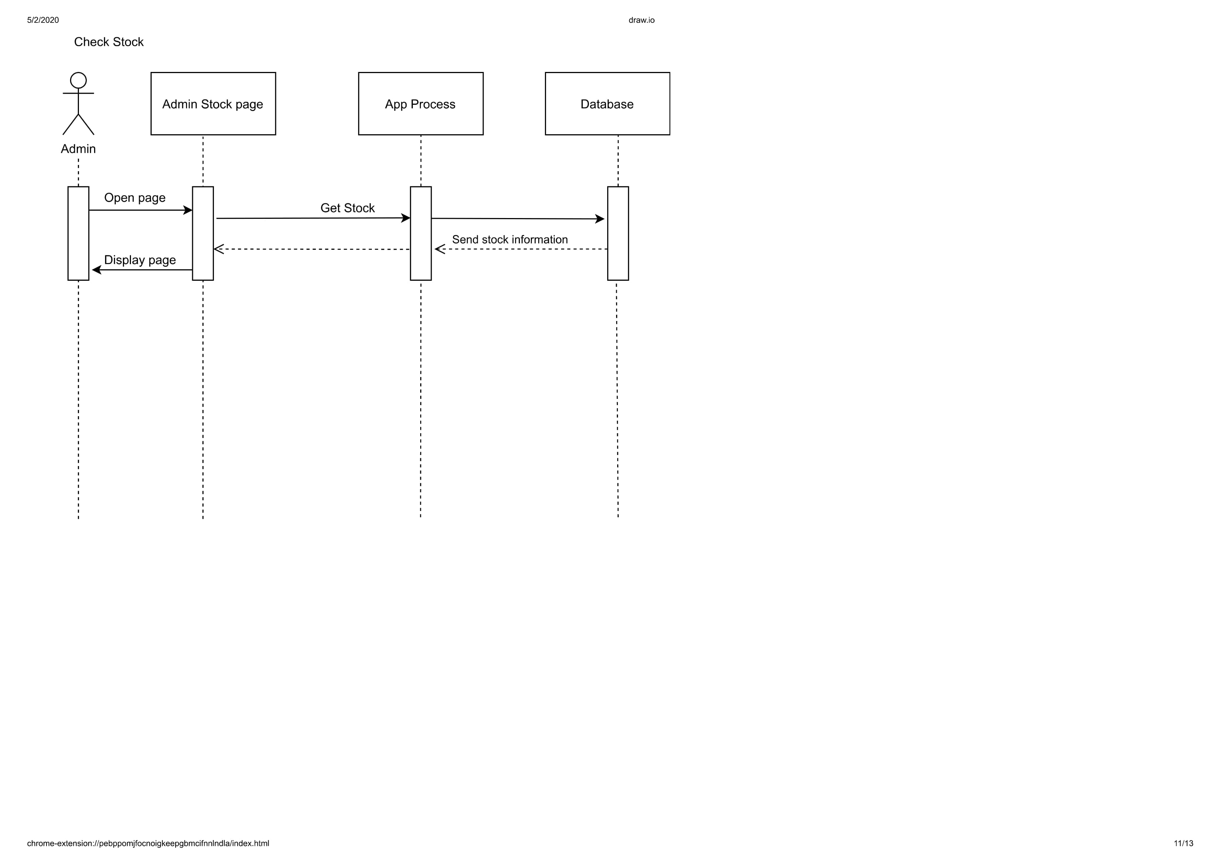

Figure 3. 20 Sequence Check Stock

#### 3.1.10.3 Class Diagram

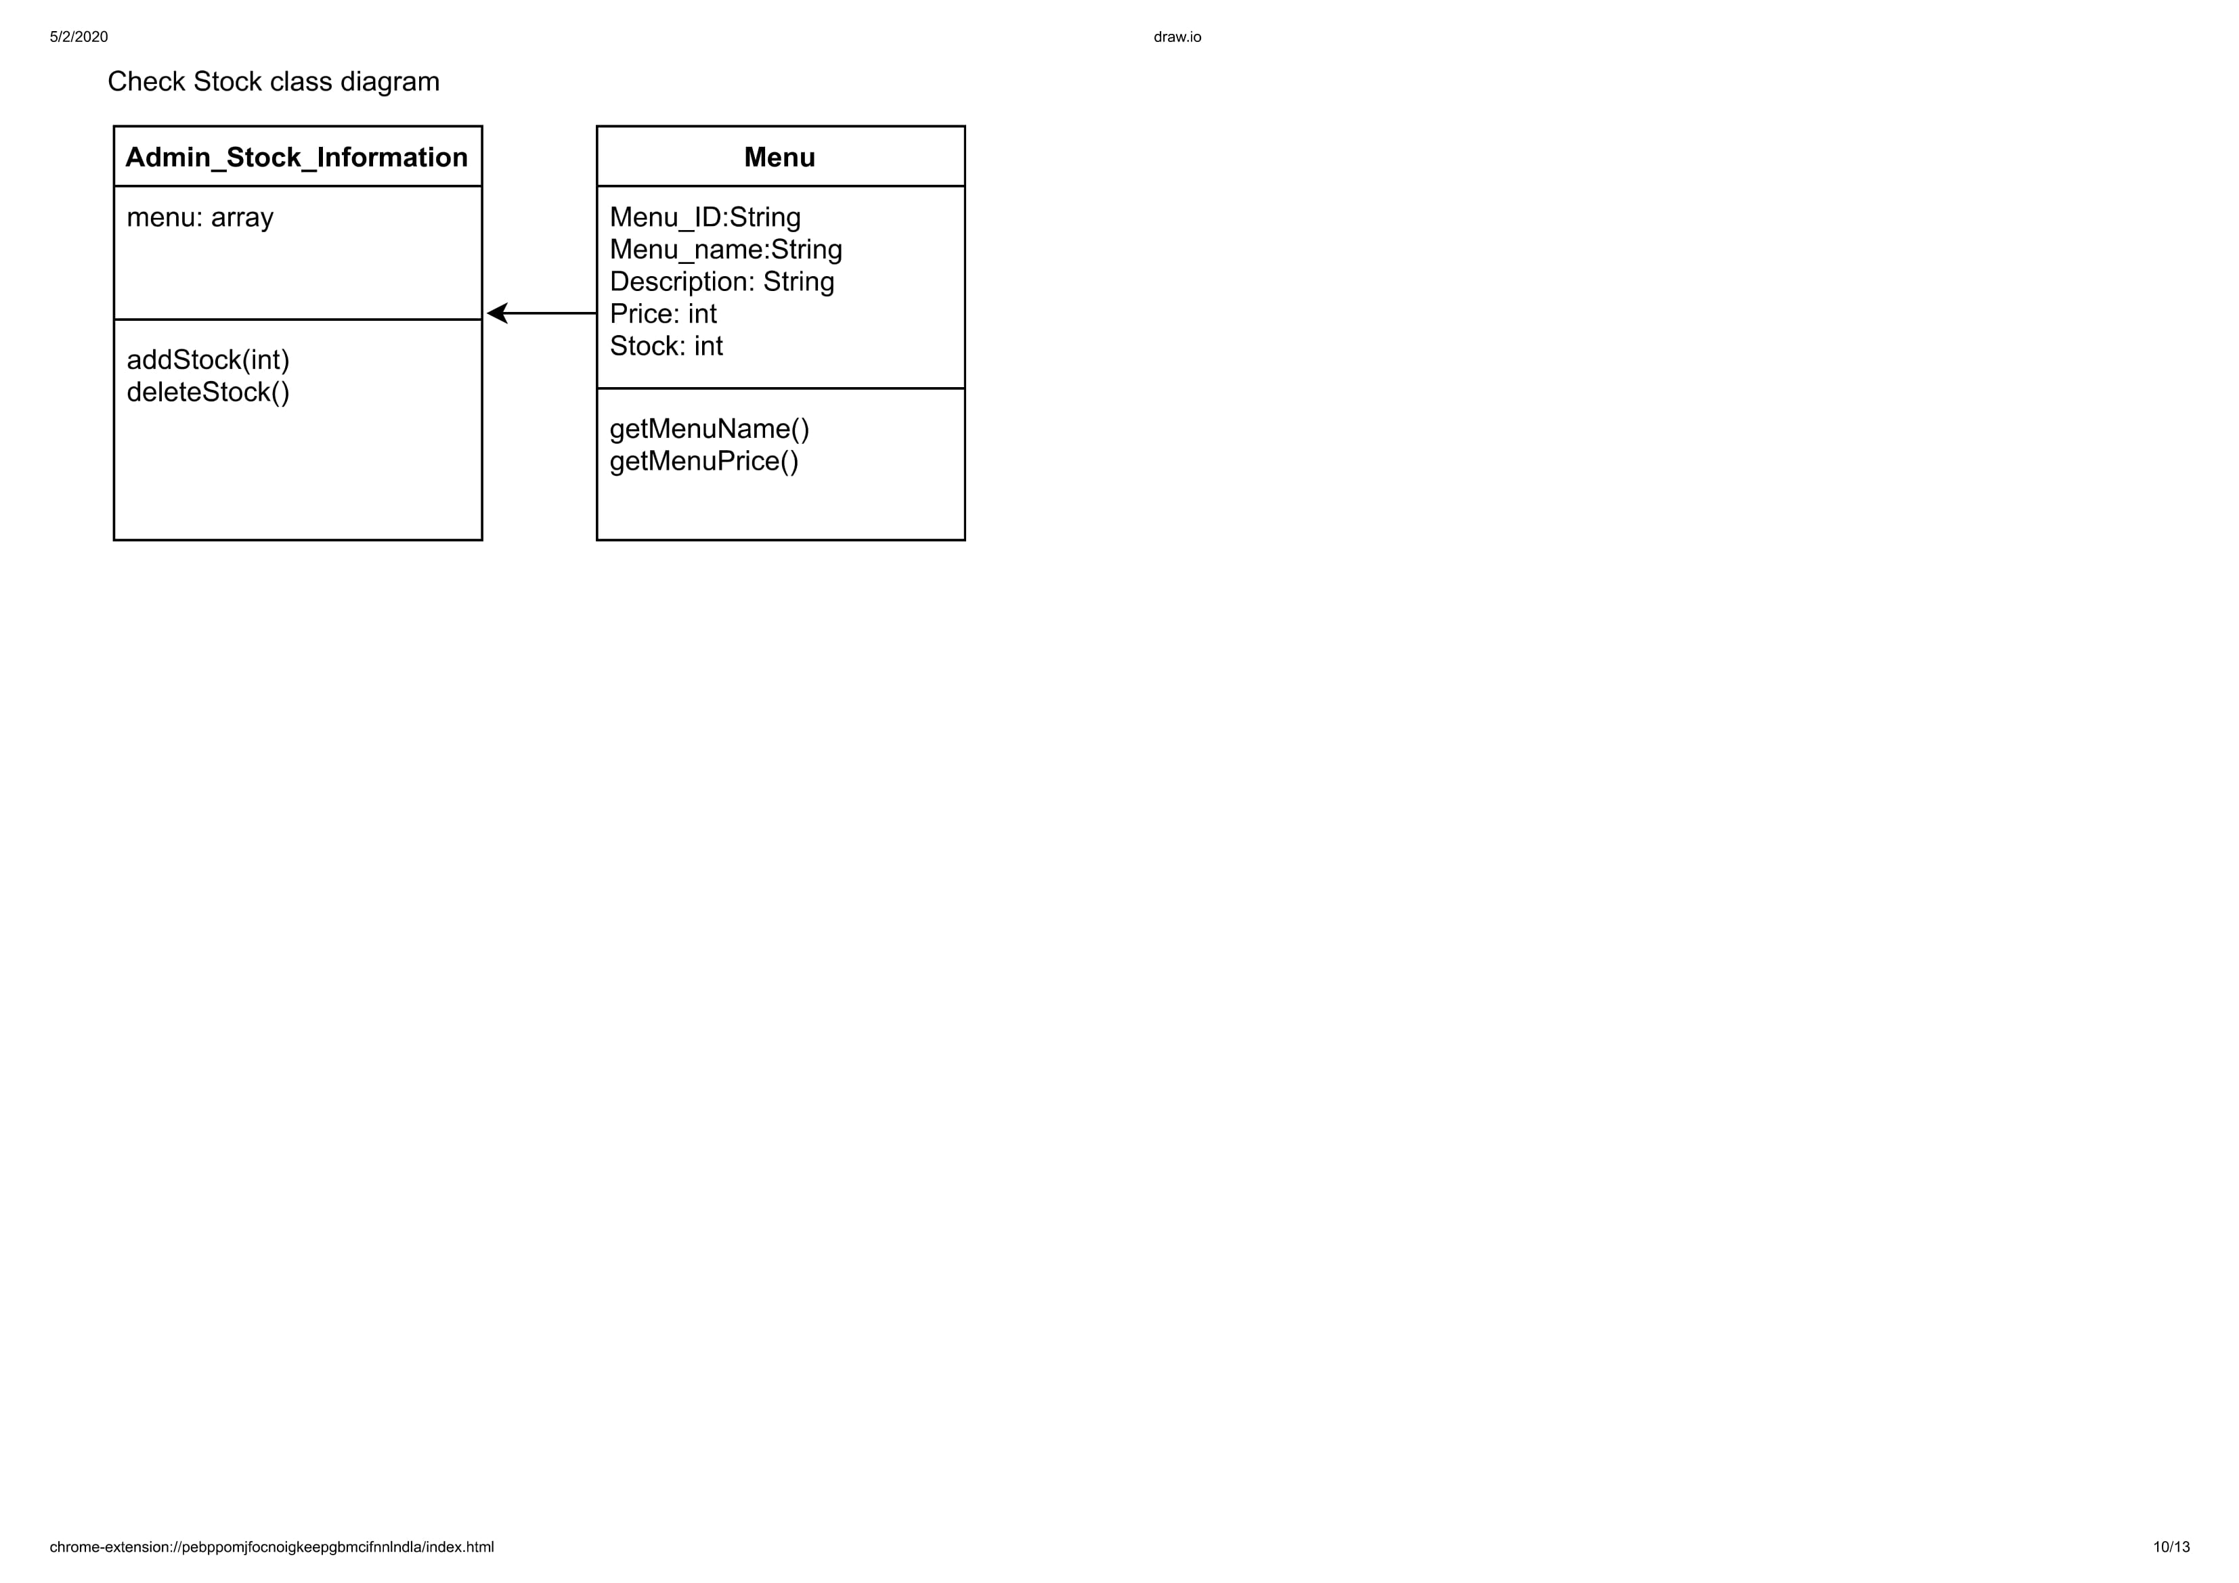

Figure 3. 21 Class Diagram Check Stock

### 3.1.11 Input Stock Use Case

Input Stock Use Case is a use case that belong to Admin that has function to input or add more stock of the menu.

#### 3.1.11.1 Class Identification

|  |  |  |
| --- | --- | --- |
| No. | Class Name | Class Type |
| 1 | AdminStockPage | Model |
| 2 | AppProcess | Controller |
| 3 | Database | Database |

Tabel 3. 11 Input Stock

#### 3.1.11.2 Sequence Diagram

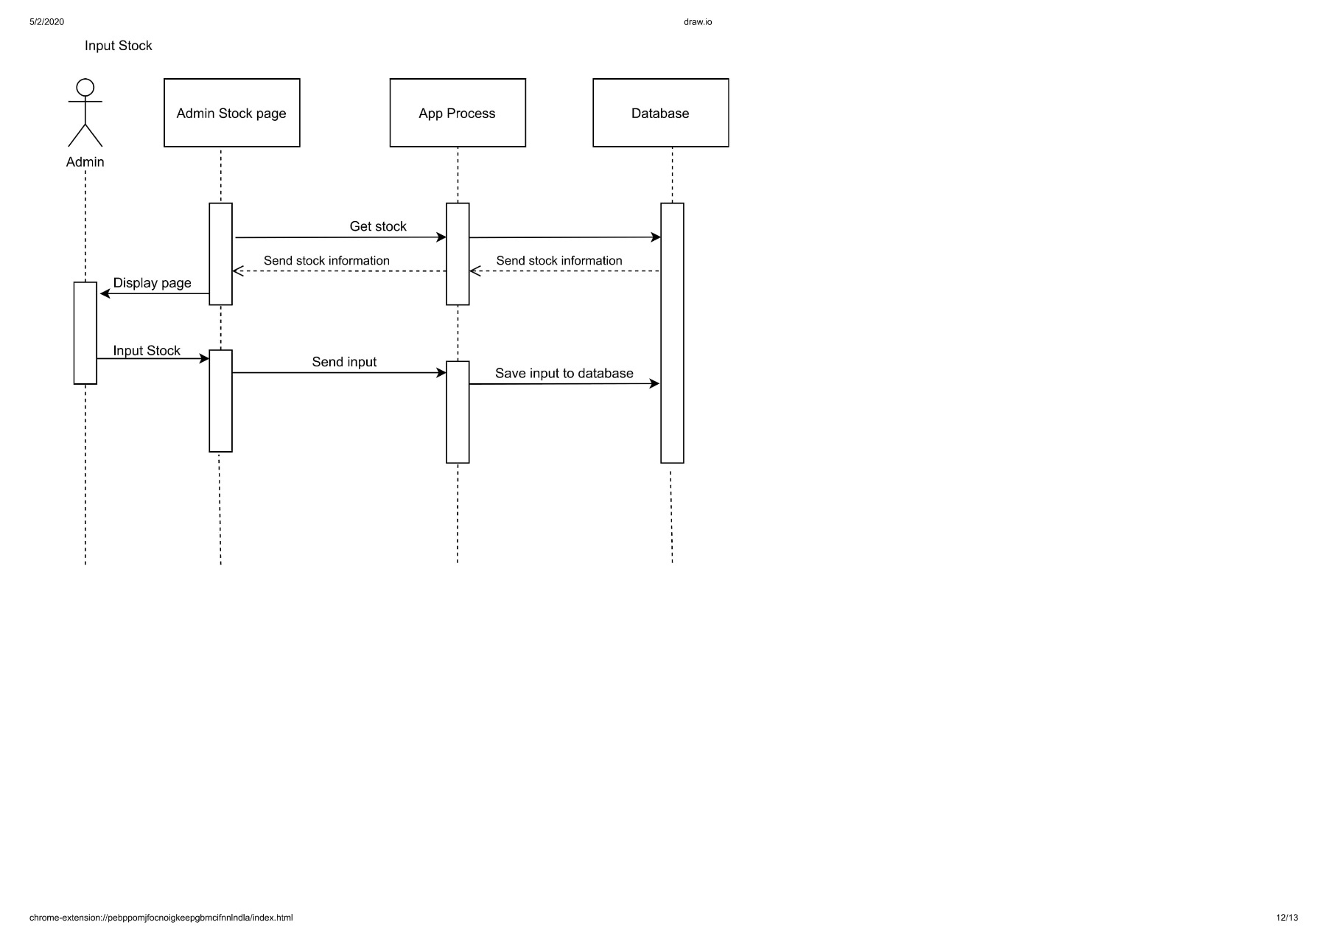

Figure 3. 22 Sequence Input Stock

#### 3.1.11.3 Class Diagram

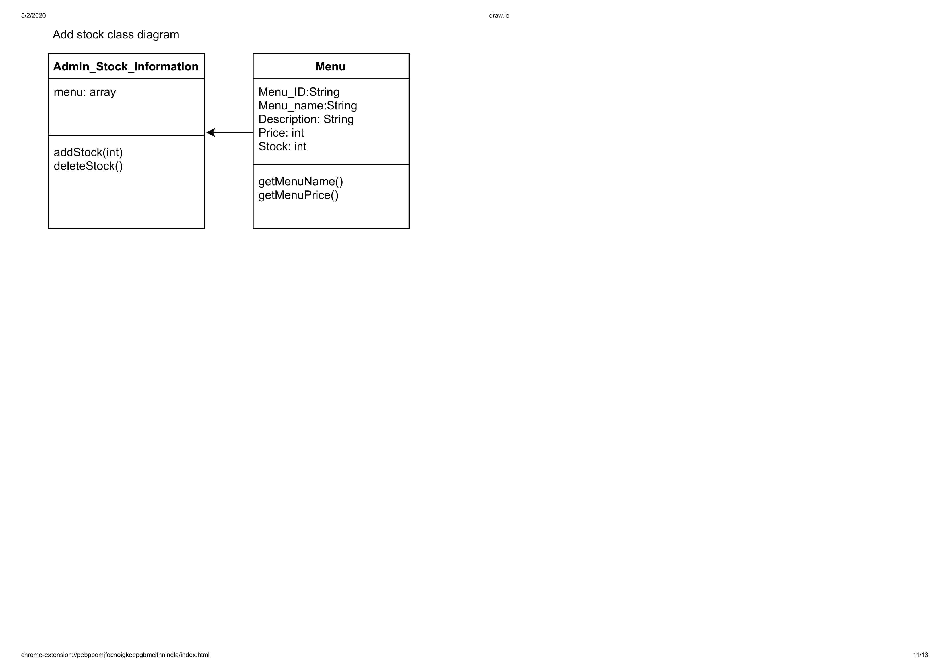

Figure 3. 23 Class Diagram Input Stock

### 3.1.12 Delete Stock Use Case

Delete Stock Use Case is a use case that belong to Admin that has function to delete or decrease the stock of the menu.

#### 3.1.12.1 Class Identification

|  |  |  |
| --- | --- | --- |
| No. | Class Name | Class Type |
| 1 | AdminStockPage | Model |
| 2 | AppProcess | Controller |
| 3 | Database | Database |

Tabel 3. 12 Delete Stock

#### 3.1.12.2 Sequence Diagram

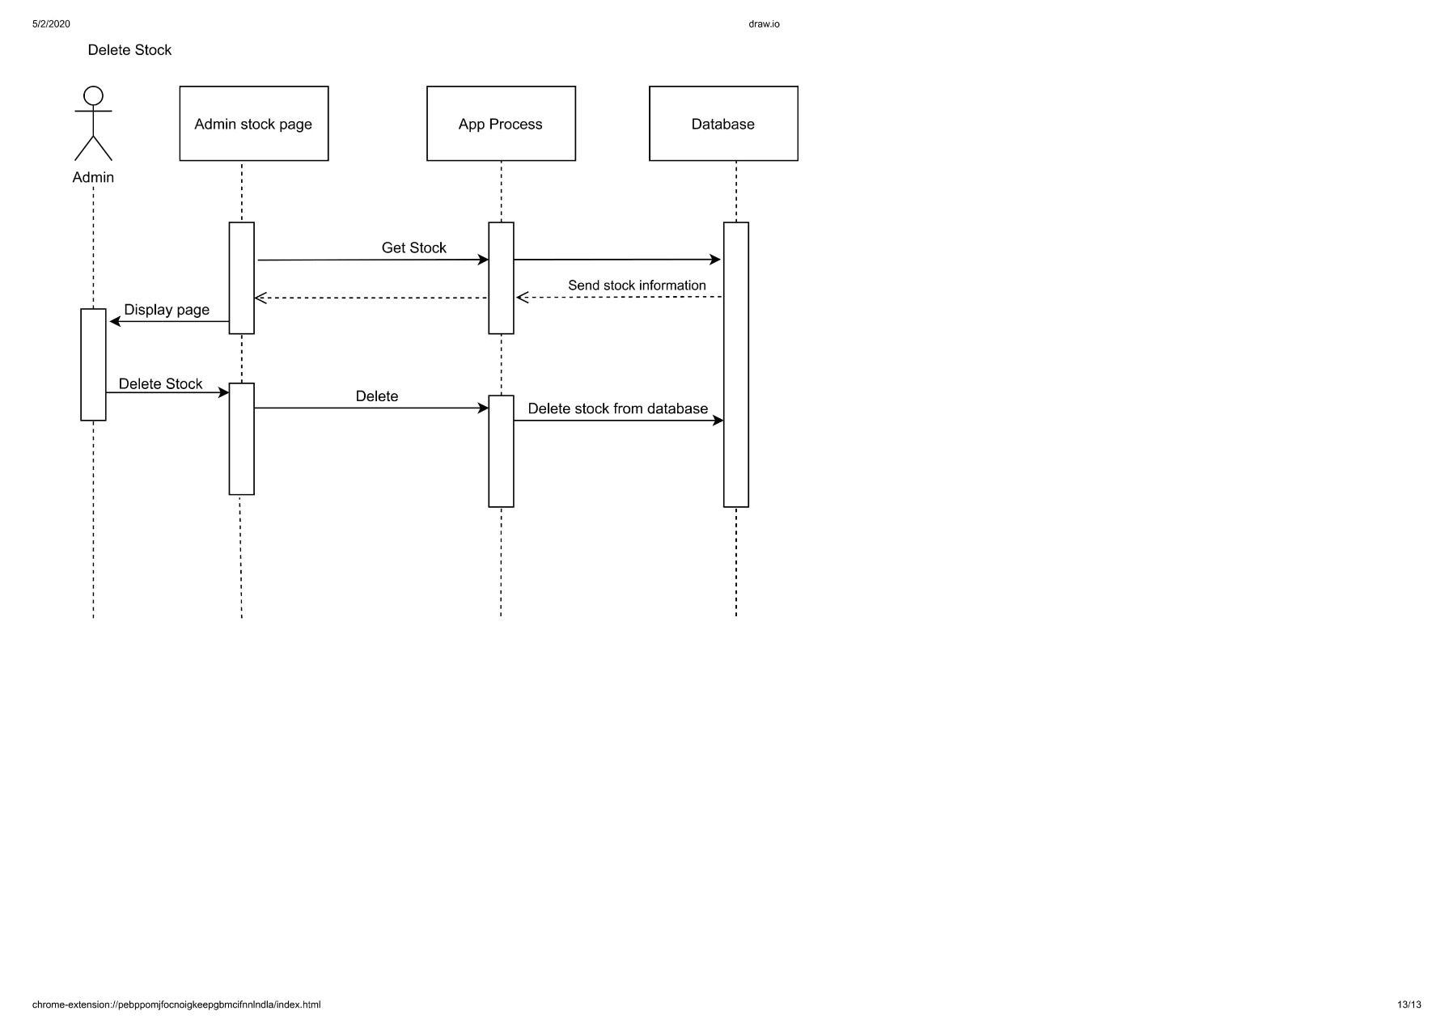

Figure 3. 24 Sequence Delete Stock

#### 3.1.12.3 Class Diagram

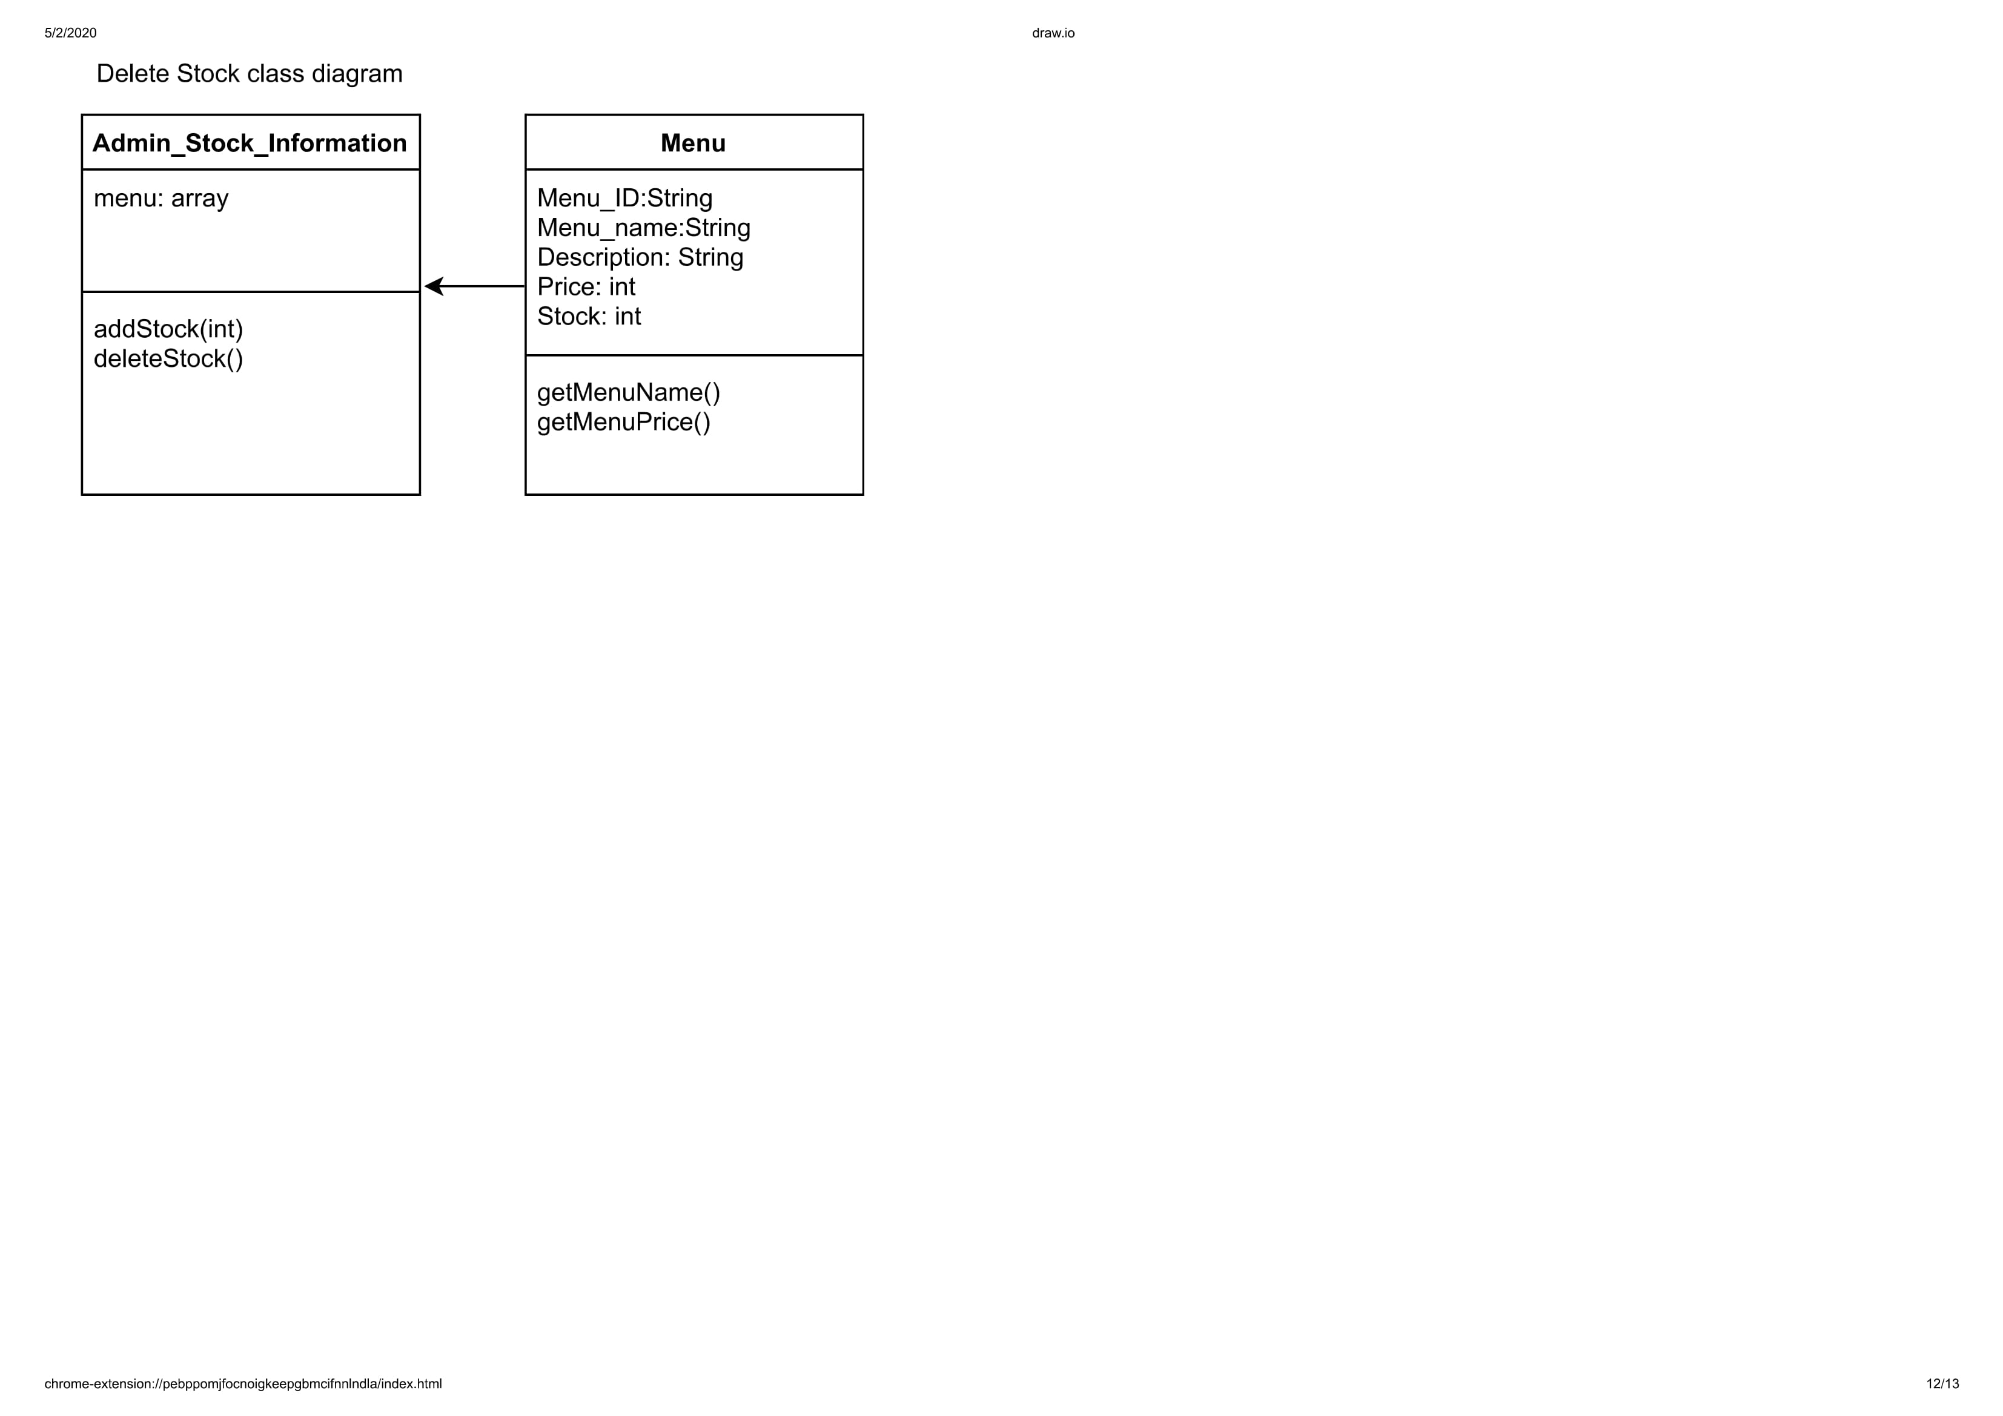

Figure 3. 25 Class Diagram Delete Stock

### 3.1.13 Admin Login Use Case

Admin Login Use Case is a use case that belong to Admin that has function to login to admin page.

#### 3.1.13.1 Class Identification

|  |  |  |
| --- | --- | --- |
| No. | Class Name | Class Type |
| 1 | Login screen | Model |
| 2 | Validation | Controller |
| 3 | Database | Database |

Tabel 3. 13 Class Identification Admin Login

#### 3.1.13.2 Sequence Diagram

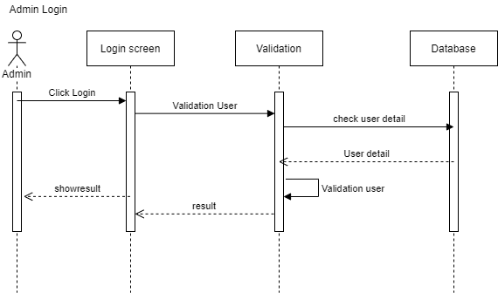

Figure 3. 26 Sequence Delete Stock

#### 3.1.13.3 Class Diagram

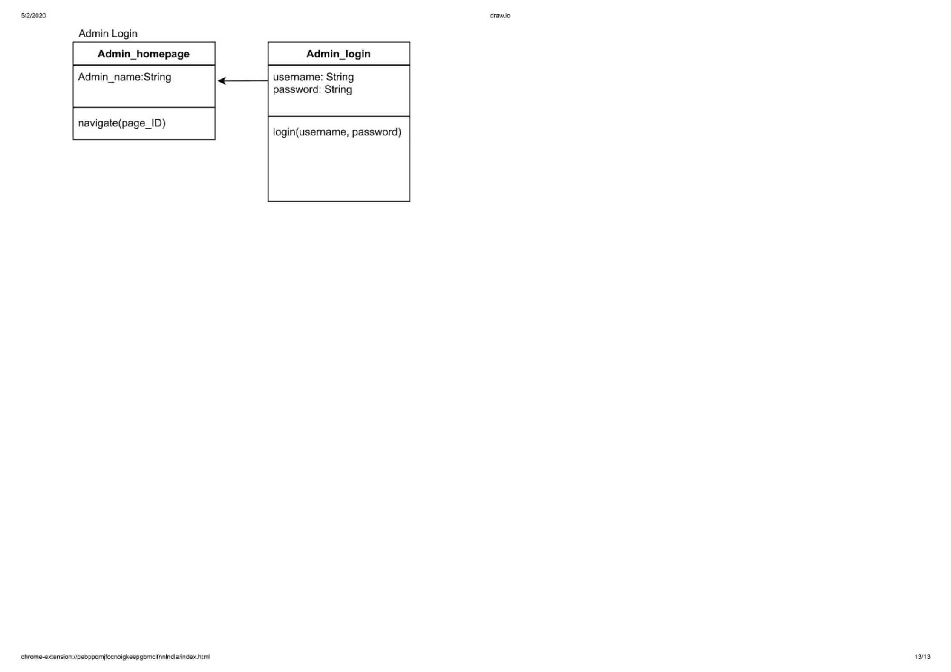

Figure 3. 27 Class Diagram Admin Login

## Detail Class Design

|  |  |  |
| --- | --- | --- |
| No | Class Name | Related Class Name |
| 1. | Admin_login | Admin_homepage |
| 2. | Admin_homapage | Admin_stock_information, Admin_menu_information , Admin_confirmation_page |
| 3. | Admin_stock_information | Menu |
| 4. | Customers | Customers_homepage |
| 5. | Admin_menu_information | Menu |
| 6. | Customers_homepage | Cutomer_confirm_page |
| 7. | Ordered_items | Admin_confirmation_page |
| 8. | Admin_confirmation_page | Receipt, Messege |

Tabel 3. 14 Detail Class Design

### Admin Login Class

Class Name : Admin login

|  |  |  |
| --- | --- | --- |
| **Operation Name** | **Visibility**  **(private, public)** | **Information** |
| Login(username,password) | Private | Admin login |
| **Attribute Name** | **Visibility**  **(private, public)** | **Type** |
| Username | Private | String |
| Password | Private | String |

Tabel 3. 15 Admin Class

### Admin Homepage Class

Class Name : Admin Homepage

|  |  |  |
| --- | --- | --- |
| **Operation Name** | **Visibility**  **(private, public)** | **Information** |
| Navigate(page_ID) | Private | Display homepage |
| **Attribute Name** | **Visibility**  **(private, public)** | **Type** |
| Admin_name | Private | String |

Tabel 3. 16 Admin Homepage

### Admin Stock Information Class

Class Name : Admin stock information

|  |  |  |
| --- | --- | --- |
| **Operation Name** | **Visibility**  **(private, public)** | **Information** |
| addStock(int) | Private | To added stock |
| deleteStock() | Private | To delete stock |
| **Attribute Name** | **Visibility**  **(private, public)** | **Type** |
| Menu | Private | Array |

Tabel 3. 17 Admin Stock Information

### Admin Menu Information Class

Class Name : Admin menu information

|  |  |  |
| --- | --- | --- |
| **Operation Name** | **Visibility**  **(private, public)** | **Information** |
| addMenu() | Private | To add the menu |
| Delete() | Private | To delete the menu |
| **Attribute Name** | **Visibility**  **(private, public)** | **Type** |
| Menu | Private | Array |

Tabel 3. 18 Admin Menu Information

### Admin Confirmation Page Class

Class Name : Admin confirmation page

|  |  |  |
| --- | --- | --- |
| **Operation Name** | **Visibility**  **(private, public)** | **Information** |
| Decline() | Private | To decline the form from cust |
| Confirm() | Private | To confirm the form from cust |
| **Attribute Name** | **Visibility**  **(private, public)** | **Type** |
| Name | Private | String |
| Table_number | Private | Integer |
| orderitem | Private a | Array |

Tabel 3. 19 Admin Confirmation Page

### Receipt Class

Class Name : Receipt

|  |  |  |
| --- | --- | --- |
| **Operation Name** | **Visibility**  **(private, public)** | **Information** |
| Print() | Public | Used to print the receipt |
| GetTotalPrice() | Public | Calculate the total price |
| **Attribute Name** | **Visibility**  **(private, public)** | **Type** |
| Order_id | Public | String |
| Customer_name | Public | String |

Tabel 3. 20 Receipt Class

### Menu Class

Class Name : Menu

|  |  |  |
| --- | --- | --- |
| **Operation Name** | **Visibility**  **(private, public)** | **Information** |
| getMenuName() | Public | The list of menu |
| getMenuPrice() | Private | The list of price |
| **Attribute Name** | **Visibility**  **(private, public)** | **Type** |
| Menu_ID | Public | String |
| Nama_menu | Public | String |
| Description | Public | String |
| Price | Public | Integer |
| Stock | Public | Integer |

Tabel 3. 21 Menu Class

### Ordered Items Class

Class Name : Ordered items

|  |  |  |
| --- | --- | --- |
| **Operation Name** | **Visibility**  **(private, public)** | **Information** |
| getName() | Public | The list of menu |
| getPrice() | Private | The list of price |
| getQuantity() | Public | The list of quantity |
| **Attribute Name** | **Visibility**  **(private, public)** | **Type** |
| Order_name | Public | String |
| Order_price | Public | Integer |
| Order_quantity | Public | Integer |

Tabel 3. 22 Ordered Items

### Message Class

Class Name : Message

|  |  |  |
| --- | --- | --- |
| **Operation Name** | **Visibility**  **(private, public)** | **Information** |
| SendMessage(msg) | Public | To send the confirm page |
| **Attribute Name** | **Visibility**  **(private, public)** | **Type** |
| orderID | Public | String |
| msg | Public | String |

Tabel 3. 23 Message Class

### Customers Homepage Class

Class Name : Customers homepage

|  |  |  |
| --- | --- | --- |
| **Operation Name** | **Visibility**  **(private, public)** | **Information** |
| inputName(string) | Public | The list of menu |
| inputTableNumber(string) | Private | The list of price |
| addQuantity(int) | Public | To add the quantity |
| minQuantity(int) | Public | The minimum of quantity |
| getTotal(int) | Public | The list of total menu |
| getMenu(array) | Public | The list og the menu |
| **Attribute Name** | **Visibility**  **(private, public)** | **Type** |
| Name | Public | String |
| Table_number | Public | Integer |

Tabel 3. 24 Customers Homepage

### Customers Class

Class Name : Customers

|  |  |  |
| --- | --- | --- |
| **Operation Name** | **Visibility**  **(private, public)** | **Information** |
| inputName() | Private | To add name cust |
| inputTableNumber() | Private | To add no table cust |
| **Attribute Name** | **Visibility**  **(private, public)** | **Type** |
| Name | Public | String |
| Table_number | Public | Integer |

Tabel 3. 25 Customers Class

### Customers Confirm Page Class

Class Name : Customers confirm page

|  |  |  |
| --- | --- | --- |
| **Operation Name** | **Visibility**  **(private, public)** | **Information** |
| Confirm(orderID) | Private | To confirm the menu |
| Modify() | Private | To modify the menu |
| **Attribute Name** | **Visibility**  **(private, public)** | **Type** |
| Order | Public | Array |
| Total | Public | Integer |

Tabel 3. 26 Customers Confirm Page

## Class Diagram

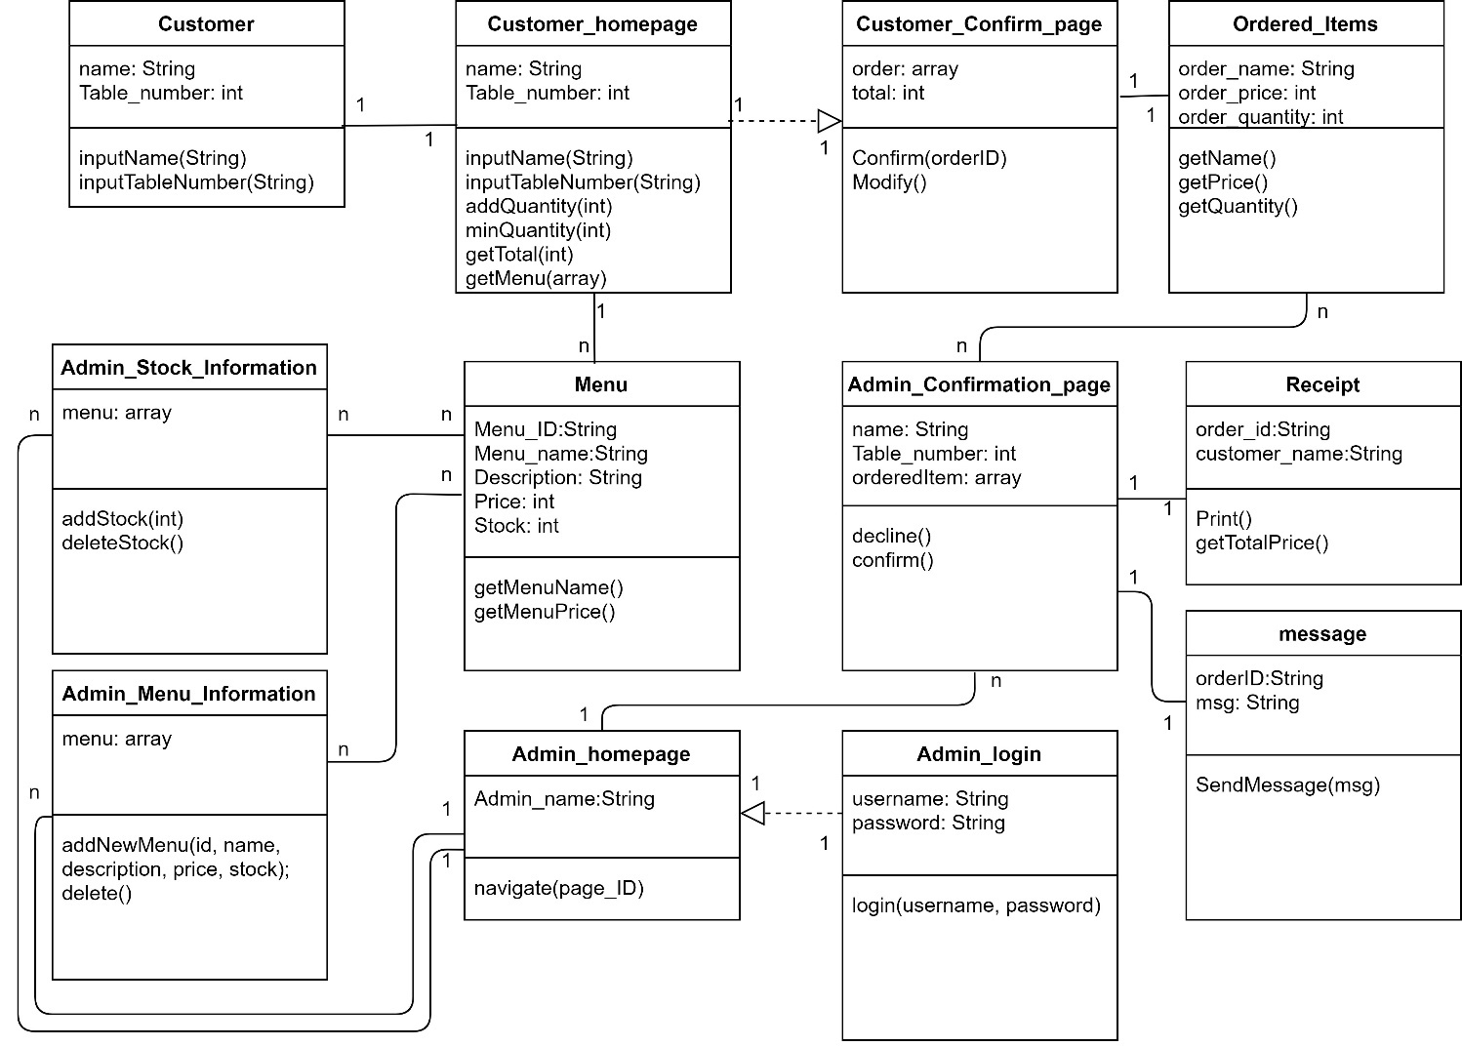

Figure 3. 28 Class Diagram

## Algorithm / Query

### *Add Quantity*

Class Name : Customer Homepage

Operation Name : Add quantity

Algorithm : (Algo-C001)

Add(int index){

Int x = ordered_item[index];

x++;

ordered_item[index] = x;

}

Query : -

|  |  |  |
| --- | --- | --- |
| No Query | Query | Information |
| - | - | - |

Tabel 3. 27 Add Quantity

### *Minus Quantity*

Class Name : Customer Homepage

Operation Name : Minus quantity

Algorithm : (Algo-C002)

Minus(int index){

Int x = ordered_item[index];

X = x-1;

ordered_item[index] = x;

}

Query :-

|  |  |  |
| --- | --- | --- |
| No Query | Query | Information |
| - | - | - |

Tabel 3. 28 Minus Quantity

### *Get menu*

Class Name : Customer Homepage

Operation Name : Get menu

Algorithm : (Algo-C003)

getMenu{

http.get(“server_address_here”);

response = json.decode(response.body);

menuArray = response;

}

Query :

|  |  |  |
| --- | --- | --- |
| No Query | Query | Information |
| Q-001 | Select menu_name, description, price, image from menu | Used to fetch information of the menu |

Tabel 3. 29 Get Menu

## Interface Design

### Interface : 001 – Customers Home Page

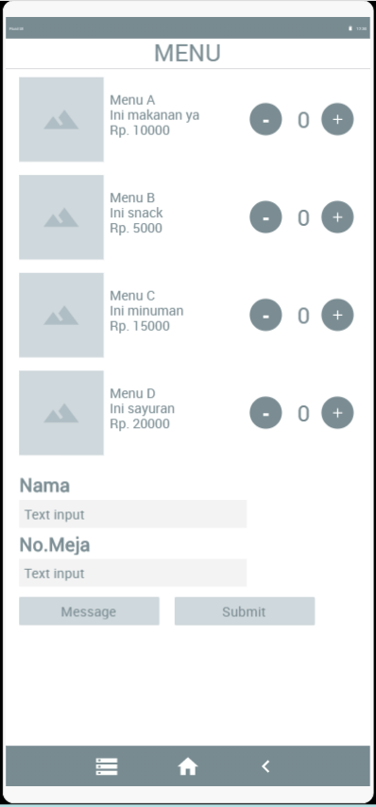

Figure 3. 29 Customers Home Page

|  |  |  |  |
| --- | --- | --- | --- |
| **Id_Object** | **Type** | **Name** | **Information** |
| InputField1 | Input | Nama | Filled with the string of name |
| InputField2 | Input | No.Meja | Filled with the String of table number |
| Button1 | Button | Submit | If the button clicked, the data from Menu page will be saved temporarily at the buffer |
| Button2 | Button | Message | To see the message from admin |
| Button3 | Button | - | To add the amount of menu that will be order |
| Button4 | Button | + | To reduce the amount of menu that will be order |

Tabel 3. 30 Description Customers Home Page

### Interface : 002 – Customers Confirm Page

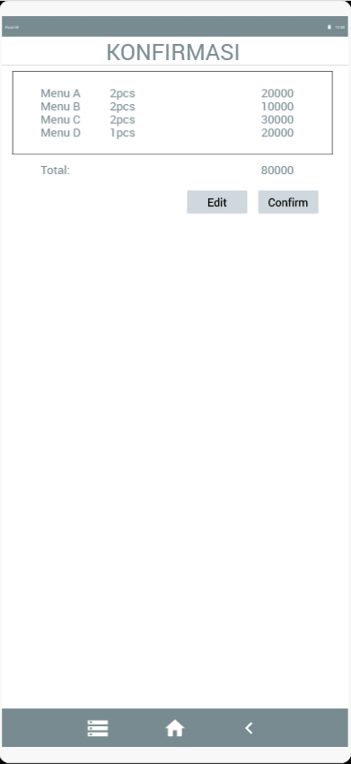

Figure 3. 30 Customers Confirm Page

|  |  |  |  |
| --- | --- | --- | --- |
| **Id_Object** | **Type** | **Name** | **Information** |
| Button1 | Button | Edit | If the button clicked, Custimer can change the menu that customer fill before |
| Button2 | Button | Konfirmasi | If clicked then the order will be send to admin to be processed |

Tabel 3. 31 Description Customers Confirm Page

### Interface : 003 – Admin Homepage

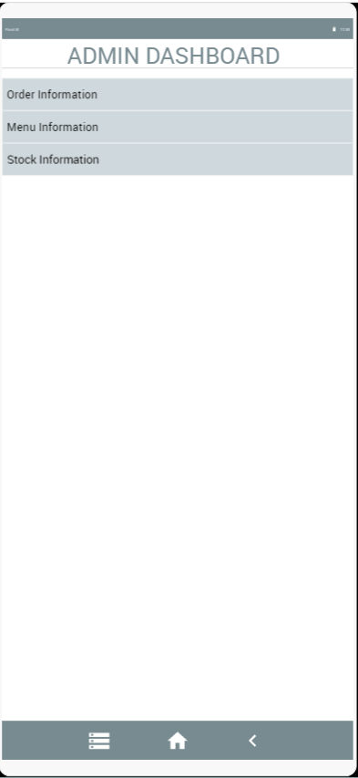

Figure 3. 31 Admin Homepage

|  |  |  |  |
| --- | --- | --- | --- |
| **Id_Object** | **Type** | **Name** | **Information** |
| Button1 | Button | Pesanan | If the button clicked, that will be show all of Customer data that will be order |
| Button2 | Button | Informasi Menu | If the button clicked, that will be show all of information about Menu. |
| Button3 | Button | Informasi Stock | If the button clicked, that will be show all of information about Stock. |

Tabel 3. 32 Description Admin Homepage

### Interface : 004 – Admin Order Page

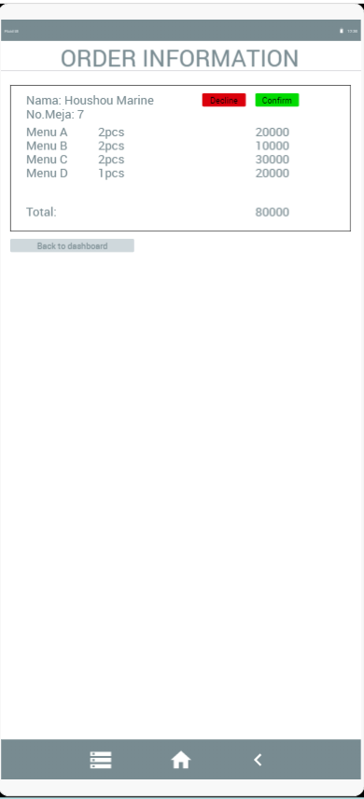

Figure 3. 32 Admin Order Page

|  |  |  |  |
| --- | --- | --- | --- |
| **Id_Object** | **Type** | **Name** | **Information** |
| Button1 | Button | Konfirmasi dan cetak kwitansi | If the button clicked, It will be Confirm and printed all of the Information Order of the Customer, and customer will be notified that the order is accepted. |
| Button2 | Button | Batalkan dan kirim pesan | If the button clicked, It will cancel the order and send a message to inform the customer |
| Button3 | Button | Kembali ke dasbor | If the button clicked, it will redirect back to the dashboard page |

Tabel 3. 33 Description Admin Order Page

### Interface : 005 – Admin Menu Information Page

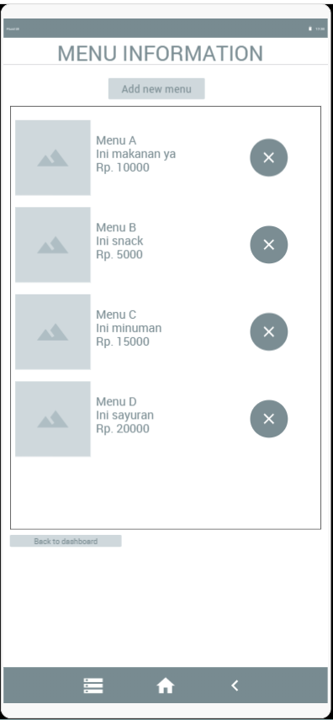

Figure 3. 33 Admin Menu Information Page

|  |  |  |  |
| --- | --- | --- | --- |
| **Id_Object** | **Type** | **Name** | **Information** |
| Button1 | Button | Tambah Menu | If the button clicked, it will add new menu |
| Button2 | Button | X | If the button clicked, it will delete a certain menu |
| Button3 | Button | Kembali ke Menu | If the button clicked, it will redirect back to the dashboard page |

Tabel 3. 34 Description Admin Menu Information Page

### Interface : 006 – Admin Stock Information Page

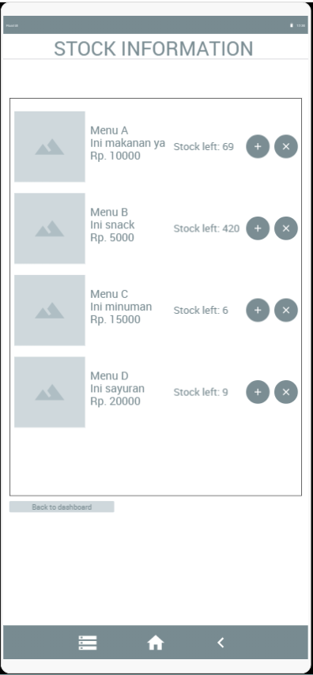

Figure 3. 34 Admin Stock Information Page

|  |  |  |  |
| --- | --- | --- | --- |
| **Id_Object** | **Type** | **Name** | **Information** |
| Button1 | Button | Tambah | If the button clicked, it will add Stock of Menu |
| Button2 | Button | Hapus | If the button clicked, it will delete Stock of Menu |
| Button3 | Button | Kembali ke Dashbor | If the button clicked, it will redirect back to the dashboard page |

Tabel 3. 35 Description Admin Stock Info Page

### Interface : 007 – Admin Login Page

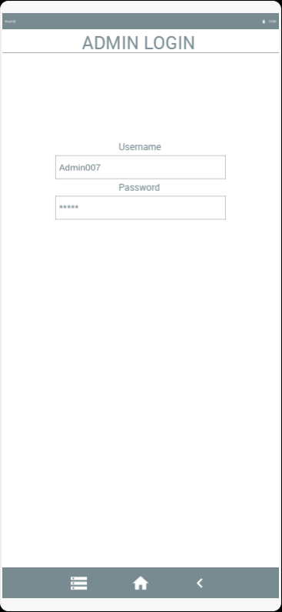

Login

Figure 3. 35 Admin Login Page

|  |  |  |  |
| --- | --- | --- | --- |
| **Id_Object** | **Type** | **Name** | **Information** |
| InputField1 | Input | Username | Field with the string name |
| InputField2 | Input | Password | Field with the string password |
| Button1 | Button | Login | If the button clicked, it take back to Admin Page |

Tabel 3. 36 Description Admin Login Page

## Design of Class Persistence Representations

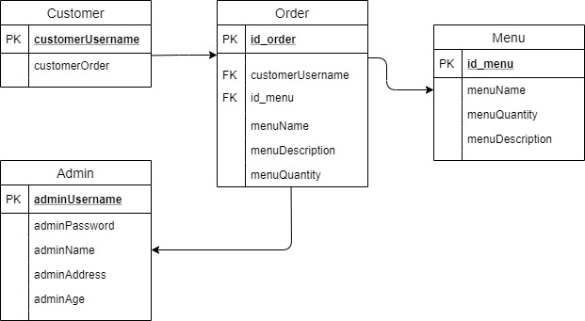

Figure 3. 36 Class Persistence Representations

# Frown Matrix

|  |  |  |
| --- | --- | --- |
| **Requirement** | **Use Case** | **Class** |
| FR-01 | Input Order | Menu, Homepage, Ordered_item |
| FR-02 | Modify Order | Confirm_page, ordered_item |
| FR-03 | Confirm Order | Confirm_page, ordered_item |
| FR-04 | Print Receipt | Admin_confirm_page, Ordered_item |
| FR-05 | Notify Customer | Admin_confirm_page, ordered_item, decline_message |
| FR-06 | Admin Confirm Order | Admin_confirm_page, ordered_item |
| FR-07 | Check Menu | Admin_menu_page, menu |
| FR-08 | Input Menu | Admin_menu_page, menu |
| FR-09 | Delete Menu | Admin_menu_page, menu |
| FR-10 | Check Stock | Admin_stock_page, menu |
| FR-11 | Input Stock | Admin_stock_page, menu |
| FR-12 | Delete Stock | Admin_stock_page, menu |
| FR-13 | Admin Login | Admin_login,menu |

Table 4. 1 Frown Matrix

# 