|  |  |  |  |
| --- | --- | --- | --- |
|  |  | **Making Monster Objects** |  |

|  |
| --- |
| **Your Tasks** |
| * Create a Monster class and a MonsterMaker class * Create the Monster class constructor * Explore Heading Sizes * Style content with Paragraphs and Headings * Show your webpage to Ms. Pluska to receive credit for this activity |

**Create a Monster Class and a MonsterMaker Class**

Obtain a large sheet of paper. On the paper,

* Draw a line down the middle of the paper to divide the paper into two sections.
* Write “Monster class” at the top of the left section
* Write “MonsterMaker Class” at the top of the right section
* Declare the Monster class and the MonsterMaker class using the appropriate signature.
* Refer to the image below. Your paper should look similar,

|  |  |
| --- | --- |
| Monster class  public Monster{  } | MonsterMaker class  public MonsterMaker{  } |

**Create the Monster class constructor**

Recall, that a constructor is needed to create an object of a class. For example, if we want to create a new “Monster” we need a constructor. The Monster constructor for this exercise will have the following signature,

public Monster (String n)

<!DOCTYPE html>

<html>

<head>

</head>

<body>

<h1> My Hobbies </h1>

<h2> Soccer </h2>

<h4> 5 years </h4>

Soccer is an awesome sport because you get to

play on a team with all your friends. I love

challenge of learning new skills like headers

and corner kicks.

<h2>Baking</h2>

<h4> 10 years </h4>

I love baking because you put together all

these things that look simple and boring on

their own to make something magical and

delicious. I also love how baked things make

people happy. Sharing things I bake might be

the best part of it!

<p>Drawing</p>

<p>2 years</p>

On the weekend sometimes I got outside and try

to draw what I see. My favorite thing to draw

are buildings.

</body>

</html>

* Save your index.html file.
* Now, navigate to your file and and open it in your browser.
* Write click on your page and select inspect.

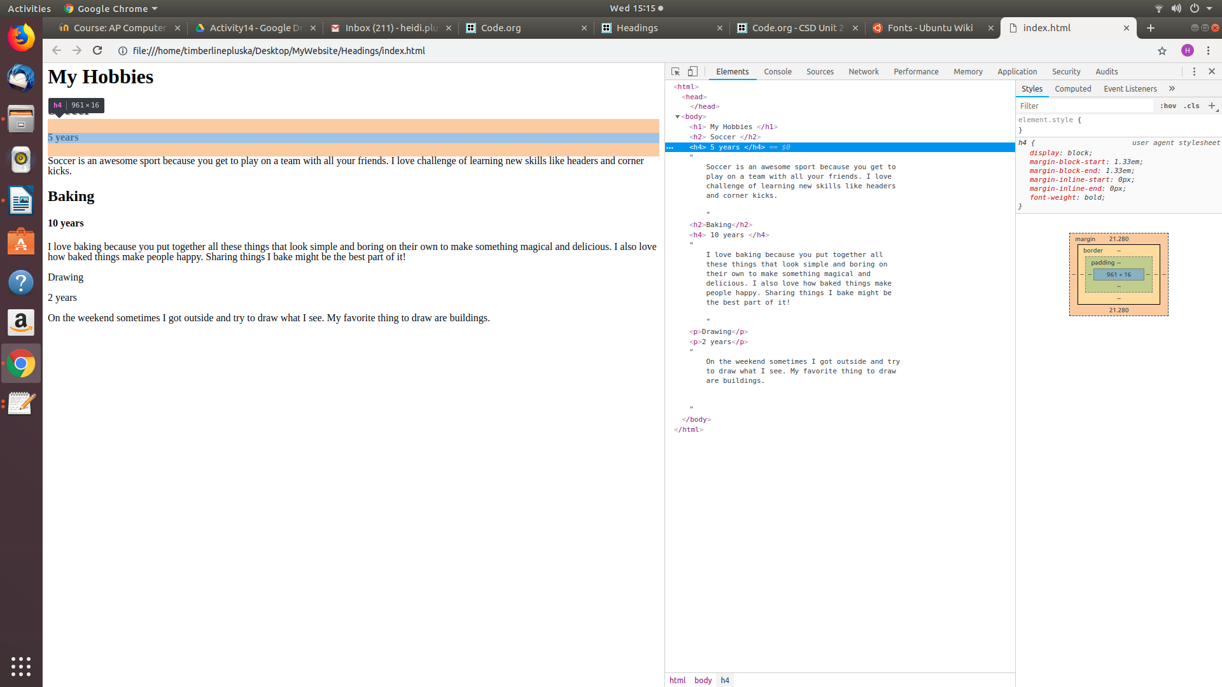

Click on the tags in the left menu and explore the highlighted elements on the HTML page.

**Explore Heading Sizes**

Headings can come in different sizes. In the code below, there are six different sized headings, but they are all mixed up.

* Copy and paste the code into the body section of your index.html page
* Use the inspector tool to figure out what makes the headings different sizes
* Change the tags so that the headings are in order from biggest to smallest, and the text says the correct size, as in the picture below.
* Save your index.html page and refresh in your browser.

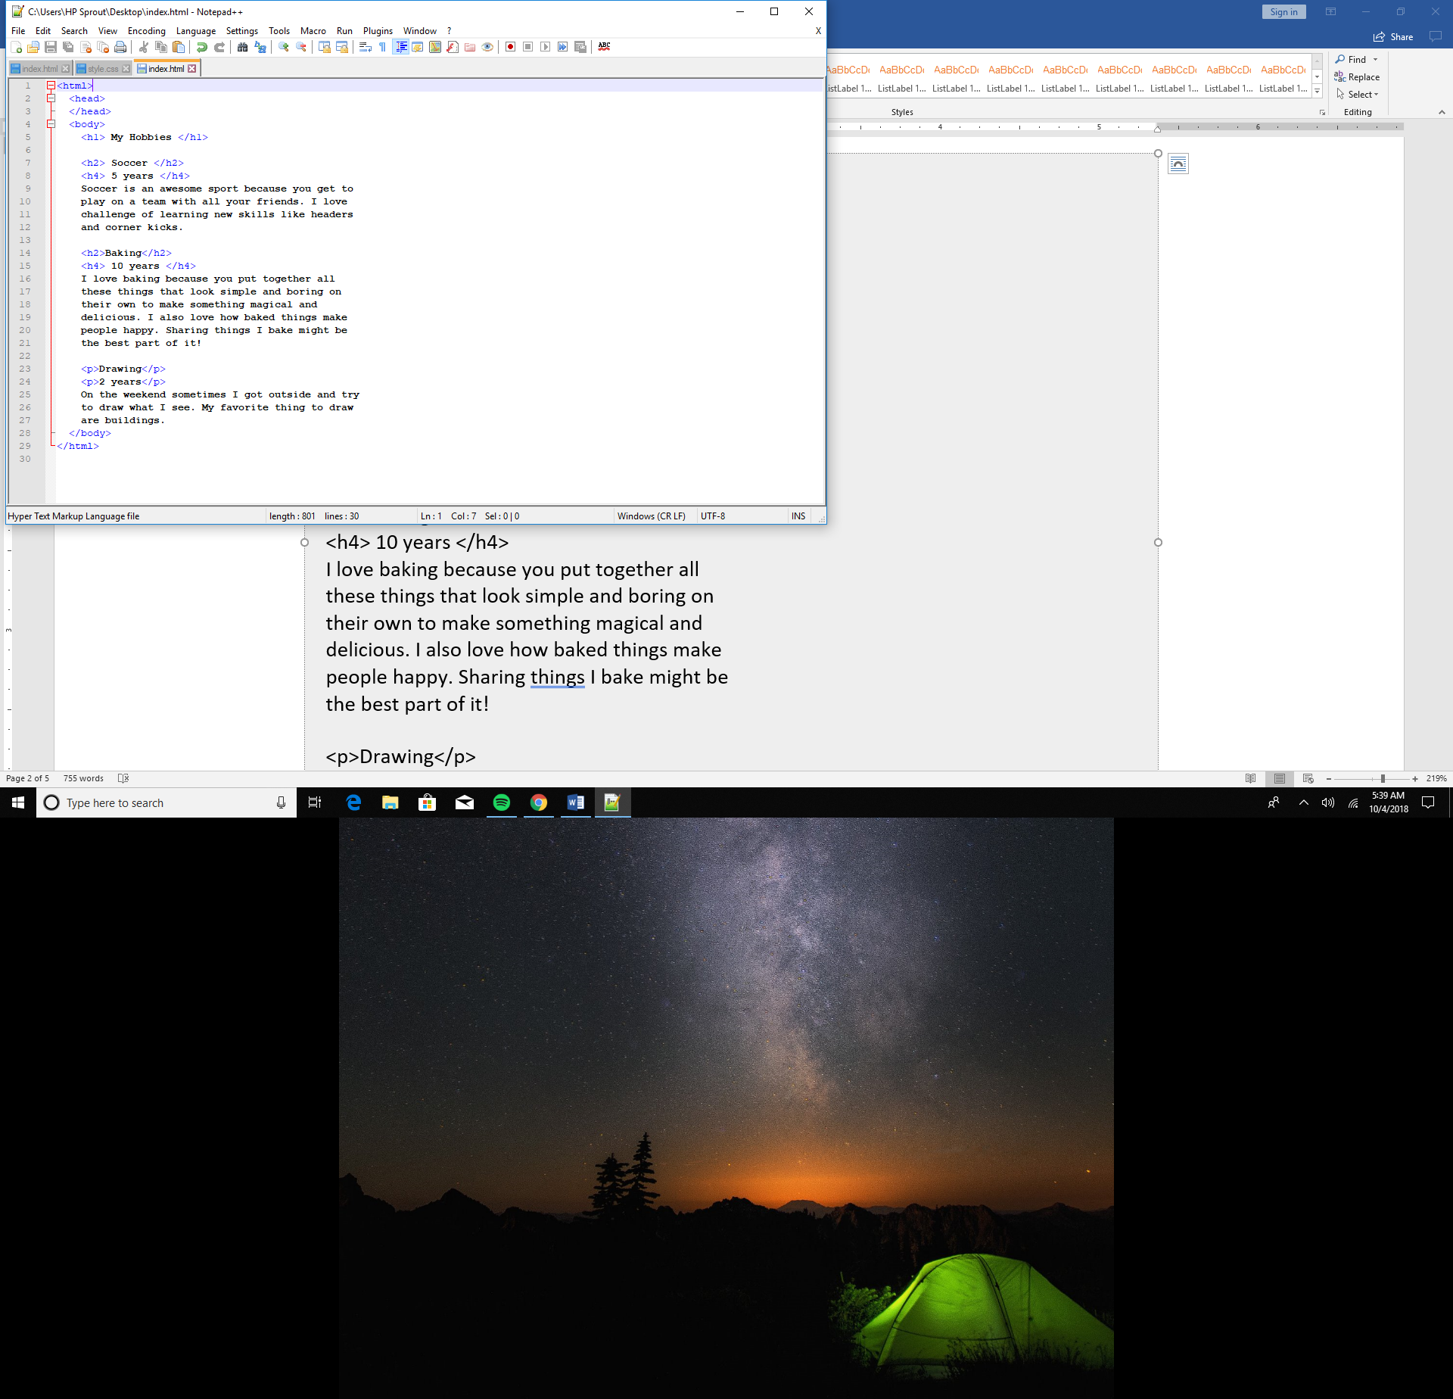

<h3>Biggest</h3>

<h6>Big</h6>

<h4>Medium Big</h4>

<h1>Medium Small</h1>

<h5>Small</h5>

<h2>Smallest</h2>

**Style content with Paragraphs and Headings**

Now that you have explored some headings, try using them to style some content.

* Copy and paste the code below into the body section of your index.html page
* Save your index.html page and refresh it in your browser



My Pets

I have three different pets, and they are all my favorite for different reasons. I feed them and give them water every day, and even though it's a lot of work, they are totally worth it.

Lula

Dog

Lula's been my dog for two years, and she's really fun to play with. I like to take her to the park. Her favorite toy is an old tennis ball.

Slowpoke

Turtle

Slowpoke is my turtle. I have had him for as long as I can remember, but he became mine for real when I turned 10 because I promised to take care of him.

Hamster

Fish

Hamster is the name of my fish. I named him hamster because I wanted a hamster and not a fish, but I like him anyway. He basically just swims around all day, but I still like him.

Notice the contents are all mashed up! Style the content using paragraph and heading tags to make it more readable.

**Show your webpage to Ms. Pluska to receive credit for this activity**

Once you are done styling the content above using paragraph and heading tags, show your completed index.html page to Ms. Pluska to receive credit for this activity.