AP Computer Science A

Project 1
Autumn Scene

Project Overview
For this project, you are going to create an animated autumn scene. You have flexibility to draw whatever you want, as long as it has the same relative complexity as the example and includes multiple shapes, colors, animations, and text.
Objectives
- Add code to a method in a given skeleton class
- Use methods from the Graphics class.
- Use the color class
- Use variables to manage data and expressions to calculate size and position of your
shapes.
Specifications
Create an animated autumn scene. Your scene should include an avatar (or object) which should move in some way (back and forth, across the screen, up and down, wave a hand, etc). The scene should include a variety of shapes and colors (these can move too). Your scene should also include a message (Boooo, Happy Halloween, haunted house, etc.).
Getting Started
Create a new NetBeans project called AutumnScene.  IMPORTANT: Note where you save your project! | 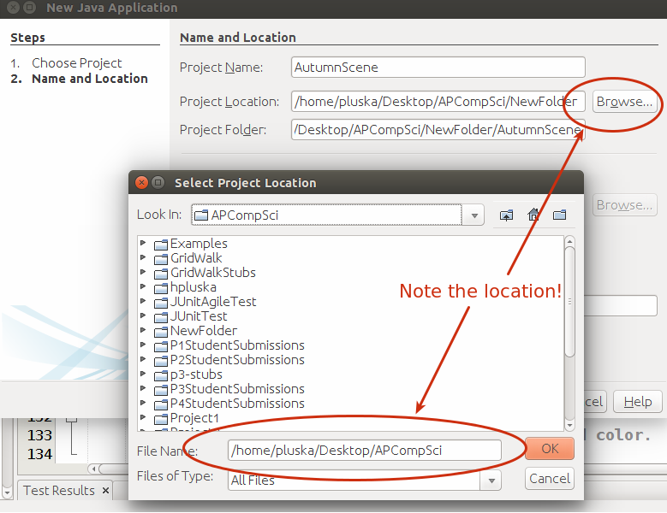
Locate the project in the project window. Navigate to  AutumnScene → Source Packages → autumnscene → AutumnScene.java  Right click on the AutumnScene.java file. Select Delete from the options. This will delete the default file. | 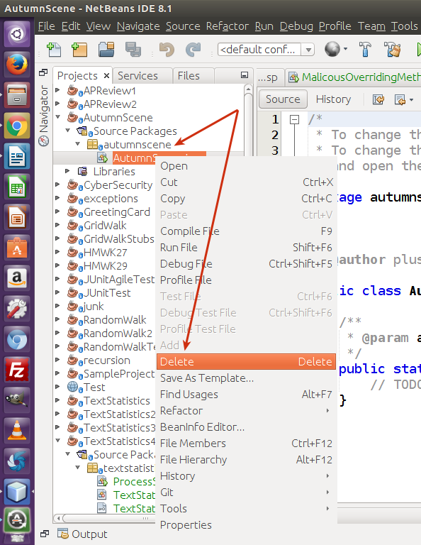
Download the starter AutumnScene.java file by clicking the link to the right. | https://drive.google.com/file/d/1Td5_r8qTmJlqlDsX0qbM00IpBSOQwkQf/view?usp=sharing
Navigate to the file in your “downloads” directory.  Right click on the file and select “copy” | 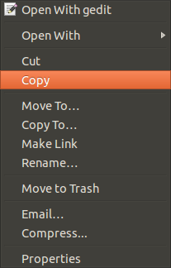
Return to NetBeans. Right click on the greetingcard packet and select Paste to paste the starter file. | 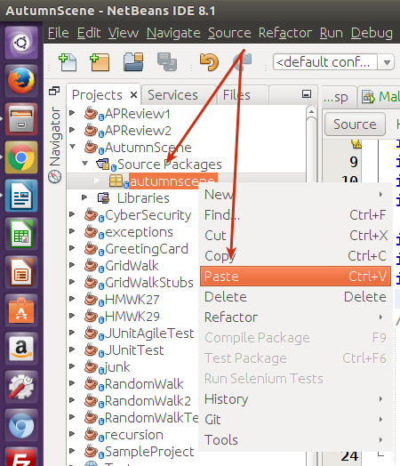
Run the program by clicking the green play button in the top menu. You should see some random shapes on the screen. | 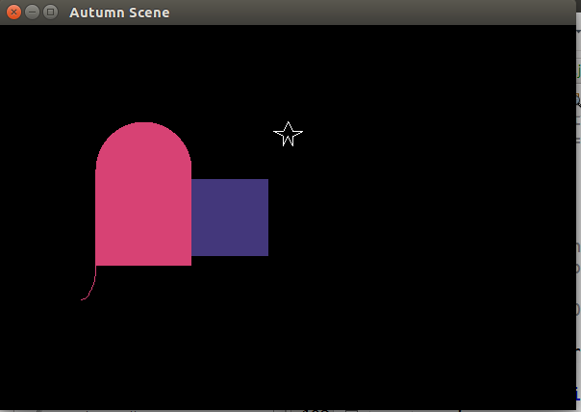
Your Tasks
- Write code that creates an avatar (or object) relative to the anchor position (the xOffset variable). The avatar should move every time the paintComponent() method is called. If the avatar goes off one edge of the window, it should come back on the other edge. By default the avatar will move right to left. Feel free to modify the program to have the avatar move differently.
- The xOffset anchor enables you to animate horizontally across the screen. Add a yOffset, then create an animation that runs vertically across the screen.
- Create an autumn scene that contains both animated and stationary objects that incorporate different shapes (rectangles, ovals, lines, etc), different colors, and different sizes. Your program must
  - Incorporate at least 5 different methods from the graphics class.
  - Must use at least four different colors plus one custom color. There are a number of sites on the web where you can find color samples with their RGB values. The following example illustrates how to create a custom color,

g.setColor(new Color (240, 240, 14)); .

  - Adjust appropriately when the window gets resized. For example, centered text should remain centered, the avatar should travel the entire length or width of the window, and all graphics should adjust or scale as needed.
  - Include an object that moves horizontally across the screen
  - Include an object that moves vertically across the screen
  - Include text – a title, a message, or whatever seems appropriately. Check out this site for additional help on how to include text, https://www.javaworld.com/article/2076869/learn-java/drawing-text-is-easy-with-three-java-classes.html
  - Add whatever else you want to the scene to make the picture interesting to you!
Extra Credit (10 points max)
- Add sounds
- Add external pictures
Documentation
- All code must be properly formatted with proper indention and naming conventions. Class files should begin with capitals (EX: AutumnScene). Variables and methods should begin with lower case and be descriptive (EX: scaryGhost, star, hauntedHouse). All names should use “camel case” convention, that is the first letter of each word is capitalized. The only exception is the first letter of variables and methods.
- You must provide description for each object or method you create. See the examples provided in the starter class. You must provide comments to note the purpose of the variables and significant blocks of code. Again, see the examples provided in the starter class.
- At the top of the class, provide a description of the class and include your name,

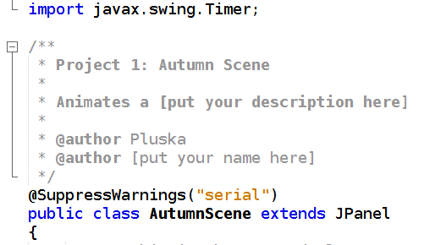

- Include a plain-text file called README that describes your program and how to use it. Expected formatting and content are described in the README TEMPLATE. An example is available in README EXAMPLE.
Inspiration
Check on a sample project here: https://drive.google.com/file/d/0B6lKrC3UayiJNDNmZUU3UmdMXzA/view?usp=sharing
Grading Rubric
https://drive.google.com/file/d/0B6lKrC3UayiJVGxSM0hoaHkyN28/view?usp=sharing

