AP Computer Science A

Project 2
Playlist

Project Overview
For this project, you will develop an application that manages a user's songs in a simplified playlist.
Objectives
- Write a class with a main method (Playlist)
- Use an existing, custom class (Song)
- Use classes from the Java standard library
- Work with numeric data
- Work with standard input and output
Specifications
Existing class that you will use: Song.java
Class that you will create: Playlist.java

Song (Provided Class)

- You do not need to modify this class. You will just use it in your Playlist driver class.
- You are given a class named Song that keeps track of the details about a song. Each song instance will keep track of the following data.

- Title of the song
- The song title must be specified when the song is created
- The artist of the song
- The song artist must be specified when the song is created
- The file path of the song
- The file path must be specified when the song is created
- The play count of the song
- The play count of the song (e.g. how many times the song has been played. This is set to 0 by default when the song is created)

- The Song class has the following methods available for you to use:

- public Song(String title, String artist, int playTime, String filePath) – (The Constructor)
- public String getTitle()
- public String getArtist()
- public int getPlayTime()
- public String getFilePath()
- public void play()
- public void stop()
- public String toString()

PlayList (the driver class)

- You will write a class called Playlist. It is the driver class, meaning, it will contain the main method. In this class, you will

  - Gather song information from the user by prompting and reading data from the command line.
  - Store the song information by creating song objects from the given data.
  - Use the methods available in the song class to extract data from the song objects and print the information to the user.
  - Finally, you will use conditional statements to order songs by play time. The ordered "playlist" will be printed to the user.

- Your Playlist code should not duplicate any data or functionality that belongs to the Song objects. Make sure that you are accessing data using the Song methods.
- Do NOT use a loop or arrays to generate your Songs. We will discuss how to do this later, but please don't over complicate things now. If you want to do something extra, see the extra credit section below.

- Console input should be handled with a Scanner object.

- Create a Scanner using the standard input as follows:

Scanner in = Scanner(System.in);

You should NEVER make more than one Scanner from System.in in any program. Creating more than one Scanner from System.in crashes the script used to test the program. There is only one keyboard; there should only be one Scanner.

- Your program will prompt the user for the following values and read the user's input from the keyboard

- A String for the song title
- A String for the song artist
- A String for the song play time (converted to an int later)
- A String for the file path

You can use the nextLine() method of the Scanner class to read each line of input.

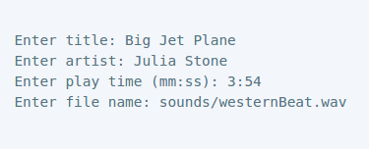
Below is a sample input session for one song. Your program must read input in the order below. If it doesn't, it will fail our tests when grading.

- As you read the values for each song, create a new Song object using the input values. Use the following process to create each new Song object.

- Read the input values from the user into temporary variables
- You will need to do some manipulation of the playing time data.

  - The play time will be entered in the format mm:ss, where mm is the number of minutes and ss is the number of seconds. You will need to convert this string to the total number of seconds before you can store it in your Song object.
  - All other input values are String objects, so you can store them directly in your Song object.
  - Use the Song constructor to instantiate a new song by passing in the variables containing the title, artist, play time, and file path.
  - Because a copy of the values will be stored in your song objects, you can re-use the same temporary variables when reading input for the next song.

- Before moving to the next step, print your song objects to make sure everything looks correct. To print a song, you may use the provided toString method. Look at the Song documentation for an example of how to print a song.

NOTE: Each Song instance you create will store its own data, so you will use the methods of the Song class to get that data when you need it. Don't use the temporary variables that you created for reading input from the user. For example, once you create a song, you may retrieve the title using song1.getTitle();

- Calculate the average play time

- Use the getPlayTime() method to retrieve the play time of each song and calculate the average play time in seconds.
- Print the average play time formatted to two decimal places. Format the output as shown in example below.

- Find the song with the play time closest to 4 minutes

- Determine which song has play time closest to 4 minutes.
- Print the title of the song formatted as shown in the output below.

- Build a sorted play list

- Build a play list of the songs from the shortest to the longest play time and print the songs in order.

Do NOT use methods from the array class to do this. You must figure out how to sort our songs using the appropriate “if” statements.

- To print the formatted song data, use the toString() method in the Song class.
- Print the play list as shown in the output below.
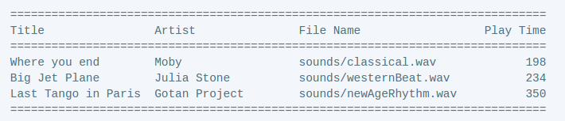

- Play the songs the user entered while the output is displayed
Extra Credit (5 points)
You may notice that you are repeating the same code to read in the song data from the user for each song (Yuck! This would get really messy if we had 10 songs).

Modify your main method to use a loop to read in the songs from the user. As you read and create new songs, you will need to store your songs in an ArrayList. This can be quite challenging if you have never used ArrayLists before, so I recommend saving a backup of your original implementation before attempting the extra credit.
Getting Started
- Create a new NetBeans project for this assignment and import Song.java (https://drive.google.com/file/d/0B6lKrC3UayiJNlhRWDNoaDZnSW8/view?usp=sharing) into your project. If clicking on the link does not work, cut and paste the link into your browser.
- Create a new Java class called Playlist and add a main method.
- Create a new folder in the project package called “sounds”. Add the following sounds to this folder, https://drive.google.com/open?id=0B6lKrC3UayiJOVVKbTBQNGpOZW8
- Read the Song documentation (right click on the project package and select “Generate Javadoc”) and if you are feeling adventurous, look through the Song.java file to familiarize yourself with what it contains and how it works before writing any code of your own.
- Start implementing your Song class according to the specifications.
Sample Input/Output
Make sure you at least test all of the following inputs (you will need to fix your code to accept the file path inputs). Use the following text file to test your program: https://drive.google.com/file/d/0B6lKrC3UayiJVDFzWW9uLUhqeXM/view?usp=sharing
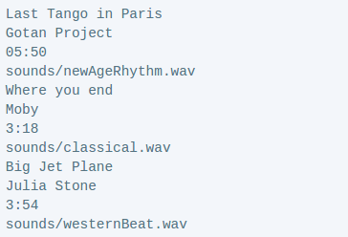

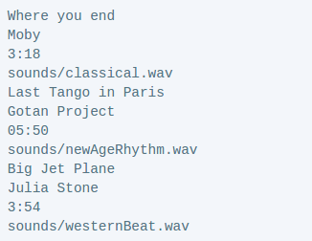

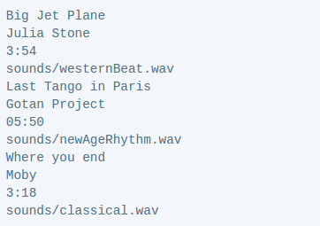

Documentation
- All code must be properly formatted with proper indention and naming conventions. Class files should begin with capitals (EX: PlayList). Variables and methods should begin with lower case and be descriptive (EX: title, playList). All names should use “camel case” convention, that is the first letter of each word is capitalized. The only exception is the first letter of variables and methods.
- At the top of the class, provide a description of the class and include your name,

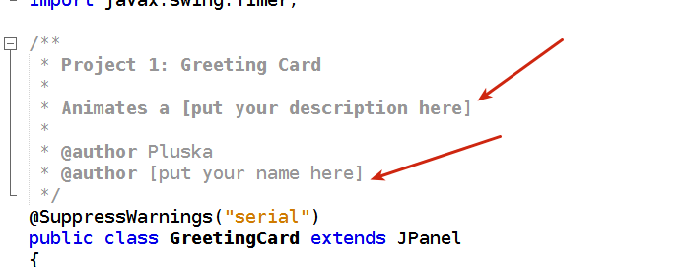

- Include a plain-text file called README that describes your program and how to use it. Expected formatting and content are described in the README template,
https://drive.google.com/open?id=0B6lKrC3UayiJbHNZUE9xTFM1ZXc
- An example is available here, https://drive.google.com/open?id=0B6lKrC3UayiJX29SNWZORVdFOWc
Grading Rubric
https://drive.google.com/file/d/0B6lKrC3UayiJcjE5NVhSdGhSUDA/view?usp=sharing
Submitting Your Project
See the project 2 submission link for details on how to submit your project

