AP Computer Science A

Project 4
Random Walk

Project Overview
In this project, you will generate a random walk on a grid that starts at the top-left corner and ends up at the bottom-right corner.
- Class that you will create: RandomWalk.java
- Class that you will modify: RandomWalkTest.java
- Existing classes that you will use: RandomWalkGUI.java, GridMap.java, RandomWalkInterface.java
Objectives
- Write a class with appropriate methods, including overloaded constructors
- Write a driver class that uses the above class
- Use static variables and methods
- Use classes from the Java standard library
- Use existing classes
- Implement an interface
- Create a list of objects using the ArrayList class
Specifications
- Generate a random walk on an n by n grid that starts at [0,0] (top left corner) and ends up at [n-1, n-1] (bottom-right corner)
- At each point there are four potential directions in which we can walk: North, East, South, and West. To avoid getting stuck we will walk to the East or South with Equal probability. This way, we will always be making progress towards the destination (the south-east corner).
- See the figure below for a sample random walk.

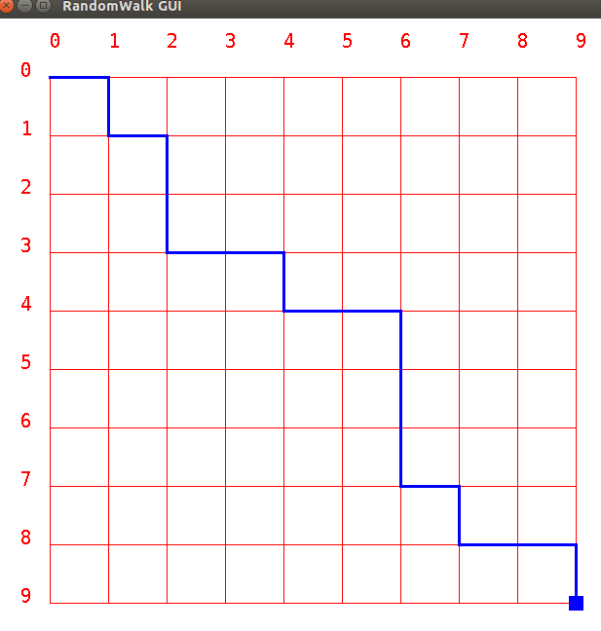

RandomWalk

The RandomWalk class will implement the RandomWalkInterface.

Use the Point class provided in the Java standard library (in the java.awt package) to represent each point on the path. For example, the start point can be be represented as:

Point start = new Point(0,0);

You can access the coordinates of the point using:

start.x, start.y

Use an ArrayList of Point objects to store the path. The ArrayList class is part of the java.util package and provides functionality for managing a list of objects. There are several methods available in the ArrayList class (e.g., add, remove, isEmpty, contains, etc).

You can construct an ArrayList instance for managing your Point objects as follows:

ArrayList<Point> path = new ArrayList<Point>();

Then, you can add new points to your path using the add(...) method of the ArrayList class as follows,

Point p1 = new Point(x, y);
path.add(p1);

The signatures for all the methods you must implement in the RandomWalk class are defined in the RandomWalkInterface. In addition to these methods, you must implement two constructors with the following signatures. The first constructor initializes the instance variables and the starting point of the walk, and creates a random number generator without a seed,
public RandomWalk(int gridSize)
The second constructor is the same as the above constructor except that we specify a seed for the random number generator. This is very useful for debugging and testing as the same seed will give the same random number sequence so that we can reproduce a bug.
public RandomWalk(int gridSize, long seed)
RandomWalkTest
Complete the provided RandomWalkTest class so that it does the following,
- Complete the private static method named getInput() that deals with the user input as follows:
- Prompts the user for the grid size and checks to make sure that user enters a positive integer. If the entered value is invalid, ask the user to enter a different integer. Keep doing this until they enter a valid integer. You can do this with a loop.
- Prompts the user for the random seed value and checks to make sure that the user enters a 0 or positive integer. If the entered value is invalid, ask the user to enter a different integer. Keep doing this until they enter a valid integer. You can also do this with a loop.

- Creates a RandomWalk object with the appropriate constructor. If the seed is zero, then call the constructor with only grid size as an argument. Otherwise call the constructor with two arguments.
- Create the walk using the createWalk() method and then print the walk using the toString() method in the RandomWalk class.
Extra Credit (Seniors Only. NOTE: This section is required for everyone else)
Modify the hasNext() method so that it checks for moves that do not take us closer to the destination (that is, West and North are also possibilities).We do not want to include the same location more than once, however, so we will need to check if the path already contains the point we are about to visit. If so, we will skip it and go back and try another point.
The ArrayList class provides a contains(...) method that makes it easy to check if a point is already in the path.
if(path.contains(new Poiont(x, y){//do something }
However, the path can still get stuck since we don’t want the walker to visit the same point twice. If the path gets stuck, clear the path and start over at [0,0].
To make it likely that your program will find a path, we would recommend setting the probability for West or North moves to be no more than 10% each/
Getting Started
Create a new NetBeans project for this assignment. Import the four java classes RandomWalkTest.java, GridMap.java, RandomWalkGUI.java, and RandomWalkInterface.java into your project from here:
https://drive.google.com/drive/folders/0B6lKrC3UayiJME5nU1pOWlVTX2M?usp=sharing
Create a new class in your project called RandomWalk which implements the interface
Complete the RandomWalkTest class such that it properly validates the user input.
- Test for bad input like negative or zero for grid size, negative random seed to make sure your program catches the error and asks user to enter values again and again until they get it right!
- Test for boundary cases: Try small values like 1, 2, 3, 4 for grid size to see if the path generated is correct.
- Try random seed like 1234 and verify that you generate the same path each time. To generate a random number with or without a seed, use the following code...

Random random = new Random();//creates a random number

Random random = new Random(seed);//creates a random number
//where seed is a variable
//of type long

- Try random seed input of zero and verify that you get different random paths each time.
- Try a few larger grid sizes like 10, 20, 100 to see if your program stops normally. It is hard to check if the output is correct for large grid size but using the GUI program will make it easier. Can you think of how to write a method that checks if the generated path is valid?
  - Use the RandomWalkGUI program to make it easier to run and debug your program!
Sample Session
java RandomWalkTest Enter grid size:6 Enter random seed (0 for no seed):1234 [0,0] [1,0] [2,0] [3,0] [4,0] [5,0] [5,1] [5,2] [5,3] [5,4] [5,5] For the same grid size and same seed, we should get the same output even though it is random! java RandomWalkTest Enter grid size:6 Enter random seed (0 for no seed):1234 [0,0] [1,0] [2,0] [3,0] [4,0] [5,0] [5,1] [5,2] [5,3] [5,4] [5,5] With a random seed of 0, we don't supply a seed to Random so the walk will be different each time we run the program java RandomWalkTest Enter grid size:8Enter random seed (0 for no seed):0 [0,0] [1,0] [2,0] [2,1] [2,2] [2,3] [2,4] [3,4] [3,5] [4,5] [5,5] [6,5] [7,5] [7,6] [7,7] java RandomWalkTest Enter grid size:8 Enter random seed (0 for no seed):0 [0,0] [0,1] [1,1] [1,2] [2,2] [3,2] [4,2] [4,3] [5,3] [5,4] [5,5] [5,6] [5,7] [6,7] [7,7] Now we show some error checking on the user supplied input java RandomWalkTest Enter grid size:-5 Error: grid size must be positive! Enter grid size:-6Error: grid size must be positive! Enter grid size:6 Enter random seed (0 for no seed):-233Error: random seed must be >= 0! Enter random seed (0 for no seed):-455 Error: random seed must be >= 0! Enter random seed (0 for no seed):1234 [0,0] [1,0] [2,0] [3,0] [4,0] [5,0] [5,1] [5,2] [5,3] [5,4] [5,5]

Grading Rubric
Coming soon
Submitting Your Project
Coming soon

