Sum-up of observations

**1) There is a subgroup of mice (usually ~3) responsible for most interactions within the network.** This can be seen by looking at the k-core (rich-club) after appropriate binarization of the graph.

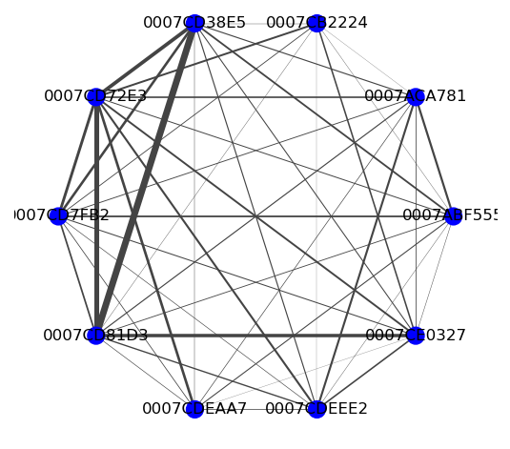 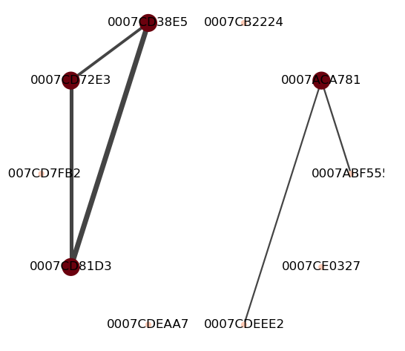

Averaged interactions for 7th group of 1st cohort

**2) There is a part of this group that is stable over the duration of the experiment (call it stable rich-club?)**

(Shown on a 1-day basis here, but maybe it is more convincing to show 3-day basis)

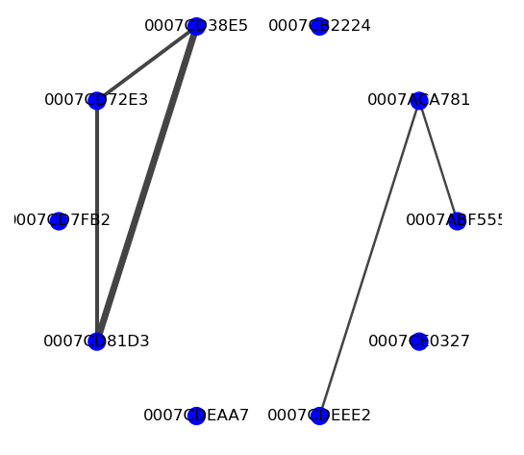 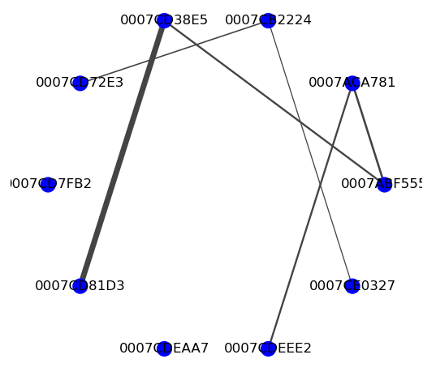

Day 2 day 4

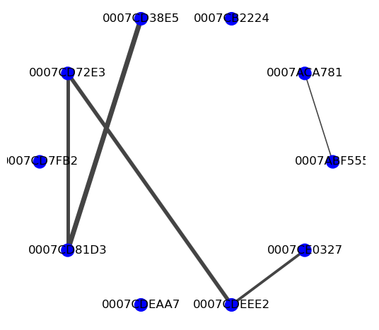 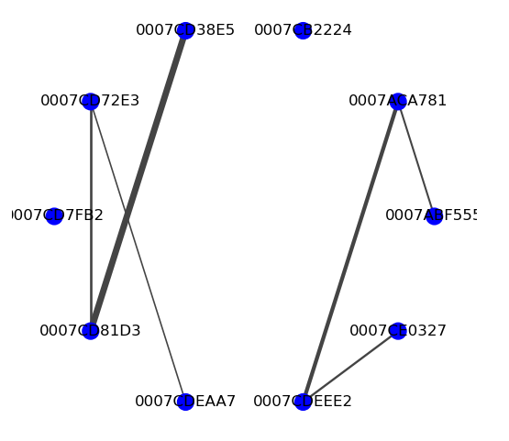

Day 6 day 8

**3) Mutants are significantly less likely to be part of this stable group:**

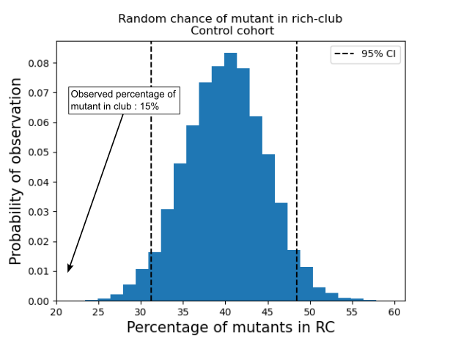

**4) Members of the stable club are doing most of the chasing:**

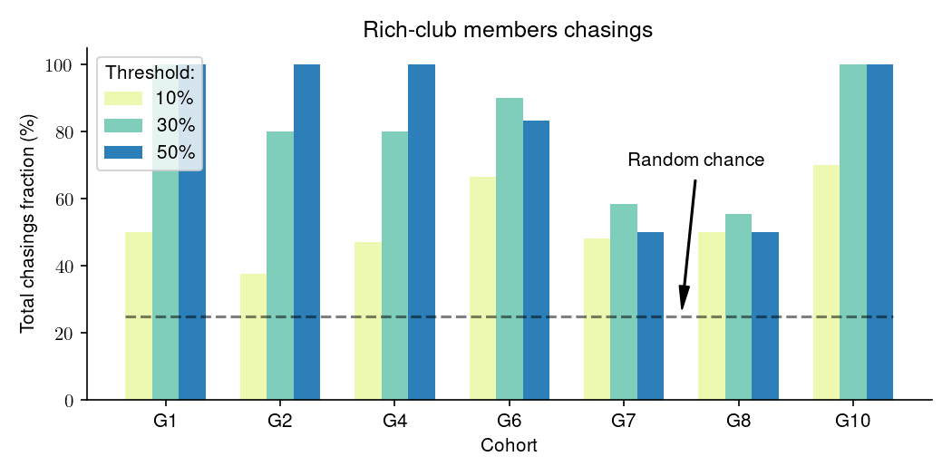

**5) Effects of gene deletion on chasing: the stronger the deletion, the less the mutants chases:**

