Library and Plugins

Javascript Library

Jquery and Materalize were used as the libraries for this web appplication. The code was improved with the use of jQuery to use shorthand code for simplify functions and create shorter ways to get to the end. Materalize was used for the development of UI in the forms.

Plugins

Slick

<http://kenwheeler.github.io/slick/>

Slick was used for the image slider in the UI. It is simple to implement and design how you want it to look. It added a intereactive element to the design and also provided a way for the user to see the activity locations .

Production tools

Github

<https://github.com/Kelseys1993/foundation-summative>

Used to manage and store files throughout production

Sublime text

Sublime text 2 was used as the code editor for the entirety of the project.

Gulp

Gulp was used to check the javascript code for errors. It was effective and also had the added benefit of having a local sever which reloaded the browser on save therefore elimnating the need to refresh the page after every new addition.

Validation

Each step has validation in place in order to stop the user from proceeding if the data was not first selected.

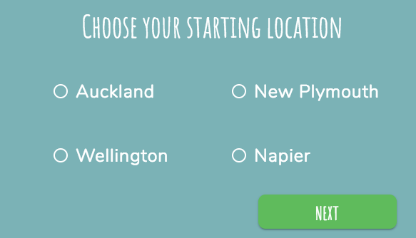

When clicked without first selcting a location the button will not proceed

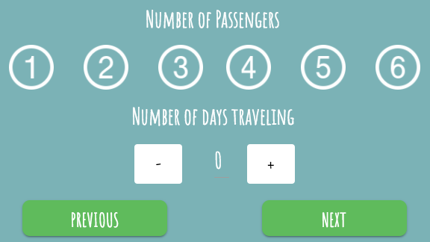

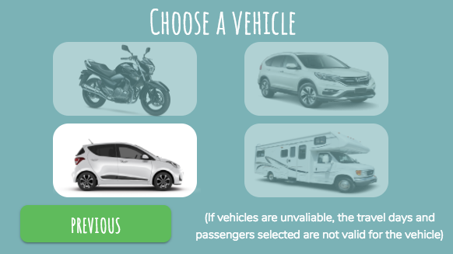If both number of passngers and number of days traveling are not selected you are unable to click the next button

Only vehicles that meet the minimum and maximum travel days and passengers are highlighted and able to be selected



This explains why some vehicles are not able to be selected

User feedback and changes

User testing was completed when website was completed. A few changes from the feedback where implemented into the final site

* Use of a second font to show heighrachy
* Adding a message as to why vehicles were unavaliable
* Adding a splash page

Deadlines

|  |  |  |
| --- | --- | --- |
| Deadline | | Result |
| Research UI and Javascript Libraries  27th Nov | | Achieved |
| Research and create a Js styleguide  27th Nov | | Achieved |
| Research colours and fonts and design concept  28th Nov | | Late – 1st December, due to not being able to do anything over that weekend I had to add a few extra days to finish this |
| Create prototype  29th Nov | | Late- 1st December, due to being later on the design research this pushed back the creationg of the protype |
| Set up documentation  Dec 1st | | Achieved |
| Start HTML and CSS  Dec 1st | | Achieved |
| Finish HTML and CSS  Dec 6th | | Achieved |
| Plan out JS user flows  Dec 5th | Early- dec 4th as this was a fairly simple flow I was able to do this while I was writing the HTML | |
| Start writing up Js  Dec 6th | Achieved | |
| Finish writing js and debug  12th Dec | Early- 10th Dec | |
| Finish documentation  13th Dec |  | |

