Kelson Denton

Student ID: 20043517

Assesment 3 (Pet Project)

Webskills

1. Target Audience Summary

This website is aimed at anyone wishing to gain knowledge about bushfires in Australia. Most likely this would be people who live in Australia, but people abroad may also be interested in the information. The information would also be more useful for people living in rural areas compared to urban as bushfires pose a much larger risk in these areas. Since it is targeting general Australian residents, marital status, gender, income level, ethnic background, and occupation do not play much of a role in who would be accessing the site. However, since people in rural areas are more likely to need this information, people with occupations linked to the country such as in the agriculture industry, are more likely to visit the site. The writing style of the site is not very friendly to children, so the age range accessing it would most likely be around 15 or older.

2. Summarize the clients need.

Possible clients for this website could be local governments. It may be easier for them to provide their community a link to this website rather than create their own to inform residents about bushfire safety and prevention. It can be used as an educational tool for older children in school as well as it is important for Australians to learn about bushfires as they will likely play a part in their lives at some point given their frequency.

3. Summarise the clients need for image content, quality and size

Images need to fit the areas they are designated to go naturally to avoid stretching and distorting them to make it fit, or decreasing their quality. This is especially true for the header background images, which are fairly wide. To successfully fill this images with suitable width and height dimensions must be selected. Image quality should be fairly high to give the website a professional look.

4. Add all images used below and include copyright.

Bushfire History page header background image

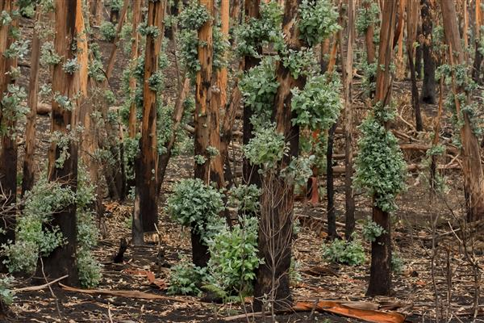

Link:

https://www.nambuccaguardian.com.au/story/6782113/the-view-from-mallacoota-six-months-after-the-bushfires/

Bushfire Prevention and plan header background image

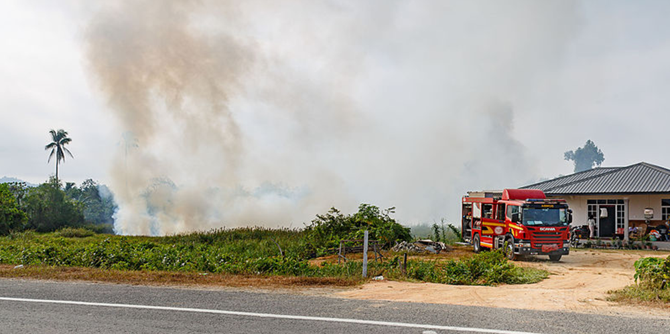

Link:

https://hub.business.vic.gov.au/other/risk-management/6-steps-to-prepare-your-business-for-a-bushfire/

Toll of Bushfires Image

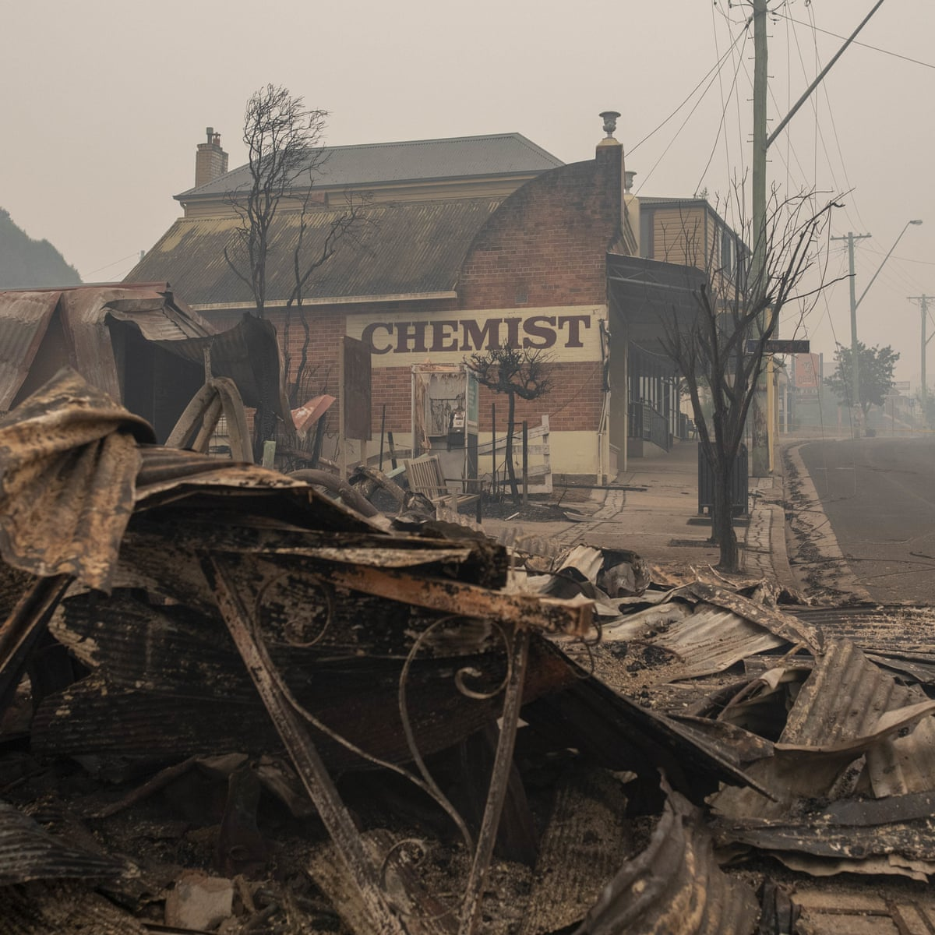

Link:

https://www.theguardian.com/australia-news/2020/jan/08/economic-impact-of-australias-bushfires-set-to-exceed-44bn-cost-of-black-saturday

Home and Newsletter Page Header Background Image

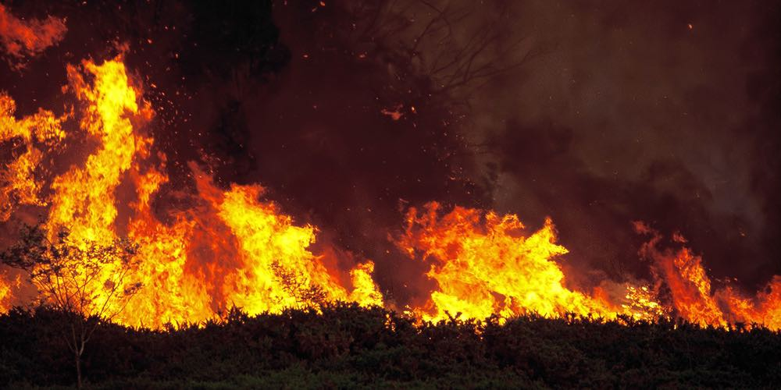

Link:

https://360newslasvegas.com/are-the-california-fires-arson-or-terrorism/

Aborigonal Bushfire Control Image

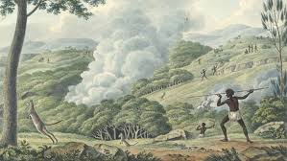

Link: https://www.google.com/url?sa=i&url=http%3A%2F%2Fupperpool.rmitidsites.net.au%2Fwomenjenka%2F&psig=AOvVaw1ZI_z2Ntlrn_ly9NbBRlOq&ust=1604805087239000&source=images&cd=vfe&ved=0CAIQjRxqFwoTCMicxfu67-wCFQAAAAAdAAAAABAD

Bushfire Flora recovery image

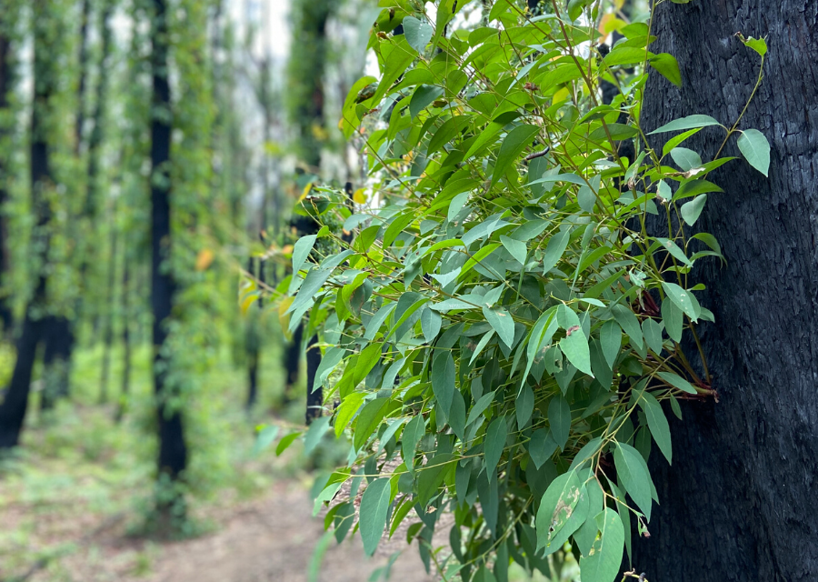

Link:

<https://www.thefoldsouthernhighlands.com.au/the-guide/bushfire-recovery-an-update-from-wingecarribee-shire-council.html>

Bushfire preparation image:

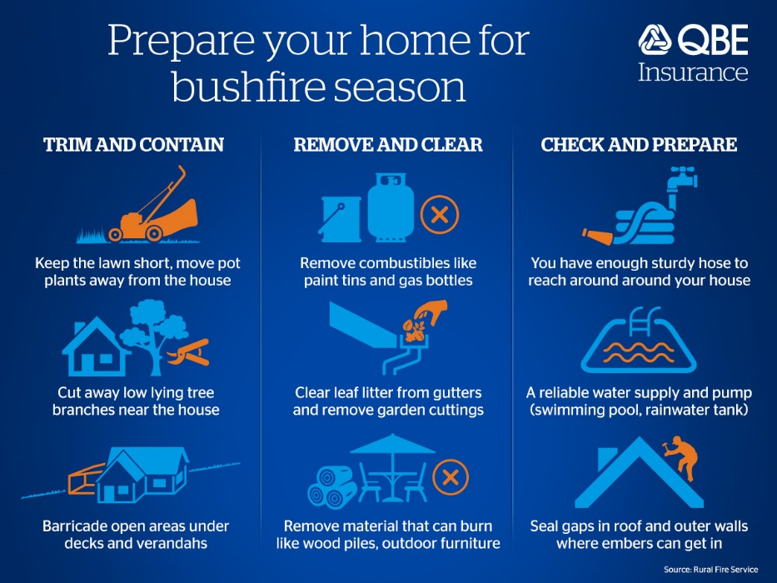

Link:

https://www.qbe.com/au/news/protecting-your-home-and-family-our

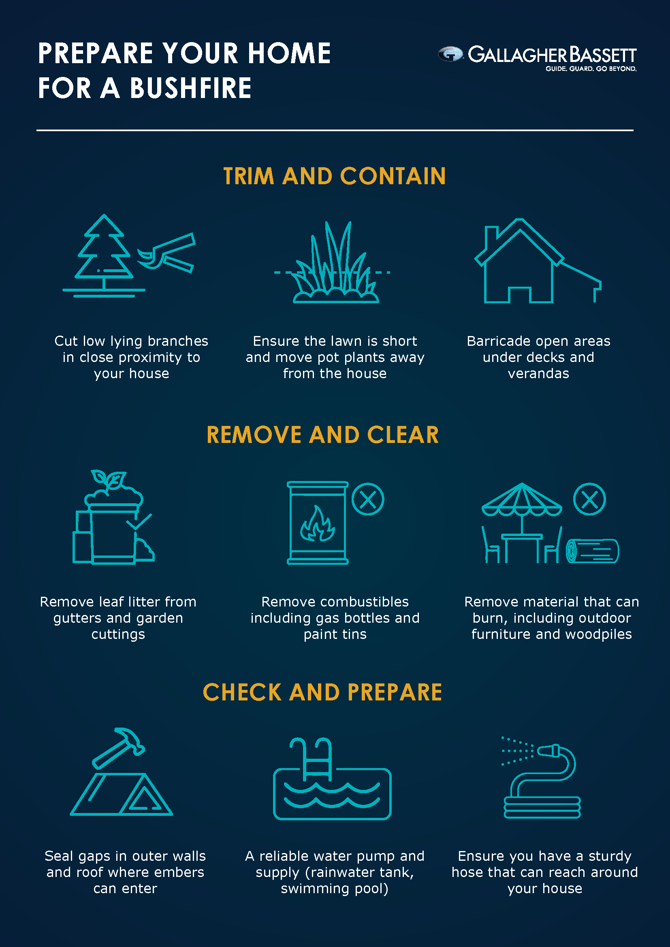

Link:

https://blog.gallagherbassett.com.au/blog/prepare-for-bushfire-season

Determine appropriate mark-up language

Describe each of the following mark-up languages, outlining their uses:

a) Dynamic hypertext mark-up language (DHTML)

DHTML is used to link CSS, JavaScript, and HTML to form a functioning webpage. The web pages must all be correctly linked to one another, using the HTML page to link everything together. This mark-up language results in a very easy to read and understand format as it divides up the layout, style, and functionality of the website into fairly separate sections. This can also make troubleshooting much easier, as it is easier to locate the problems source when different aspects of a webpage come from different areas. For example, if there is a problem with a storage function on the website, instead of going through a huge singular HTML page the function can be found straight away in the JS file.

b) Hypertext mark-up language (HTML)

HTML provides browsers with the desired sequential layout of a webpage. It is the centre where the CSS and JS are linked to if they are used for a webpage.

c) Extensible hypertext mark-up language (XHTML)

* 1. XHTML is important as it provides rigid guidelines for the formatting of an HTML webpage. Most browsers are fairly lenient with how HTML is written and will still run if indents are incorrect or closing tags are missing. However, this makes for messy and difficult to read code, and if left unchecked and lead to a webpage crashing if the mistakes get too out of hand. Debugging and updates can become very difficult as well if the code is difficult to follow. Using XHTML ensures that the code is written in a more rigid format which ensures readability and functionality, and can save time further down the track.

DHTML and XHTML will be used to create the webpage to serve our client base. For the reasons outlined above these are the most efficient methods of creating a webpage.