Chapter 1 : Project Introduction and Background

Problem Statement

Agriculture remains the backbone of many economies worldwide, especially in developing countries like Kenya. It contributes significantly to the Gross Domestic Product (GDP) and employs a large portion of the population. Despite its importance, the agricultural sector faces significant challenges that hinder its productivity and sustainability. Key among these challenges are water scarcity, inefficient irrigation practices, and climate variability.

In Kenya, inconsistent rainfall patterns and prolonged droughts have become more frequent due to climate change, exacerbating water scarcity issues. Traditional irrigation methods commonly used in the country, such as surface irrigation techniques like furrow and basin irrigation, are largely inefficient. These methods involve flooding the fields with water, leading to substantial water wastage through evaporation and runoff. Additionally, they often result in uneven water distribution, causing some areas to be over-irrigated while others remain dry. This not only wastes water but also affects crop yields negatively due to waterlogging or drought stress in different parts of the field.

Another traditional method used is manual watering using buckets or watering cans, which is labor-intensive and impractical for larger farm areas. These conventional methods lack precision and do not account for the specific water needs of different crops or the varying moisture levels in the soil. Farmers also lack real-time data on soil moisture levels, weather conditions, and crop water requirements, making it difficult to make informed irrigation decisions. This often leads to over-irrigation or under-irrigation, both of which can reduce crop yields and waste valuable water resources.

The inefficient use of water in agriculture increases production costs and contributes to the depletion of already scarce water resources. It also affects the sustainability of the agricultural sector and poses a threat to food security in the country. With the growing population and increasing demand for food, there is a pressing need to optimize agricultural practices to produce more with less.

The advent of the Internet of Things (IoT) and affordable microcontrollers like the ESP32 presents an opportunity to revolutionize irrigation practices. By developing a smart irrigation system that can monitor soil moisture levels, weather data, and crop requirements in real-time, farmers can optimize water usage. Automating irrigation schedules based on precise data ensures that crops receive the right amount of water at the right time, enhancing growth while conserving water. Such a system can significantly improve water management practices in agriculture, reduce costs, and increase crop yields.

Implementing this technology addresses the limitations of traditional irrigation methods by providing precise, data-driven irrigation. It reduces labor requirements, minimizes water wastage, and adapts to the specific needs of different crops and soil conditions. Moreover, integrating real-time weather data allows the system to adjust irrigation schedules in response to rainfall or changes in weather conditions, further enhancing efficiency.

Project Objectives

### A. Main Objective

To develop an intelligent, IoT-based irrigation system specifically tailored for coffee farming, optimizing water usage by integrating real-time soil moisture data, weather conditions, and coffee crop water requirements, thereby enhancing agricultural productivity and promoting sustainable farming practices.

**B. Specific Objectives**

1. **To Integrate** advanced sensors and microcontrollers for real-time monitoring of soil moisture, ambient temperature, humidity, sunlight intensity, and nutrient levels specific to coffee crops. This integration will ensure precise irrigation management by considering the unique needs of coffee plants at various growth stages.
2. **To Develop** a user-friendly application that allows coffee farmers to remotely monitor soil conditions, adjust irrigation settings, and receive notifications and alerts. The application will enable farmers to select their coffee variety, input growth stages, and customize irrigation schedules, enhancing user engagement and accessibility.
3. **To Enhance** water resource management in coffee farming by tracking water usage, predicting irrigation patterns based on the growth stages of coffee plants, and calculating evaporation rates. This objective aims to minimize water wastage and optimize water utilization, ensuring that coffee crops receive adequate hydration without overuse of water resources.
4. **To Facilitate** sustainable coffee farming practices by providing data-driven insights into soil health, optimal irrigation schedules, and crop-specific requirements. The system will offer recommendations on nutrient management, detect soil types, and assess soil health parameters like pH and nutrient content, empowering farmers to make informed decisions that improve crop yields and quality.

### Justification

Efficient water management in agriculture is no longer optional; it is imperative for sustainability and food security. Implementing a smart irrigation system addresses several critical issues, making it a transformative solution for farmers.

Water conservation is one of the primary benefits of this system. By delivering the right amount of water at the right time, it minimizes water wastage, which is especially crucial in water-scarce regions. For coffee farming, where water needs to be carefully managed, this technology ensures that crops receive adequate hydration without excess, especially during dry spells and inconsistent rainfall patterns.

Increased crop yields are another important outcome of optimal irrigation practices. The system enhances plant health and productivity by providing water when it is most needed. For coffee farmers, this means healthier plants, better-quality beans, and ultimately higher market prices, which contributes to improved income and livelihoods.

In terms of cost reduction, automating irrigation significantly reduces labor and energy costs traditionally associated with manual methods. I plan to deploy this system on our home farm in Nyeri town to reduce labor costs, where manual irrigation has been both labor-intensive and time-consuming. By automating this process, the labor force can focus on other critical farm activities, leading to more efficient farm management.

The smart irrigation system also empowers farmers to make data-driven decisions. By providing real-time data on soil moisture, weather conditions, and crop nutrient levels, farmers can better understand their farm's needs and act accordingly. This data helps in improving overall farm management, ensuring that resources are used optimally, and potential issues are addressed promptly.

Scalability and adaptability are key features of the system. While the focus of this project is on coffee farming, the technology can easily be adapted to other crops and farm sizes. This makes it a versatile solution that can be applied across various agricultural settings, offering widespread benefits.

By integrating modern technology into traditional farming practices, this project aims to bridge the gap between resource limitations and agricultural demands. The deployment of the system at our family farm in Nyeri will serve as a practical demonstration of how smart irrigation can reduce costs, conserve water, and improve crop yields, contributing to the socio-economic development of rural communities.

CHAPTER 2

Litrature Review

#### Manual Irrigation Methods

Traditional farming in many regions, including Kenya, heavily relies on manual irrigation techniques. These include flood irrigation, furrow irrigation, and sprinkler irrigation, which depend on human intervention to estimate and control water application. While these methods have been used for generations, they are often imprecise. The reliance on farmers' experience to determine water requirements for different crops at various growth stages can result in inconsistencies, leading to over-irrigation or under-irrigation. This manual approach often results in significant water wastage, as there is no real-time data to guide decisions on water application.

#### Automatic Irrigation Methods

To overcome the inefficiencies of manual irrigation, automatic irrigation systems have been developed. These systems employ timers, sensors, and controllers to automate the process. Timer-based systems, while an improvement, are limited in that they operate on fixed schedules without considering the real-time needs of crops or weather conditions. More advanced systems incorporate soil moisture sensors or tensiometers to measure moisture levels and adjust water flow accordingly. However, these sensor-based systems often lack integration with other data sources, such as weather forecasts, and do not account for specific crop water requirements, limiting their effectiveness.

### Global Perspective

Smart irrigation systems have gained widespread attention as a sustainable solution to optimize water use in agriculture. Globally, several countries have adopted advanced technologies to improve water management. For example, in Australia, researchers developed an IoT-based irrigation system that uses soil moisture sensors and weather data to ensure precise water delivery. In the United States, the University of California implemented a wireless sensor network for vineyard irrigation, significantly reducing water consumption while improving crop quality.

These examples highlight how technology can drastically enhance irrigation practices, making agriculture more efficient and sustainable. The integration of real-time data, from sensors and weather forecasts, enables farmers to optimize water usage based on the actual needs of their crops, rather than relying on pre-set schedules or human judgment.

### African Context

In Africa, the adoption of smart irrigation systems is gaining momentum. In South Africa, a solar-powered smart irrigation system has been tested that integrates soil moisture sensors with GSM modules for data transmission. This system offers a sustainable and energy-efficient way to optimize water use, especially in areas with limited access to electricity. Similarly, in Nigeria, automated irrigation systems have been developed using Arduino microcontrollers and GSM communication. These systems assist smallholder farmers by automating irrigation based on real-time data, offering a cost-effective solution to improve water management.

These innovations demonstrate the potential of smart irrigation in addressing the water challenges faced by African farmers, who often contend with erratic weather patterns and limited access to water resources. By integrating modern technology into their farming practices, African farmers can improve crop yields, reduce water waste, and contribute to food security in the region.

### Kenyan Scenario

Kenya is grappling with the challenges of water scarcity and unreliable rain-fed agriculture due to erratic climate changes. According to a study by Meru University of Science and Technology, there is an urgent need for increased food production to meet the demands of a growing population. Kenya is classified as a water-scarce country, necessitating the conservation and efficient use of available water resources, especially for irrigation. In response to this, the team from Meru University developed an automatic irrigation system using soil moisture sensors to detect dry soil and channel water to crops, thus reducing water wastage. The system can be operated remotely through SMS commands, making irrigation not only more efficient but also reducing labor costs. Plans for further upgrades to this system include real-time soil nutrient evaluation and crop stress monitoring, which will further optimize crop health and productivity.

In addition, a local initiative led by Odhiambo and Odhiambo demonstrates the potential of solar-powered irrigation systems in Kenya. They developed a climate-smart, solar-powered water pumping system for a 25-hectare banana plantation in Garissa. This system utilizes high-efficiency photovoltaic modules to generate 23kW of electrical power, pumping water from the Tana River to the plantation. This project has supported 25 households, transforming the community from reliance on food aid to a self-sustaining, middle-income status, with an annual gross income of 40 million Kenyan shillings. The system is not only easy to operate and maintain but also offers a scalable model for sustainable irrigation in Kenya.

These case studies highlight the diversity of smart irrigation approaches already in use across Kenya. They provide valuable insights and serve as foundational references for further developing IoT-based smart irrigation systems aimed at technology-driven crop farming. By leveraging these innovations and integrating advanced technologies like soil moisture sensors, real-time data analytics, and solar power, Kenya can significantly improve water management, boost agricultural productivity, and reduce labor costs.

**Unique Contribution of This Project**

While previous systems offer valuable insights, our project distinguishes itself through:

* **Comprehensive Sensor Integration:** Combining soil moisture, temperature, humidity, sunlight intensity, and nutrient sensors for a holistic view of the farm environment.
* **Real-Time Weather API Integration:** Using live weather data to adjust irrigation schedules dynamically.
* **User-Friendly Application:** Providing a platform where farmers can monitor real-time data, adjust settings, and receive personalized notifications.
* **Local Adaptation:** Tailoring the system to the specific needs of Kenyan farmers by considering local crops, soil types, and climatic conditions.
* **Affordability and Accessibility:** Utilizing cost-effective components like the ESP32 microcontroller to make the system affordable for smallholder farmers.

By building upon existing research and addressing the gaps in current solutions, this project aims to deliver a robust, scalable, and user-centric smart irrigation system that can significantly impact agricultural practices in Kenya.

CHAPTER 3: Methodology

## 3.0 Overview

The project employs a combination of hardware and software components to develop an intelligent irrigation system. The methodology encompasses the design, development, and testing phases, ensuring that the system meets the defined objectives and user requirements.

## 3.1 Preliminary Investigation

### User Requirements Analysis and Elicitation Methods

To gather comprehensive user requirements, the following methods will be employed:

* **Interviews:** Conduct face-to-face and telephone interviews with farmers, farm managers, and agricultural experts to understand their needs and challenges.
* **Surveys and Questionnaires:** Distribute questionnaires to a broader audience to collect quantitative data on irrigation practices and preferences.
* **Observation:** Visit farms to observe current irrigation systems and identify areas for improvement.

### Functional Requirements

* **Real-Time Monitoring:** The system shall monitor soil moisture, temperature, humidity, sunlight intensity, and nutrient levels in real-time.
* **Automated Irrigation Control:** The system shall automatically control the solenoid valves to regulate water flow based on sensor data and predefined thresholds.
* **Remote Access:** Users shall access the system remotely via an application to monitor data and adjust the solenoid valv.
* **Notifications and Alerts:** The system shall send notifications regarding irrigation schedules, water usage, tank levels, and system faults.
* **Weather Data Integration:** The system shall integrate real-time weather data to adjust irrigation schedules accordingly.

### Non-Functional Requirements

* **Reliability:** The system shall function consistently under various environmental conditions.
* **Scalability:** The system shall accommodate additional sensors or expansion to larger farm areas.
* **Usability:** The web application shall have an intuitive interface for ease of use by farmers with varying technical expertise.
* **Energy Efficiency:** The system shall optimize power consumption, utilizing solar power where possible.
* **Security:** Data transmission and storage shall be secure to prevent unauthorized access.

## 3.2 Design Phase

### Resources and Tools

* **Hardware Components**

ESP32 Microcontroller- Main controller, handles logic and sensors 5V

18650 Batteries (3.7V)- Power supply 7.4V (in series)

LM7805 Voltage Regulator- Regulates 7.4V to 5V for ESP32 and sensors 7.4V in, 5V out

MT3608 Buck-Boost Converter- Boosts 7.4V to 12V for solenoid valve 7.4V in, 12V out

CR2032 Battery- Power for the RTC module 3V

Relay Module (5V)-Controls the solenoid valve (12V) 5V signal

Capacitive Soil Moisture Sensor- Measures soil moisture 5V

DHT22/DHT11- Measures temperature and humidity 3.3V/5V

Ultrasonic Sensor (HC-SR04) -Measures water level in the tank 5V

Water Flow Sensor (YF-S201) -Measures water usage 5V

pH Sensor (Gravity Analog)-Measures soil pH 5V

NPK Soil Sensor-Measures soil nutrient levels 5V

Pyranometer-Measures sunlight intensity 5V

LCD I2C Display-Displays system info 5V

Real-Time Clock (RTC)- Keeps track of time for scheduling 3.3V

4x4 Membrane Keypad- User input for settings 5V

DC Solenoid Valve (12V)-Controls water flow 12V

- SIM800 L GSM module – to act as a back

* **Software Tools:** Arduino IDE for microcontroller programming, web development frameworks for the web application, database systems for data storage.
* **Communication Modules:** GSM (SIM800L) for data transmission, Wi-Fi for local network connectivity.

### Process Overview

1. **System Architecture Design:** Outline the overall system architecture, defining how hardware components interact with software modules.
2. **Hardware Integration:** Assemble and configure sensors, microcontrollers, and actuators according to the design specifications.
3. **Software Development:**
   * **Microcontroller Programming:** Develop firmware for the ESP32 to process sensor data and control actuators.
   * **Web Application Development:** Create a responsive web interface for user interaction.
   * **Database Design:** Set up a database to store sensor data, user settings, and system logs.
4. **Testing and Validation:** Conduct unit tests on individual components and perform system integration tests to ensure all parts work seamlessly.
5. **User Feedback and Iteration:** Deploy a prototype to selected users for feedback and refine the system based on their inputs.

# CHAPTER 4: Implementation

## 4.0 System Analysis & Design

The system integrates multiple hardware and software components to achieve intelligent irrigation management. The design focuses on modularity, scalability, and user-friendliness.

## 4.1 Data Flow Diagram (DFD)

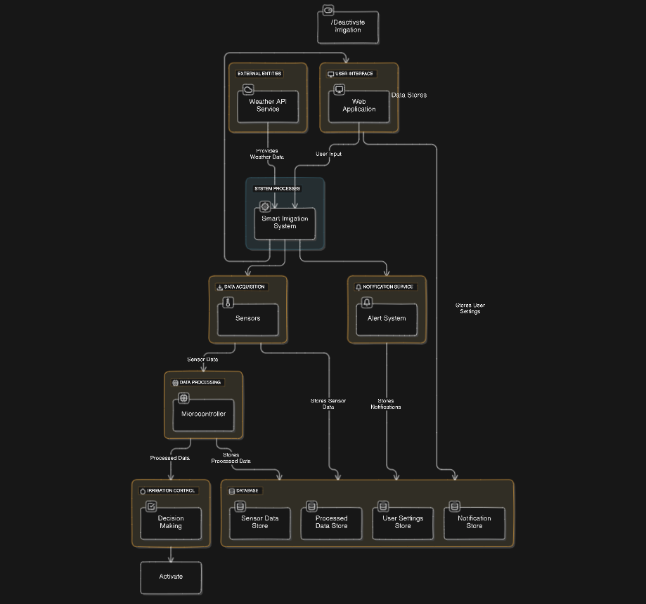

4.2 Entity Relationship (ER) Diagram

