Keltan Thomas Davies

(P151489)

Introduction to Web Development

HTML & CSS Web Development

Lecturer: Kemi Ademoye

Table of Contents

1. Introduction
2. Concepts Investigation
3. Requirements
4. Implementation
5. Evaluation
6. References

Introduction

This report is based on the Introduction to Web Development assignment. I will be covering the requirements of the project which includes an introduction to my website, it’s purpose and the target audience and the relevance of the project. The requirements section will also include a site map and wireframe diagrams to help the reader get a better understanding of my design decisions.

I also reference to the WCAG 2.0 guidelines for making web content more accessible in the concepts investigation section which follows this introduction.

The implementation section will include screenshots of the completed website for each page. It will also show the validation results for both the index.html and main.css code where I will discuss any errors that occur and any possible solutions to correct them.

In the evaluation section I will talk about the website with consideration to design, functionality and content. I will also discuss future improvements I would make to the website.

Concepts Introduction

The WCAG 2.0 (<https://www.w3.org/TR/WCAG20/>) lists guidelines for improvement of the accessibility of web content. The WCAG 2.0 guidelines are as follows:

1 - Perceivable

1.1 Provide text alternatives for any non-text content so that it can be changed into other forms people need, such as large print, braille, speech, symbols or simpler language.

1.2 Provide alternatives for time-based media.

1.3 Create content that can be presented in different ways (for example simpler layout) without losing information or structure.

1.4 Make it easier for users to see and hear content including separating foreground from background.

2 - Operable

2.1 Make all functionality available from a keyboard.

2.2 Provide users enough time to read and use content.

2.3 Do not design content in a way that is known to cause seizures.

2.4 Provide ways to help users navigate, find content, and determine where they are.

3 - Understandable

3.1 Make text content readable and understandable.

3.2 Make Web pages appear and operate in predictable ways.

3.3 Help users avoid and correct mistakes.

4 - Robust

4.1 Maximize compatibility with current and future user agents, including assistive technologies.

Requirements

The website I have created for my assignment is for a piece of software I have been working on in my spare time outside of university. The program is called “Syphr” and is a desktop application developed to try and make file encryption as simple as possible for everybody and anybody who wishes to encrypt a file.

The purpose of the website is to explain to the user what the product is and to show what the product can do.

The site should also explain what encryption is as some users may not be knowledgeable of why encryption is important to everybody, why encryption should be used by everyone.

Finally, the website should provide the “Syphr” software as a solution for people who might not be technically skilled yet still wish to keep their data safe. Therefore, the target audience for this website ranges from your average person who might not know much about encryption to technically skilled professionals who want a quick and easy way to encrypt their data.

Since the target audience covers a diverse group of people it is important that the website conveys the information properly to all users and doesn’t make people new to encryption feel uncomfortable and confused. So, I took the decision to design the entire site with a minimalist approach to keep the user experience a simple one to try and keep the user focused on the content of the site as its primary purpose is to promote the software product.

The website should meet these requirements in order for it to serve its purpose.

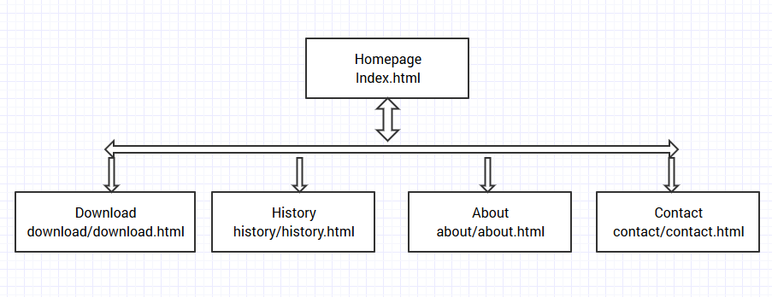Site Map:

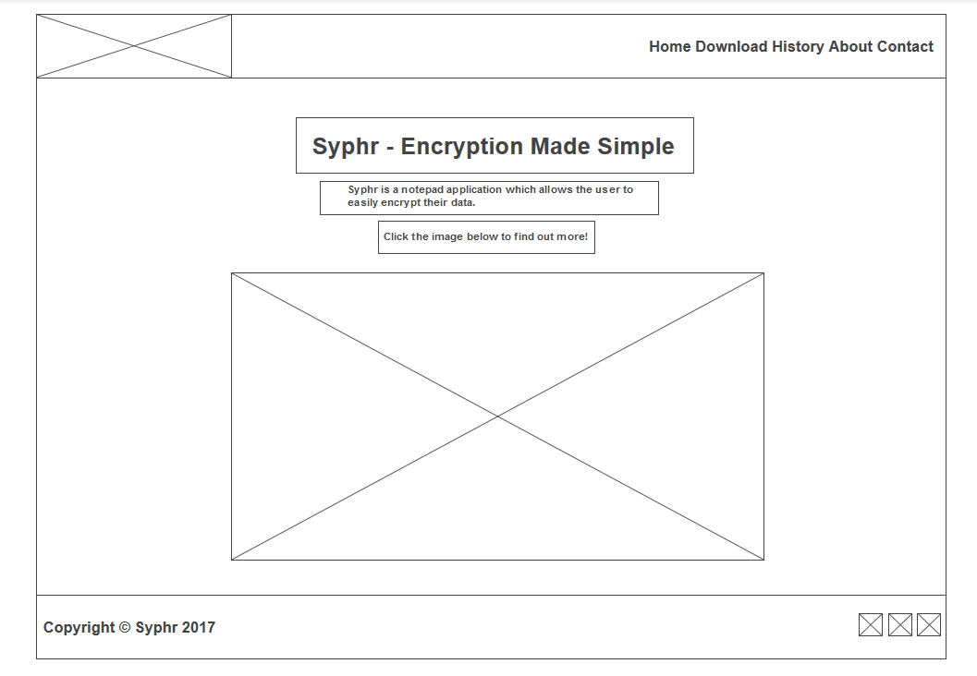Wireframe diagram:

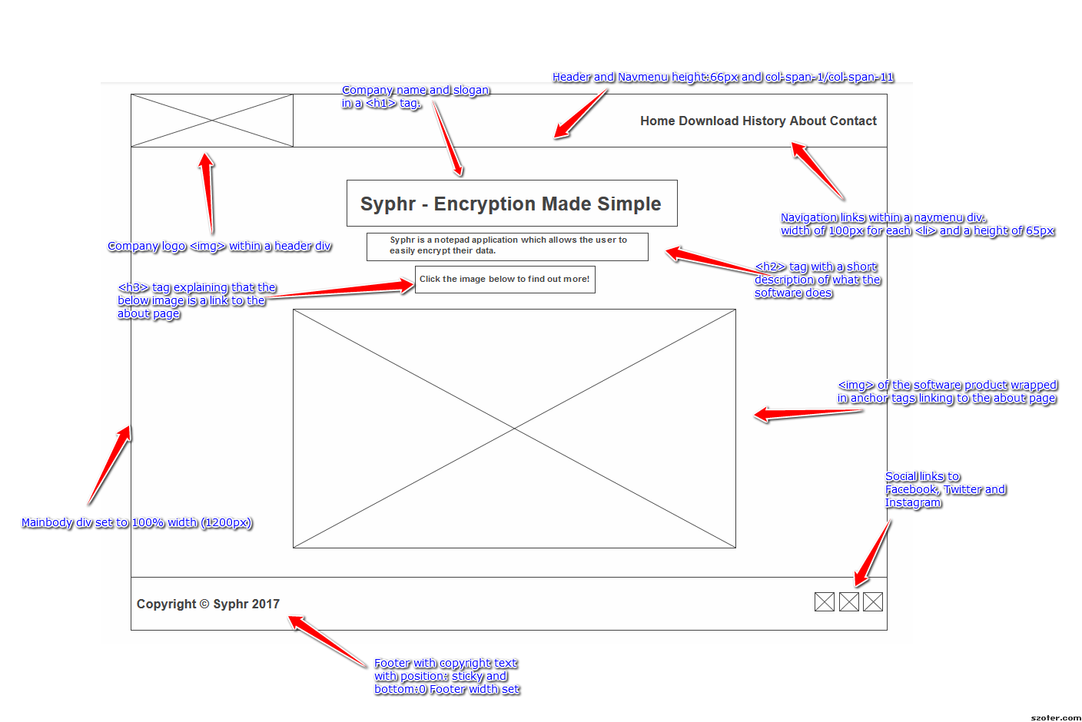Wireframe annotated:

Implementation

Screenshots

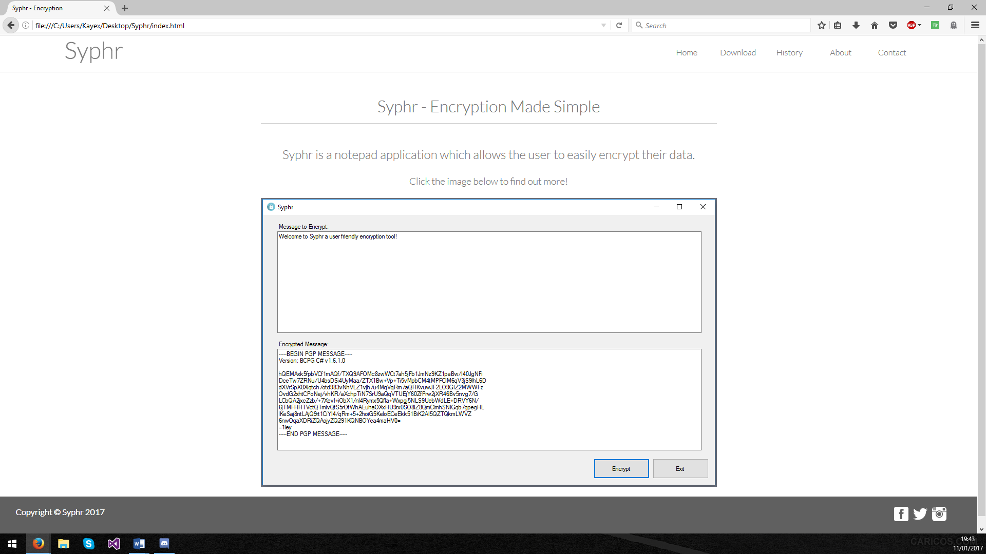Index.html:

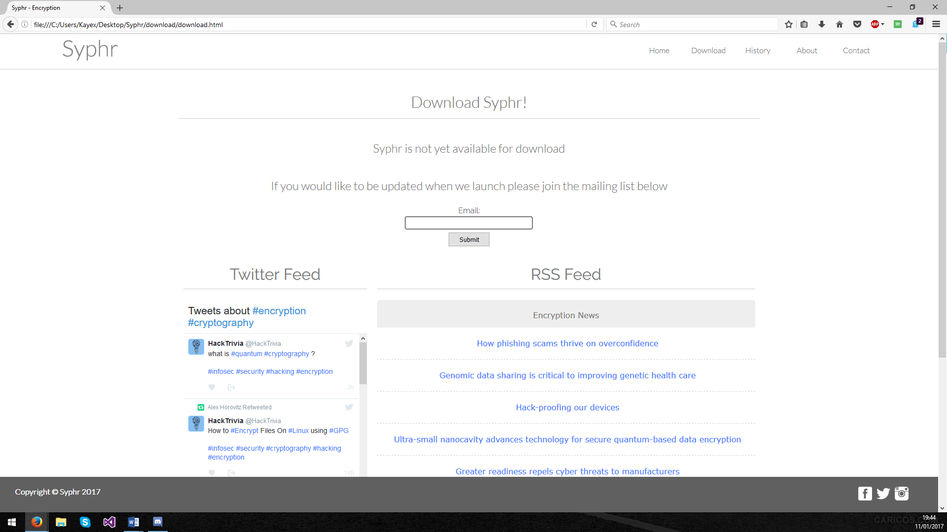Download.html:

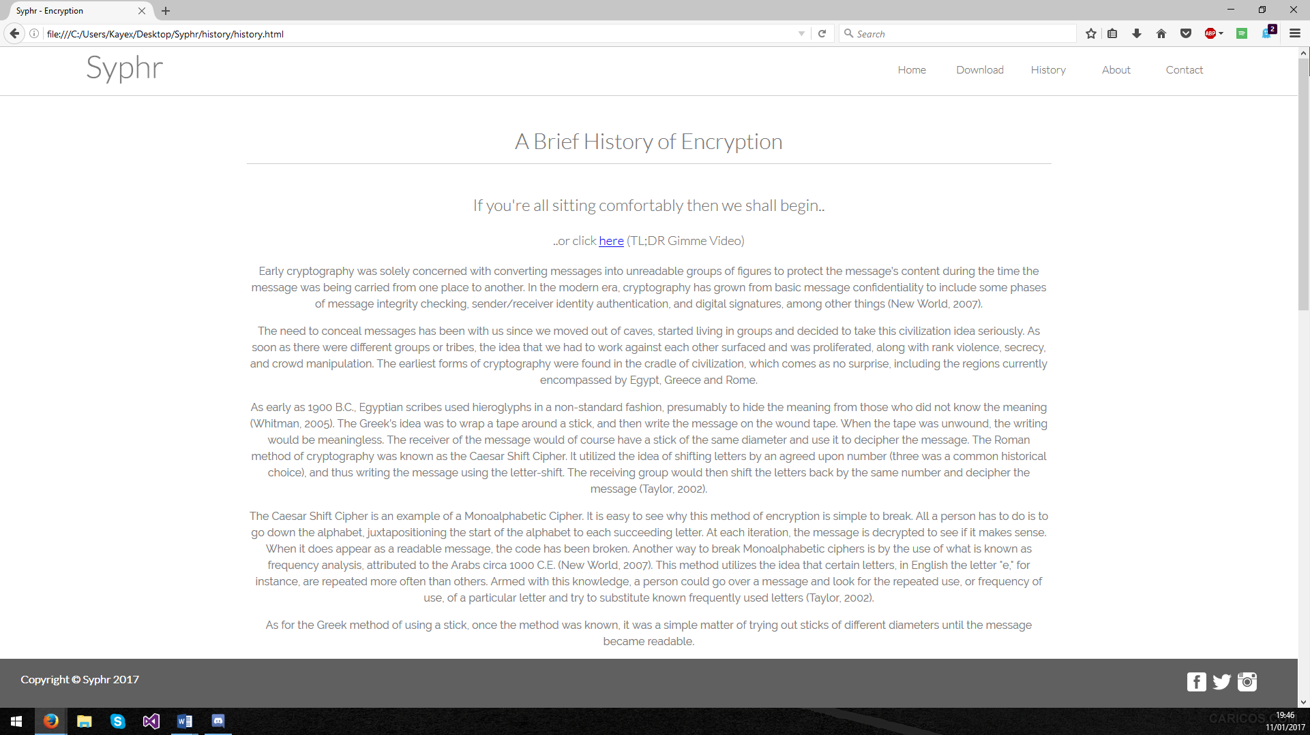History.html:

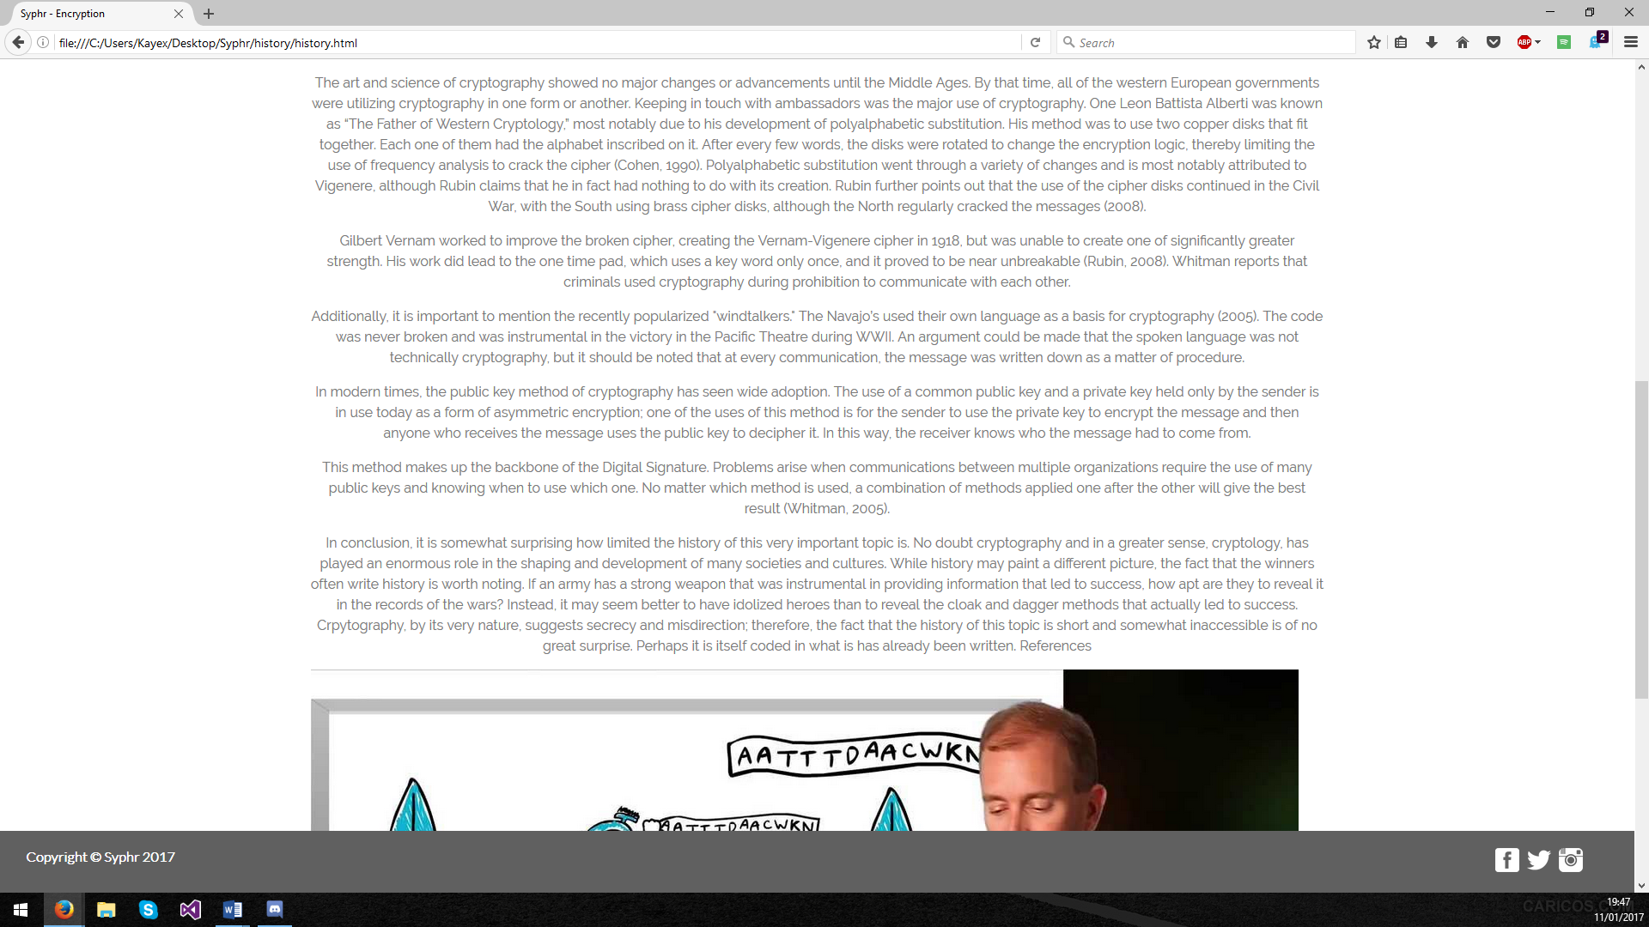

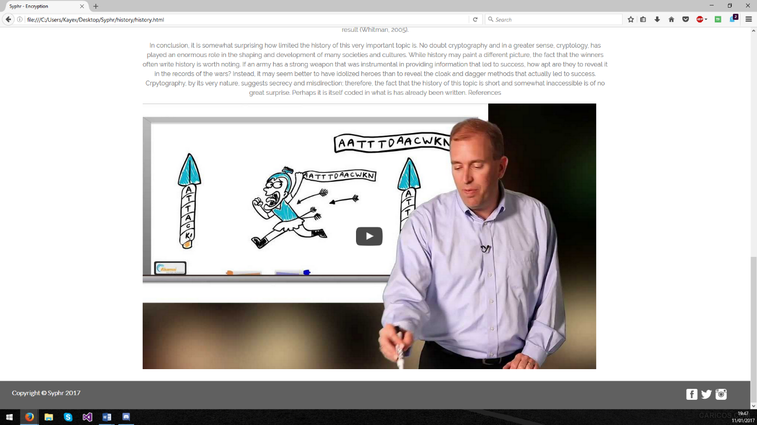

About.html:

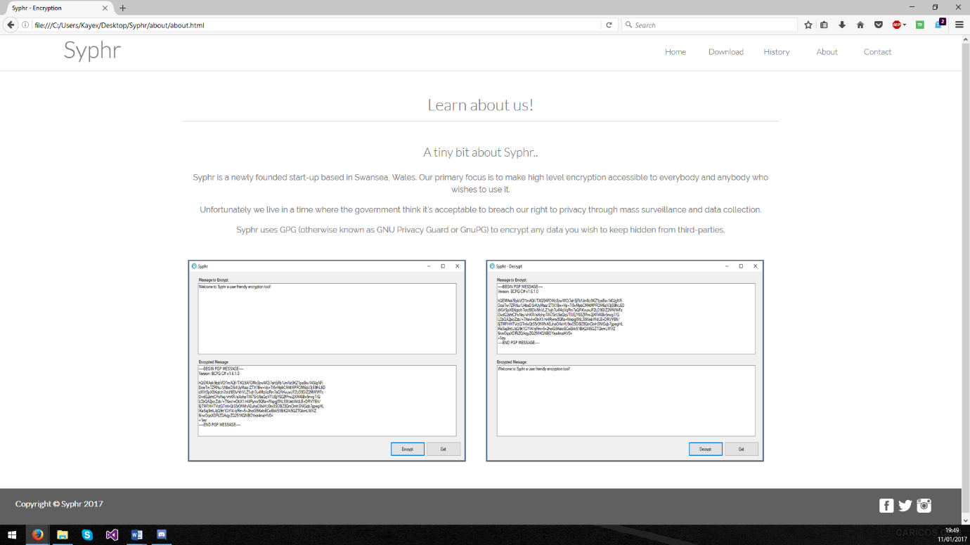

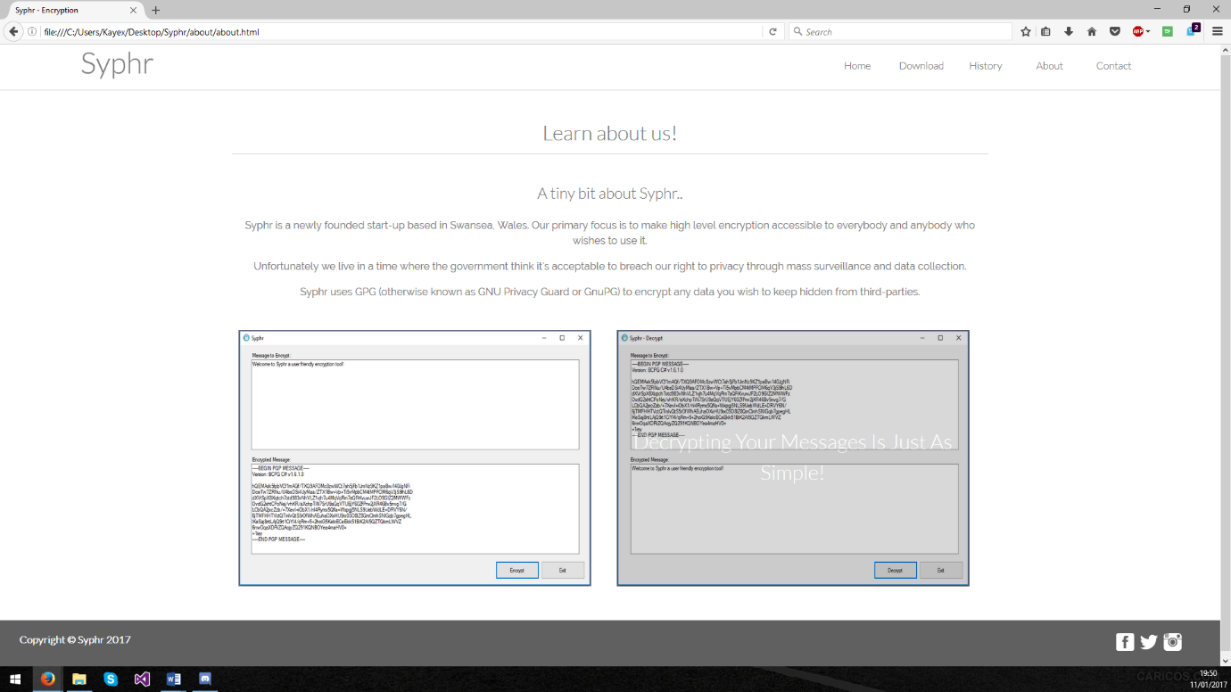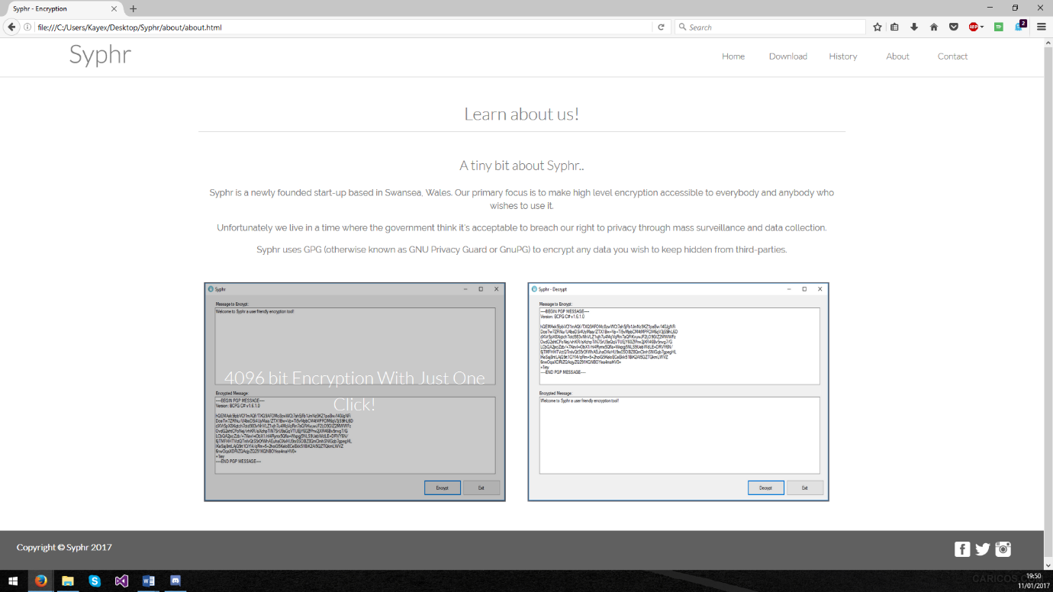

Contact.html:

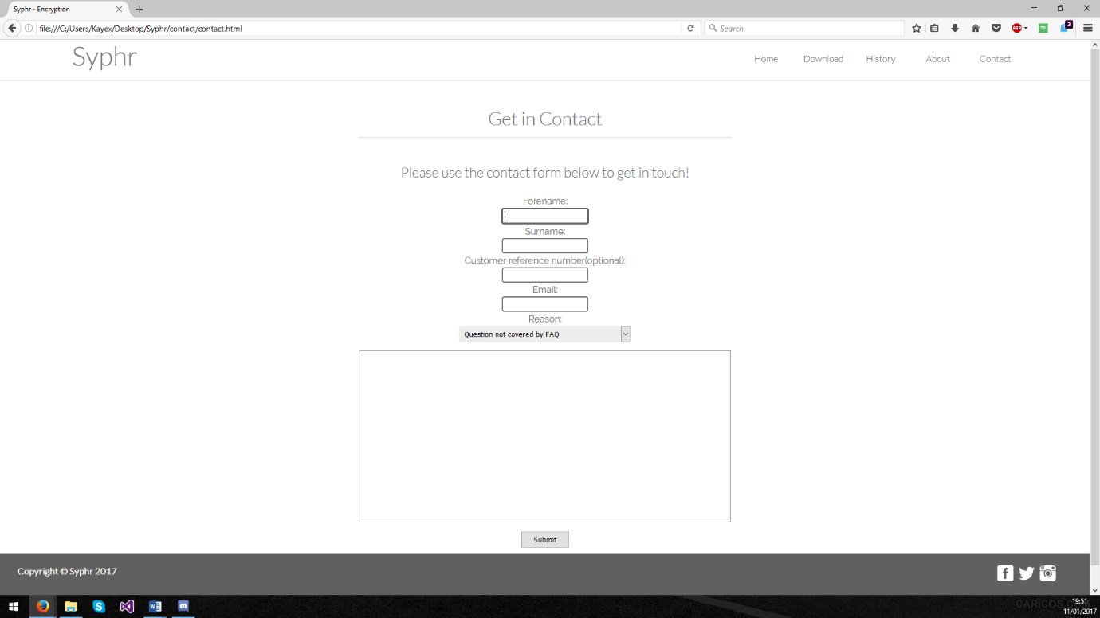

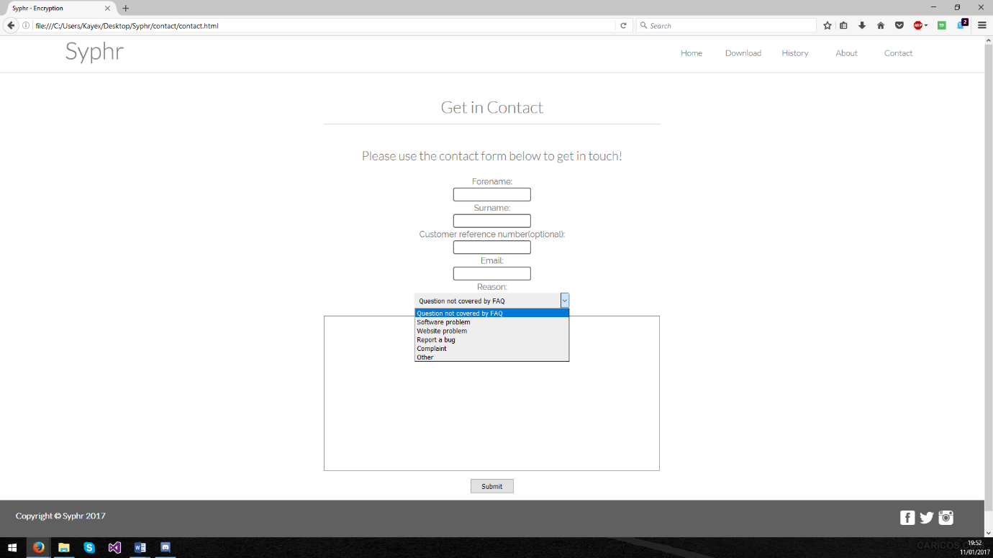

Validation:

Upon validating my index.html I had a few validation errors. The first validation error was caused by an illegal character within a web font link generated by Google Fonts *(*<https://fonts.google.com/>).



This could be resolved by generating another link for the “Raleway” font and linking it separately below the “Lato” web font link in the html.

The second, third and fourth errors I received all pointed towards my social icons within the footer.

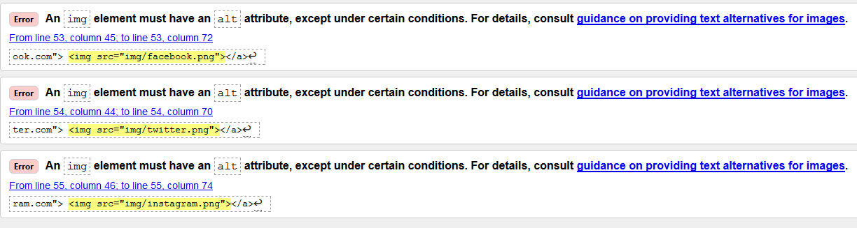

For an <img> element to be valid it must have an alt attribute so that in the event that the image cannot be displayed alternative text will be in place of the image.

When validating my main.css I also had two errors occur.



The first error was found in my footer ID and is caused by the value of position being “sticky” after some searching I discovered that the value sticky is a new value for position and could possibly be flagged up because of this.

The second error is related to my .flex-container and is caused by an error I made when creating my flex-grid.css.

Evaluation

When designing the website, I wanted the site to reflect the simplicity of the product so I decided to go with light greys and whites to create a minimalist feel. I also picked fonts (Lato, Raleway and Sans-Serif) that complimented the style of the site. By picking very few colours I feel that the attention of the user is brought towards the content of the site first and that the content of the site has been curated in such a way that the user is only getting the important points about the software product. I also decided on having a large image displaying the software in use on the homepage (index.html) to direct attention to the product as soon as they had read the page title and headings. This image then links directly to the about page where they can find out more about the company and the product on offer. This grabs the user’s attention then guides them through the site showing them more of the product until hopefully they feel like they know enough to head to the download page and purchase the product. I feel that I could add more content but I would have to make sure it didn’t distract from the simplicity of the site.

I also feel that numerous improvements could be made to the website in the future. Firstly, in the future I would like to offer actual downloads from the download page either to a mirror site or potentially host them on my own file servers as the software the site is providing is under development currently as a side project of mine and I would like to see it finished. I would also like to add some PHP to add some functionality to the contacts form as currently the contacts form has no actual functionality. The content on the history page could be shorter and more concise and possibly focus more on current events relating to the world of cryptography such as issues relating to Wikileaks and the press when it comes to protecting sources. I would also add a cascading navigation menu once more content is added to the site as this would allow me to offer more information about the product to potential users. I feel that I could have used CSS animations a bit more throughout the site if I had more content suitable for animation.

References

While working on the assignment I referred to a few websites offering tutorials on learning HTML and CSS. Also for my concept investigation I reference the WCAG 2.0 guidelines taken from their website. I used Google fonts to add the “lato” and “raleway” fonts to my webpage and I used the contrast checker to check the colours I have used were suitable. I have listed these sites below.

Web-fonts:

<https://fonts.google.com/>

HTML and CSS learning resources:

<https://css-tricks.com/>

<http://www.w3schools.com/html/>

<http://www.w3schools.com/css/>

WCAG 2.0 guidelines:

<https://www.w3.org/TR/WCAG20/>

Contrast checker:

<http://contrastchecker.com/>