Commands git:

The next commands are focus in the next line “clone”

* **. git:** have all the metadata of the repository from the cloud
* you must know the default Branch is “Main”
* **git clone:** clone the repository
* **git branch:** show all the branch that we got in the file
* **git checkout “nave_of_the_banch”:** swap to another branch
* **git pull:** update all the metadata
* **git status:** show all the changes that we got comparator it with the cloud
* **git add “file_want_to_add”:**
* **git commit -m “your_message”**
* **git push**: push the project into the branch you are in
* **git rever “” :** reverse the last commit or the commit you want to reverse
* **git checkout -–** **“file_name_for_reverse”:** this command helps you to reverse a file to the last commit

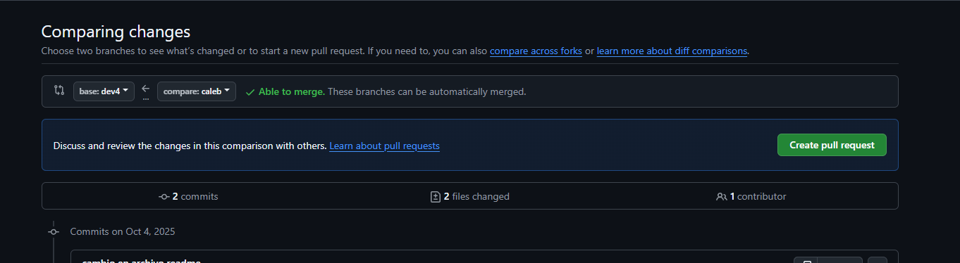

Start right to left

Homework 1:

Mention in teams, and the professor

In the same repository there is a file called “. kt”

In that file add all the methods in

Class car: IVehicle{

}

So, each member do one function

Today in 15 days

Each one needs to think in our project individually, so start thinking what you want in your own project for each week.

mockups