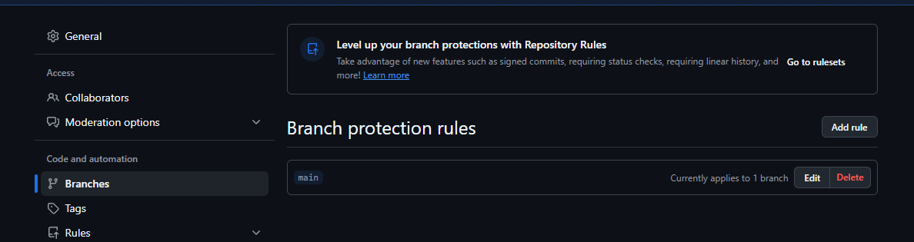

Like this you can create a rule for save the main branch, and dont do any mistake

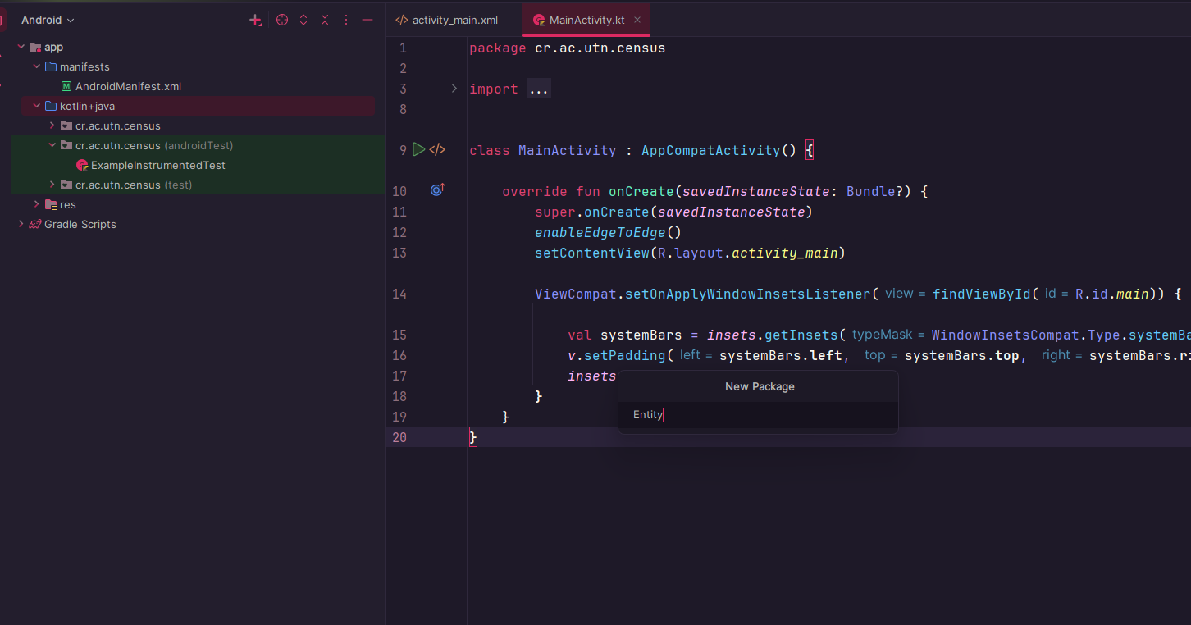

We need to create each package

And inside we creat each file (class)

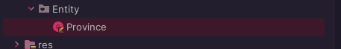

Lateinit Works as a condition for the language that said “wait, latter I will start this”

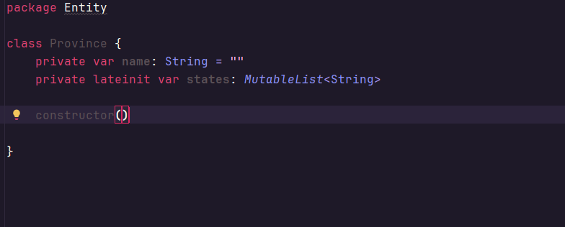



This means this parameter can receive a null or a bitmap

Adds the gets and sets as well and the constructor

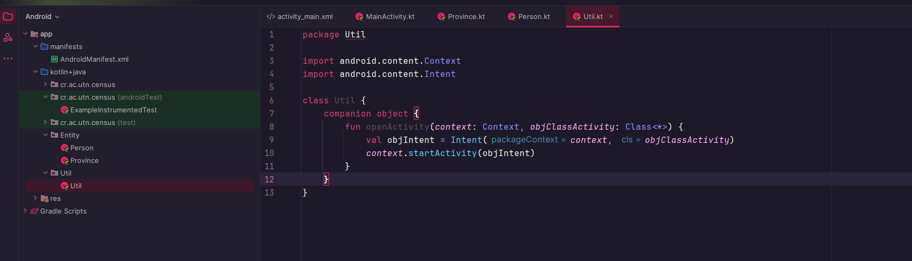

In the last image we created another package called Util, and a class with the same name as well, and we wrote this:

package Util  
  
import android.content.Context  
import android.content.Intent  
  
class Util {  
 companion object {  
 fun openActivity(*context*: Context, *objClassActivity*: Class<\*>) {  
 val objIntent = Intent(*context*, *objClassActivity*)  
 *context*.startActivity(objIntent)  
 }  
 }  
}

look at the repository called Censo week5

what we need for week 6

basic create everything for my project

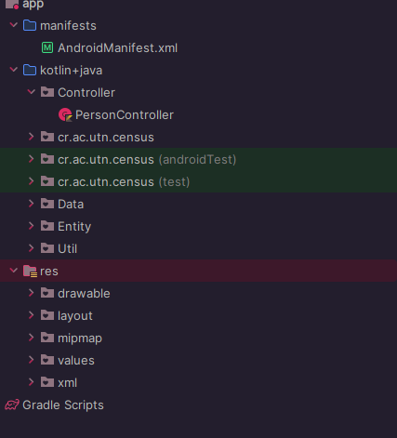

This Is an example, but remember think about your project