[](http://en.wikipedia.org/wiki/File:Ngee_Ann_Poly_Logo.png)

**NGEE ANN POLYTECHNIC**

# **School of InfoComm Technology**

**Advanced Databases (ADB)**

Diploma in IT / DS

October 2022 Semester

**Assignment 2 Preparation Checkpoint**

**Team cum Individual**

(10% of ADB Module)

12 December 2022 – 06 January 2023

**Deadline for Checkpoint Submission:**

**8 January 2023 (Sunday), 23:59hr**

|  |  |  |  |  |
| --- | --- | --- | --- | --- |
| **Team Number** | **:** | **T2** | | |
| **Tutor** | **:** | **Choon Peng TAN** | | |
| **Members** | **:** | **SNo.** | **Student No.** | **Student Name** |
|  |  | **1** | S10221788K | Lim Wee Liang Kelven |
|  |  | **2** | S10227896K | Hafeezur Rahman Bin Mohamed Ismail |
|  |  | **3** | S10222863J | Tan Kok Kai |
|  |  | **4** | S10223486G | Ambrish Krishna Muralitharan |

**Penalty for late submission:**

10% of the marks will be deducted every day after the deadline.

**NO** submission will be accepted after 15 January 2023, 23:59hr.

Contents

**School of InfoComm Technology** 1

Relational Mapping: 3

Description of core functions: 4

Flight Schedule: 4

Seat Availability: 4

Fare Quotes: 4

Reservation of seats: 4

Ticket information: 5

Cancellation and refunds: 5

Recording of plane’s location: 5

Customer loyalty programme: 5

Entity Relationship Diagram: 7

Assumptions: 8

Data Dictionary: 8

FlightSchedule 8

Reservation 9

Customer 9

CustomerContact 10

Aircraft 10

Seats 11

Ticket 12

RouteInformation 12

Queries: 14

Kelven 14

Ambrish 14

Kok Kai 14

Hafeezur 14

# Relational Mapping:

Aircraft (ACID, ACModel, EconomySeatsCapacity, BusinessSeatsCapacity, FirstClassSeatsCapacity, ACMfdBy, ACMfdOn)

Seats (SeatNo, <ACID>, SeatClass, SeatStatus)

FlightSchedule (FlightNo, <ACID>, DepDateTime, EconomyPrice, BusinessPrice, FirstClassPrice, FlightStatus, <RIID>)

RouteInfo (RIID, DepCity, ArrCity, Distance, EstDuration)

Customer (CustID, CustName, CustEmail, CustDOB, CustGender, CustNationality, Points)

CustomerContact (<CustID>, ContactNo)

Reservation (ReservID, ReservStatus, NoOfChild, NoOfAdult, ServiceClass, <CustID>, <FlightNo>, <ACID>)

Ticket (TicketID, Price, TicketStatus, TicketType, BoardingTime, GateNo, <SeatNo>, <ReservID>)

# Description of core functions:

## Flight Schedule:

The flight schedule shows information about the departure date and time of flights and prices for Economy, Business, and First class, and flight status. This is important as it allows flyers to manage their time better by knowing when the flight happens and notifies them if there are any problems with the flight.

A flight schedule will be made for some aircrafts depending on the time of year, and all flights will have a base economy, business, and first-class cost depending on the destination.

## Seat Availability:

The Seat Availability shows information about the number seats left by service class in each flight. The remaining number of seats for the aircraft for a particular flight can be calculated using

*[Aircraft capacity]* - *[number of booked seats for a reservation for that flight]*

Having this function of seat availability on a flight based on service class is important because it would help customers check if the flights have enough seats to determine whether they would like to book another flight or another service class.

## Fare Quotes:

The fare quote is a consolidated fare based on the flight, day, time, service class (first, business, economy), and passenger type (child, adult, elderly). A fare quote is important as it shows all the different costs and discounts in a neat and simple manner. The fare quote will be calculated using the service class price from FlightSchedule and the TicketType from Ticket.

## Reservation of seats:

The reservation of seats shows the total number of seats booked by a customer. The customer must first make a reservation before ordering their ticket(s). Upon starting the reservation, the status will be “Pending”. After completing the reservation, it will be changed to “Booked” and the subsequent ordered ticket contains the seat number. All the SeatNo of an aircraft grouped by service class are shown to the user. The customer then selects a SeatNo. This SeatStatus of this SeatNo will be changed to “Booked”.

Reservation of seats is important because it allows customers to book their preferred seats beforehand, maximising their comfort during the flight

## Ticket information:

Information regarding the generation and storing of tickets. A ticket shows the seat number, type, and boarding time of the flight. A ticket can only be purchased after booking a reservation. The ticket price is dependent on the age (child, adult, elderly) and whether the customer has a membership account. Upon purchasing the ticket, the ticket status will be set to “Paid”.

Ticket information is important because it acts as a proof that the customers have booked the seats in a specific flight and shows the consolidated fare.

## Cancellation and refunds:

The cancellation of existing booking of tickets made by customers and the refunds to be made. Customers schedules are ever-changing; thus this function is important as it allows customers to relax about booking at a wrong date and time. Customers may have also booked the wrong seat number; thus this function also allows customers to change seats.

Upon cancelling the reservation, the reservation status will be changed to “Cancelled” and the respective ticket status will be set to “Refunded”. The funds are refunded to the customer, but not any used coupons.

## Recording of plane’s location:

The recording of plane’s location keeps track of the latitude, longitude and altitude of the plane at every minute during a flight to check if the flight is on schedule. This is important as constant system updates ensure the aircraft is operating well, the flight is unimpeded, and continuous communication between the pilot and command centre.

## Customer loyalty programme:

The customer loyalty programme shows information about customers that bought tickets for flight frequently. A loyalty programme is important as it ensures returning customers are satisfied, have a good impression of the company, and continue coming back.

New customers have no points by default. Points are awarded based on the travel distance, and flyers need to gather between 5,000 to 147,000 miles to be eligible for this reward where 1 point = 1 mile. Reaching certain milestones earn rewards, such as class upgrades, merchandise, VIP lounge access, and many more.

# Entity Relationship Diagram:

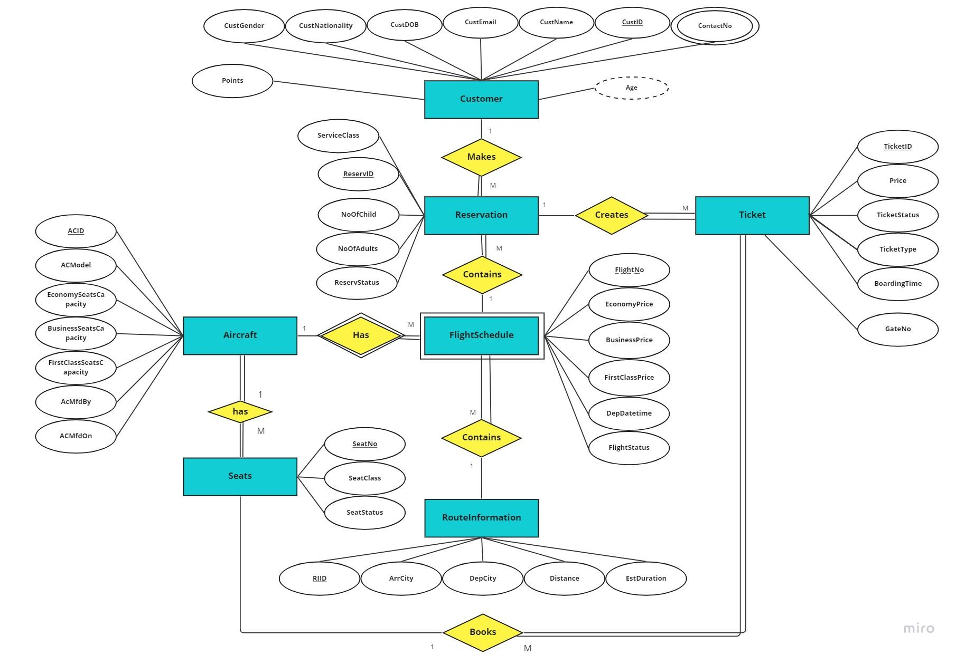

# Assumptions:

* One reservation can only have one service class.
* Seats can only be chosen when buying the tickets.
* The discounts given to each category are constant, etc child = 30% of adult price

# Data Dictionary:

## FlightSchedule

|  |  |  |  |
| --- | --- | --- | --- |
| **Attribute** | **Data Type** | **Description** | **Constraint** |
| **FlightNo** | INT | Unique ID for each flight | PRIMARY KEY |
| **ACID** | VARCHAR(12) | Unique ID for each aircraft | PRIMARY KEY  FOREIGN KEY > Aircraft(ACID) |
| EconomyPrice | SMALLMONEY | Price for an economy class seat | NOT NULL |
| BusinessPrice | SMALLMONEY | Price for an business class seat | NOT NULL |
| FirstClassPrice | SMALLMONEY | Price for an first class seat | NOT NULL |
| DepDateTime | DATETIME | Date and time of departure | NOT NULL |
| FlightStatus | VARCHAR(20) | Status of flight  Accepted values: Scheduled, Delayed, Departed, In Air, Expected, Diverted, Recovery, Landed, Arrived, Cancelled | NOT NULL |
| <RIID> | INT | Uniquely identifies each route information | FOREIGN KEY > RouteInformation(RIID),  Not Null |

## Reservation

| **Attribute** | **Data Type** | **Description** | **Constraint** |
| --- | --- | --- | --- |
| **ReservID** | INT | Unique ID for each reservation | PRIMARY KEY |
| ReservStatus | VARCHAR(20) | Status of reservation  Accepted values: Pending, Booked, Cancelled, Failed | NOT NULL |
| NoOfChild | TINYINT | Number of children in the booking | NOT NULL |
| NoOfAdult | TINYINT | Number of adults in the booking | NOT NULL |
| ServiceClass | Varchar(20) | The service class that was booked which consists of First class, business and economy | Not Null |
| <FlightNo> | INT | Unique ID for each flight | FOREIGN KEY > FlightSchedule(FlightNo),  Not null |
| <ACID> | INT | Unique ID for each aircraft | PRIMARY KEY  FOREIGN KEY > Aircraft(ACID) |
| <CustID> | INT | Unique ID for each customer | FOREIGN KEY > Customer(CustID),  Not null |

## Customer

|  |  |  |  |
| --- | --- | --- | --- |
| **Attribute** | **Data Type** | **Description** | **Constraint** |
| **CustID** | INT | Unique ID for each customer | PRIMARY KEY |
| CustName | VARCHAR(99) | Name of customer | NOT NULL |
| CustEmail | VARCHAR(99) | Email of customer | NOT NULL |
| CustDOB | DATETIME | Date of birth of customer | NOT NULL |
| CustGender | CHAR(1) | Customer Gender  Accepted values: M, F | NOT NULL |
| CustNationality | VARCHAR(99) | Customer Nationality | NOT NULL |
| Points | INT | Number of loyalty points  Default value = 0 for new customers  1 point = 1 mile.  Flyers need to gather between 5000 and 147,000 miles to be eligible | NOT NULL |

## CustomerContact

|  |  |  |  |
| --- | --- | --- | --- |
| **Attribute** | **Data Type** | **Description** | **Constraint** |
| **<CustID>** | INT | Unique ID for each customer | FOREIGN KEY, PRIMARY KEY |
| **ContactNo** | CHAR(8) | Contact number of customer | PRIMARY KEY |

## Aircraft

|  |  |  |  |
| --- | --- | --- | --- |
| **Attribute** | **Data Type** | **Description** | **Constraint** |
| **ACID** | INT | Unique ID for each aircraft | PRIMARY KEY |
| ACModel | VARCHAR(99) | Name of aircraft model | NOT NULL |
| EconomySeatsCapacity | TINYINT | Number of economy seats on the aircraft | NOT NULL |
| BusinessSeatsCapacity | TINYINT | Number of business seats on the aircraft | NOT NULL |
| FirstClassSeatsCapacity | TINYINT | Number of first class seats on the aircraft | NOT NULL |
| ACMfdBy | VARCHAR(99) | Name of aircraft manufacturer | NOT NULL |
| ACMfdOn | DATETIME | Aircraft manufactered Date | NOT NULL |

## Seats

|  |  |  |  |
| --- | --- | --- | --- |
| **Attribute** | **Data Type** | **Description** | **Constraint** |
| **SeatNo** | VARCHAR(3) | Unique ID for each seat | PRIMARY KEY |
| **<ACID>** | INT | Unique ID for each aircraft | PRIMARY KEY,  Foreign key > Aircraft(ACID) |
| SeatClass | VARCHAR(11) | Service class where the seat is located  Accepted values: Economy, Business, First Class | NOT NULL |
| SeatStatus | VARCHAR(9) | Booking status of the seat  Accepted values: Available, Booked | NOT NULL |

## Ticket

|  |  |  |  |
| --- | --- | --- | --- |
| **Attribute** | **Data Type** | **Description** | **Constraint** |
| **TicketID** | INT | Unique ID for each ticket | PRIMARY KEY |
| <ReservID> | INT | Unique ID for each reservation | FOREIGN KEY > Reservation(ReservID) |
| <SeatNo> | VARCHAR(3) | Seat number of passenger | FOREIGN KEY > Seats(SeatNo) |
| Price | SMALLMONEY | Price of the ticket | NOT NULL |
| TicketStatus | VARCHAR(10) | Status of reservation  Accepted values: Paid, Refunded, Failed | NOT NULL |
| TicketType | CHAR(7) | Type of ticket of passenger  Accepted values: Child, Adult, Elderly | NOT NULL |
| GateNo | VARCHAR(3) | Gate the passenger needs to report to | NOT NULL |
| BoardingTime | DATETIME | Time at which boarding of flight occurs | NOT NULL |

## RouteInformation

|  |  |  |  |
| --- | --- | --- | --- |
| **Attribute** | **Data Type** | **Description** | **Constraint** |
| **RIID** | INT | Unique ID for each route info | PRIMARY KEY |
| DepCity | VARCHAR(99) | Departing city of flight | NOT NULL |
| ArrCity | VARCHAR(99) | Arriving city of flight | NOT NULL |
| Distance | FLOAT | Flight distance | NOT NULL |
| EstDuration | TIME | Estimated duration of flight | NOT NULL |

# Queries:

## Kelven

Show the number of different nationalities for a certain flight. Else, show the total number of customers across all flights grouped by nationality.

## Ambrish

Show the number of flights departing from each city alongside the average number of people per flight and the average fare (In descending order of fare).

## Kok Kai

Show available flight schedule for a specific route information where there are enough seat capacity for the total number of people in a reservation in ascending order of depDateTime.

## Hafeezur

Show customer details for all flights departing from Singapore during december In ascending order of CustID.