Contents

Network Diagram 2

Diagram Explanation 2

Screenshot of NoSQL Database 3

Video Link 3

# Network Diagram

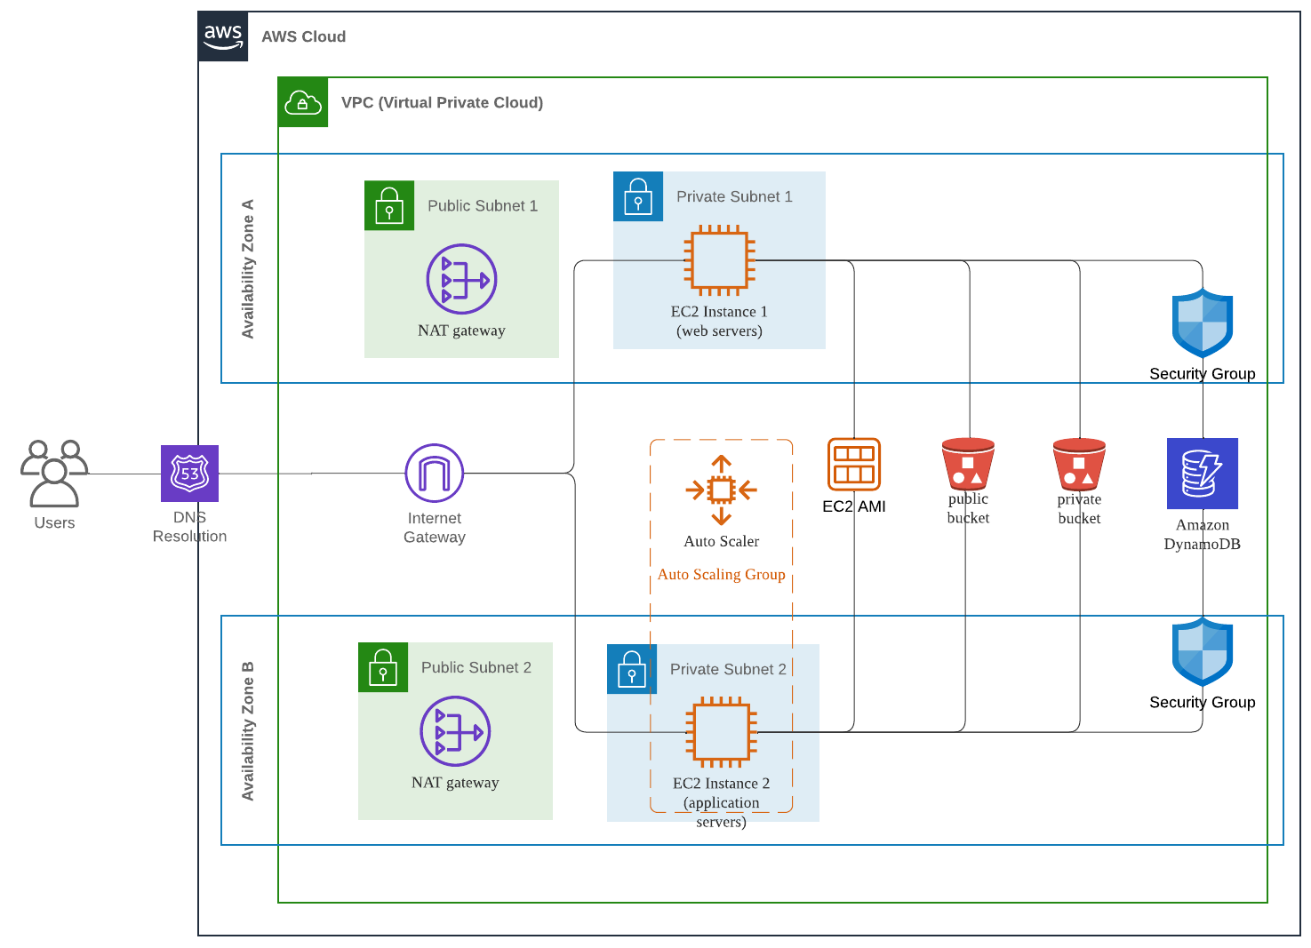

# Diagram Explanation

The domain Name System (DNS) translates what a user types into a browser into something the machine can utilise to find the cloud storage on a webpage.

Natural Address Translation (NAT) gateways are used in each public subnet to enable EC2 instances in private subnets to access the internet.

The 2 EC2 instances are placed in different availability zones to ensure resiliency and fault tolerance. If one zone fails, the other still works. Even though the instances are separate, it is still inexpensive, and has a low latency.

One instance is a web service, and the other is a web application server. Thus, the web application instance has an auto scaler that scales to traffic.

The Amazon Machine Image (AMI) is needed to create the instances. AMIs contain pre-installed packages and can be installed ahead of time.

The company utilises a hybrid cloud deployment using buckets. There are 2 S3 buckets; one public and one private. The public bucket provides the public with marketing materials to download, while the private bucket stores important files for the company. Buckets auto-scale and store data redundantly, meaning it stores file copies across multiple AWS facilities.

Before accessing the database, the instances go through a security group which act as a firewall that controls the traffic allowed to and from the resources in your virtual private cloud (VPC).

DynamoDB is a relational NoSQL database with a high storage capacity and low-latency queries. Thus, many files can be stored and retrieved swiftly.

# Screenshot of NoSQL Database

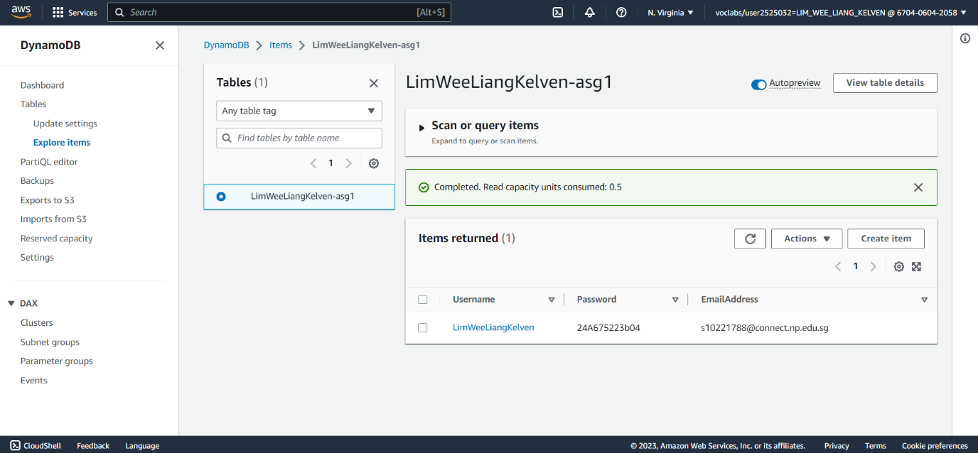

# Video Link

<https://youtu.be/fg4RUjGOCso>