|  |  |  |  |
| --- | --- | --- | --- |
| **Name & Student ID:** | Lim Wee Liang Kelven, S10221788K | **Class:** | T03 |
| **Chosen SDG:** | 11: Sustainable Cities & Communities | **Chosen Target:** | 11.6: Reduce the environmental impact of cities |
| **Chosen Country:** | USA | **Word Count (exclude headings, captions, and citations):** | 467 |

# A brief introduction to the USA

## Amount of waste generated

In 2018, the USA generated 292.4 million tons of municipal solid waste (MSW), an increase of 23.7 million tons from 2017, which equates to 4.9 pounds or 2.2 kilograms of waste per capita per day. The top three materials are paper (23.05%), food (21.59%), and plastics (12.2%) (EPA United States Environmental Protection Agency, 2022).

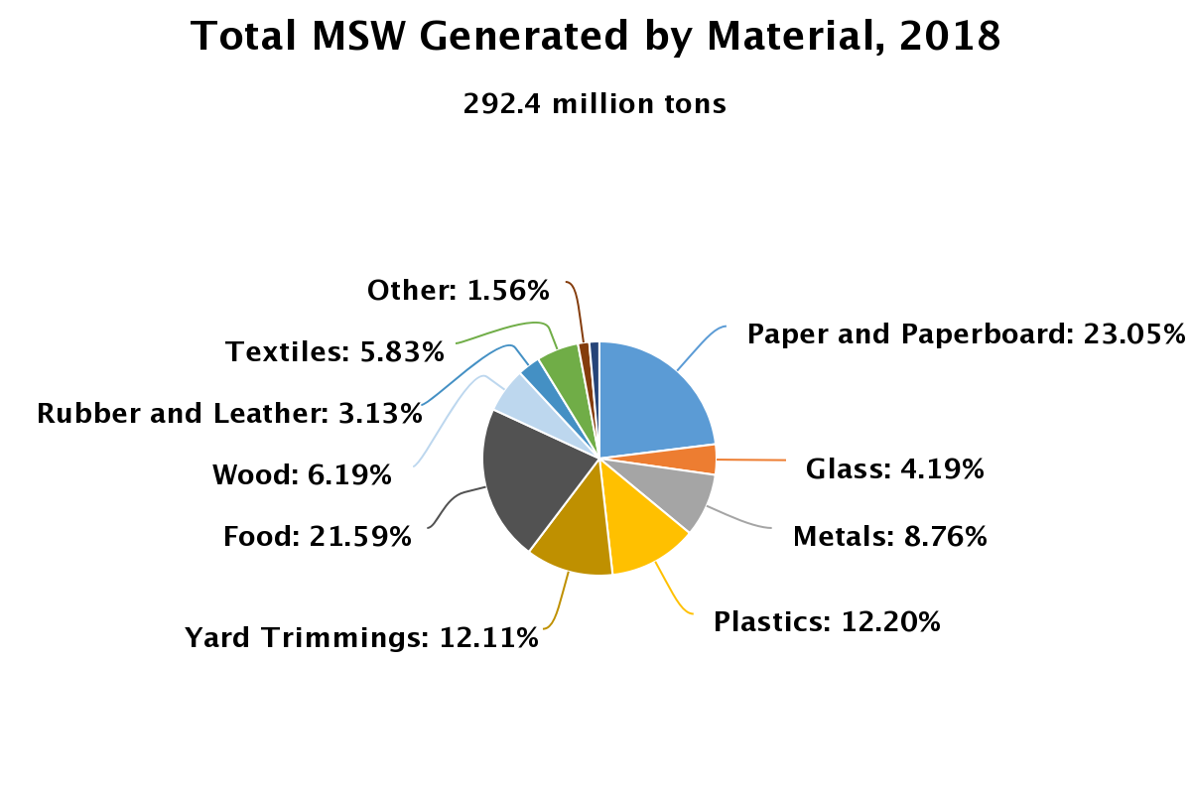

*(The pie chart above shows the proportion of materials discarded in 2018* (EPA United States Environmental Protection Agency, 2022)*)*

## How is the waste treated?

Currently, there are four main waste treatment methods – recycling, composting, combustion with energy recovery, and landfill. This report will focus on landfills. In 2018, about 146.1 million tons, or almost 50% of all landfilled waste. Most of these are food (24.14%), plastics (18.46%), and paper (11.78%) (EPA United States Environmental Protection Agency, 2022).

# Why is the target important to the USA?

## Environmental impact

As organic waste decomposes in landfills, methane and leachate are released. Methane is a greenhouse gas more potent than carbon dioxide, and leachate is a toxic liquid that can pollute surrounding soil and water quality (Deer, 2021). However, some landfills have inadequate collection systems for these chemicals.

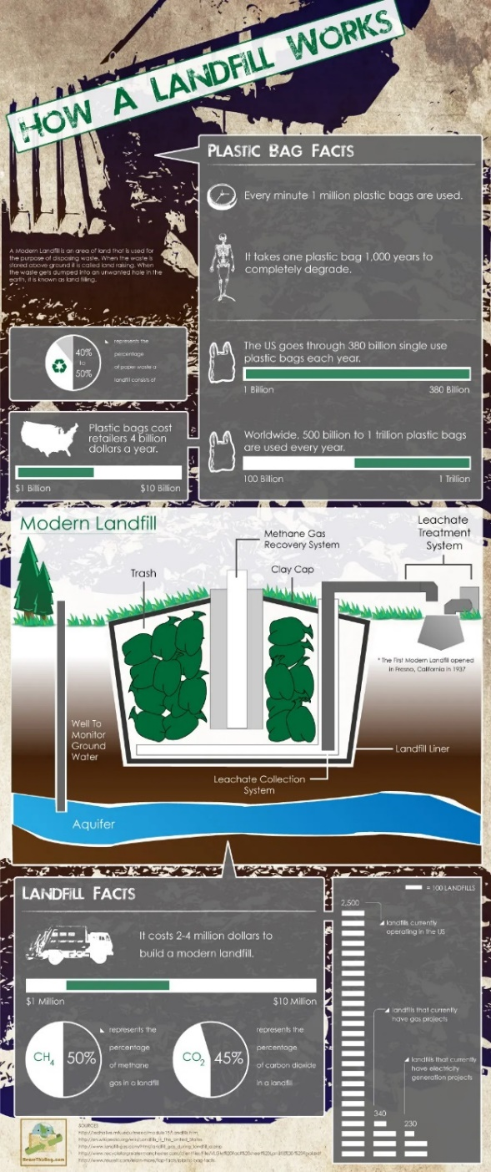

*(The infographic above shows the collection of methane and leachate,* (Lober, 2020)*)*

## Economical costs

Waste management is expensive. In 2019, the waste management market reached US$208 billion (CNBC, 2021), which equates to 0.97% of the USA’s GDP. Money is misspent through maintaining the landfills, producing the waste, and treating the waste. 86% of plastics produced in the same year were landfilled. The energy used in manufacturing them could supply 5% of the country’s transportation sector (Heffernan, 2022).

# What are the challenges faced by the USA in achieving the target?

The first reason nearly half of all waste is landfilled were that consumers often misunderstand recyclables and how they can recycle properly (EPA United States Environmental Protection Agency, 2022). While many understand the general four recyclables – paper, plastic, metal, and glass, not all may realise the other forms of recyclables like food and electronics. Most people may also not realise the importance of cleaning and separating waste. Most wastes sent for recycling are either contaminated or mixed. For example, a can of food may still contain food debris, or a plastic label remains on a glass bottle. They are thus unrecyclable and ironically sent to landfills.

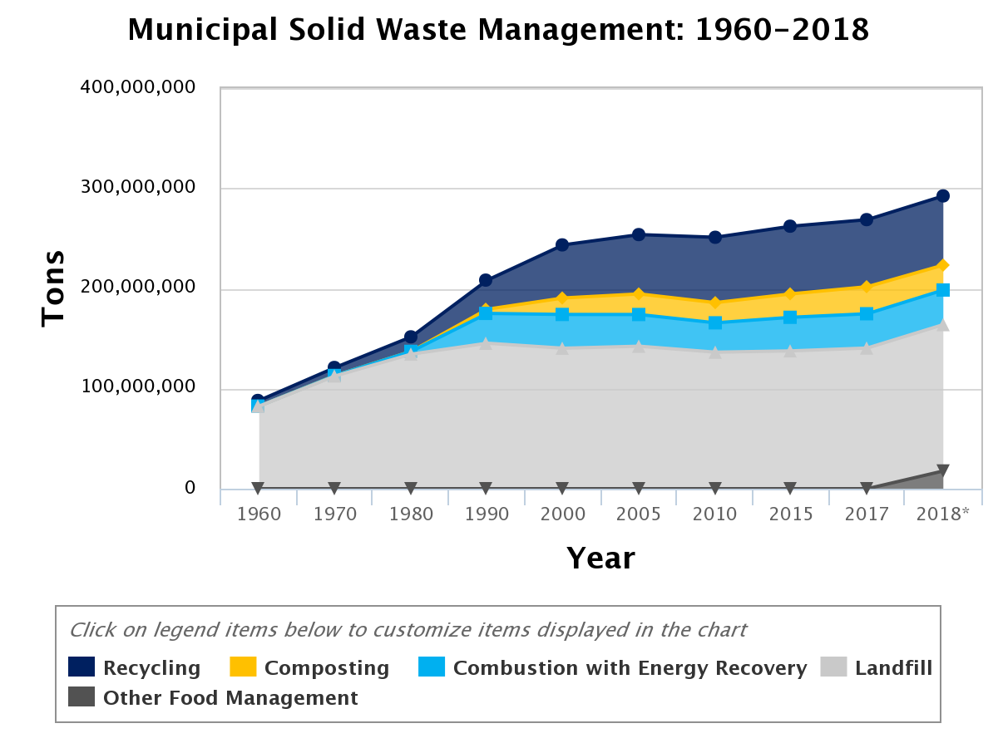

*(The filled line chart above shows amount of waste sent for different managements/treatments* (EPA United States Environmental Protection Agency, 2022)*. It is observed that Landfills (grey) take up the majority)*

Another reason why landfilling rates are increasing is because USA’s recycling infrastructure cannot keep pace with waste generation. Historically, the USA has sent its plastic waste to foreign countries like China. However, in 2018, China enacted an import ban that includes materials like plastics. As a result, the USA now has an abundance of recyclable plastics, and has landfilled many.

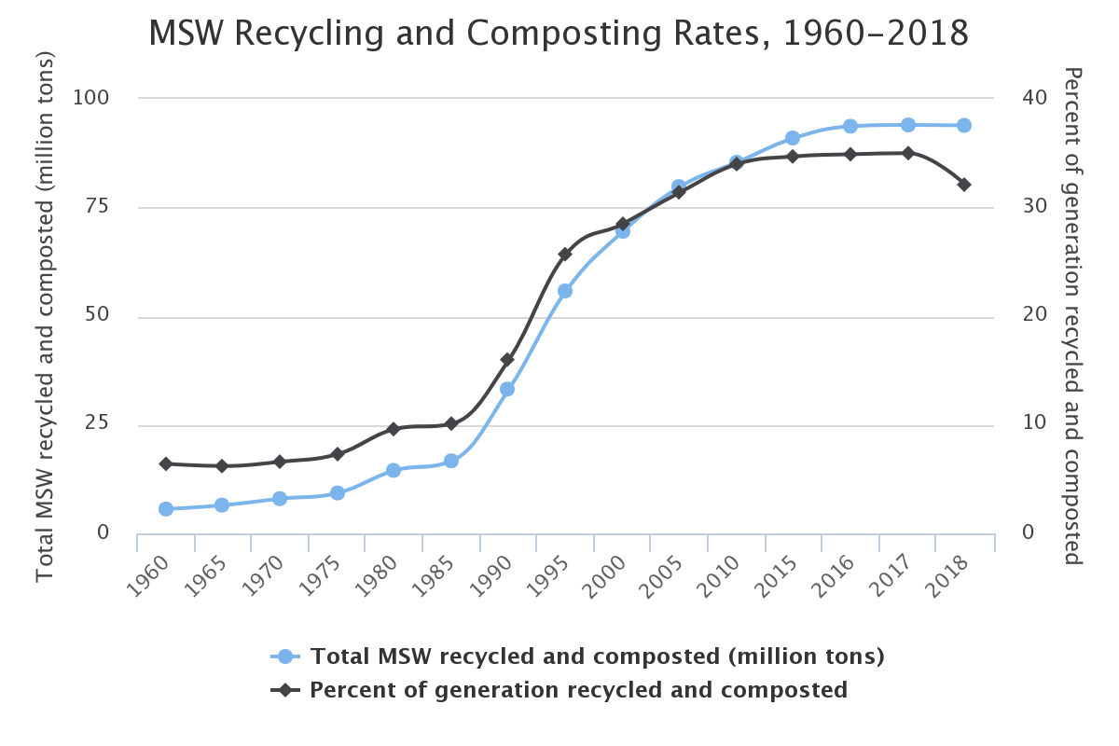

*(The line chart above shows recycling and composting percentage (black) has been plateauing* (EPA United States Environmental Protection Agency, 2022)*)*

# What is one initiative that has been implemented? To what extent has it been effective?

One solution that has garnered interest is the waste-to-energy (WTE) gasification process. This process involves turning organic and inorganic waste into synthetic gas (syngas) that is applicable in many industries. Gasification has a myriad of other benefits as well. Firstly, it reduces the use of fossil fuels for energy production; secondly, it is more efficient than combustion; and lastly, it reduces the space required for landfills (National Energy Technology Laboratory, n.d.).

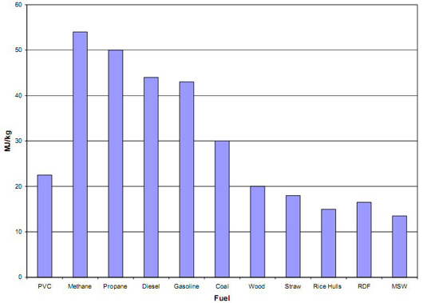

*(The bar chart above shows the energy required to extract syngas for different fuels. It is observed that MSW on the right requires the least energy* (National Energy Technology Laboratory, n.d.)*)*

However, the main challenge is that various wastes require different conditions to extract syngas. As such, it is difficult to conclude how clean this process will be as it evolves. Despite this, companies like Sierra Energy, Enerkem, and Plasco are spearheading this front (CNBC, 2020).

# Bibliography

CNBC. (2020, February 9). *How Gasification Turns Waste Into Energy*. Retrieved from YouTube: https://www.youtube.com/watch?v=zm0jslIE1kk&t=302s&ab_channel=CNBC

CNBC. (2021, July 23). *How Trash Makes Money In The U.S.* Retrieved from YouTube: https://www.youtube.com/watch?v=uUmtJIBibMM&ab_channel=CNBC

Deer, R. (2021, March 4). *RoadRunner Smarter Recycling*. Retrieved from LANDFILLS: WE'RE RUNNING OUT OF SPACE: https://www.roadrunnerwm.com/blog/landfills-were-running-out-of-space

EPA United States Environmental Protection Agency. (2022, July 31). *Facts and Figures about Materials, Waste and Recycling*. Retrieved from National Overview: Facts and Figures on Materials, Wastes and Recycling: https://www.epa.gov/facts-and-figures-about-materials-waste-and-recycling/national-overview-facts-and-figures-materials

EPA United States Environmental Protection Agency. (2022, Novemeber 15). *The U.S. Recycling System*. Retrieved from National Recycling Strategy: https://www.epa.gov/recyclingstrategy/us-recycling-system

Heffernan, M. (2022, May 4). *Plastics Recycling Update*. Retrieved from Federal study finds 86% of US plastic landfilled in 2019: https://resource-recycling.com/plastics/2022/05/04/federal-study-finds-86-of-us-plastic-landfilled-in-2019/

Lober, D. (2020, September 28). *ReuseThisBag.com*. Retrieved from How a Landfill Works [INFOGRAPHIC]: https://www.reusethisbag.com/articles/how-a-landfill-works

National Energy Technology Laboratory. (n.d.). *1.3.1. WASTE STREAMS*. Retrieved from 1.3.1. WASTE STREAMS: https://netl.doe.gov/research/coal/energy-systems/gasification/gasifipedia/waste