Superstore Executive Performance Dashboard
Executive Brief
Prepared for the VP of Retail Operations
Kelvin Thit
HA1

Target Audience and Role Alignment
The VP of Retail Operations has to decide where to intervene on sales growth, profit margin and returns across regions and product lines. The dashboard's three tiers follow that decision in order. The first tier answers whether the business is on track through metrics which are $2.33M (93% of target), net profit margin is 12.6% against 15%, and the return rate is 5.8% against a 5% limit. Tier 2 explains the why where I compared margin and returns by state, region and sub-category. Tier 3 lists the top ten products losing the most money. Clicking a state filters Tiers 2 and 3 to the certain market.
Visual Design Rationale
I used Bar charts because I was ranking comparisons. In addition, the bar length is read more accurately than colour or area, and I kept the map for geographic patterns. I kept the colors the same where orange always means a loss. Profit sits beside average discount so a likely cause appears next to the outcome. Customer counts and top-customer rankings were left out as vanity metrics because they do not change a decision. The three benchmarks are assumed targets, since the dataset contains none.
Three Strategic Business Insights
- Fix returns in the West. West returns 11.6% of orders, against about 3% in the other three regions, which is what pushes the company over its limit. Inspect West fulfilment and return policy first.
- Cap deep discounts. Tables lose $17,753 at a 26% average discount, and seven of the ten worst products sell at 35% off or more. I would suggest a requirement for approval for any discount above 30%.
- Reprice the Central region, starting with Texas. Central's margin is 7.9%, about half of West's 15.0%, and Texas runs at -15.1% on $170,188 of sales.

Appendix A: Tableau Mechanics Proof-of-Skill Screenshots
All screenshots are from the Part 1 tutorial workbook and I used the data provided by the video

Screenshot 1: Custom Calculated Field Window. The "Above Average Sales" field compares each sub-category's sales with the window average.

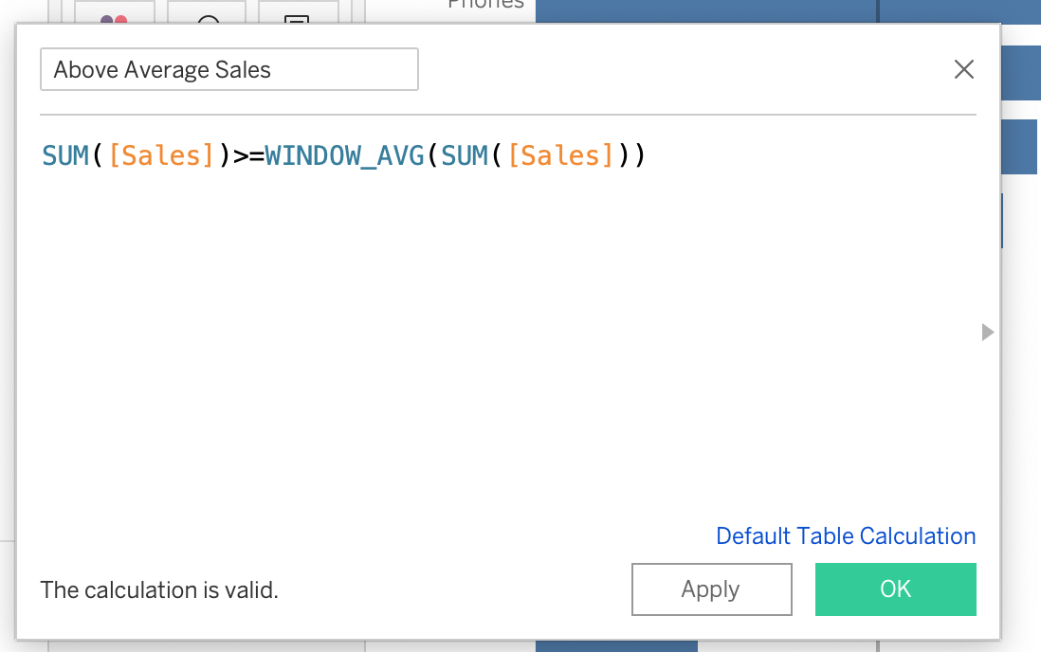
Screenshot 2: Marks Card and Tooltip Customization. Above Average Sales is on Color, Profit is on Size, and the tooltip shows euro-formatted values with plain labels.

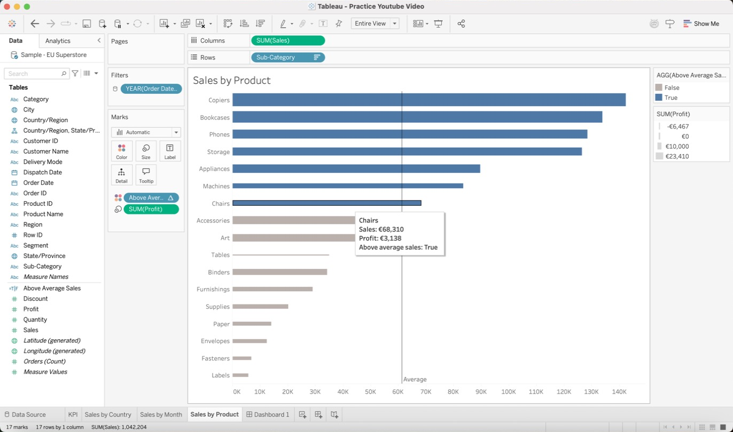

Screenshot 3: Interactive Dashboard Action Setup. The "Filter by Country" action runs on Select from Sales by Country and filters the KPI, Sales by Month and Sales by Product sheets.

