## VibTran

Author: Lau Kam Hon (55208914)

# Description

**VibTran is a mobile Peer-to-Peer Payment System based on Vibration Channel**

# Installation and User Instructions

## System Requirement

Mobile

* Operating system: Android ( version recommend: 2.3 or above)
* Built-in vibrator and accelerometer are required
* Mobile IP pre-set to 10.2.6.0/24. E.g. 10.2.6.100

Web Server

* Server IP pre-set to 10.2.6.45
* Port 8000
* Operating system: Linux (recommend Ubuntu 18.04)
* PHP version 7.2, with Composer
* Database version MySQL 5.7

## Source

https://github.com/Kelvin0v0/fyp.git

## Installation

Mobile

Step 1: Install the .apk file to the mobile phone

Step 2: Accept for the application to have permission in using phone id, internet, and built-in vibrator.

Web Server

Step 1: install MySQL server and create user account (kelvin@localhost without password)

Step 2: Import the fyp.sql file using mysql client command.

Step 3: Install PHP 7.2 with composer

Step 4: PHP composer update to update Laravel library.

Step 5: Type php artisan serve --host=10.2.6.45 to start server

## User Instructions

Once the installation completed, the mobile application displays the login page in the beginning.

### Login

Step 1: User can login their account by email and password if they are already registered.

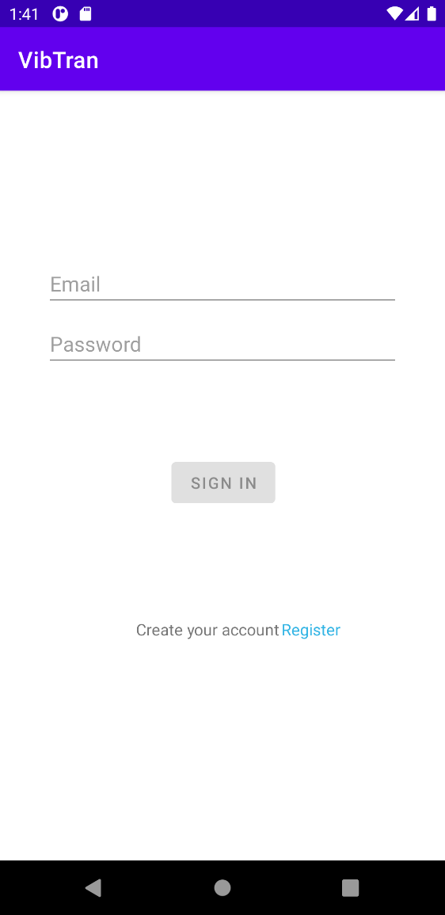

User Password

User Email

Step 2: Press the Sign in button to login. The home page shows up after user login

### Registration

Step 1: User can register a new account by clicking register button in login page.



Register Button

Step 2: User type their information, new password and confirm password for registration. User also can claim their role as a merchant for this account. Every transactions is type as payment if user is a merchant.

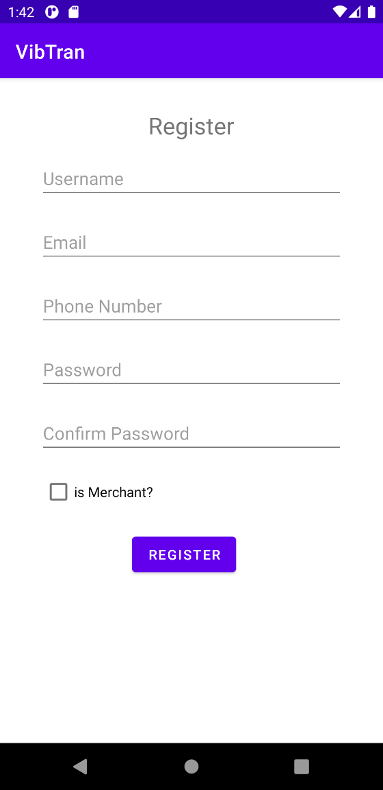

Step 3: Press the Register Button to completed the registration and it relocates to the login page for login.

### Transaction

Users can have transactions with other people. They can play a role as receiver or sender.

#### Receiver side

Step 1: The receiver can click the receive button to initiates the transaction

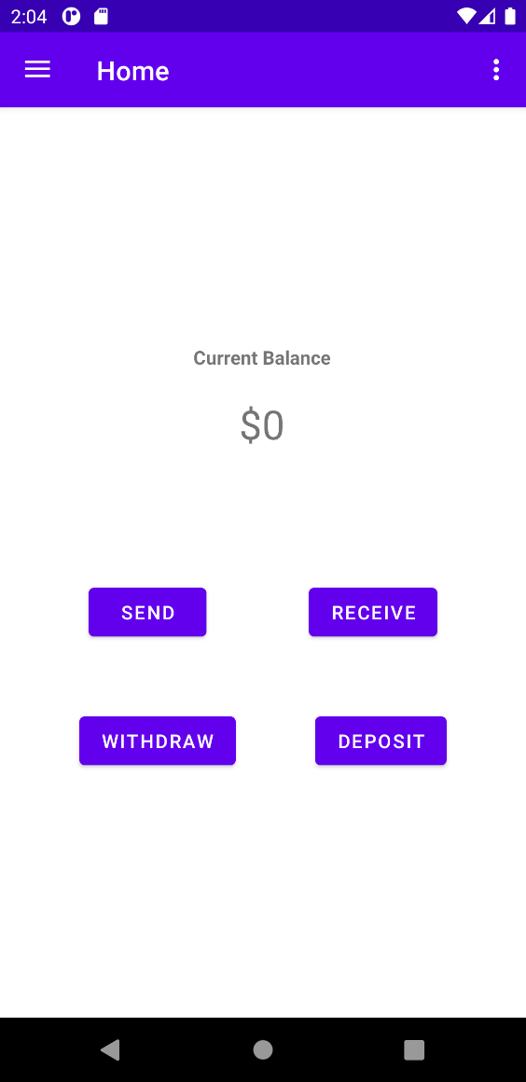

Receive Button

Step 2: Receiver require to type the specific amount, power and no signal delay time before the vibration communication. Then press the start button to transmit the vibration signal.

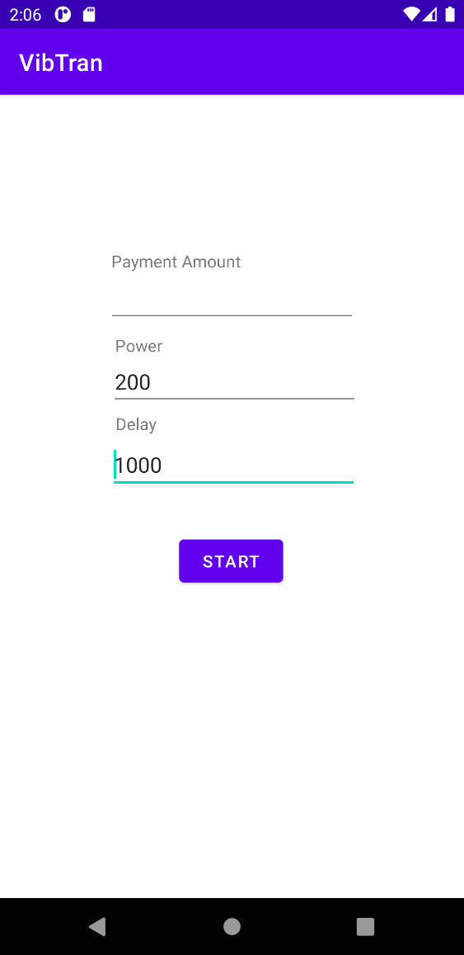

Start vibration

Vibation Setting

Amount for receive

User can view the transmission page after pressing the start button. Receiver can cancel the payment by the cancel button.

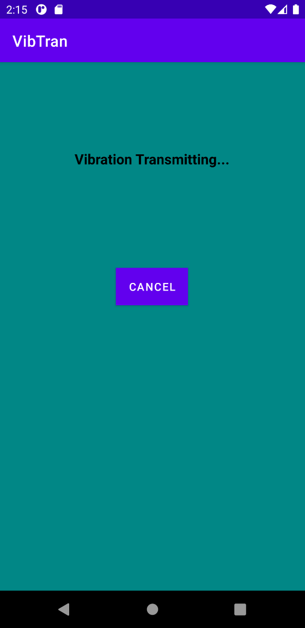

The message display “Wait for sender” if the sender gets the correct vibration pattern or “Sender cancelled the payment” if the sender cancel the trade.

#### Sender side

Step 1: While receiver press the start button, the sender can click the send button to open accelerometer to sense vibration



Send Button

User view the data sense page. The rescan button allows sender restart the accelerometer to detect the vibration signal again.

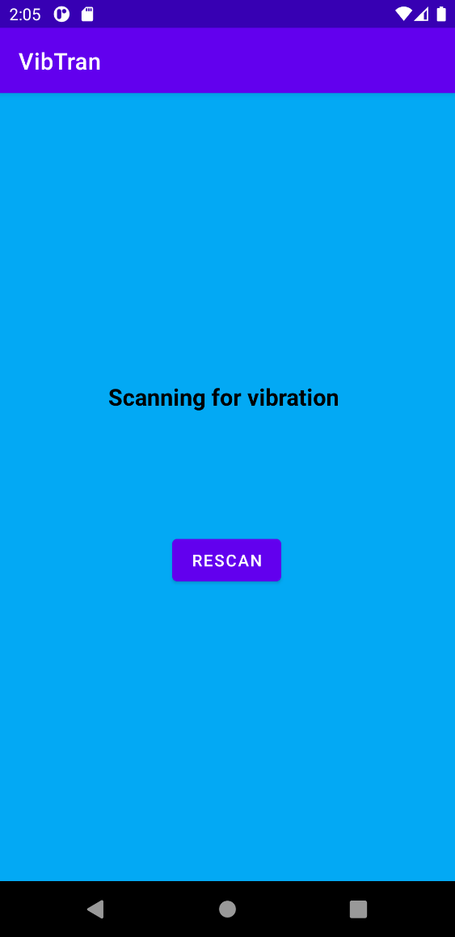

The text displays “Otp is not correct. Please Rescan” if the decoded vibration pattern is wrong.

Step 2: After sender get correct OTP, the confirm page displays immediately. Sender can confirm or cancel the payment.

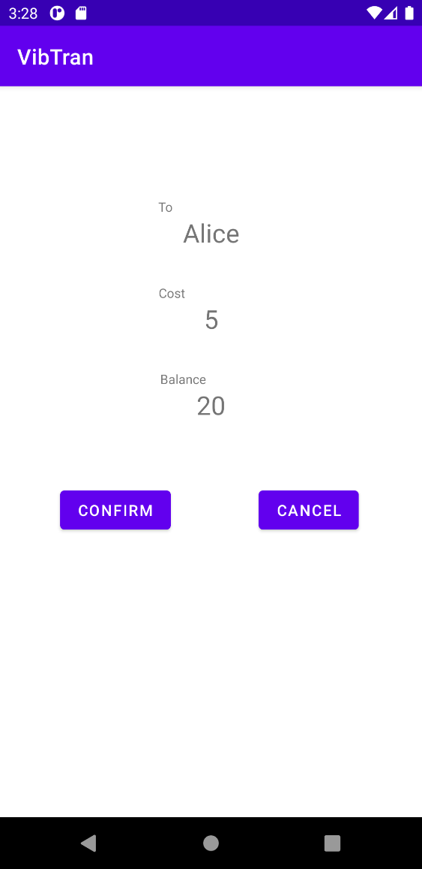

Sender Current Balance

Amount Required

Receiver Name

#### Receipt

After the sender confirm the payment, both side can review the information for this transaction. Press the Next Transaction can relocate to the Home page to do another transaction.

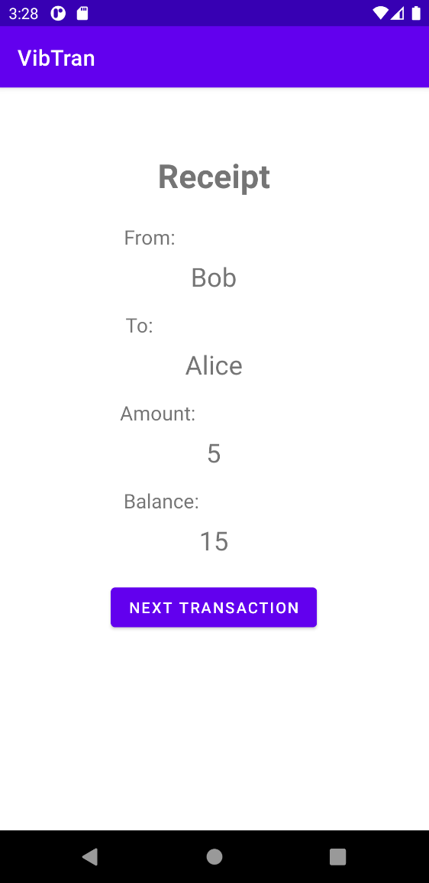

### History

The transaction records are kept in history page.

Step 1: Open the menu bar from Home page

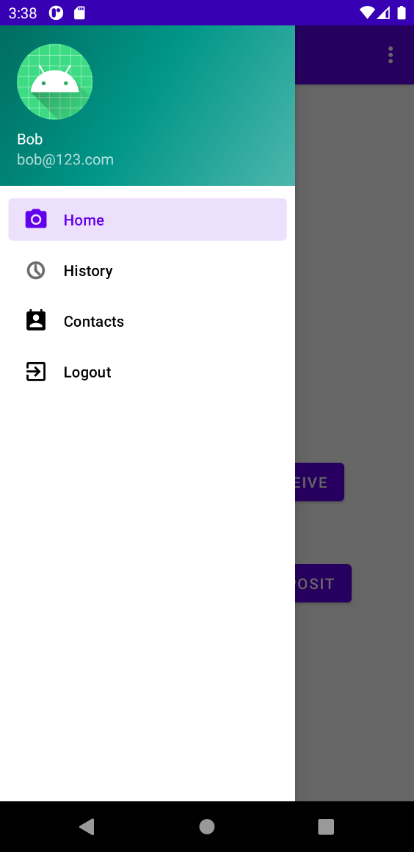

Menu Button

Step 2: Press the History page to view the record. User can view the information for completed transaction

