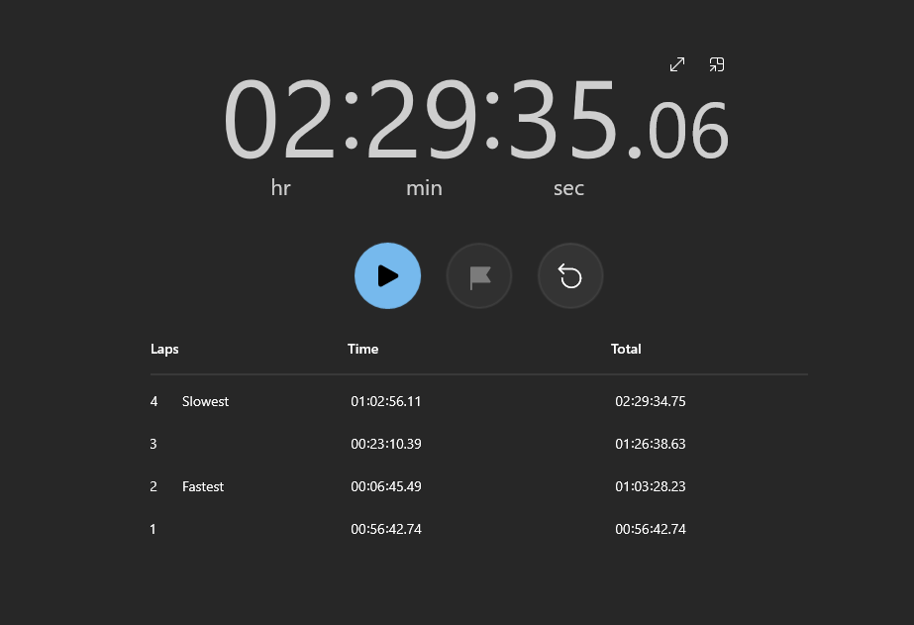

00:00:00.00->01:03:28.23 = Program Coding

01:03:28.23->01:26:38.63 = Flowchart

01:26:38.63->02:29:34.75 = Dokumentasi