# An analysis of 589 Quakers, their relationships and CEDA memberships

import csv  
import pandas as pd  
import matplotlib.pyplot as plt  
import numpy as np  
from operator import itemgetter  
import networkx as nx  
from networkx.algorithms import community   
#This part of networkx, for community detection, needs to be imported separately.  
import nbconvert  
import seaborn as sns  
plt.rc('figure', figsize=(20, 10))  
# <img src=" xxx.png">

quakers = pd.read_csv ('vw_1_quakers.csv')  
quakers['birth_year'] = quakers['death_year'].fillna(0).astype(np.int64)  
quakers['death_year'] = quakers['death_year'].fillna(0).astype(np.int64)  
  
quaker_relationships = pd.read_csv ('vw_5_person1_person2.csv')  
immediate = pd.read_csv ('vw_5_quaker_relationships_3.csv')  
close = pd.read_csv ('vw_5_quaker_relationships_2.csv')  
distant = pd.read_csv ('vw_5_quaker_relationships_1.csv')  
  
quaker_ceda = pd.read_csv('vw_4_ceda_membership_quakers2.csv')  
quaker_aps = pd.read_csv ('vw_4_ceda_membership_quakers_aps2.csv')  
quaker_esl = pd.read_csv('vw_4_ceda_membership_quakers_esl2.csv')  
quaker_asl = pd.read_csv('vw_4_ceda_membership_quakers_asl2.csv')  
quaker_ai = pd.read_csv('vw_4_ceda_membership_quakers_ai2.csv')  
quaker_qca = pd.read_csv('vw_4_ceda_membership_quakers_qca2.csv')  
quaker_hod = pd.read_csv('vw_4_ceda_membership_quakers_hod2.csv')  
quaker_not_hod = pd.read_csv('vw_4_ceda_membership_quakers_not_hod2.csv')

# Quakers occupy roughly 50% of the APS (and 100% of the QCA)

# List out all Quakers in the database

quakers

Name birth_year death_year data_source_id  
0 William Aldam 1890 1890 1  
1 S Stafford Allen 1870 1870 1  
2 Edward Backhouse 1879 1879 1  
3 James (1) Backhouse 1869 1869 1  
4 James Bell 1872 1872 1  
.. ... ... ... ...  
584 Joshua Wilson 0 0 3  
585 F Woodhead 0 0 3  
586 W Woolston 0 0 3  
587 Francis Wright 0 0 3  
588 S W Wright 0 0 3  
  
[589 rows x 4 columns]

quaker_relationships

Source Target relationship_type_id  
0 William Aldam x Fox 1  
1 William Jun Aldam x Fox 1  
2 Frederick Alexander R D Alexander 1  
3 G W Alexander R D Alexander 1  
4 Henry Alexander R D Alexander 1  
... ... ... ...  
2001 Alfred Waterhouse R Waterhouse 3  
2002 Mary Waterhouse Paul Bevan 3  
2003 Lucy Westcombe Thomas Westcombe 3  
2004 Benjamin Wheeler Samuel Wheeler 3  
2005 Charles Wilson Joshua Wilson 3  
  
[2006 rows x 3 columns]

quaker_relationships.groupby('relationship_type_id')['Source'].nunique().plot(kind='pie')  
plt.title ("Quaker Relationships in CEDA")  
plt.xlabel ("Relationships")  
plt.ylabel ("Number of Quakers")  
plt.legend(["1 = Distant", "2 = Close", "3 = Immediate"], loc ="lower right")  
plt.show()

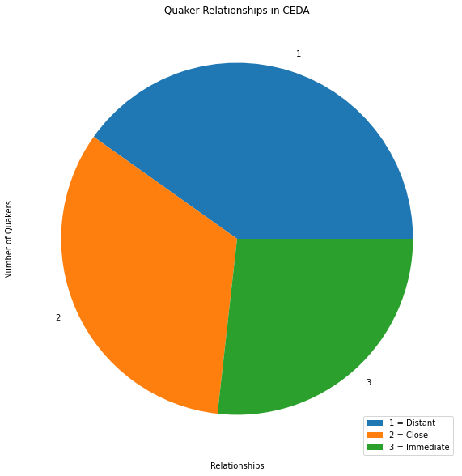

immediate

Source Target relationship_type_id  
0 Arthur Albright John M Albright 3  
1 Arthur Albright Rachel Albright 3  
2 Arthur Albright William Albright 3  
3 Rachel Albright John M Albright 3  
4 Rachel Albright William Albright 3  
.. ... ... ...  
236 Alfred Waterhouse R Waterhouse 3  
237 Mary Waterhouse Paul Bevan 3  
238 Lucy Westcombe Thomas Westcombe 3  
239 Benjamin Wheeler Samuel Wheeler 3  
240 Charles Wilson Joshua Wilson 3  
  
[241 rows x 3 columns]

close

Source Target relationship_type_id  
0 R D Alexander Christopher Bowley 2  
1 R D Alexander Robert Charleton 2  
2 R D Alexander Frederick H Fox 2  
3 R D Alexander Thomas Maw 2  
4 R D Alexander William Norton 2  
.. ... ... ...  
495 W Whiting John Whiting 2  
496 Isaac Wilson S Braithwaite 2  
497 Isaac Wilson John Jowett 2  
498 Isaac Wilson John E Wilson 2  
499 William Spicer Wood Daniel Doncaster 2  
  
[500 rows x 3 columns]

distant

Source Target relationship_type_id  
0 William Aldam x Fox 1  
1 William Jun Aldam x Fox 1  
2 Frederick Alexander R D Alexander 1  
3 G W Alexander R D Alexander 1  
4 Henry Alexander R D Alexander 1  
... ... ... ...  
1260 William Wilson Barnard Dickinson 1  
1261 William Wilson Frederick Fryer 1  
1262 William Wilson Benjamin Jowett (2) 1  
1263 William Wilson John Pease 1  
1264 William Wilson Joseph Pease 1  
  
[1265 rows x 3 columns]

# List out all Quaker CEDA memberships

quaker_ceda

Name religion_name ceda_name first_year last_year  
0 William Spicer Wood Quaker APS 1864.0 1867.0  
1 William Spicer Wood Quaker ASL 1863.0 1871.0  
2 William Spicer Wood Quaker AI 1863.0 1871.0  
3 William Wilson Quaker APS 1838.0 1865.0  
4 William Wilson Quaker ASL 1865.0 1866.0  
.. ... ... ... ... ...  
683 Joshua Wilson Quaker APS 1860.0 1860.0  
684 F Woodhead Quaker APS 1861.0 1862.0  
685 W Woolston Quaker APS 1861.0 1861.0  
686 Francis Wright Quaker APS 1838.0 1838.0  
687 S W Wright Quaker APS 1861.0 1861.0  
  
[688 rows x 5 columns]

# Pie chart Quaker CEDA memberships

quaker_ceda.groupby('ceda_name')['Name'].nunique().plot(kind='pie')  
plt.title ("Quakers in CEDA")  
plt.xlabel ("CEDA")  
plt.ylabel ("Number of Quakers")  
plt.show()

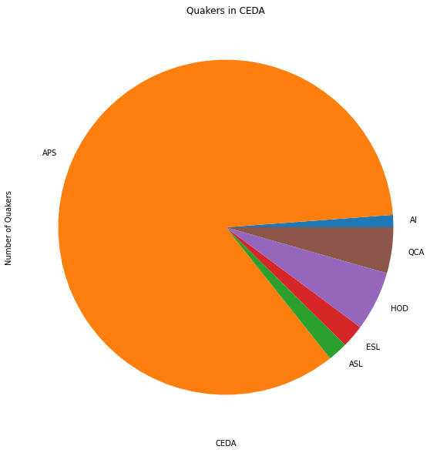

# Show Quaker 'joiners' and 'leavers' of the CEDA

## (Predominantly the APS)

quaker_ceda.groupby('first_year')['Name'].nunique().plot(kind='bar')  
plt.title ("Number of Quaker CEDA joiners in each year")  
plt.ylabel ("No. of joiners")  
plt.show()

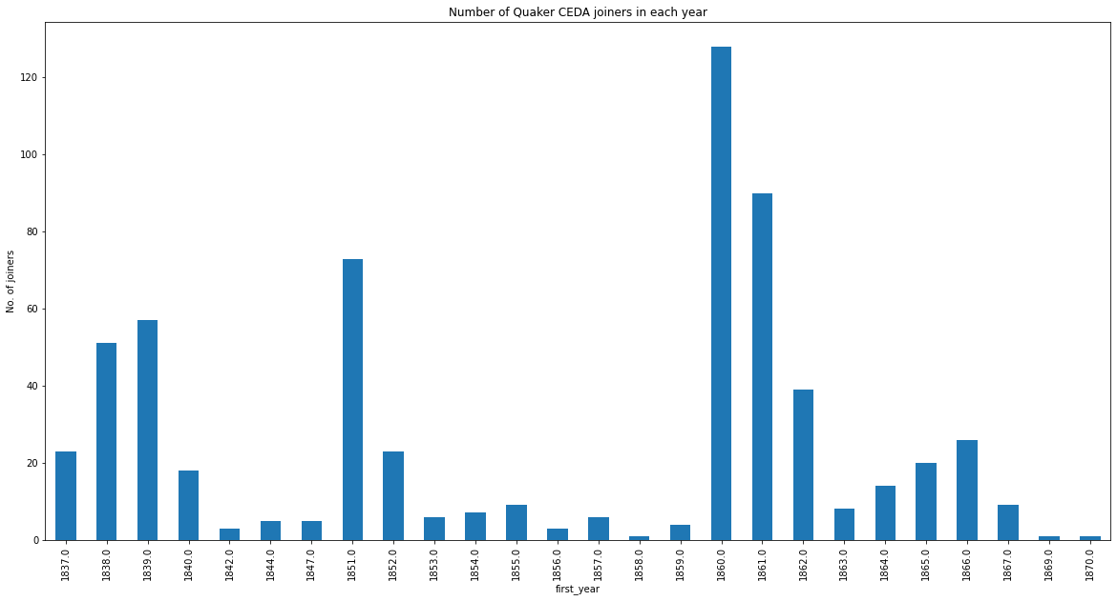

quaker_ceda.groupby('last_year')['Name'].nunique().plot(kind='bar')  
plt.title ("Number of Quaker CEDA leavers in each year")  
plt.ylabel ("No. of joiners")  
plt.show()

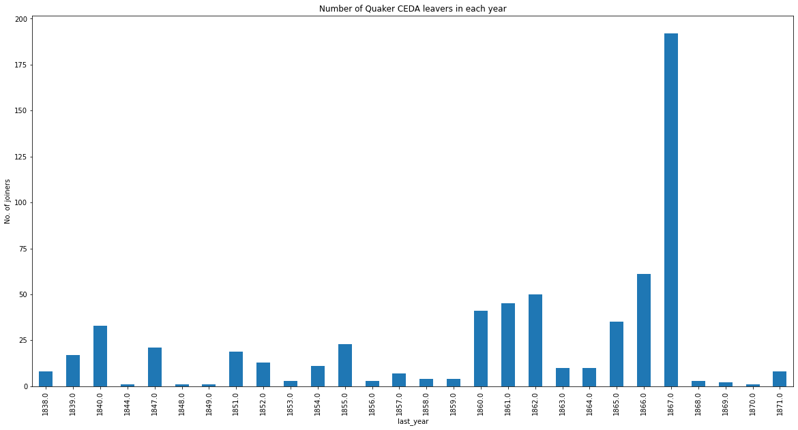

# Show the Quaker members of the QCA

quaker_qca

Name religion_name ceda_name first_year last_year  
0 Thomas (1) Hodgkin Quaker QCA 1839 1847  
1 James Bowden Quaker QCA 1842 1847  
2 William Nash Quaker QCA 1842 1847  
3 Joseph Sturge Quaker QCA 1842 1847  
4 William Jun Grimshaw Quaker QCA 1840 1847  
5 Henry Knight Quaker QCA 1840 1847  
6 Edward Paull Quaker QCA 1840 1847  
7 Robert Jun Alsop Quaker QCA 1837 1847  
8 Abram Rawlinson Barclay Quaker QCA 1837 1839  
9 John Barclay Quaker QCA 1837 1839  
10 Richard Barrett Quaker QCA 1837 1839  
11 John Thomas Barry Quaker QCA 1837 1847  
12 Peter Bedford Quaker QCA 1837 1847  
13 John Bell Quaker QCA 1837 1839  
14 Thomas Christy Quaker QCA 1837 1839  
15 Samuel Darton Quaker QCA 1837 1839  
16 Josiah Forster Quaker QCA 1837 1847  
17 Robert Forster Quaker QCA 1837 1847  
18 William Forster Quaker QCA 1837 1847  
19 Joseph Talwin Foster Quaker QCA 1837 1847  
20 John Hamilton Quaker QCA 1837 1839  
21 Edwd Harris Quaker QCA 1837 1847  
22 Geo Holmes Quaker QCA 1837 1839  
23 Robert Howard Quaker QCA 1837 1839  
24 John Kitching Quaker QCA 1837 1839  
25 Joseph Neatby Quaker QCA 1837 1847  
26 John Sanderson Quaker QCA 1837 1847  
27 Joseph Shewell Quaker QCA 1837 1839  
28 George Stacey Quaker QCA 1837 1847  
29 Joseph Storrs Quaker QCA 1837 1847

quaker_qca.groupby('first_year')['Name'].nunique().plot(kind='bar')  
plt.title ("QCA Number of Quaker joiners in each year")  
plt.ylabel ("No. of joiners")  
plt.show()

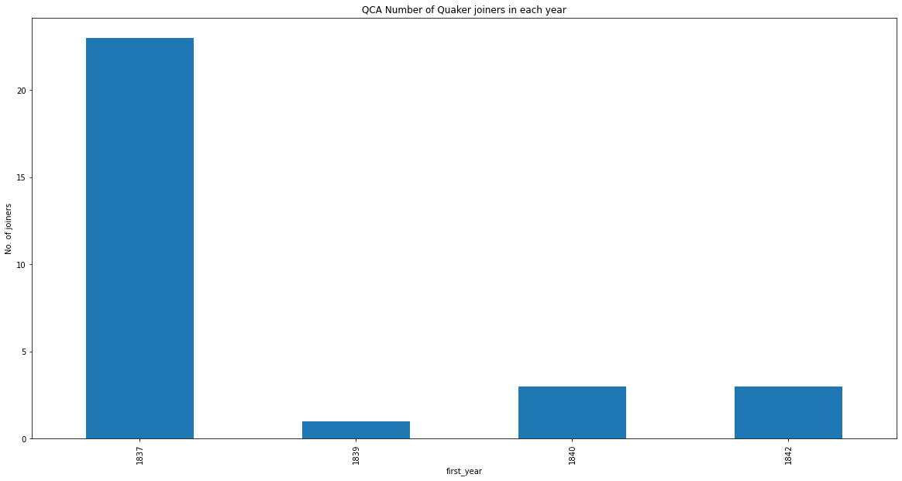

quaker_qca.groupby('last_year')['Name'].nunique().plot(kind='bar')  
plt.title ("QCA Number of Quaker leavers in each year")  
plt.ylabel ("No. of joiners")  
plt.show()

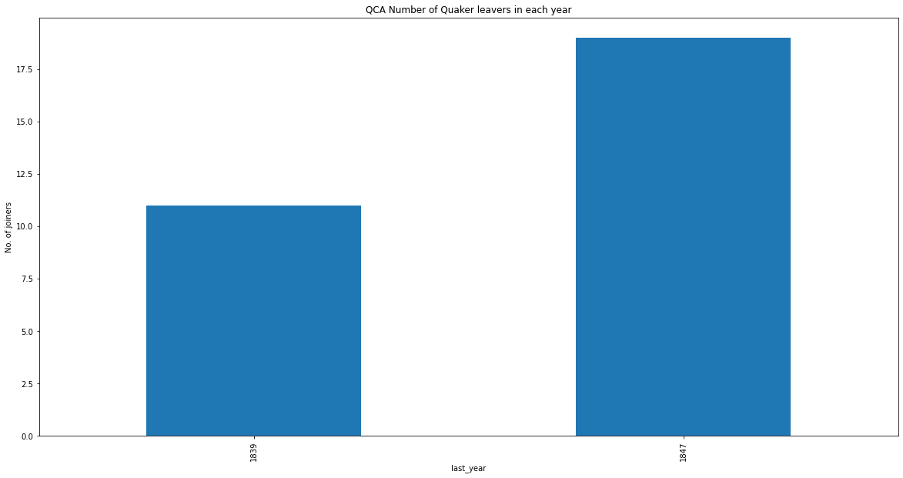

# Show the Quaker members of the HOD

## Note There are no 'first' and 'last' year data for this CEDA

quaker_hod

Name birth_year death_year religion_name ceda_name  
0 E T Wakefield NaN NaN Quaker HOD  
1 John Ross NaN NaN Quaker HOD  
2 J Robinson NaN NaN Quaker HOD  
3 Joseph Lister 1827.0 1912.0 Quaker HOD  
4 Thomas (1) Hodgkin 1798.0 1866.0 Quaker HOD  
5 Thomas (1) Hodgkin 1798.0 1866.0 Quaker HOD  
6 Robert Nicholas Fowler 1828.0 1891.0 Quaker HOD  
7 Henry Christy 1810.0 1865.0 Quaker HOD  
8 James (1) Backhouse 1794.0 1869.0 Quaker HOD  
9 James (1) Backhouse 1794.0 1869.0 Quaker HOD  
10 Jonathan Backhouse NaN NaN Quaker HOD  
11 W G Gibson NaN NaN Quaker HOD  
12 x Hadfield NaN NaN Quaker HOD  
13 Thomas Harvey NaN NaN Quaker HOD  
14 Thomas Hughes NaN NaN Quaker HOD  
15 S Rickman NaN NaN Quaker HOD  
16 Richard Smith NaN NaN Quaker HOD  
17 W Thompson NaN NaN Quaker HOD  
18 Frederick Tuckett NaN NaN Quaker HOD  
19 Frederick Tuckett NaN NaN Quaker HOD  
20 Joseph Sturge NaN NaN Quaker HOD  
21 Robert Jun Alsop NaN NaN Quaker HOD  
22 Peter Bedford NaN NaN Quaker HOD  
23 Josiah Forster NaN NaN Quaker HOD  
24 Josiah Forster NaN NaN Quaker HOD  
25 William Forster NaN NaN Quaker HOD  
26 Robert Howard NaN NaN Quaker HOD  
27 Robert Howard NaN NaN Quaker HOD  
28 R D Alexander NaN NaN Quaker HOD  
29 J Gurney Barclay NaN NaN Quaker HOD  
30 Joseph B Braithwaite NaN NaN Quaker HOD  
31 Edward Carroll NaN NaN Quaker HOD  
32 Elliott Cresson NaN NaN Quaker HOD  
33 Elliott Cresson NaN NaN Quaker HOD  
34 James Cropper NaN NaN Quaker HOD  
35 Burwood Godlee NaN NaN Quaker HOD  
36 Anna Gurney NaN NaN Quaker HOD  
37 Anna Gurney NaN NaN Quaker HOD  
38 Samuel Gurney NaN NaN Quaker HOD  
39 Samuel Gurney NaN NaN Quaker HOD  
40 John Barton Hack NaN NaN Quaker HOD  
41 John Hodgkin NaN NaN Quaker HOD  
42 John Hodgkin NaN NaN Quaker HOD  
43 Luke Howard NaN NaN Quaker HOD  
44 Luke Howard NaN NaN Quaker HOD  
45 William Howitt NaN NaN Quaker HOD  
46 Andrew Johnston NaN NaN Quaker HOD  
47 Joseph Pease NaN NaN Quaker HOD  
48 Joseph Whitwell Pease NaN NaN Quaker HOD

# Show the Quaker members not HOD

quaker_not_hod

Name religion_name ceda_name first_year last_year  
0 William Spicer Wood Quaker APS 1864 1867  
1 William Spicer Wood Quaker ASL 1863 1871  
2 William Spicer Wood Quaker AI 1863 1871  
3 William Wilson Quaker APS 1838 1865  
4 William Wilson Quaker ASL 1865 1866  
.. ... ... ... ... ...  
634 Joshua Wilson Quaker APS 1860 1860  
635 F Woodhead Quaker APS 1861 1862  
636 W Woolston Quaker APS 1861 1861  
637 Francis Wright Quaker APS 1838 1838  
638 S W Wright Quaker APS 1861 1861  
  
[639 rows x 5 columns]

# Show the Quaker members of the APS

## Note Quakers make up roughly half of the members over all years

Png goes here

## Quaker members of the APS - distant relationships

Png goes here

## Quaker members of the APS - close relationships

Png goes here

## Quaker members of the APS - immediate relationships

Png goes here

Individual networks

quaker_aps

Name religion_name ceda_name first_year last_year  
0 William Spicer Wood Quaker APS 1864 1867  
1 William Wilson Quaker APS 1838 1865  
2 James Wilson Quaker APS 1862 1867  
3 E T Wakefield Quaker APS 1853 1864  
4 John Ross Quaker APS 1839 1852  
.. ... ... ... ... ...  
568 Joshua Wilson Quaker APS 1860 1860  
569 F Woodhead Quaker APS 1861 1862  
570 W Woolston Quaker APS 1861 1861  
571 Francis Wright Quaker APS 1838 1838  
572 S W Wright Quaker APS 1861 1861  
  
[573 rows x 5 columns]

# Pie chart Quaker 'joiners' and 'leavers' of the APS

quaker_aps.groupby('first_year')['Name'].nunique().plot(kind='bar')  
plt.title ("APS Number of Quaker joiners in each year")  
plt.ylabel ("No. of joiners")  
plt.show()

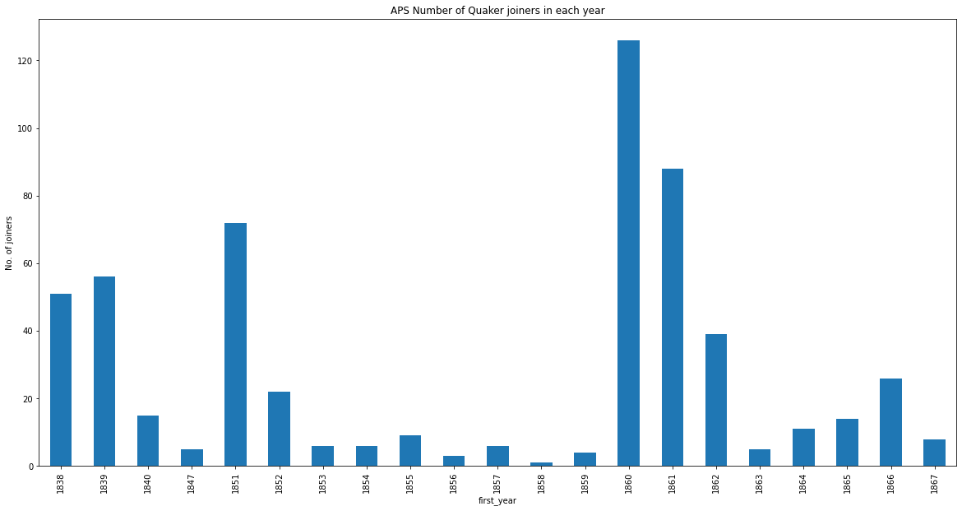

quaker_aps.groupby('last_year')['Name'].nunique().plot(kind='bar')  
plt.title ("APS Number of Quaker leavers in each year")  
plt.ylabel ("No. of joiners")  
plt.show()

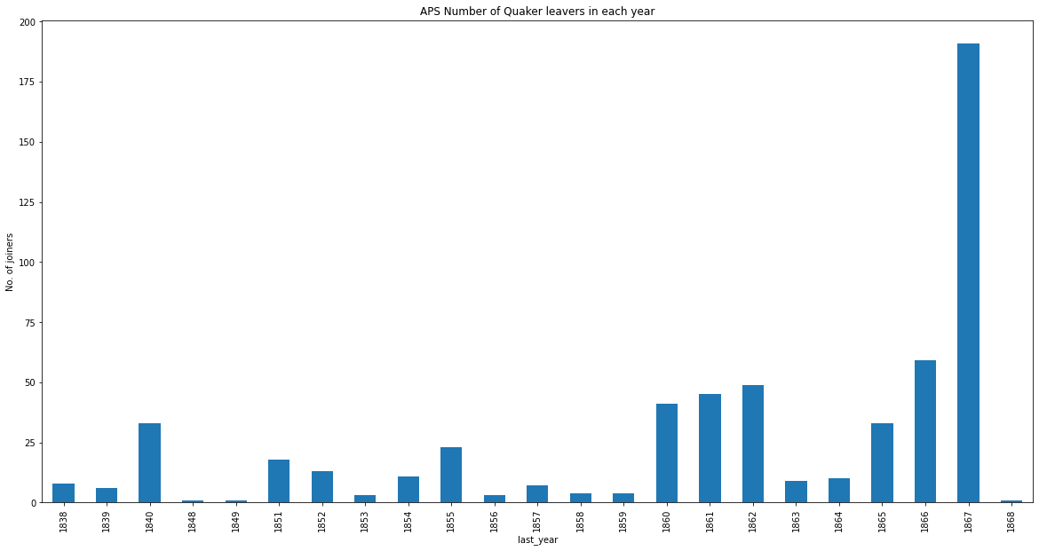

# Show Quaker members of the ESL

quaker_esl

Name religion_name ceda_name first_year last_year  
0 William Horton Lloyd Quaker ESL 1844 1847  
1 Joseph Lister Quaker ESL 1844 1847  
2 Thomas (1) Hodgkin Quaker ESL 1844 1862  
3 John Henry Gurney Quaker ESL 1860 1867  
4 Charles Henry Fox Quaker ESL 1861 1871  
5 William Fowler Quaker ESL 1851 1851  
6 Robert Nicholas Fowler Quaker ESL 1851 1871  
7 David Dale Quaker ESL 1860 1863  
8 x Collier Quaker ESL 1844 1844  
9 William Clay Quaker ESL 1861 1868  
10 Henry Christy Quaker ESL 1854 1865  
11 James Bell Quaker ESL 1852 1862  
12 James (1) Backhouse Quaker ESL 1869 1869  
13 Edward Backhouse Quaker ESL 1870 1871  
14 William Aldam Quaker ESL 1844 1848

# Show Quaker 'joiners' and 'leavers' of the ESL

quaker_esl.groupby('first_year')['Name'].nunique().plot(kind='bar')  
plt.title ("ESL Number of Quaker joiners in each year")  
plt.ylabel ("No. of joiners")  
plt.show()

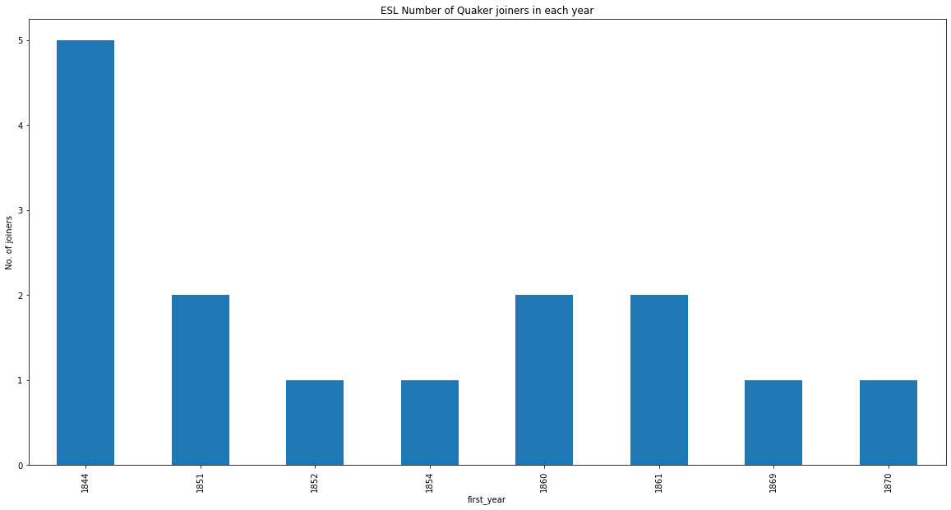

quaker_esl.groupby('last_year')['Name'].nunique().plot(kind='bar')  
plt.title ("ESL Number of Quaker leavers in each year")  
plt.ylabel ("No. of joiners")  
plt.show()

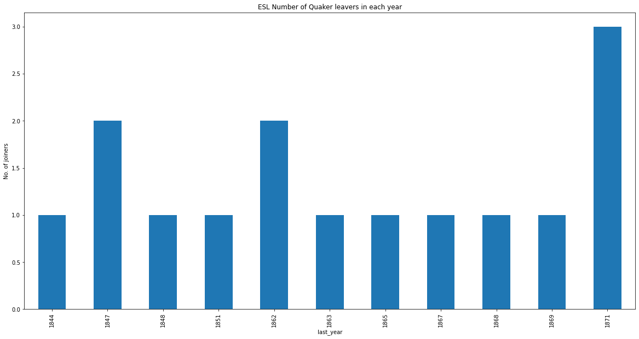

# Show Quaker members of the ASL

quaker_asl

Name religion_name ceda_name first_year last_year  
0 William Spicer Wood Quaker ASL 1863 1871  
1 William Wilson Quaker ASL 1865 1866  
2 James Wilson Quaker ASL 1865 1865  
3 E T Wakefield Quaker ASL 1865 1868  
4 J Robinson Quaker ASL 1865 1865  
5 Jonathan Hutchinson Quaker ASL 1863 1871  
6 William Holmes Quaker ASL 1865 1869  
7 George Stacey Gibson Quaker ASL 1864 1866  
8 James T J Doyle Quaker ASL 1865 1868  
9 Henry Crowley Quaker ASL 1864 1871  
10 William Bull Quaker ASL 1867 1871  
11 Antonio Brady Quaker ASL 1864 1871  
12 S Stafford Allen Quaker ASL 1863 1870

# Show quaker 'joiners' and 'leavers' of the ASL

quaker_asl.groupby('first_year')['Name'].nunique().plot(kind='bar')  
plt.title ("ASL Number of Quaker joiners in each year")  
plt.ylabel ("No. of joiners")  
plt.show()

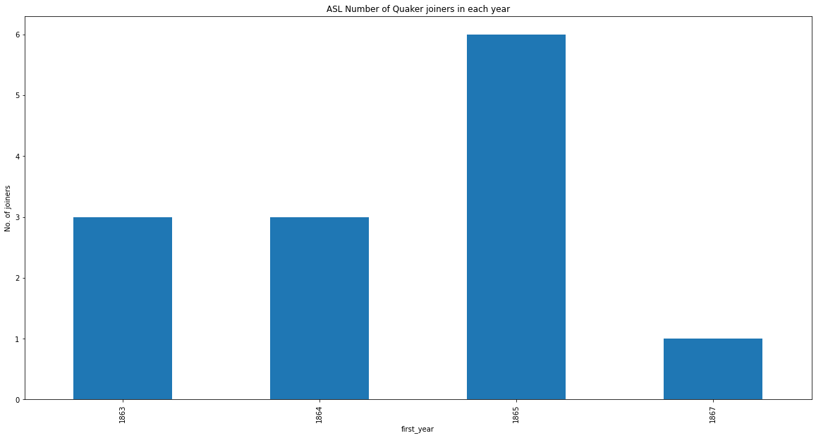

quaker_asl.groupby('last_year')['Name'].nunique().plot(kind='bar')  
plt.title ("ASL Number of Quaker leavers in each year")  
plt.ylabel ("No. of joiners")  
plt.show()

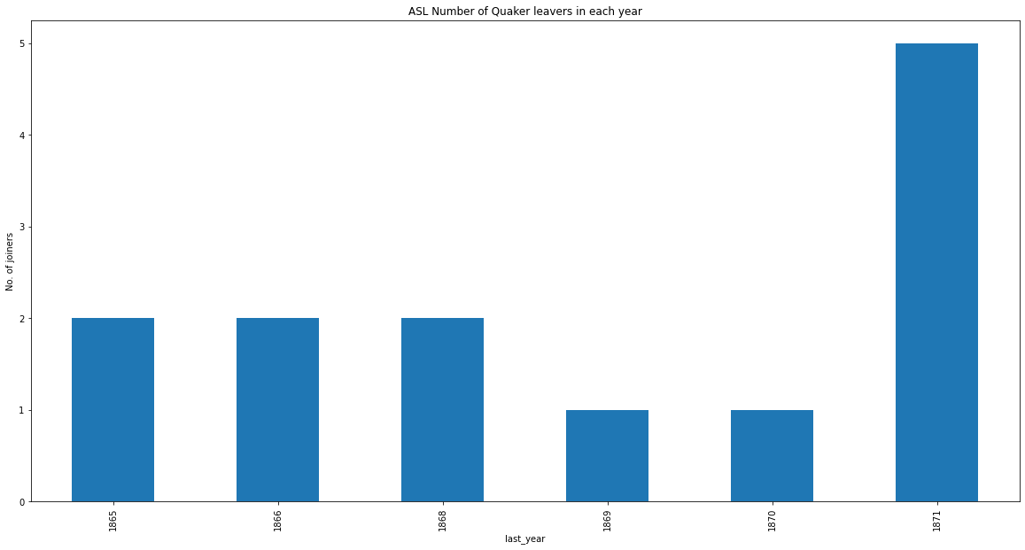

# Show Quaker members of the AI

quaker_ai

Name religion_name ceda_name first_year last_year  
0 William Spicer Wood Quaker AI 1863 1871  
1 Jonathan Hutchinson Quaker AI 1863 1871  
2 Charles Henry Fox Quaker AI 1861 1871  
3 Robert Nicholas Fowler Quaker AI 1851 1871  
4 Henry Crowley Quaker AI 1864 1871  
5 William Bull Quaker AI 1867 1871  
6 Antonio Brady Quaker AI 1864 1871  
7 Edward Backhouse Quaker AI 1870 1871

# show Quaker 'joiners' and 'leavers' of the AI

quaker_ai.groupby('first_year')['Name'].nunique().plot(kind='bar')  
plt.title ("AI Number of Quaker joiners in each year")  
plt.ylabel ("No. of joiners")  
plt.show()

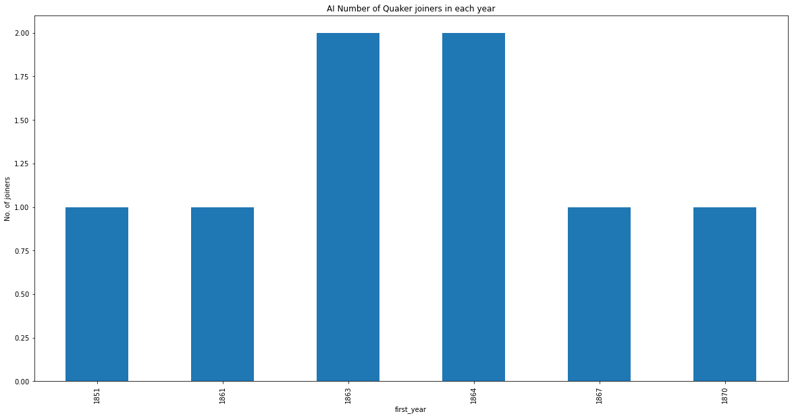

quaker_ai.groupby('last_year')['Name'].nunique().plot(kind='bar')  
plt.title ("AI Number of Quaker leavers in each year")  
plt.ylabel ("No. of joiners")  
plt.show()

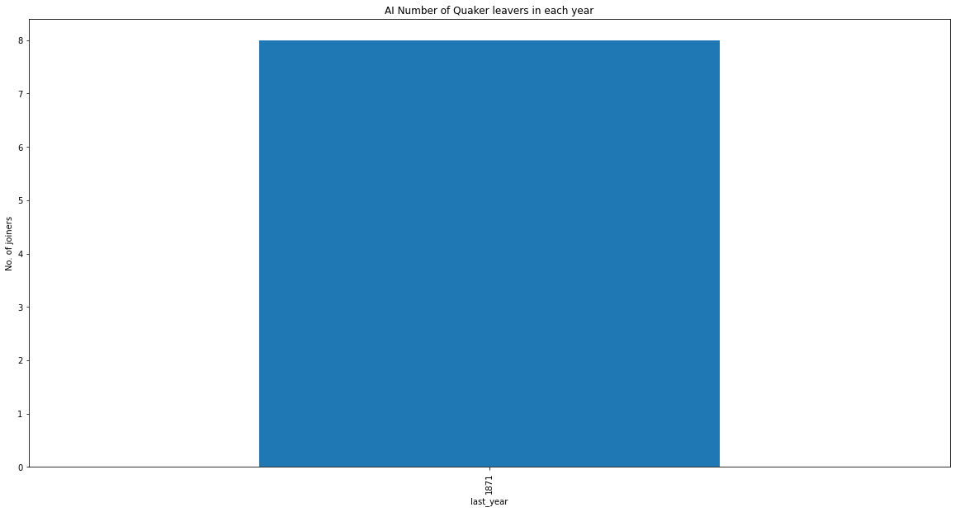

# END