# Learning Unsupervised Localized Activation Maps through Classification Model

# Abstract

Most deep learning models, although powerful, acts like a black box where it is hard to explain a model’s decision-making process. We review the Class Activation Mapping (CAM) technique that modifies the last layer of a classification model on some image dataset, so that in addition to the usual logits’ prediction, one can view a map that tells us which region from the image activates such prediction. When training an image classifier, researchers found out that the model can learn a certain map indicating the region of interest on the image without explicit supervision. Such activation map can be used to explain the reason of classification. Our report will be focus on building a simple baseline model on creating the activation maps of our datasets, and then improve the architecture hoping to generate more precise activation maps. We use the Flower-17 dataset that is available on Kaggle to experiment the CAM technique, which has not been done before. To speed up our experiment, we use the feature extractor of a pretrained VGG16 model and freeze its parameter during training, which allow efficient memory usage when storing our trained models.

***Keywords: Deep Learning, Image Classification, Convolutional Neural Network, Class Activation Mapping, Weakly Supervised Learning, Pseudo-mask.***

# Introduction and Background

We have seen competitive advancements on deep learning in the past few years, and it is only going faster. Among all of the deep learning categories, image classification remains the most researched and there are plenty of state-of-the-art models available. Some examples include Residual Neural Network (ResNet) that alleviates gradient vanishing issue in a very deep neural network (Kaiming He et al., 2016; Ross Wightman et al., 2021) and the YOLO series that keep improves the result of classification (Chien-Yao Wang et al., 2022).

With such improvements on classification accuracies, it strikes curiosity in our heart to wonder how exactly does a classification model make a decision that an image belong to one of the many classes? This process is kind of like mathematical theories, where people first assume something heuristically work and then take plenty of times to justify the rationale of its mechanics, in contrasts to common beliefs that mathematical theorems are first rigorously proved before widely used. However, current deep learning model, especially the ones involving convolutional neural network (CNN) layers are too complex to be able to clearly justified, thus we might take a step back and try to explain better than what we can for now. Class Activation Mapping (CAM) is one of such technique that improves the interpretability of a classifier (Bolei Zhou et al., 2015), as shown in Figure 1. The CAM technique clearly explain the decision of classifying the data as “Australian terrier” by showing that the last convolutional layer is activated by the “dog” part of the image, rather than the “human” part. In the discussion below we will use CAM to refer to the class activation mapping technique and the class activation map itself interchangeably.

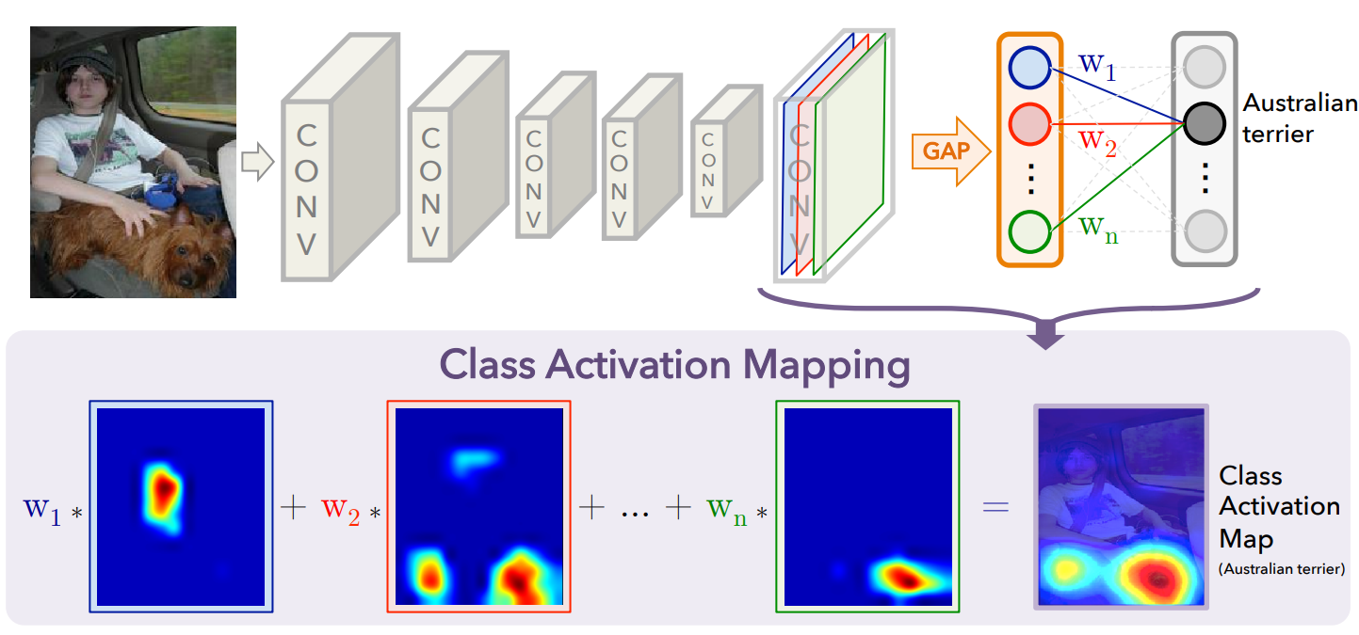

Figure 1: CAM visualization. (Image taken from Bolei Zhou et al., 2015)

The importance of CAM can sometimes help explain some ambiguity in a classifier, especially when the dataset is biased. For example, one classifier could be handling a task of classifying animals, and one of the classes is “polar bear”. It is highly possible that all of the “polar bear” images­ are taken in a snow-white scenery because it is unlikely for them to live in a more tropical environment, classifier could falsely rely on the white scenery for identifying “polar bear” class, which might lead to false classification when there is a white fox in a snow scenery. Therefore, we can analyze the CAM of some “white bear” images to know the model’s CAM is relying on the snow scenery or the bear itself, informing us potential issue with the model in advanced.

Our main objective is to investigate various implementations of CAM technique by using a pretrained VGG16 network and analyze its result critically. Moreover, different implementations will be carried out to generate fine grained CAM to better visualize the region of interest by the classifier. This project is mostly interesting in a particular way, that CAM generation can be done in a weakly supervised manner. This is because it only relies on the image level label where no mask is given. This provides another practical entry where instance segmentation is needed without ground truth masks at hand (Yang Liu et al., 2022; Zhaozheng Chen et al., 2022).

**Domain Knowledge**

Class Activation Mapping (CAM) can generate a mask similar to a heatmap indicating the region of interests. To use CAM, one does not need to create an entirely new model or heavily alter existing architecture. It is normally done by starting with a pretrained classification model then only modify the last linear layer of the model as in Figure 1. If the classifier is multiclass, one can generate CAM on a single class, where if it is a multilabel classifier, it can generate multiple CAMs overlaying on a single image, acting as pseudo-masks in a weakly-supervised manner (Peng-Tao Jiang et al., 2015) (Figure 2).

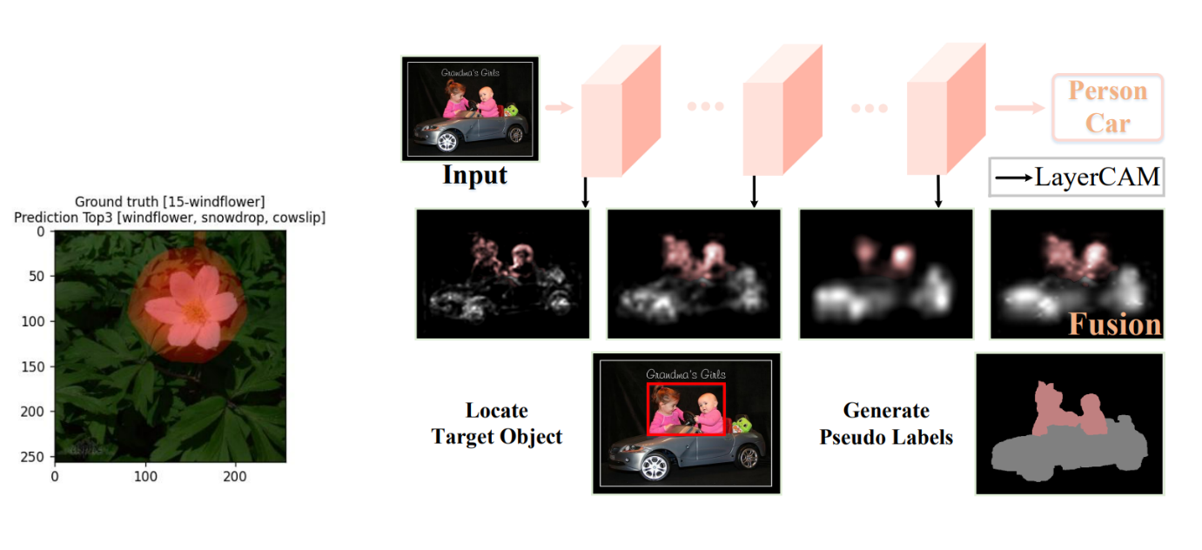

Figure 2 Multiclass and Multilabel CAM

The first implementation of CAM does not generate a detailed map, several improvements have been carried since then, either by using feature maps from shallow layers or rethink the weight coefficients.

# Justification and Review on Existing Models

A huge reason for selecting Class Activation Mapping (CAM) technique for this report is from the curiosity of understanding the rationale behind a working classifier. Modern state-of-the-art image classifiers that validate on the ImageNet Dataset (Jia Deng et al., 2009) are usually very heavy and huge, around 200 million parameters. While certain effort has been spending on keeping the model small (model distillation, pruning and quantization), understanding the decision-making process of a classifier is also equally important especially in the medical field.

The original CAM implementation (Bolei Zhou et al., 2015) simply modifies the last layer of a classification model to include a Global Average Pooling (GAP) layer before feeding the neurons into the last linear layer. Strictly speaking, a classification model can be viewed as a concatenation of a feature extractor and a direct classifier. Given an image of shape , let be its feature map of shape (we assume the feature maps are squares). Since we have discarded the original classifier from the model, we design a new end classifier as follows: A GAP layer that average the values from each map hence giving an output of shape , assuming this output is written as and there are classes in the dataset, we feed it through a linear layer to obtain an output of shape (Figure 3). This output can then be softmaxed and performed other operations normally for a classification model. Also note that GAP is a function for pure operation, it doesn’t have any trainable parameters.

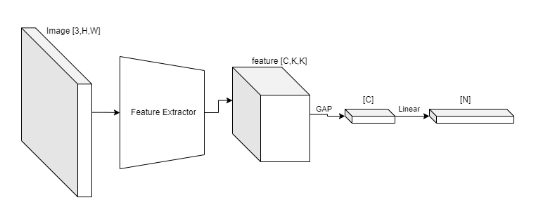

Figure 3 CAM architecture

At first glance, this is just a standard image classification model, but after the training is completed, it can be used to generate CAM. The last linear layer has weight and bias parameters that are of shape and . By skipping the GAP layer, one can pass the feature map of an image directly to the last linear layer to obtain a collection of CAMs with shape . Then, resizing the CAMs to constitutes as a rough activation map for each of classes.

The role of Global Average Pooling layer in CAM is subtle: It merely average the neuron activations from the feature map, while requiring no trainable parameters, it suits perfectly well with the objective. Since the model’s last linear layer is trained on the GAP output from the feature map, it reacts well to the original feature map as well. This is why CAM can be generated by skipping GAP layer, let us observe the regions activating the decision (Figure 4).

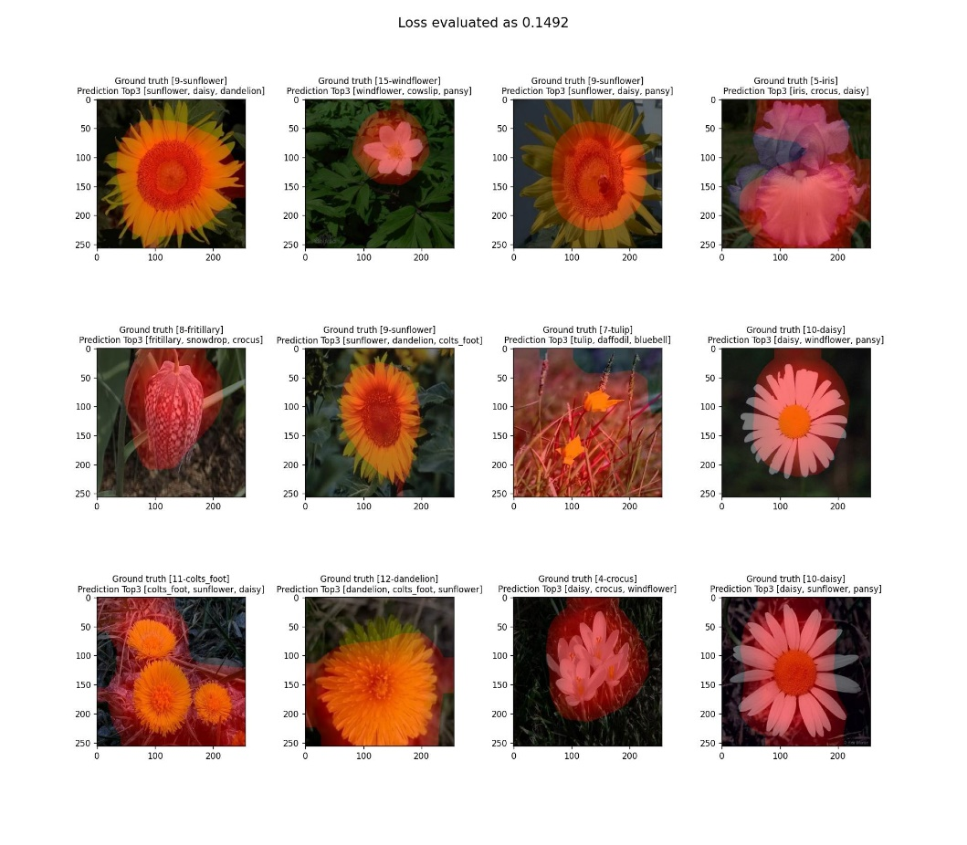

Figure 4 Original CAM Implementation

However, the approach of CAM generates blurry mappings because the feature maps has very small dimensions, the last linear layer’s weight is heuristically used in the process, and the generated CAM might include false positive regions (for example, the 7th image from (Figure 4)).

# Implementation

# Discussion

# Conclusion

# References