PART A · Report section (paste into the team report)

Design of the storage component
The disk is simulated by one binary file, data.db, divided into fixed-size 4,096-byte blocks. All storage code goes through a Disk class whose readBlock and writeBlock always move exactly one whole block and count it as one I/O. As in a real disk, the block is the unit of transfer between disk and memory, so every block access in Tasks 2 and 3 is counted in one place. 4 KB is the typical block size and matches the OS page size. It is defined once (BLOCK_SIZE in config.h) and shared with the B+ tree.
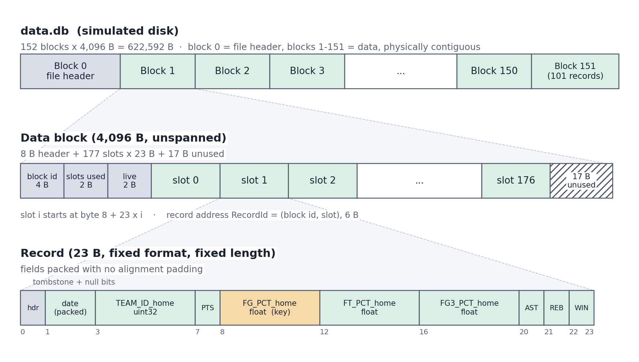
Figure 1. Storage hierarchy: the database file is a sequence of 4 KB blocks, each data block holds 177 fixed-length slots, and each slot holds one 23-byte record.

Record
A record stores one game, i.e. one line of games.txt. Every attribute is numeric, so we use a fixed-format, fixed-length record. Each field is at the same offset in every record, no separators or length fields are needed, and slot i of a block starts at byte 8 + 23·i.
Offset | Field | Type | Bytes | Reason
0 | header | bit flags | 1 | bit 7 = deleted (tombstone); bits 0–6 = null flags
1 | GAME_DATE_EST | packed date | 2 | 7-bit year − 2000, 4-bit month, 5-bit day (a string would take 10 B)
3 | TEAM_ID_home | uint32 | 4 | IDs are about 1.61 × 10⁹, so they need 4 bytes
7 | PTS_home | uint8 | 1 | maximum in the data is 168
8 | FG_PCT_home | float | 4 | IEEE 754 single precision; B+ tree key
12 | FT_PCT_home | float | 4 | 3-decimal percentages
16 | FG3_PCT_home | float | 4 | 3-decimal percentages
20 | AST_home | uint8 | 1 | maximum 50
21 | REB_home | uint8 | 1 | maximum 72
22 | HOME_TEAM_WINS | uint8 | 1 | 0 or 1
 | Total |  | 23
Table 1. Record format. Each field's type is the smallest one that holds its full range in games.txt; the loader checks every value against it.
- No alignment padding. Fields are serialised one by one with memcpy. Writing the C++ struct directly would let the compiler pad it to 28 B, which gives 146 records per block and 183 blocks instead of 177 and 151: 32 more blocks, so 21% more I/Os for a full scan.
- Missing values. 99 games have empty PTS, FG_PCT, FT_PCT, FG3_PCT, AST and REB. A null bit marks each one instead of a sentinel value such as 0, which would be a valid percentage and would wrongly enter the index.
- Schema stored once. The field list is kept in the file header rather than giving every record a pointer to the schema.

Block
- Layout: an 8-byte block header (block ID 4 B, slots used 2 B, live records 2 B), then fixed-length slots.
- Records per block = ⌊(4,096 − 8) / 23⌋ = 177. The remaining 17 B (0.4%) stay unused.
- Unspanned: a record never crosses a block boundary, so any record is fetched with exactly one block read. The cost is 17 B per block.
- No separators: because every record is 23 B, the slot number alone locates a record.

Database file
- Block 0 = file header: magic string, version, block size, record size, block-header size, records per block, number of data blocks, number of records and the schema. It is read once when the file is opened, and a file built with different sizes is rejected.
- Blocks 1–151 = data blocks, physically contiguous, so a full scan reads them sequentially, which is the cheap disk access pattern.
- Record address: a physical address RecordId = (block ID, slot) stored in 6 B. Its byte position is block × 4,096 + 8 + slot × 23. B+ tree leaves store it as the record pointer.
- Deletion sets the tombstone bit and decrements the block's live count instead of shifting records, so every RecordId held by the index stays valid. Deletions are grouped by block, so each affected block is read and written once. Insertion appends to the last block, or allocates a new block when the last one is full.
- Record order: records are stored in games.txt order, so the file is not sequential on FG_PCT_home and the B+ tree on it is a dense, non-clustered index. (task1 --sorted stores the file in FG_PCT_home order instead, which makes the index clustered.)

Storage workflow (Task 1)
- Parse games.txt line by line (tab-separated). Empty values set null bits, and every value is range-checked against its field type.
- Serialise each record to 23 B and pack 177 records per block.
- Write data blocks 1–151 in order, then the file header in block 0.
- Verify: reopen data.db, read all 151 data blocks and compare every stored record with games.txt. All 26,651 records are identical.

Task 1 results
Statistic | Value
Size of a record | 23 bytes
Number of records | 26,651
Number of records stored in a block | 177
Number of blocks for storing the data | 151
Table 2. Task 1 statistics (block size 4,096 B).
Supporting figure | Value
Records in the last data block | 101 (26,651 − 150 × 177)
Database file size | 622,592 B (1 header + 151 data blocks)
Records with missing values | 99
Records read back identical to games.txt | 26,651 / 26,651
Table 3. Supporting figures from the Task 1 run.

Notes for the team
Code: Project/member1_storage/ (README has the build command and install guide for Windows, macOS and Linux). Build with g++ -std=c++17 -O2 -o task1 src/task1.cpp src/disk.cpp src/record.cpp src/storage.cpp. task1_output.txt is a saved run.
Storage API | Used by | Cost / note
readDataBlock(id) over [firstDataBlock(), endDataBlock()) | Members 3, 5 | 1 data-block read; DataBlock gives slotsUsed, isLive, record, recordId
getRecord(rid) | Member 4 | 1 data-block read
deleteRecords(rids) | Member 4 | 1 read + 1 write per affected block (tombstone)
encodeRecordId / decodeRecordId, RECORD_ID_SIZE = 6 | Member 2 | record pointer stored in leaf nodes
Disk class on a separate file, e.g. index.db | Member 2 | disk-based tree nodes with their own I/O counters
dataBlockReads() / resetDataBlockReads() | Members 4, 5 | data-block accesses only (the header block is excluded)
BLOCK_SIZE in config.h | Member 2 | derive n for the tree from the same block size

To agree as a team:
- NULL keys: 99 records have no FG_PCT_home. They are stored, but the tree should skip them (isNull(NULL_FG_PCT)).
- Record order: the default (games.txt order) gives a non-clustered index. --sorted gives a clustered one. On our data, the games with FG_PCT_home > 0.5 are spread over all 151 blocks in games.txt order, but fit in 36 blocks when sorted, so this choice changes Task 3’s block counts. Pick one before Task 3 is measured.
- Key precision: keys are 4-byte floats. 848 records are exactly 0.500, which is representable exactly, so key > 0.5f correctly excludes them.
- Counting: count data blocks with dataBlockReads() and index nodes on the tree's own Disk, so the two numbers are reported separately.

