
STUDENT DETAILS:
Student Name: Kelvin Mein
Admission Number: BSCCS/2024/56078
Course/Class: Computer Science
Unit Code: BIT3208
Unit Name: Advanced Web Design and Development
Lecturer Name: Michael Nyoro
Semester/Academic Year: Year III Sem II

WEEK 8 4
Task 1: Create a Responsive Personal Profile Page 4
Fig1: Profile page screenshot 4
Task 2: Build a Responsive Product Showcase 5
Fig 1:Product page screenshot 5
Extra Practical Assignment 6
Fig 1: Home page 6
Fig 2: About us page 7
Fig 3 : Product page 8
Fig 4: Training Service Page 9
Fig 5: Contact page 10

WEEK 8

Task 1: Create a Responsive Personal Profile Page
Requirements
Create a webpage containing:
- Your name
- Profile picture
- About section
- Contact information

Fig1: Profile page screenshot
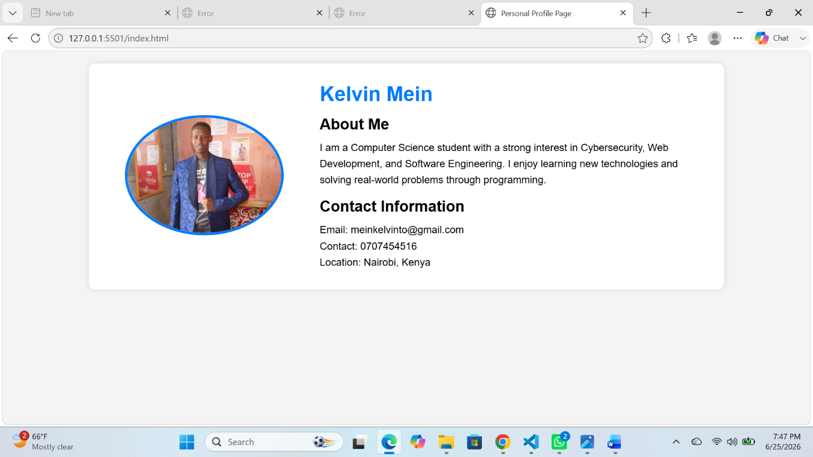

Task 2: Build a Responsive Product Showcase
Scenario
Design a product showcase page for a small business.
Requirements
Include:
- Four products
- Product image
- Product name
- Product description
- Price

Fig 1:Product page screenshot
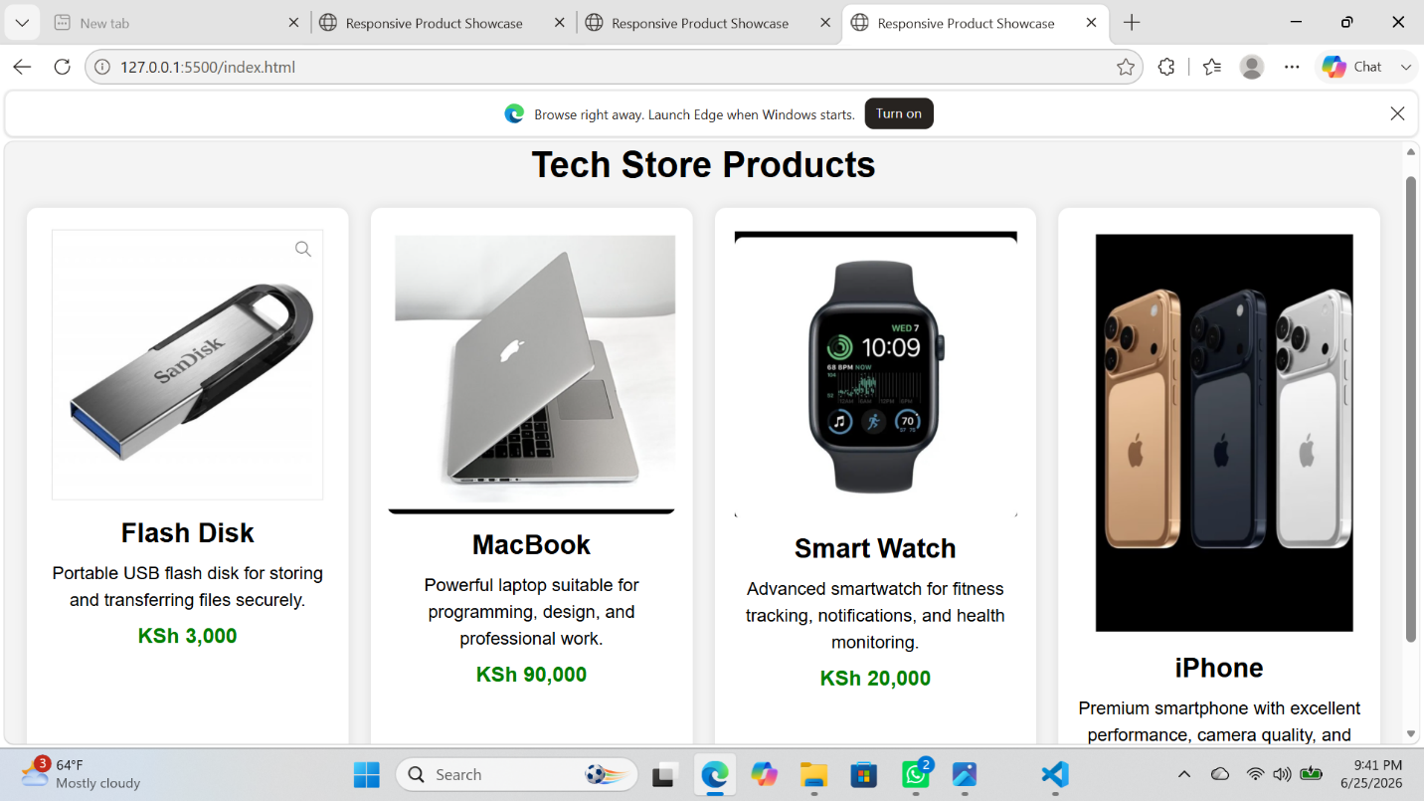

Extra Practical Assignment
Design a complete responsive website for a Cake Training and Supplies Business containing:
- Home Page
- About Us
- Products Page
- Training Services Page
- Contact Page

Fig 1: Home page
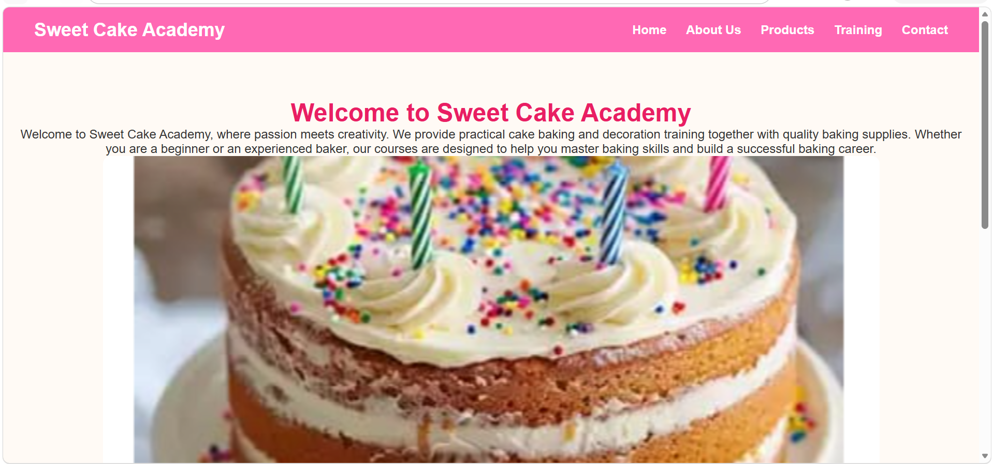

Fig 2: About us page
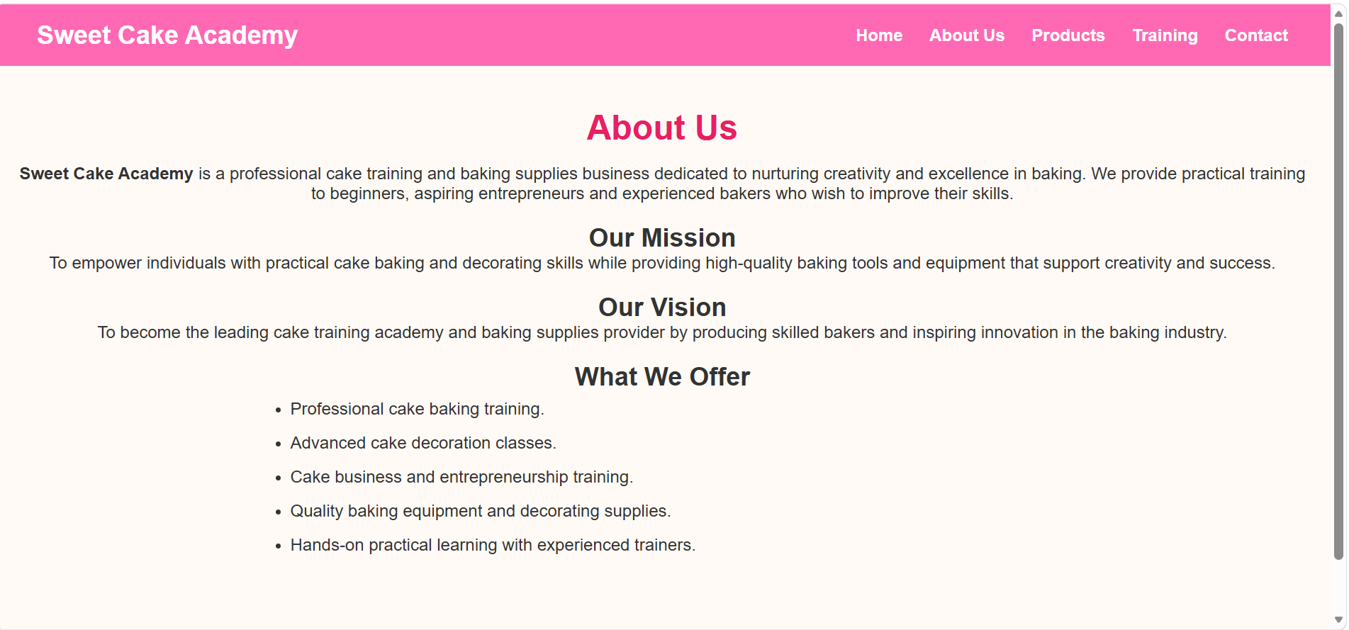

Fig 3 : Product page
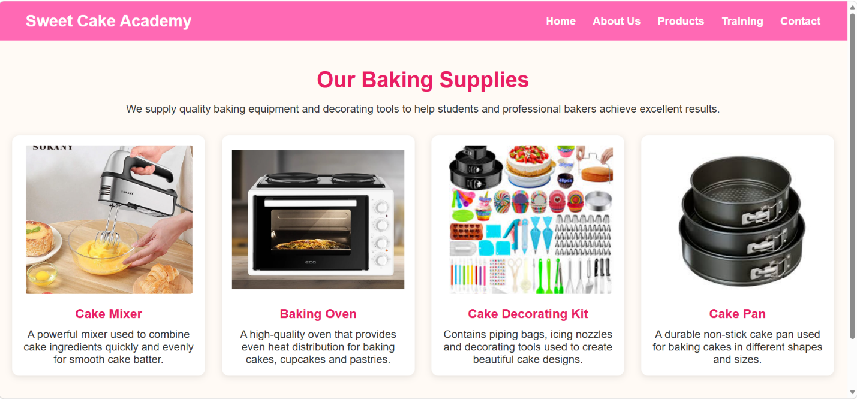

Fig 4: Training Service Page
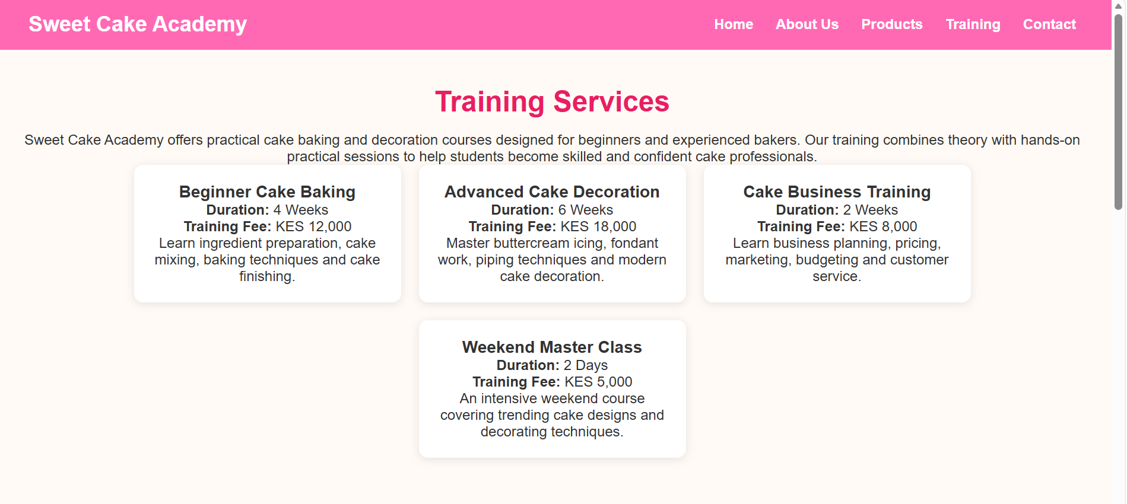

Fig 5: Contact page
