System:

x0(n)

…

xk(n)

y0(n)

…

yk(n)

**y(n) = T{x(n)}**

Filter:

a(1)*y(n)+ a(2)*y(n-1) + ... + a(na+1)*y(n-na) = b(1)*x(n) + b(2)*x(n-1) + ... + b(nb+1)*x(n-nb)

[a(1) a(2) …]*[y(n) y(n-1)…]

= [b(1) b(2) …]*[x(n) x(n-1)]

[A][Y] = [B][X]

[Y] = ([B]/[A])*[X]

Y = (num/den)*X = FILTER

Num stand for Numerator

Den stand for Denominator

Linear System:

Input: x1(n), x2(n)

Output: y1(n) = T{x1(n)}, y2(n) = T{x2(n)}

Input: x3(n) = a*x1(n)+b*x2(n)

Output: y3(n) = T{x3(n)} = T{a*x1(n)+b*x2(n)}

Then y3(n) = a*y1(n) + b*y2(n)

Time-Invariant System:

Input: x(n)

Output: y(n) = T{x(n)}

Then

Input: x(n+D)

Output: y(n+D) = T{x(n+D)}

Impulse Response

x(n) = u(n)

y(n) = h(n)

**y(n) = x(n)*h(n)**

Linear and Time-Invariant System = LTI System

Z transform => Impulse Response

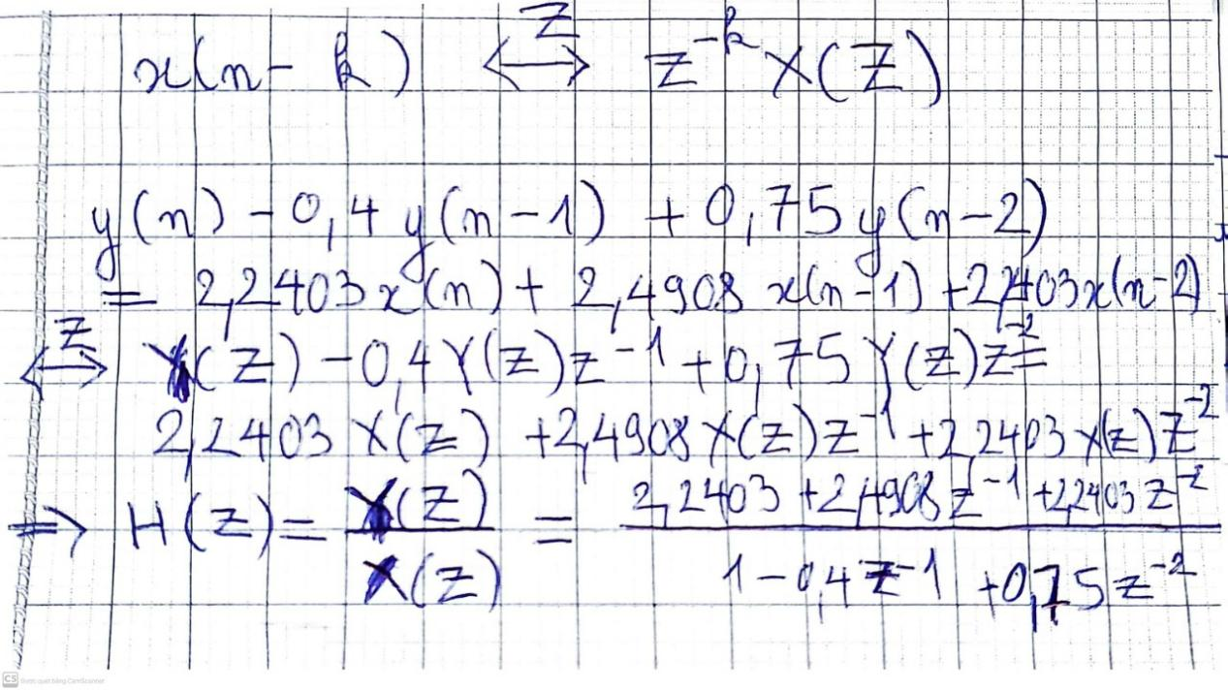

y(n) = x(n)*h(n)

Z transform: Y(Z) = X(Z)xH(Z)

Cascade

