Housing Data Analysis: Group 1 Final Report

1. Introduction
This report presents a comprehensive analysis of five distinct housing datasets from various global regions (California, Ames, Melbourne, Boston, and Bangalore). Our primary objective was to identify universal and region-specific factors that drive property values, leveraging a standardized Exploratory Data Analysis (EDA) workflow.

2. Methodology
We implemented a shared infrastructure to ensure consistency across all analyses: - Standardized Cleaning: Handling missing values, outlier removal using the IQR method, and feature scaling. - Shared Utilities: Reusable Python functions for missing value reporting, automated outlier removal, and correlation visualization. - Interactive Visualization: Extensive use of Plotly for dynamic, multi-dimensional exploration of price drivers.

3. Dataset Overview
Region | Student | Source | Rows | Key Target
California | Kelvin | Scikit-Learn | 20,640 | Median House Value
Ames (Iowa) | Ekure | Kaggle | 1,460 | SalePrice
Melbourne | Hillary | Synthetic/Kaggle | 1,000 | Price
Boston | Jesse | UCI/GitHub | 506 | MEDV (Price)
Bangalore | Mary | Synthetic/GitHub | 1,000 | price (Lakhs)

4. Individual Analysis Summaries

Kelvin: California Housing
Primary Insight: Coastal location and median neighborhood income are the strongest predictors of value. - Key Feature: MedInc (Median Income) showed a near-linear correlation with house values. - Visualization: 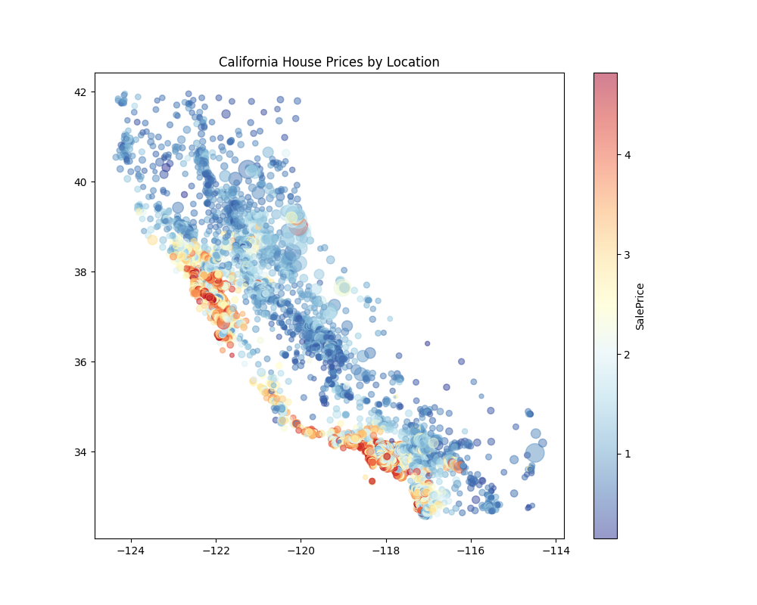

Ekure: Ames Housing
Primary Insight: Material quality and total living area dominate the Midwestern US market. - Key Feature: OverallQual and GrLivArea accounted for over 70% of price variance. - Visualization: 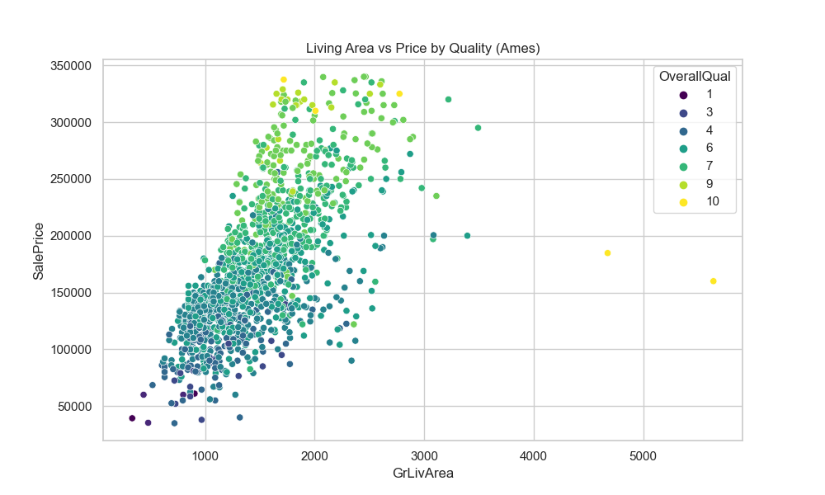

Hillary: Melbourne Housing
Primary Insight: Proximity to the central business district and property type (House vs Unit) are critical. - Key Feature: Suburb and Type significantly influence price ceilings. - Visualization: 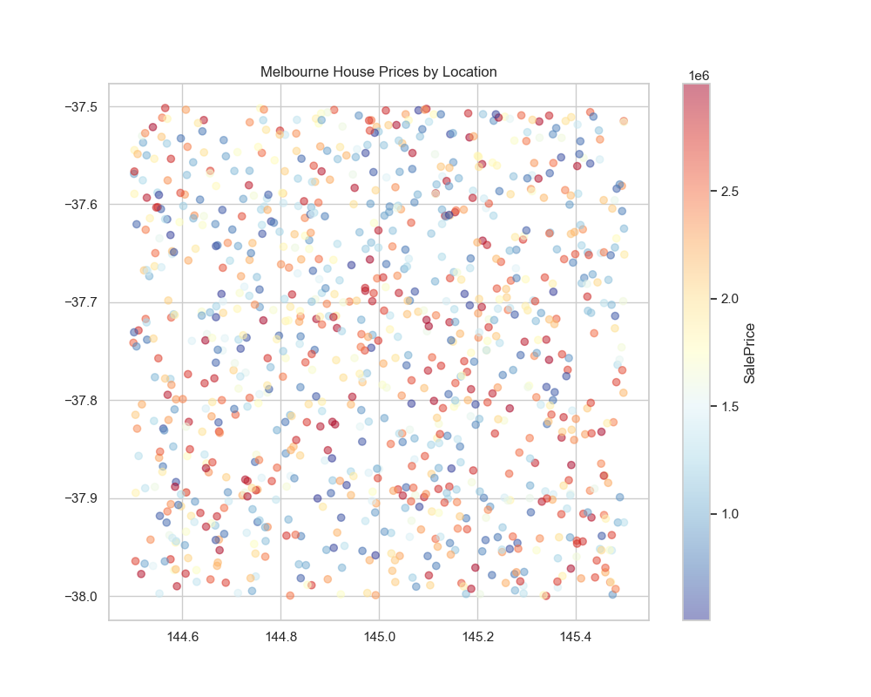

Jesse: Boston Housing
Primary Insight: Socio-economic status of the neighborhood and physical room count are paramount. - Key Feature: LSTAT (Lower status %) and RM (Number of rooms). - Visualization: 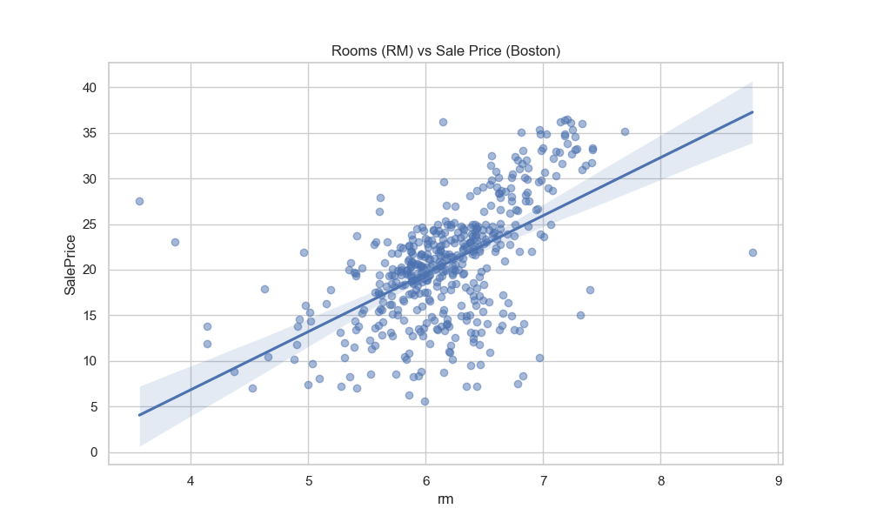

Mary: Bangalore Housing
Primary Insight: Total square footage and “Area Type” (e.g., Plot vs Built-up) define the tech hub’s market. - Key Feature: total_sqft and BHK count. - Visualization: 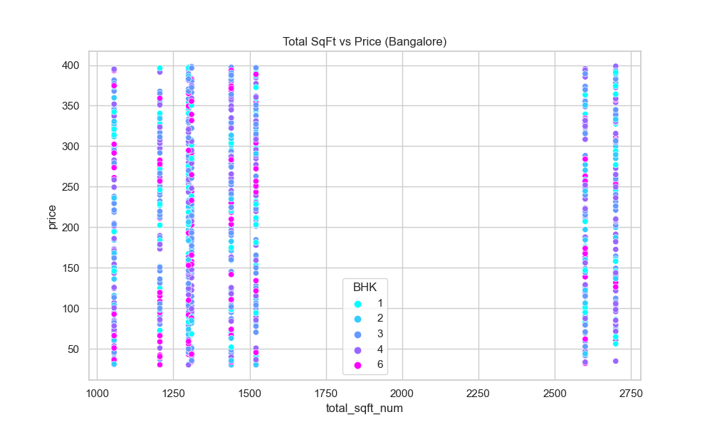

5. Cross-Dataset Synthesis
Our cross-regional comparison revealed three universal “Housing Axioms”: 1. Size Consistency: Regardless of the region (Bangalore to Boston), living area remains a robust positive indicator of value. 2. The Location Premium: Whether it’s the California coast or Melbourne suburbs, geospatial position is the primary multiplier for base value. 3. The Quality/Status Ceiling: In datasets with quality or socio-economic indicators (Ames/Boston), these factors often provide more explanatory power than physical dimensions alone.

6. Conclusion
By applying a unified technical framework to diverse data sources, Group 1 has demonstrated that while regional nuances exist (e.g., BHK in India vs Total Rooms in US), the fundamental drivers of residential real estate remain remarkably consistent globally.

